Family Learning Walk – Rouken Glen
Here are some fun things to do in this beautiful park. It will take around 1 hour to complete the whole circuit (depending on how long you spend in each area), however you may choose to complete only part of it or one or two of the challenges. You will need a camera (phone will do). When you have finished, please e-mail your photos in small batches (we can only receive e-mails of up to 10 MB) to schoolmail@hazeldene.e-renfrew.sch.uk
We hope you have fun together and look forward to seeing your photos.
- Start at the Garden Centre. Facing the entrance, turn left and walk in front of the building towards the main path through the park.
Find a sign which shows the speed limit in the park. What is the speed limit?

- At the main path, turn right. Look for a clock on a building with a bell. How many thistles can you see at the top of the turrets?

- Continue along the path to the Wildlife Garden. Enter by the second gate. Take a photo of yourself next to the butterfly.

- Find a square pattern on the ground. Which colours can you see in the pattern?

- What is the insect on top of the thistle at the Bug Corner?

- What shape are the clay containers on top of the bug hotel?

- How many nesting boxes can you find in the garden?

- Find the bench which was presented by Cascade.

- Go to the Wild Area. Why has it been left wild?

- Which carved animal can you see close to the Wildlife pond?

- Leave the Wildlife garden and turn right. Find a sit and ride toy and take a photo of yourself on it.

- Look for a large tree stump close to ground level to the right of the path. Find some natural materials such as sticks, leaves and stones to make a picture or pattern on the tree stump. Take a photo of your artwork, then return the items to where you found them.

- Look for a large tree on the left side of the path, with thick, low, curved branches. Ask your parent to check if the tree is safe to climb. If the tree is not too wet or slippery, ask your parent to take a photo of you on one of the low branches.

- Look for the shelter to the right of the path. How many slabs lead to the shelter?

- Where the paths meet, take the path to the right. Follow the path between 2 rows of trees. Look for a flag pole. Follow the path until you reach the duck pond. What animal can you see on the notice at the entrance to the pond?

- What should you not feed to the ducks?

- Which bird sits at the top of the weathervane?

- Take the path to the right round the pond. How many ducks can you see? How many swans?

- Look for a wooden carving of ducks. How many ducklings are with the mother duck?

- Follow the path to the bridge over the waterfall. What can you see fastened onto the fence?

- Walk down the stairs to the viewing point. Take a photo of yourself with the waterfall.

- Follow the path along the river. Cross the bridge near 3 large stone structures (on the left).
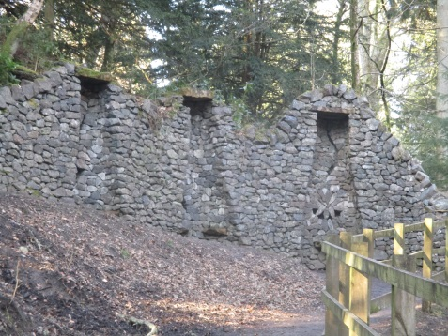

- At the fork, keep to the main path, with the river to your left. Look for a stone wall on the left. Take a photo of yourself next to a triangle with a circle inside.

- Find a flight of steps and count them as you climb up.

- Follow the path back to the main path. Turn left near the shelter and follow the path back to the Garden Centre.

Congratulations. You have completed the trail.

Please e-mail your photos in small batches (we can only receive e-mails of up to 10 MB) to schoolmail@hazeldene.e-renfrew.sch.uk

Thank you for participating in this Family Learning walk.

