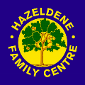Family Learning 1

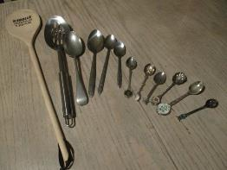

Thank you for choosing this play and learn at home pack.

Please take some photos of your learning and e-mail them to us.

Take out all of the spoons out of the bag. What can you see on the spoons? What do they feel like? What shapes can you see?

What are they made from? How many spoons are there?

What do you think each could be used for? Why do you think that?

Put them in a row starting with the shortest to the longest spoon.

Are there any the same length? Which has the shortest handle?

Which spoon is the longest?

Which is the shortest?

Find the shortest and longest spoons in your house.

Compare your short spoon with the shortest spoon from the bag. Is yours shorter? Is the bowl of your spoon narrower or wider than the one from the bag? Take a photo of the two spoons together.

Repeat with your long spoon.

Use the longest spoon to measure along a piece of furniture in your house. How many spoons wide is it? How many spoons high is it? Write down the numbers or draw the number of spoons. Measure it again with the shortest spoon. Compare the number of spoons. What do you notice?

Use different spoons to measure various items in your house. Take some photos of your learning and send them to [schoolmail@hazeldene.e-renfrew.sch.uk](mailto:schoolmail@hazeldene.e-renfrew.sch.uk)

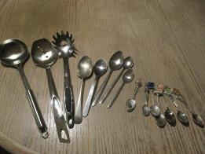Family Learning 2

Thank you for choosing this play and learn at home pack.

Please take some photos of your learning and e-mail them to us.

Take out all of the spoons out of the bag. What can you see on the spoons?

What do the spoons feel like? What shapes can you see on the spoons?

What do you think each could be used for? Why do you think that?

Why do you think some have holes at the top of the handles?

Can you read any of the writing on the spoons?

What are the spoons made from? How many spoons are there?

Put them in a row starting with the narrowest to the widest bowl.

Are there any the same width? Which is the widest?

Take a photo of the spoons with the widest and narrowest bowls.

Collect a cup and a bowl of water from your house. Put down a towel or choose a place where a little water can be spilled without causing damage.

Choose one of the spoons and count out how many spoonfuls of water it takes to fill the cup. Write down or draw your answer.

Repeat with other spoons.

Which spoon holds the most water?

Which holds the least water?

Some of the spoons have holes in them. What happens when you try to scoop out water with them? Why do you think these spoons have holes in them?

Take some photos of your learning and send them to: [schoolmail@hazeldene.e-renfrew.sch.uk](mailto:schoolmail@hazeldene.e-renfrew.sch.uk)

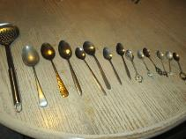Family Learning 3

Thank you for choosing this play and learn at home pack.

Please take some photos of your learning and e-mail them to us.

Take out all of the spoons out of the bag.

What do they feel like? What can you see on the spoons?

Can you read any of the words on the spoons?

What do you think each could be used for? Why do you think that?

Which spoon do you like best and why?

How many spoons are there?

The spoons are made from different metals. Which ones are the same?

Some of the spoons have writing and numbers on them telling you what they are made of. Do any of them have the same numbers or words on them?

Find some items in your house or outside which are made of metal.

Are they soft or hard? What shapes are the metal things?

What are these things used for?

Take 6 photos of metal things in your house or outside.

Could a spoon be made from something which is not metal?

Take some photos of spoons in your house which are made of different materials. What are they made from?

What would happen if you tried to eat your soup with a spoon which was made out of paper? Which materials could be used for spoons?

Send your photos to [schoolmail@hazeldene.e-renfrew.sch.uk](mailto:schoolmail@hazeldene.e-renfrew.sch.uk)

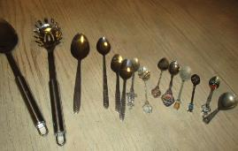Family Learning 4

Thank you for choosing this play and learn at home pack.

Please take some photos of your learning and e-mail them to us.

Take out all of the spoons out of the bag. What can you see on the spoons? Can you read any of the writing on the spoons?

What do the spoons feel like? What shapes can you see on the spoons?

What are the spoons made from? How many spoons are there?

What do you think each could be used for? Why do you think that?

Some of the spoons have numbers on them. Which numbers can you recognise?

Write down some of the numbers you see on the spoons.

Do any have the same numbers on them?

Take photos to show which spoons you find.

Find the spoon with the numbers 1937 on it.

This was the date when the spoon was made.

Look closely at the spoon. Why do you think that date was important?

What day is it today? Can you say the days of the week in the right order?

Do you know the date of your birthday?

Find something in your house which shows today’s date and take a photo of it.

Find some other items in your house which have numbers on them.

Take photos of 6 things in your house or outdoors which have numbers on them and send them to: [schoolmail@hazeldene.e-renfrew.sch.uk](mailto:schoolmail@hazeldene.e-renfrew.sch.uk)

Family Learning 5

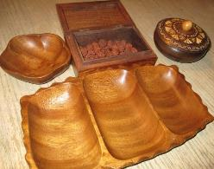

Thank you for choosing this play and learn at home pack.

Please take some photos of your learning and e-mail them to us.

This bag contains some large seeds. Choose a safe place to play and keep the seeds away from younger brothers or sisters who may try to put them into their mouths.

Take out all of the items out of the bag. What do they feel like? What shapes are they? What is the same about the items? What is different about them?

Which item do you like the best and why?

Open up the box and have a look at the seeds. What do they feel like?

Put 2 seeds into each section of the tray.

How many are in the tray all together?

(Count the first section. Hold that number in your head. Say the next number when you move to the next section. Hold that number in your head… count on)

Add one more seed to each section of the tray. How many are in each section?

How many are there in the whole tray now?

Add 2 more to each section of the tray. How many are there in each section?

Count all of the seeds in the tray together. How many are there?

Take one away from each section. How many are there now?

Use the bowls and tray to practise counting on, addition and subtraction.

Share the seeds between the bowls and each section of the tray. Take a photo.

Take 4 photos of items in your house or outdoors which are made of wood and send them to: [schoolmail@hazeldene.e-renfrew.sch.uk](mailto:schoolmail@hazeldene.e-renfrew.sch.uk)

Family Learning 6

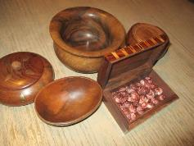

Thank you for choosing this play and learn at home pack.

Please take some photos of your learning and e-mail them to us.

This bag contains some large seeds. Choose a safe place to play and keep the seeds away from younger brothers or sisters who may try to put them into their mouths.

Take out all of the items out of the bag. What do they feel like? What shapes are they? What is the same about the items? What is different about them?

Which item do you like the best and why?

Open up the box and have a look at the seeds. What do they feel like?

Put 3 seeds into each bowl.

How many seeds are there in the bowls all together?

(Count the first bowl. Hold that number in your head. Say the next number when you move to the next bowl. Hold that number in your head… count on)

Add 2 more seeds to each bowl. How many are in bowl now?

How many are there in the bowls all together?

Return the seeds to the box.

Turn over the coasters. Look at the numerals and say each number.

Place a coaster next to each bowl.

Count out the number of seeds into the bowl to match the numeral.

Repeat using different numbers to practise counting on, addition and subtraction.

Take 6 photos and send them to: [schoolmail@hazeldene.e-renfrew.sch.uk](mailto:schoolmail@hazeldene.e-renfrew.sch.uk)

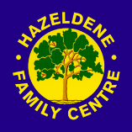Family Learning 7

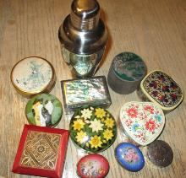

Thank you for choosing this play and learn at home pack.

Please take some photos of your learning and email them to us.

Take all the items out of the bag. What do they have in common/What is the same about them? What do they feel like? What shapes are they?

Which ones have similar shapes? What do you think the containers could be used for? Which one do you like best and why?

Look carefully at the different materials they are made of. Sort them into groups of the same materials (metal, paper mache , wood, shell.)

Take a photo of the sets.

Put them in a row starting with the smallest to the biggest container.

Find some things in your house which you could put into the containers.

(You might try pasta shapes, coins, buttons or pebbles).

Count the things as you add them to the container.

What can you fit into the blue oval container?

How many coins can you fit in the wooden box? Take a photo.

How many things can you fit into the smallest box. Take a photo.

Can you fit any of the boxes inside each other?

Take photos of 3 different containers in your home.

Take some photos of your learning and send them to: [schoolmail@hazeldene.e-renfrew.sch.uk](mailto:schoolmail@hazeldene.e-renfrew.sch.uk)