The Three Bears Rap

(Children beat the rhythm – “knees, hands” 4x slapping thighs then clapping)
(Continuing to beat rhythm:)

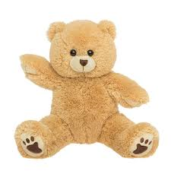
Once upon a time in the nursery rhyme there were 3 bears, 3 bears
One was a papa bear, one was a mama bear and one was a wee bear.
They all went a-walking in the deep woods a-talking
When along came a girl with long flowing, golden hair.
She knocked on the door but no-one was there, so she walked on in.
Along came the 3 bears.

“Someone’s been eating my porridge,” said the papa bear,
Said the papa bear. (Deep voice, fold arms and scowl)
“Someone’s been eating my porridge,” said the mama bear,
Said the mama bear. (High voice, hands on hips)
“Hey mama wee bear” said the little wee bear
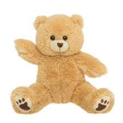
“Someone as broken my chair!” (slap hands on thighs quickly 7x)
(Throw hands up in air and gasp)
“Someone has broken my chair!” (slap hands on thighs quickly 7x)
(Throw hands up in air and gasp)

“Someone’s been sitting in my chair,” said the papa bear,
Said the papa bear. (Deep voice, fold arms and scowl)
“Someone’s been sitting in my chair,” said the mama bear,
Said the mama bear. (High voice, hands on hips)
“Hey mama wee bear” said the little wee bear
“Someone has broken my chair!” (slap hands on thighs quickly 7x)
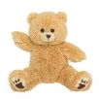
(Throw hands up in air and gasp)
“Someone has broken my chair!” (slap hands on thighs quickly 7x)
(Throw hands up in air and gasp)

“Someone’s been sleeping in my bed” said the papa bear,
Said the papa bear. (Deep voice, fold arms and scowl)
“Someone’s been sleeping in my bed,” said the mama bear,
Said the mama bear. (High voice, hands on hips)
“Hey mama wee bear” said the little wee bear
“Someone has broken my chair!” (slap hands on thighs quickly 7x)
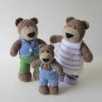
(Throw hands up in air and gasp)
“Someone has broken my chair!” (slap hands on thighs quickly 7x)
(Throw hands up in air and gasp)

Goldilocks woke up and broke up the party as she ran out of there
As she ran out of there.
“Bye, bye, bye, bye, bye, bye, bye” (slap hands on thighs 7x)
Said the papa bear (clap, slap thighs, clap, slap thighs)
“Bye, bye, bye, bye, bye, bye, bye” (slap hands on thighs 7x)
Said the mama bear (return to clap, slap thighs, clap, slap thighs etc. till end)
“Hey mama wee bear” said the little wee bear.
And that’s the story of The 3 Bears Rap! Yeah!

