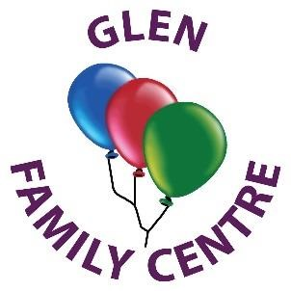
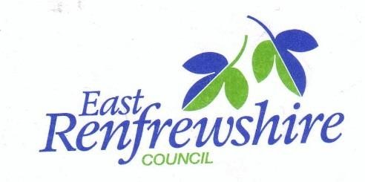

Glen Family Centre
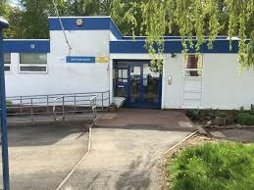
Handbook
2026

Family Centre Information

Address: Woodfarm Road
Thornliebank
G46 7JJ

Telephone no: 0141 570 7510

Email: schoolmail@glen.e-renfrew.sch.uk
Website: https://blogs.glowscotland.org.uk/er/glen/

Denominational Status: Non-Denominational

Nursery Roll: 50 Full-time equivalents

Age Group: 6 weeks – 3 years

Welcome to Glen Family Centre

On behalf of everyone at Glen Family Centre, I would like to wish you a warm welcome. I hope you and your family enjoy looking at our handbook and find the information helpful and supportive in your first steps to becoming part of our Glen family.

Early years experiences are the most important we will have in our lives. Positive early experiences promote positive future life chances. They shape how we grow in all areas of development both now and in the future.

We aim to make your child’s time at Glen a happy one, where they are nurtured, given the time, support and freedom to develop to their full potential.
When your child is allocated a place at the centre, we will work with you to get to know your child and family. This ensures we provide care and early education based on individual needs as well as supporting you.
Glen Family Centre is non-denominational. We welcome and respect children and families of all religions, faiths and beliefs.

This Handbook provides information on the services we offer for children from birth to 3 years and their families and should tell you what you need to know about the Centre; however please feel free to speak to a member of the management team or your allocated key worker if you have any questions.

Thank you for allowing Glen Family Centre team to be part of this precious stage in your child’s learning journey.

Christine Bell
Head of Centre
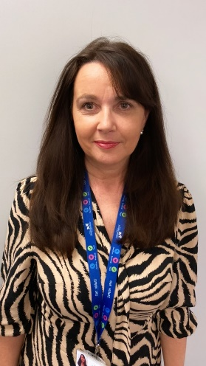
Our Vision Statement
To create a learning and caring environment that nurtures growth, collaboration and curiosity where every child thrives and knowledge blossoms with every discovery.
Article 2- Rights for all
Article 2 says all children have the rights set out in the UNCRC, and individual children and young people shouldn’t be discriminated against. This covers both direct and indirect discrimination.
Belonging

Achieving
Nurture
Kindness

Our aims:
- To be advocates of children and their childhood ensuring children’s voice and children’s rights are at the forefront of our practice.
- To ensure our children’s emotional health and wellbeing is met by providing an inclusive, happy and nurturing environment where everyone feels safe, valued respected and a sense of belonging.
- To create a learning environment indoors and outdoors which is engaging, challenging, developmentally appropriate, connected and relevant.
- To provide high quality learning experiences supporting children to become confident, independent and curious about the world around them.
- To develop positive relationships with parents and carers, working closely alongside them, valuing their partnership and contribution in every step of their child’s learning journey.
- To build a knowledgeable, compassionate and skilled workforce where practitioners have a sound knowledge of child development valuing previous learning and understanding the individual needs and learning styles of our children.
- Work in partnership with other agencies to support improvement and quality through professional discussion, self-reflection and questioning.

GLEN FAMILY CENTRE
CLOSURE DATES 2025 - 2026

In-service Monday 11th August 2025
Tuesday 12th August 2025

September Weekend Friday 26th September 2025
Monday 29th September 2025

In-Service Friday 10th October 2025

Christmas Holidays Wednesday 24th December 2025
(Early closure 2pm)
Thursday 25th December 2025 to
Friday 2nd January 2026 (Inclusive)

In-Service Friday 13th February 2026

Easter Weekend Friday 3rd April 2026 Monday 6th April 2026

May Day Monday 4th May 2026
In-Service Thursday 7th May 2026

May Weekend Friday 22nd May 2026
May Weekend Monday 25th May 2026

Fair Monday Monday 20th July 2026

In-Service Monday 10th August 2026
Tuesday 11th August 2026
September Weekend Friday 25th September 2026
Monday 28th September 2026
In-Service Friday 9th October 2026
Christmas Holidays Thursday 25th December 2026
(Early closure 2pm)

Allocation of Spaces
At Glen we can accommodate up to 31 two-year-olds and 19 babies aged 6 weeks – 2years.

Places are allocated by East Renfrewshire Council in accordance with their admissions policy which reflects The Standards in Scotland’s Schools Act 2000 and the Children and Young People (Scotland) Act 2014, which place a duty on local authorities to provide 1140 hours of free Early Learning and Childcare for all eligible 2 year olds. All places are allocated by the Education Departments Admissions Team in accordance with East Renfrewshire’s Admission policy.

1140hrs are allocated as follows:
Stretch A: morning session: 5 x 8.00am – 12.45pm
Afternoon session: 5 x 1.00pm – 5.45pm
Stretch B: 2x9 hrs 30mins and 1x4hrs 45mins per week (two and a half days)
Term time: Monday – Friday 9.00-3.00 (do not attend during school holiday periods)

Children requiring an additional or alternative placement must be referred by their Health visitor, social worker or educational psychologist. The referral will be made to the authority’s EYIG (Early Years Intervention Group).This is a multi-agency group which meets monthly to consider each case received on an individual basis.

All enquiries regarding allocations should be made to:

Education Department
Admin and Support Section
211 Main Street
Barrhead
G78 1SY
Telephone: 0141 577 3288
Email: earlylearningandchildcare@eastrenfrewshire.gov.uk

Almost all our children have been allocated either through the Early Years Intervention Group (EYIG) or Local Authority Placements (LAP). We also offer a limited number of paying places. These places can be applied for up to 12 weeks before the placement is required by emailing earlylearningandchildcare@eastrenfrewshire.gov.uk for an application form. All applications go to a ballot at the end of the LAP allocations meeting and families will be informed thereafter if they have been successful. Movement from 0-2 room to 2-3’s requires a new application which again has to be entered into the ballot.

The acceptance of a place within an establishment does not give your child any additional priority should you wish to submit an application for their funded entitlement / 2 year old place.
If you require any further information then please speak to either Catherine our Business Support or a member of the management team.

Meet Our Staff Team
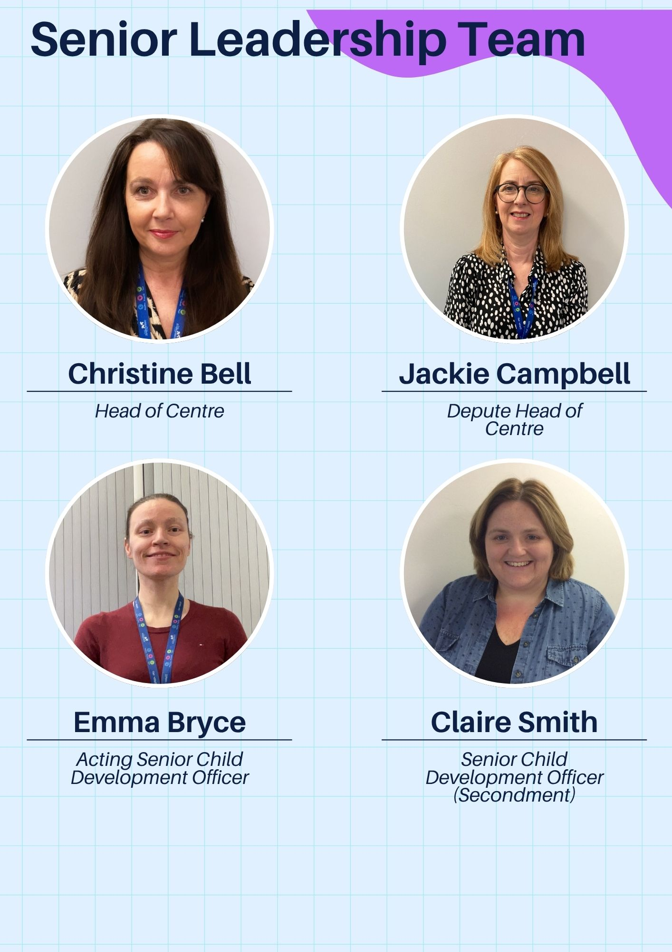
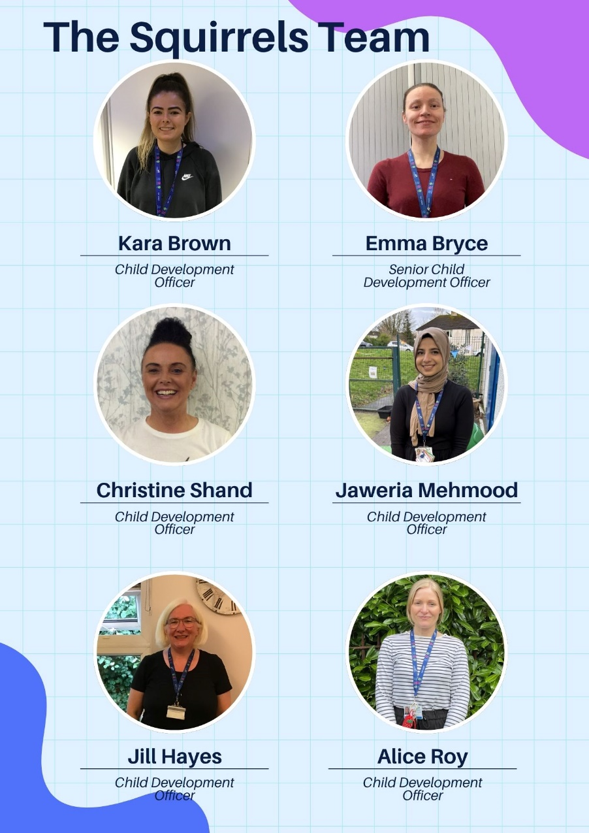
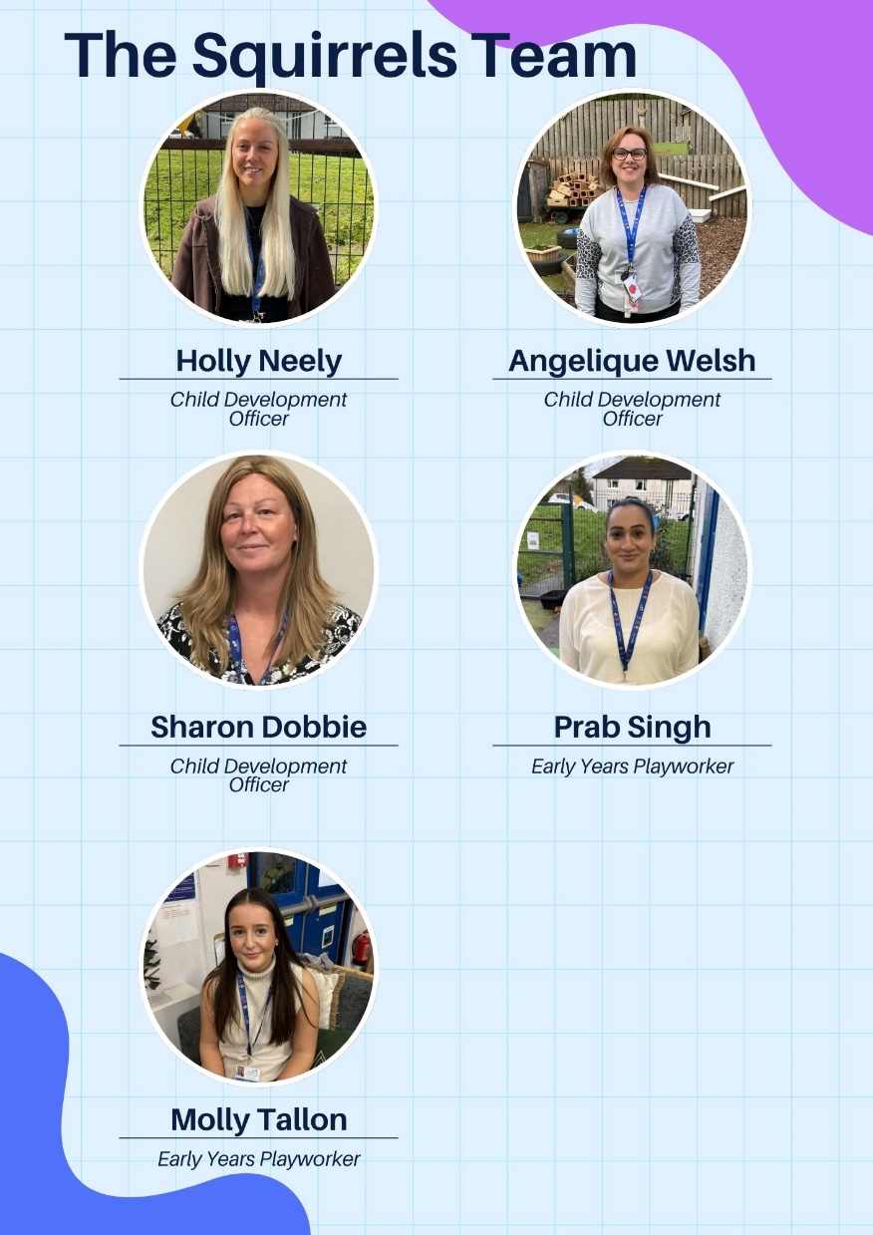
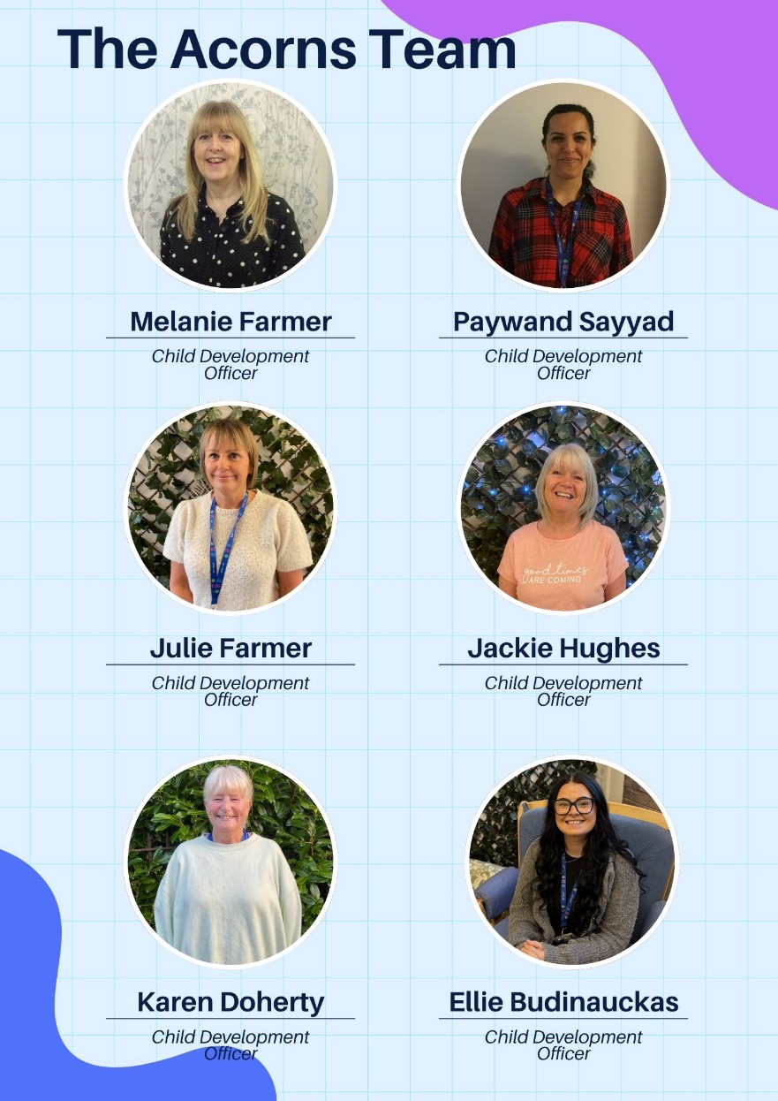
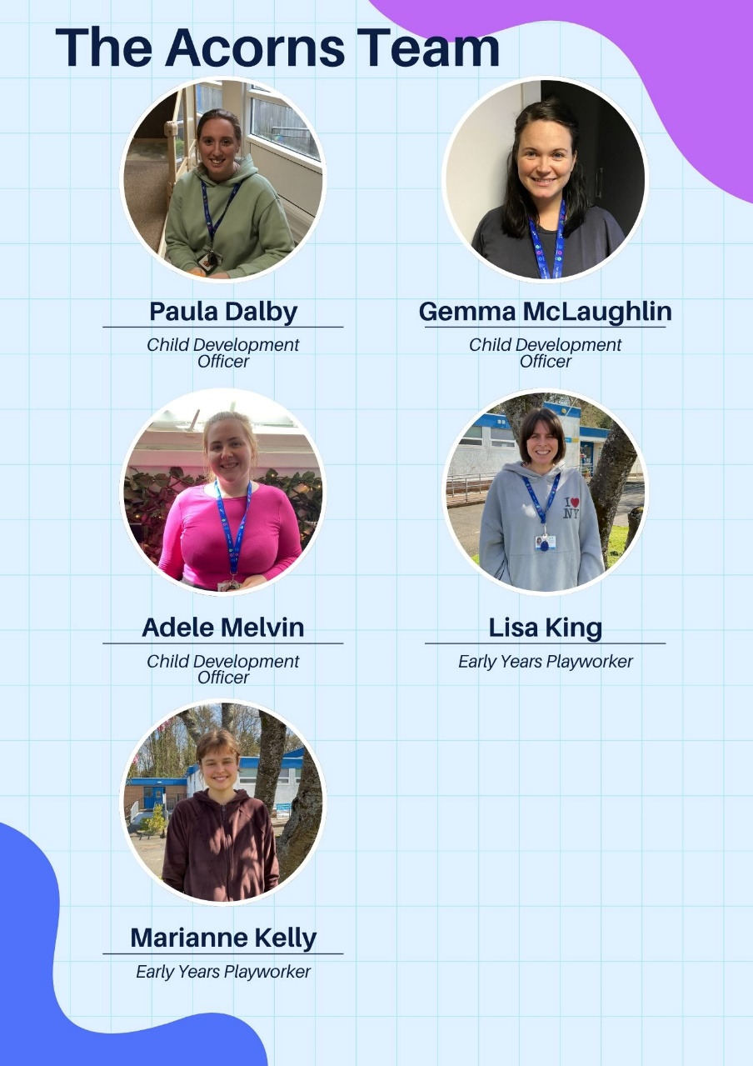

Attendance

If your child is unable to attend nursery please let us know either in advance or by telephone on the day of absence. If we do not have prior notification a member of the management team or your key worker will contact you by text/telephone to confirm the absence and ask how your child is and when you hope they will be return.

If you are planning a holiday and your child will be absent, please let your key worker or the office staff know. This will then be recorded on the register and we will not need to text or telephone you while you are relaxing.
Attendance is monitored to ensure best use of places allocated.

Centre Holidays / Closures

Glen Family Centre is opened all year round with a few exceptions. We close over the Christmas holiday period, for designated public holidays and ERC Education Department ‘In Service’ days.
As detailed in the ‘Allocation of Places’ section, children who have a ‘term time’ placement do not attend during school holiday periods even though the centre is open. Details of school holidays for the current session are displayed in the centre and on the leaflet accompanying this handbook


Emergency Closure Arrangements

Establishments may be affected by unforeseeable events, such as, severe weather, power failures or difficulties with heating. If this happens we will do our best to let you know about the details of the closure either by telephone, text, Twitter, in the press or on local radio. Updates will also be on East Renfrewshire Council’s website - www.eastrenfrewshire.gov.uk

Should we have to evacuate the centre and not be able to re-enter for any reason, staff and children will walk to Glenwood Nursery School which is further down Woodfarm Road. Parents will be notified as above.

Enrolment

When your child has been allocated a place with us, a member of Glen FC management team will contact you and arrange to visit you and your child at home. Your key worker will also come along on the visit.
During this visit we will chat with you about your child and your family, and try to get to know you a little. This also means your child gets to meet his/her key worker in their home environment and will then have a familiar face when they attend the centre for the first time.

We will take this opportunity to discuss any referrals and complete all necessary forms. You will need to have the following documents: your child’s birth certificate and one of the following; mortgage statement, rental agreement, current council tax notice, child benefit letter or utility bill.
Your key worker will bring along some toys from the centre and will use this time to play, bond, engage and form a relationship with your child. During the visit we will arrange a suitable day and time for your child to start nursery.

Settling In

During the first few days at nursery you should make yourself available to support your child to settle into the nursery environment. Please remember this is a new experience for both you and your child and as every child is unique, we treat everyone individually with the care and
attention they deserve. Some may take a little longer to settle than others; don’t worry and be guided by your key worker. The settling process is very important and ensures your child is happy and secure in making the transition from home to the Centre.

During the settling period you will be asked to complete a Care Plan and will discuss with the keyworker your child’s developmental stage. This information will enable the key worker to plan learning opportunities individual to your child’s needs.

What does my child need to bring?

Your child will have a nursery bag/box which is kept on their own peg in the cloakroom. Your child should be dressed appropriately for the weather conditions. A pair of soft shoes and a change of clothes – pants, socks, t-shirt and skirt/trousers. We have a limited stock of clothes for changing children so it is important that you refresh these items once they have been used.

A supply of nappies and wipes should also be put in the bag/box. Remember to top these up as required.

Outdoor learning is an important part of our curriculum. The children play outdoors daily and must have suitable clothes for all weathers.

What should my child wear?

Early education is about exploring, discovering, creating and experimenting. This often means messy play and messy clothes. Please bring your child to the centre in ‘play’ clothes which you won’t mind being covered in paint, mud, glue and much more. Clothes which have sleeves that roll up easily and trousers which allow independence are also beneficial.

On cold days children should have a warm jacket, gloves and a hat. Even if you come by car, remember we spend part of the session outdoors in all weathers.

On warm sunny days children should:

- Come to nursery wearing sunscreen (factor 30 or above)
- Have sunscreen in their bag or at nursery to top up throughout the day
- Have a sun hat in their bag


Parents/Carers should ensure the first application of sun screen is applied to their child before arriving at nursery regardless of your child’s skin tone. This information should be shared with your child’s key worker. Please supply sun screen for your child for top ups throughout the day.


Safety & Security

The safety and security of our children, families and staff is of paramount importance. Our security entry systems allow us to be sure we are in control of who is in the centre and aware of why they are here. If you are leaving the building and someone is waiting to enter, please get a member of staff. Please do not open the doors to anyone, even if you think you recognise them.

To ensure your child’s safety, we will only let them leave with those adults, over 16 years, whom you have nominated during enrolment. (To comply with general Data Protection Regulations please ensure that this person has given their permission to be added for this purpose.) If you need to make a change to these arrangements please speak to your key worker or office staff. Should you need someone different to collect your child at short notice or in an emergency situation, you will be asked to provide us and that person with a password to enable us to verify their identity.

Welcome Time and Home Time

When you bring your child to nursery you should make them comfortable by removing their outdoor clothes and changing shoes in the cloakroom before bringing them to the playroom.

Personal Care and Toilet Training

Your child’s personal care needs will be met with respect and dignity. Our changing stations and toilets ensure privacy is maintained while allowing staff to appropriately supervise and support children. Parents should NOT enter the children’s toilet. If your child needs to use the toilet while you are with them in the centre, please speak to a member of staff if they cannot manage on their own and need help.

When you think your child is displaying signs that he/she is ready for toilet training please speak with your key worker who will explain the methods we use to support you and your child.


Toilet training will not be started in nursery without it being discussed and agreed with you.

It is important that children have enough spare clothes in nursery to manage any accidents e.g. many pairs of pants, socks, and trousers/tights/skirts, shoes (crocs are good as these are rubber and easily cleaned.

Keeping us up to date
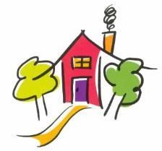
To allow us to provide effective support for your child and family it is important that we are kept up to date with any changes. Obviously having the correct emergency contact information is crucial should we need to get in touch quickly; however, it is just as important to let us know about other

things that might be changing to ensure we can help your child manage changes in their circumstances. Things it might be good for us to know include-

- Change of phone numbers, moving house
- illness of close family, new babies, change of sleep pattern, - bereavement, hospital admissions, separation

Food and Drink


Snacks A healthy snack is offered to children during their sessions. Glen is a health promoting nursery and all snacks are in line with National Nutritional Guidelines. We offer milk and water to drink and provide a selection of snacks which include a variety of fresh fruit, toast, cereal, raisins, crudities and dips. On special occasions and end of term parties, snacks may vary to include some treats such as a small biscuit or some crisps. You will be notified of these special occasions in the newsletter. Water is available throughout the session and every child is encouraged to bring in their own water bottle to nursery. This can be brought in daily or left at our Hydration Station and staff will wash and refill it for your child. To enable our team to continue to support the children to eat healthy, we ask that parents contribute 50p per day to our nursery snack through Parent Pay. This is in addition to any hot meals that parents purchase for their child’s lunch.

Lunchtime
Children who are allocated a place through EYIG (Early Years Intervention Group) or LAP (Local Admissions Panel) will be entitled to a free hot lunch. If you are paying for a place and your child attends over lunchtime you have the option to buy a hot lunch, or you can provide a healthy packed lunch for you child.

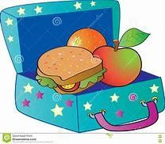
There is a three week lunch menu which is rotated weekly and offers two courses which will include options for children with specific dietary requirements e.g. food allergies, vegetarian. A copy of the menu is available on the East Renfrewshire website.

If you prefer to provide a packed lunch for your child we would ask that it is a healthy lunch avoiding sweets, chocolate and sugary drinks. Please ensure that all lunch boxes are labelled and have an ice pack in them as lunch boxes are not kept in a fridge. If you want your child to have something hot, please ensure it is heated in a thermos as due to health and safety guidance, we are unable to heat food.

If your child has any allergies or is on a special diet, please alert the management team who will provide you with the correct ER form to complete with your dietary request.

Breastfeeding Friendly

Breastfeeding is widely recognised as the most favourable means of infant feeding with considerable benefits for both mum and baby. Glen Family Centre is a ‘Breastfeeding Friendly’ establishment where staff are specially trained to promote an environment where breastfeeding is seen as the normal way to feed babies and infants.

At Glen Family Centre the staff team will support breastfeeding and parent: infant relationships as well as raising awareness in children to improve acceptance and standards of care within today’s society.

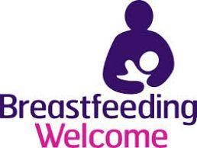
Staff promote, protect and support any mother who chooses to breastfeed and welcome this within any public or private area of our nursery where both mum and baby feel relaxed and comfortable during this special time. We also promote the awareness in children of breastfeeding as a normal activity through books and resources in the nursery.
A full policy with more detail is available on our website or at the office.

Consents

As part of everyday nursery life children will participate in many different events and opportunities. During enrolment you will be asked to consent (or not) to a variety of activities including environmental walks in the local area exploring concepts of nature, numbers, print and healthy living or taking your child to nearby parks or areas of interest. When excursions further afield are planned, you will be informed in advance and asked to complete an additional consent form giving your permissions for your child’s participation. Only children whose parents/carers have given the necessary consent will be able to take part in outings.

Staff also like to take photographs and video recordings of the children during these events as well as during every day nursery sessions. This helps to provide a record of your child’s learning and development for both you and them to enjoy and recognise their achievements. Photographs and recordings may also be used for displays in the Centre, our website or staff training. Your child’s images will only be used if you are happy to sign the consent form.

Tooth-brushing Programme

Childsmile is a national programme designed to improve the oral health of children in Scotland and reduce inequalities both in dental health and access to dental services. Good oral health in childhood means healthy teeth and gums throughout life. Childsmile is working to ensure all children, regardless of income or background, have the best possible start in life. Young children need help with tooth brushing on a daily basis, with research showing us we need to brush at least twice a day with fluoride toothpaste.
For more information please log on at: www.child-smile.org
At Glen Family Centre we have a ‘Smile Too’ award and understand the importance of tooth brushing in young children. Our tooth-brushing programme is part of our daily nursery routine and is a fun and educational experience for your child. Your child will be allocated a toothbrush with a picture on it that will be stored in an individual container.
Containers are washed regularly with hot soapy water and the toothbrushes are replaced on a regular basis. Someone from ‘Smile Too’ visits the centre regularly.

Medical Information & Illness

To ensure your child receives the appropriate care while they are at nursery it is important for us to be aware of any medical needs he/she has. You have the opportunity to inform us of any conditions/allergies during enrolment; however you must remember to keep us up to date with any changes or if your child develops a medical condition after enrolment.
If your child requires to be given medication during the nursery session you should discuss this with your key worker. We can only administer drugs which have been prescribed for your child and cannot give cough bottles or pain relief such as ‘Calpol’ on an ‘ad hoc’ basis. You need to complete a form which authorises nursery staff to administer the medication. This is called the ‘Administration of Medication’ form and is available from the office or our website. You should read the ‘Medication- Guidance for Parents’ information which is also available from the office or on the website.


If your child suffers from asthma or allergies and requires medication when they are having an attack or reaction, you will need to complete a ‘Symptoms’ form. Again this is available from the office or on the website. We cannot accept medication that says ‘as required’ without details of the circumstance when the medicine would need to be given.

Accidents and illness


All minor accidents or injuries are recorded in our Accident Log. If your child has an accident, you will be asked to sign an accident form. A copy will be held in office files and another will be given to you if you so require.

If your child becomes ill while attending the Family Centre, we will contact you immediately. If you cannot be reached, we will use the information you have provided to contact the named emergency contact person. Please remember to keep contact details up to date. Your child will be given immediate attention as necessary in order to make him/her comfortable until a parent or carer arrives to collect them. If we were unable to contact anyone, we would contact emergency services directly if necessary.


If your child is unwell prior to coming to nursery, it is important that you keep them at home. This will ensure a speedier recovery and prevent other children or staff becoming infected. If your child is suffering from a virus or any kind of contagious illness, we ask that you keep them at home where they will be most comfortable and to avoid infecting other children. PLEASE NOTE Public Health Authority guidelines stipulate that children should be absent from nursery for 48 hours following a bout of sickness or diarrhoea


If your child has an accident which needs further attention, we will follow the same procedures to contact you as above; however, should there be the need for emergency treatment, we will call an ambulance first and a member of staff will accompany your child to hospital and meet you there. Any incident resulting in a child needing hospital treatment will be logged on ERC’s electronic system and the Care Inspectorate will be notified.

Wellbeing

The best way of getting to know your child is by using information only you can give to us. The information gathered from the home visit will give a starting point for planning personal learning goals agreed between the parent and keyworker taking into consideration individual needs, interests and stage of development.

Many children need a little extra support from time to time for a variety of reasons. This may be because they are having difficulty with an area of development, have an identified learning need or medical difficulty or there is something going on in their life such as a family bereavement, breakdown of parents’ relationship or perhaps they have moved house and are struggling to adjust.

Sometimes this support can be provided by staff within the centre, however, occasionally it is necessary to call on the expertise of others for advice on how to support children to achieve their full potential. We work with a range of other professionals to ensure the right people with the appropriate knowledge and skills are available should they be needed. We have very close links with Health Visitors, Speech and Language Therapists and Educational Psychologists.

If we feel your child could benefit from some additional support, we will always speak to you first. Nobody will work with your child without your knowledge. If you feel your child needs extra support please speak to your key worker or our Depute Head of Centre, Jackie Campbell who is our Additional Support Needs Co-ordinator. Parents can also approach all of these services independently.

Joint Support Team

When it is agreed a child should be considered for additional support we may discuss their needs at our Joint Support Team meeting. Our JST is chaired by the Depute Head of Centre and the other members include:

Head of Centre- Christine Bell
Educational Psychologist – Ainsley McGoldrick
Link Speech and Language Therapist – Katherine Walters

While your child is receiving additional support we will use ERC’s Wellbeing Plans to ensure this support is monitored, reviewed and evaluated. You will be invited to attend a meeting every term to participate in setting and reviewing targets for your child.

The purpose of this multiagency support is to ensure that the intervention/support given suits the individual needs of both the child and the family. The nursery can offer a variety of support with the help of various agencies. Please let us know if you require any further information.

Curriculum and Pedagogy

Curriculum and Pedagogy…very fancy words which really mean what we do and how we do it.

At Glen Family Centre the key workers are all qualified and registered as Childcare
Practitioners. In addition the staff team have received specific training in ‘Nurturing & Child Led Play Approaches’ which is the method, or pedagogy, embraced in our centre.

Research has highlighted how vital early experiences are in shaping and developing a young child’s brain and how future development and learning are impacted by those earliest experiences. In recognising this we understand the importance of a child’s emotional wellbeing and social competence in enabling them to reach their full potential. Providing play and learning experiences using nurturing and child led approaches ensures we are supporting children emotionally and socially which, in turn, enables them to engage fully and meaningfully with all learning opportunities.

Play lies at the heart of the curriculum and makes a major contribution to your child's development. Children learn as they play and as they share experiences with other children and adults. Through play, children practice and develop many skills they need in life. Using a 'Child Led' approach in implementing the curriculum through play means that your child has the opportunity to learn through the experiences they enjoy most.

The Wellbeing wheel details the indicators we consider in all aspects of our work as we aim to get it right for every child.
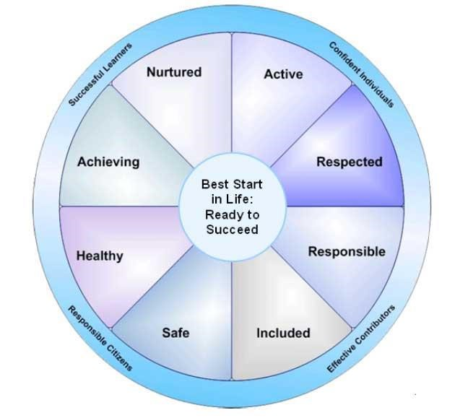

Pre birth – 3: Positive Outcomes for Scotland’s Children
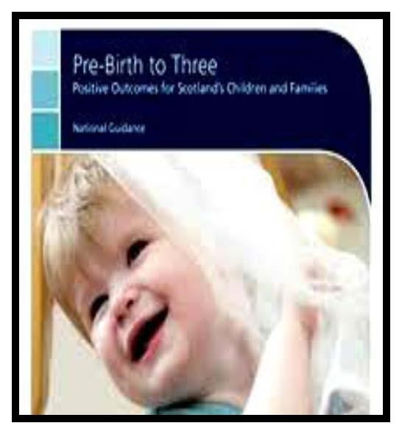
At Glen Family Centre we believe that our children are unique individuals and active participants within the world around them showing particular interests, preferences and capabilities in all that they say and do.

Our children’s views and attitudes are shaped from a very early age and being part of a family and community helps to determine individual values and beliefs. We value, respect and respond to parents’ knowledge of their child and this information is imperative to ensuring effective practice within our centre.

When planning for our children’s learning we focus on
each individual child while using the ‘Pre-Birth to Three’ document as a valuable tool to support the ‘Rights of the Child’, ‘Relationships’, ‘Responsive Care’ and ‘Respect’ which in turn supports the celebration of the skills and achievements of all our children.

Realising the Ambition: Being Me

This document builds on the original philosophy of Building the Ambition extending and strengthening it in line with current research and evidence about how children learn.
It supports us to explore the range of interactions, experiences and spaces we need to provide for babies and young children to help them learn and grow best from their earliest days. All babies and young children develop their individual skills, knowledge and attributes at different rates according to who they are. We also use this guidance to support children with more complex needs by taking this into account.
We have a strong focus on ensuring that the early learning and childcare experience we offer is of high quality and meets the developmental needs of our young learners. The quality of interactions that children have with adults who are caring for them fundamentally affects not only their enjoyment of their nursery experience but also the contribution made to their development.

Outdoor Play
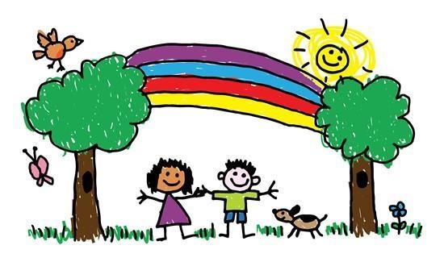
Outdoor play is a very important part of a young child’s learning journey and, at Glen, we extend the playroom to the outdoor environment by ensuring children have access to outdoor learning every day. Children will have choice to move freely between indoors / outdoors throughout their session.

Our aspiration for all children and for every young person is that they should be successful learners, confident individuals, responsible citizens and effective contributors to society and at work. By providing structure, support and direction to young people’s learning, the curriculum should enable them to develop these four capacities. The curriculum should complement the important contributions of families and communities.

The role of planning in our nursery

In order to support learning and development through play we create a high quality curriculum for young children which:-


provides opportunities to play alone, in pairs, in small groups and large groups depending on
the child’s stage of development

supports independence, interdependence, making choices and decisions is content, rich and relevant
values and extends children’s ways of thinking reasoning and understanding
helps children to acquire the tools for thinking, learning and playing which enables them to
become successful learners
is culturally diverse and reflects the customs, culture and lifestyles of different ethnic
groups
involves parents in the processes of playing and learning
Taking into consideration children’s interests and consultation with parents, staff prepare plans for each playroom which are displayed on our learning walls. We also encourage you to become involved in planning by reviewing and commenting on your child’s learning story regularly. At the end of each playroom plan, staff observations of children, their interests, reactions and their experiences will form the basis of an evaluation which will inform the content of the next playroom plan. Observations of the children will also help to record each child’s progress and achievement and will be recorded in their Learning Journals.

Useful information available at http://www.educationscotland.gov.uk/parentzone/

Measuring and Reporting Progress

In Glen Family Centre we know that children will achieve in a variety of ways.
We assess their developmental progress so that we can use this information to develop an appropriate curriculum for each child.

Your child’s key worker monitors the progress of each child in collaboration with other child development officers. Using observations of your child during free-play, a Learning Journal will be built up showing you child’s learning and achievements.

Your child’s progress in nursery will be reported to you:

- Informally through discussions on an on-going basis
- At the end of the Winter & Summer terms your child’s Learning Journal will be sent home for you to look at as a family and for you to add a comment and let us know of any achievement you child has made at home. This said, your child’s journal is available to take home and add to at any time throughout the course of the term if you wish.
- Formally at parent consultation phone calls (until we can come together face to face).

Children are encouraged to be involved in the compilation of their own Learning Journals according to their stage of development. As children participate in opportunities in the playrooms, they are encouraged to reflect upon their efforts and perhaps to make some comment about it, or, for younger children, staff will take note of their response and interactions to particular learning opportunities.



Celebrating Achievements

Even the smallest achievement can mean so much and give us an
amazing feeling and it can be even better when someone else notices and makes the effort to acknowledge it. We strive to capture that WOW moment in your child’s learning and celebrate it through praise, photographs, displays and twitter.

Our Wider Community


Glen FC is located within a vibrant community and we are keen to promote positive partnerships and use it to the benefit of our children and families. We use many of our community resources in the course of our everyday work and encourage staff, parents and children to do so too. We also welcome members of the community into the centre to strengthen links and widen the experiences on offer.

You will often find us out and about in our local community enjoying opportunities such as:

- Walks in Eastwood Park where we love exploring the woodland and the stream.
- Outings to Rouken Glen Park where we love to stretch our legs and enjoy the park, waterfall and duck pond.
- Visits to the local café and chatting with the worker in Eastwood Theatre

As stated above, we also invite members of organisations from the community into the centre to talk about their role in the area. This can include;

- The emergency services to talk about their work and support children in keeping themselves safe and well.

- Charities and voluntary sector organisation

- School Crossing Patrol Person
Transitions

Children experience many transitions in their lives such as starting nursery, moving to a new room, a new key worker or moving on to a different nursery or school. While these are normal changes that occur, it is important for us as adults to realise these can be daunting experiences for young children. Think about how you felt when you started your first job, had a change of manager or a trusted advisor/friend moved away. Yes, these were events that we can expect in our lives, but they can still cause us anxiety. This is just the same for children when they make transitions and it is important that we help them to adjust and reduce the worry as much as possible by planning effective transition periods.

Internal Transitions:
Internal transitions are simply moves and changes your child will experience within the Centre. If your child joins us when they are just a baby, you can expect them to change room, and possibly key worker, at least once if not more. We will work closely with you and your child to plan any changes and these will always be gradual whenever possible.

Transition to 3-5 Placement:
Children will leave Glen FC on or as soon after they turn three. If your child turns 3 after February then they will transition in August or over the summer period.
When your child turns 2 years of age we will support you in completing a ‘First Steps’ application form. If you do not complete and return the form to the Pre 5 Admission Team at ERC, your child may not be allocated a place in your local nursery.
We work closely with all of our local nurseries to ensure continuity in children’s learning and development and aim to ensure the receiving nursery has a good picture of your child’s strengths and needs before they move. Some of the ways we do this include-
• Introducing the idea of moving on through our everyday work in the Centre
• Information regarding your child’s achievements and stage of development will be shared prior to transfer.
• Arranging visits to the new nursery with your child.
• Informing you of induction events and visits at the new nursery.
Should your child experience any difficulties in settling into the new environment every effort will be made to arrange for his/her key worker to attend and support.

Family Friendly Status, Parental Participation & Involvement

The Scottish Government has set out clear intentions to improve outcomes for all of Scotland’s children and aspires to make Scotland the ‘best place in the world to bring up children’.
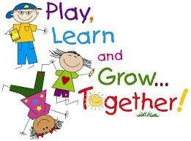
At Glen FC we recognise parents as the primary educators of their children. We are continually developing a range of creative and interesting ways to address the needs of children and families. Underpinning all we do are the principles of a nurturing, supportive and family friendly approach which will enhance family wellbeing and support the whole family to reach their full potential. Below are details of some of the ways you can get involved and some of the opportunities you can participate in.

Stay & Play
Nursery isn’t just for your child. You too can stay and play and learn more about what your child gets up to during the session. You can also learn some new ways to play from working alongside your key worker with your child. This can be particularly useful in your child’s earliest months when it may seem that all they can do is eat, sleep and cry! Your toddler / older child will love showing you around and getting you involved in their learning.

Groups for Parents
There are a range of groups run throughout the year at Glen for you to get involved in. Groups usually meet weekly for around 1.5 – 2 hours and last between 4 -8 weeks depending on the topic. Some groups are ongoing and continue to meet every week. Groups are led by a variety of people including those in our own staff team, Family & Adult Learning Team, Educational Psychologist, voluntary organisations and other parents and many more. Below are some of the topics we have covered. If you have a suggestion or idea for a group you would like to see us offer, please speak to a member of staff or anyone in the Senior Leadership Team.

POPP

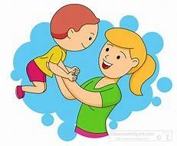
If your child is displaying difficulty with behaviours or regulating emotions, East Renfrewshire have staff trained in Incredible Years Parenting Programme and Triple P. Support is available throughout the year and we would be able to help you find the right programme for you and your family.

The Positive Parenting Programme explores our relationships with our children in the context of helping us to positively manage behaviours. Most parents who take part say the best thing is realising ‘it’s not just me!

Baby Massage
Spend some quality time with your baby learning simple baby massage techniques. This can help you both relax, support sleep and help with things like colic.

Other ways to get involved.

Individual Support
As well as a range of groups, we can also offer support on an individual bases. The staff team are skilled and knowledgeable in many areas including baby feeding and weaning, toilet training and more. Speak to your key worker or a member of the management team if you interested.

Parents’ Committee

The Parents’ Committee represent parents in many aspects of the work of the Centre including:
Supporting self-evaluation and improvement
Overseeing fundraising efforts
Engaging with staff in the development and review of policies
Promoting community involvement in the life of the centre
Joint Policy Review

If you are interested in joining the Parents’ Committee please speak to your key worker, a member of the management team or Parents’ Committee members.

Fundraising


Parents are encouraged to make a small weekly donation of 50p per day to the Centre’s Nursery Fund. These funds are used to help pay for baking ingredients, outings & trips, special events & parties, and any other additional resources required when working with your children. In addition we have larger fund raising events throughout the year. We need your support to make these as successful as possible.

Nursery Fund Committee

Funds raised through Nursery Fund donations and other activities are overseen by the Nursery Fund Committee. Membership of the Committee includes staff and parent representatives and is chaired by the Head of Centre. The current membership can be seen on the Centre’s website.
The Nursery Fund Committee has an agreed formal constitution. Accounts are kept for all monies collected and are available for inspection at any time. The accounts are audited by an external, independent auditor annually.

Giving your views and suggestions

At Glen Family Centre we aim to work in partnership with all our families to strengthen the service we provide.

The easiest way to help us improve our service is to get involved and talk to us and tell us what we do well and what we could do better. There are many ways you can do this throughout the year including completing questionnaires, taking part in consultation events, commenting on your child’s profile, completing a comment/suggestion form or talking to us directly. We’re always happy to hear your views and will keep you informed as to how we use them.

Communication

We publish a regular newsletter to keep you informed about life in the nursery. Notices will also be placed on the notice boards in the foyer and playrooms. Please make time to have a look when you drop off or collect your child.

The Centre has a website/ twitter feed which has up to date information and useful links to other interesting sites.

If English is not your first language and you would prefer information in an alternative language, please let us know.

Centre Improvement

We are continually striving to be the best we can be for you and your children. We carry out self-evaluation and monitoring activities throughout the year using a variety of methods and measures including national policy and guidance documents such as Getting it Right for Every Child, How Good is Our Early Learning and Childcare? and the national Health and Social Care Standards .

We gather information from everyone involved in the work of the centre including parents, children, the community and other professional. Using this information we identify what we have done well and what we need to develop. We put our evaluation together in a document called the ‘Quality and Standards Report’ and use the information gathered to develop a centre ‘Improvement Plan’. Both of these documents can be found on our website or you can ask for a paper copy from the office.

Our Policies


Glen Family Centre has policies in place to ensure that staff, parents and visitors to our centre are clear on our work practices and standards. Our policies are written in line with local and national guidelines including Getting it Right for Every Child, Pre Birth- 3, Health and Social Care Standards and How Good is Our Early Learning and Childcare?. These documents are also used to plan, monitor and evaluate our work. The policies are available in the main entrance, the Parents’ Room and on our website. Policies are monitored and reviewed regularly reflecting our commitment to continuous improvement.
In addition, as part of ERC’s Education Department, Glen Family Centre also use the wider policies of ERC to guide and influence our work with children and families. ERC Policies can be found on ERC Website.

Equalities

East Renfrewshire Council Education Department is committed to ensuring equality and fairness for all.

In accordance with the requirements set out by the Equalities and Human Rights Commission, we seek to –
- Eliminate unlawful discrimination, harassment and victimisation and other conduct that is prohibited by the Equality Act 2012
- Advance equality of opportunity between people who share relevant protected characteristic and those who do not
- Foster good relations between people who share a protected characteristic and those who do not.
Glen Family Centre has clear guidelines and procedures for dealing with incidents of inequality, as advised by the Education Department. We encourage that any concerns be raised with us. Everyone should feel that they are fairly treated and equally valued. Bias, segregation, stereotyping or discrimination are completely unacceptable. Our Equalities Coordinator is our Senior Child Development Officer Claire Smith and can be contacted by emailing or telephoning the centre.
In addition, as part of ERC’s Education Department, Glen FC also uses the wider policies of ERC to guide and influence our work with children and families. ERC policies can be found on the ERC website.



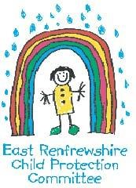
Child Protection Policy and Procedures

At Glen Family Centre we take the care, welfare and protection of our children very seriously. We believe all children have a right to feel safe within nursery, home and community.

Within our nursery we strive to provide a safe, secure and nurturing environment for our pupils, which promotes inclusion and achievement. All Education staff have a statutory and professional responsibility to take action if we have reason to believe a child is suffering or is at risk of abuse.

Our child protection policy and procedure sets out what we will do if we have reason to believe a child is being abused or is at risk of abuse, either within the home or the community. These policies are designed to ensure that children get the help they need when they need it.

Every staff member undergoes a minimum of one child protection training activity every session. Many of our staff are more extensively trained in specific areas of child protection to support and identify potential child protection concerns.

All schools in East Renfrewshire have comprehensive Pupil Support systems in place and we work closely with our partners in Social Work, Health and the Police. The nursery operates a multi-agency Joint Support Team to ensure that the best possible supports are available to children when they need them.

The Child Protection Co-ordinator for the nursery is Christine Bell, Head of Centre. If you wish any further information or a copy of the nursery policy, please contact the office. If you wish to discuss this important matter further, please make an appointment to speak with Christine.

If you are worried or know of a child who could be at risk of abuse or neglect please speak to the Child Protection Coordinator, Depute Head of Centre or please call one of the numbers below.

Clarkston Social Work Office 0141 577 4000
Barrhead Social Work Office 0141 577 8300

Strathclyde Police Family Protection Unit 0141 532 4900
Standby Social Work Out of Hours 0300 343 1505

Improvement Planning

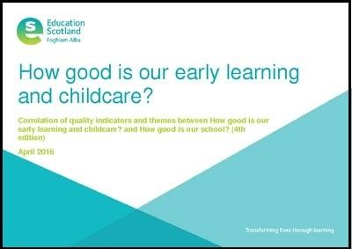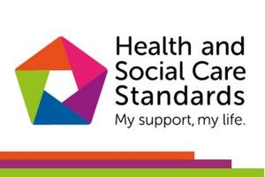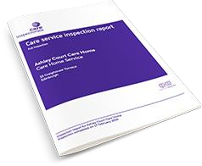

To continually improve our service, we will seek your views in a variety of ways such as questionnaires, consultations and focus groups. We value the opinions of all our stakeholders and will endeavour to consult with you when making big changes. Where possible and through whatever means we can, we will include the children in our consultations allowing them to have a say in decisions that may affect them.

Each year we evaluate the quality of our service using the quality indicators from How Good is our Early Learning and Childcare and The Health and Social Care Standards and use the information gathered to put together our Standards and Quality report. This will identify what we have done well and what our next steps will be. The next steps are then taken forward in our Improvement Plan. You can find both these documents on our website as well as our Care Inspection Report.

Data Protection

Data Protection Act 1998
Information on children, parents and guardians is stored on a computer system and may be used for teaching, registration, assessment and other administrative duties. The information is protected by the Data Protection Act 1998 and may only be disclosed in accordance with the Codes of Practice. For further information please contact the centre.

Data protection GDPR and the Data Protection Act 2018 means we have a privacy notice which will let you know what we do with the information you provide to the nursery. You can find out more about how we handle this information and your rights by going to www.eastrenfrewshire.gov.uk/privacy. If you do not have access to a computer and wish a paper copy please let us know by contacting the centre.

Privacy notice – Education
Who will process your information?

The personal information you give to us through any of our forms relating to Education and any other pupil administrative information we hold about you in this context will be processed by East Renfrewshire Council, Eastwood Park Giffnock, G46 6UG for the administration of Education and any additional support you or your child may require.
Why do we process your information?

Your information is processed to help us administer education provision and related functions within East Renfrewshire. Your information may be shared with other departments within the council and other organisations for the same purposes and also to check the information we have is accurate; prevent and/or detect crime; and protect public funds. Other organisations may include bodies responsible for auditing or administering public funds, other councils, public sector agencies, government departments, exam bodies and other private companies or partners we use to process information and distribution services for the issue of correspondence.

What is the legal basis for us to process your information?

The council processes your information in order to perform a task carried out in the public interest and also to fulfil its legal obligations to ensure proper administration of the council’s financial affairs in terms of the Local Government (Scotland) Act 1973. The law gives certain types of information special significance because of its sensitivity e.g. health information. If we process this type of information about you in relation to Education we do so on the basis that it is necessary for reasons of substantial public interest.

Do you have to provide your information?

Education needs your information to allow us to carry out public tasks in the public interest that is set out in law such as teaching in primary and secondary schools. It allows us to organise and administer classes, lunches, exams etc.

How do we collect information about you?

Most of the information the council holds about you will come from you as an individual and it provided at your first encounter with education whether it is applying for a place in an early learning and childcare establishment, support in the early years or applying for a place in one of our schools.

Such information includes:-

Such information includes:-
Child’s Forename
Child’s Surname
Child’s gender
School Stage
Details of child’s medical condition
Any other name child is known by
Child’s date of birth
Address including postcode
Mother’s/Carer’s Name
Father’s/Carer’s Name
Mother’s/Carer’s address including postcode
Father’s/Carer’s address including postcode
Mother’s/Carer’s telephone number
Father’s/Carer’s telephone number
Mother’s/Carer’s email address
Father’s/Carer’s email address
Single Parent/Carer family
Name of Brother/Sister
Date of Birth of Brother/Sister
School stage of Brother/Sister
Additional Information Support Application
School applying for
Preferred Alternative School
Early Learning and Childcare place applied for
Council Tax Evidence
Mortgage Statement
Rental Agreement
Rental Agreement End Date
Landlord Registration Number
Birth Certificate
Baptism Certificate
Date of Baptism
Name of Church venue
Child Benefit Statement
Utility Statements
Other Catchment Evidence
How long will we keep your information?
The council will hold your information from when your child first has contact with one of our services through to five years beyond them leaving school.
Who is your information shared with?
Your information will be accessed by council staff who need to do so to administer education and the many services that run alongside it. If such administration is provided on the council’s behalf by an external agency, that agency will also have access to your information. The information will be shared with SEEMiS, CRB, ParentPay, the Diocese of Paisley (in
Roman Catholic schools), Scottish Government including their Analytical Services, Education
Scotland, Glow (Scotland’s national education network), SQA, 2Cqr, BAM FM (Carlibar
Primary, Barrhead Mearns Castle, Williamwood, Woodfarm High Schools), Bellrock FM (Mearns Primary and St Ninian’s High), Skills Development Scotland, Scholar (Heriot Watt University) and East Renfrewshire Culture and Leisure Trust.
The council also needs to ensure proper administration of its funds so details will be checked internally for fraud prevention and verification purposes. Information is also analysed internally in order to provide management information and inform future service delivery. Your information may also be shared with other departments within the Council. The council also generally complies with requests for specific information from other regulatory and law enforcement bodies where this is necessary and appropriate.
Do we transfer your information outside the UK?
In general we do not transfer personal information outside the UK but on the rare occasions we do we will inform you. We will only transfer information outside the UK when we are satisfied that the party that will handle the data and the country it is being processed in have adequate safeguards for personal privacy comparable to those which are in place in the UK.
Profiling and automated decision-making
The Education Department does not use profiling or automated decision making for administration.
Your rights
You have the right to be informed of the council’s use of your information. This notice is intended to give you relevant information to meet this right.
Access personal data held about you
You have the right to access personal information the council holds about you by making what is known as a subject access request. You can receive a copy of your personal data held by the council, details on why it is being held, who it has been or will be shared with, how long it will be held for , the source of the information and if the council uses computer systems to profile or take decisions about you.
- Request rectification of your personal data
You have the right to request that the council corrects any personal data held about you that is inaccurate.

- Request that the council restricts processing of your personal data

You have the right to request that the council restricts processing your personal data if you think the personal data is inaccurate, the processing is unlawful, the council no longer need the personal data but you may need it for a legal purpose or you object to the council processing for the performance of a public interest task.
- To object to the processing of your data

You have the right to object to the council’s use of your personal data. The council will have to demonstrate why it is appropriate to continue to use your data.

Complaints
If you have an issue with the way the council handles your information or wish to exercise any of the above rights in respect of your information you can contact the council’s data protection officer by post at:
The Data Protection Officer
East Renfrewshire Council
Council headquarters
Eastwood Park
Giffnock G46 6UG or by email at DPO@eastrenfrewshire.gov.uk
You have the right to complain directly to the Information Commissioner’s office (ICO). The address of their head office is:
Wycliffe House, Water Lane, Wilmslow, Cheshire, SK9 5EF Telephone: 0303 123 1113
Alternatively, you can report a concern via their website at www.ico.org.uk The ICO also have a regional office at:
45 Melville Street, Edinburgh EH3 7HI Telephone: 0303 123 1115 e-mail: scotland@ico.org.uk
While you can go directly to the ICO, the council would welcome an opportunity to address any issues you have in the first instance.

Complaints

We hope that you will always be happy with the service we provide you and your family; however, if this is not the case, please speak to a member of the management team and we will do our very best to work through and resolve any difficulties. We follow East Renfrewshire Council’s Complaints Procedure which encourages complaints to be made directly to the service involved but if you are still unhappy, you can contact ERC directly:

Mr Mark Rattar, Director of Education
East Renfrewshire Council Education Department
211 Main Street
Barrhead
G78 1SY
0141 577 3000

If you feel your concern has not been managed effectively or are not satisfied with the outcome, you can contact the following for further support and guidance:

The Care Inspectorate
4th Floor
1 Smithhills Street
Paisley PA1 1EB
0141 843 6840

The Care Inspectorate has produced a leaflet to support those who wish to complain about a care service. It can be accessed on their website or from the link below.

http://www.scswis.com/index.php?option=com_content&view=article&id=7569&Itemid=369


Contacts Information

Director of Education Mark Rattar 577 3481

Head of Service Janice Collins 577 3204

Quality Improvement Officer Pre 5 Rosamund Rodriguez 577 3222

Quality Improvement Officer Siobhan McColgan 577 8346
(Woodfarm Cluster)

Psychological Service Ainsley McGoldrick 577 8510

Early Education and Childcare
Admissions Jennifer Ross 577 3288

East Renfrewshire Council General Enquiries 577 3000

Useful Links

Glen Family Centre Website: http://blogs.glowscotland.org.uk/er/Glen/

East Renfrewshire Council Policies and Links

Sending your child to Nursery (3-5years):
http://www.eastrenfrewshire.gov.uk/article/1820/Sending-your-child-to-nursery

Complaints: http://www.eastrenfrewshire.gov.uk/index.aspx?articleid=1573

Child Protection: http://www.eastrenfrewshire.gov.uk/index.aspx?articleid=1923

Pre Birth to 3: http://www.educationscotland.gov.uk/earlyyears/prebirthtothree/

Building the Ambition: http://blogs.glowscotland.org.uk/er/curriculinks/

Curriculum for Excellence:
http://www.educationscotland.gov.uk/thecurriculum/whatiscurriculumforexcellence/

Curriculum Links: http://blogs.glowscotland.org.uk/er/curriculinks/

Dyslexia: http://www.addressingdyslexia.org/

Emergency Closure of Schools and Establishments – Severe Weather Conditions:
http://intranet.erc.insider/CHttpHandler.ashx?id=4193&p=0

ENABLE – ASN Support: http://www.enable.org.uk

ENQUIRE - ASN Support: http://enquire.org.uk/

ERC Website – general enquiries:
http://www.eastrenfrewshire.gov.uk/index.aspx?articleid=1489

Inclusion: http://www.ea.e-renfrew.sch.uk/curriculinks/Links/Teachers/inclusion.htm

Internet Safety : http://www.ea.e-
renfrew.sch.uk/curriculinks/Links/Parents/Parental%20Leaflets/Internet%20leaflet.pdf

Local improvement plan: http://www.eastrenfrewshire.gov.uk/local-development-plan

Psychological Services: https://blogs.glowscotland.org.uk/er/PsychologicalService/

Safe Use of ICT: http://www.ea.e-
renfrew.sch.uk/curriculinks/Links/Parents/Parental%20Leaflets/Internet%20leaflet.pdf

