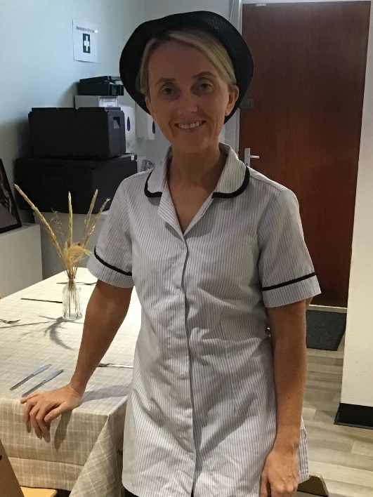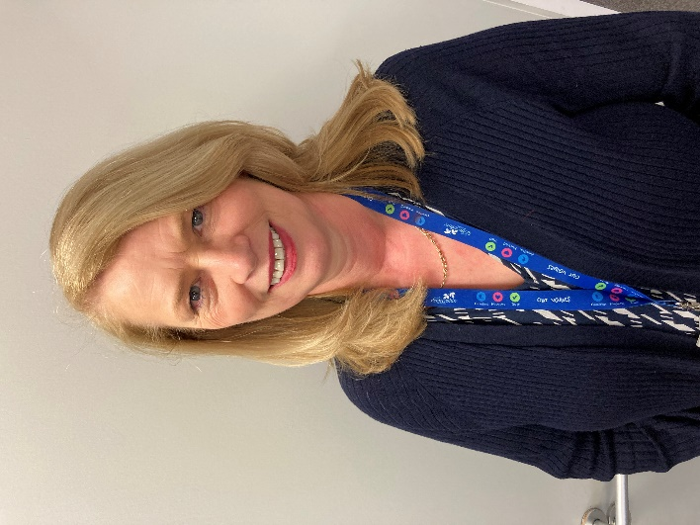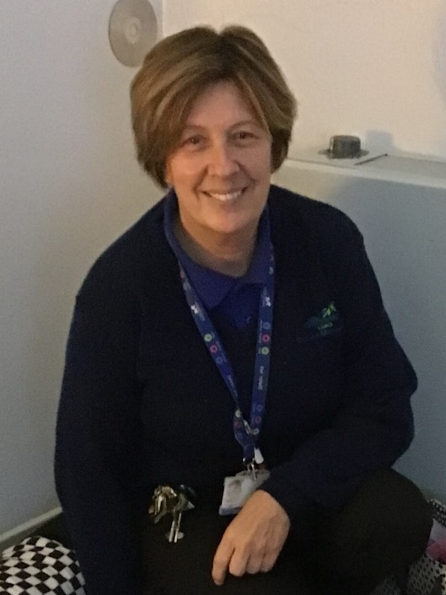

**Katie Sutherland**

**Catering Assistant**

**Catherine Carrigan**

**Senior Business support**

**Caroline Lamb**

**Janitor/Cleaner**