

 Standards and Quality Summary

2020-2021

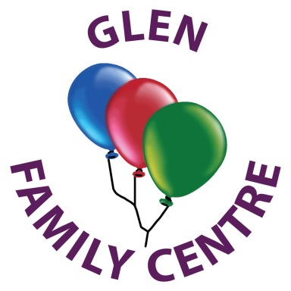

Everyone Achieving, Everyone Attaining through Excellent Experiences

**What is our capacity for continuous improvement?**

Glen Family Centre has a very strong capacity to continue to improve. Our commitment to improve outcomes are embedded across our staff team. Through rigorous self-evaluation, we continue to look inwards, outwards and forwards on our journey of improvement. The high level of commitment and motivation within the team ensures that all children continue to develop and attain their milestones through the delivery of excellent experiences. Our nurturing ethos and strength together as a community ensures flexible, reflective and creative thinking in our aspirations for all children and our community needs.

Thank you for taking the time to read some examples of our successes.

If you would like to learn more, you can read the full Standards and Quality Report by logging onto our website at:

<https://blogs.glowscotland.org.uk/er/Glen/>

Or you can follow us on Twitter @Glen_FC

Our Improvement Priorities for 2021-2022

**Leadership and Management**

* Build and expand a confident workforce committed to professional learning and improving outcomes for children.
* Review Vision Values and Aims

**Learning provision**

* Reconnect and strengthen partnerships through accreditation ensuring a high quality learning provision for all children.
* Family Friendly Gold Award
* Develop a wild sensory garden

**Successes and Achievements**

* Ensure all children are attaining and achieving through excellent experiences across the extended day.
* Review children’s experiences to ensure high quality learning across the extended day including quality mealtimes.

**How good is the quality of care and education we offer?**

**We have made very good progress in the learning provision provided across the extended day.**

Children have learned about healthy eating by growing fruit and vegetables in our garden, which they ate for snack.

Staff took on responsibility for developing Family Learning Weeks working collaboratively with families tweeting open-ended opportunities which promoted children’s creativity.

Parent’s comment:

*It was really helpful when looking for more activities to do at home. He was keener to do them as he saw his keyworker doing them.*

Through the development of our outdoor areas and woodland walks, staff observed and recorded children’s eagerness to embrace new opportunities that supported their health and wellbeing, promoting problem solving and physical skills.

Through consultation on Learning Journals, parents indicated that they would like information to include more detail. Staff successfully undertook training that resulted in a positive impact on the recording of children’s learning and progression.

**Next Steps:**

**Improve approaches to planning, observations and documentation.**

**Further develop our approach to Science, Technology, Engineering and Maths (STEM)**

**Develop robust systems for planning and tracking children’s progress.**

**How good are we at ensuring the best possible outcomes for all our children?**

**Very good progress has** been **made to ensure the best outcomes for children.**

Most children are making good progress in literacy and numeracy evidenced within our tracking tool.

Children’s health and wellbeing is at the heart of our provision and through partnership working with other services we were able to provide appropriate intervention/support resulting in most children making very good progress.

Parent’s comment:

*Without staff support with the IPad I would never have managed to join my child’s meeting, I can’t thank you enough*.

Through responsive planning, staff ensured children were consulted to be leaders of their own learning and responsive to the pace of the longer day.

**How are we doing?**

Our Standards and Quality Report reflects the achievements we have made over the past year. As we move forward into 2021-22 we will endeavour to ensure our priorities allow us to Build Back Better.

**How good is Our Leadership and Approach to Improvement?**

**We have made very good progress in developing leadership at all levels.**

Staff engaged in an 8 week online course ‘Virtual Nature School’ embracing child led learning.

Parental engagement remained a key focus with staff leading literacy and numeracy experiences through twitter.

Parent’s comment:

*We often showed our son the Twitter videos of staff singing songs and telling stories and used an app that was recommended to encourage numeracy.*

We focused on recovery and reengagement devising a Wellbeing Pack and Wellbeing Check-ins for families, staff and children.

Staff chose areas of research that focused on numeracy, literacy and wellbeing. This resulted in enhanced practice and improvements.