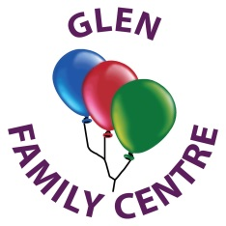

Dear Parents/Carers,

Welcome to our January 2021 newsletter. We hope you all had a lovely Christmas and New Year and hope Santa was good to everyone. Thank you so much for all your kind gifts and cards, it means a lot to receive kind words of appreciation.

December was a very busy month but we were so pleased that Santa still managed to visit us here at Glen. Staff worked really hard to ensure the children still had the same excellent experiences and hope you all managed to see the pictures of our Festive Fun Week on Twitter. Although we couldn’t have our usual party we still managed to have a special time.

All our staff returned to work on Tuesday 5th January and will be working between the centre and home following the guidance set out by the Scottish Government. We re-opened on Wednesday 6th January for the children of keyworkers who have absolutely no other means of childcare and cannot work from home. Staff are working rotas to care for the children in order to minimise the risk to all. This is not how we hoped to start the year but here we are again in another lockdown. This is necessary to keep us all safe and well so hopefully, if we all stick to the rules and with the vaccine being rolled out we will get through this. There is light at the end of the tunnel!

Once again we will try to support you and your family through tweets on our twitter page. We recognise how difficult it is being at home with nowhere to go and children demanding attention. Some of you will be juggling work with childcare which brings an added stress, so please keep an eye on our twitter page where we will regularly post videos and ideas for you to watch and take part in with your child. Please also tweet us pictures of what you are doing at home. It is good to keep in touch and hear what everyone is up to.

As you know, children learn and develop through play, therefore, if you can, this is a great opportunity to set aside time to play together. Singing songs, reading stories, playing those Christmas games Santa brought, building dens, playing out in the snow or baking are all ideas you could do at home: also children love just helping out around the house learning valuable life skills.

We continue to develop early literacy and numeracy skills through play both indoors and outdoors. We continue to share our learning on our website and closed Twitter page. If you don’t already do so, please follow us as this allows you to have an insight and contribute to your child’s learning in our centre.

We will keep you up to date as much as possible as to when the centre will reopen. We are following government guidance and hope we can all come together again in the not too distant future.

Please use the links below to access our blog and twitter for pictures and updates.

<https://blogs.glowscotland.org.uk/er/Glen/>

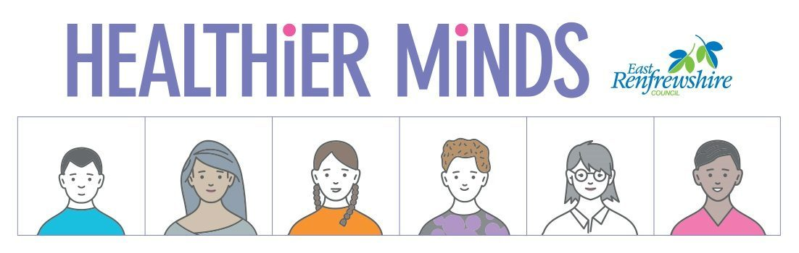<https://twitter.com/glen_fc>

Healthier Minds

We recognise how difficult it is for everyone at the moment but we must follow Government guidance to ensure we all stay safe and well. There are supports available to help everyone in this very difficult time.

East Renfrewshire has developed a guide ‘Healthier Minds’ to promote the mental wellbeing of our children and young people.There is also a guide for parents/carer’s which brings together information and practical advice to help you support your children to manage life’s challenges.

Information about relevant local sevices in East Renfrewshire and the differnet roles that professionals can have in supporting children, young people and families who are experiencing more severe mental health needs is also included.

<https://blogs.glowscotland.org.uk/er/healthierminds/coping-covid-19>

Please keep in touch and give us a call if you need further help.

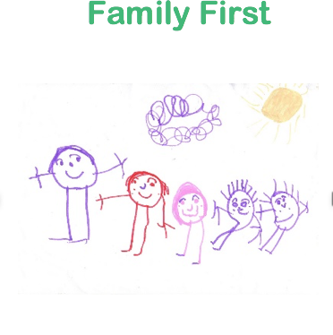Family First

The Family First Team offer a free, confidential service to support with any worries you might have. They can help you find the right people when you don’t know who to ask for help.  The highly skilled team will try to stop any issues you bring to them from getting worse and help you find the right support.

Contact the team at [familyfirst@eastrenfrewshire.go.uk](mailto:familyfirst@eastrenfrewshire.go.uk)

**Family First- Work with families living in ERC and have children aged 0-11years**

For daily updates from a range of national and local organisations on themes of parenting, family wellbeing, ASN, money advice and rights, health and safety and education and learning, please log on at: **Website –**<https://www.eastrenfrewshire.gov.uk/family-services>

**School/nursery Applications**

2 Year Olds Eligible 2 year old children and families will be entitled to 1140hrs free early learning and childcare. If your family is receiving certain benefits then your child may be eligible.

3 Year Olds Applications for a 3 or 4 year old place in a nursery or family centre close on 28 February. Please ensure you have your application in on time.

Applications are available from East Renfrewshire Council Education Department on 0141 577 3288 or email: [earlylearningandchildcare@eastrenfrewhsire.gov.uk](mailto:earlylearningandchildcare@eastrenfrewhsire.gov.uk)

If you have pre-school children at home and have not yet applied for a school place for primary one, then please do so as soon as possible. This is an online process and applications should be made by 22 January 2021.

<http://www.eastrenfrewshire.gov.uk/apply-for-p1>

Phone: 0141 577 3246 or Email: [admissions@eastrenfrewshire.gov.uk](mailto:admissions@eastrenfrewshire.gov.uk)

**Coronavirus Vaccine**

Please see below link for information on COVID vaccines for mothers that are breast feeding. Covid-19 resource and guidance page - new guidance on how to discuss the Covid-19 vaccine with women who are breastfeeding (see FAQ #14).

**Corona Virus Information for Early Learning and Childcare Settings**

We continue to receive guidance from both the Scottish Government and Care Inspectorate on how to ensure we are providing the safest environment for both our children and staff team.

Please read some helpful information from the Scottish Government which applies to our Early Learning and Childcare establishments.

**Toys from home to nursery**

* Children should be discouraged from bringing toys from home to the setting.  We recognise that some children may require a transitional object or toy as a comforter and we will fully support your child to transition from home to Glen to feel reassured and comforted. These comforters cannot be shared with other children therefore please place the comforter in your child’s bag where staff can help them access it if necessary.

**Ventilation**

* All settings must ensure the opening of doors and windows to increase natural ventilation where it is practical, safe and secure to do so, while maintaining appropriate internal temperatures.
* With increased ventilation, it would be helpful if you could layer your child’s clothing and we will monitor their comfort throughout their session.

### **Wellbeing, nurture and experiences**

* It is essential, at this time of transition that ELC continues to be informed by the principles, which underpin high quality provision. While aspects of practice may be delivered differently, staff will still be working to meet the needs of children and their families.
* Children have the right to play and learn, as set out in Article 31(1) of the United Nations Convention on the Rights of the Child. At Glen we recognise the right of the child to rest and leisure, to engage in play and recreational activities appropriate to their age and to participate freely in cultural life.

**Face masks**

We ask that parents and carers wear face coverings at drop-off and pick-up unless there is a medical reason not to do so. All staff follow the same guidelines. This helps us to continue to operate as safely as we can.

**General Advice**

* If your child displays any of the three main Covid-19 symptoms (new persistent cough, high temperature or fever, change of taste or smell), do not send them to nursery – everyone in your household should stay at home and you should book your child a test.
* If anyone in your household develops Covid-19 symptoms the whole household must isolate. This applies even when the individual is awaiting the results of a test or waiting to have a test taken.
* Wherever a new positive case is detected and Test and Protect is activated for any possible transmission in the nursery, we will contact all parents and carers at that nursery to make them aware. Please be aware, where a pupil or member of staff hasn’t been within the nursery during the infectious period, we would not normally share information on a positive case.

**Extreme Weather**

[](https://www.google.co.uk/imgres?imgurl=http://d2u4q3iydaupsp.cloudfront.net/smr3Z7up7nBfn40W0TdLxgue0MLEYJWBjgSGEIy8TJi954j0apummOHkwqO8OmnuPvfDbgJE4HlxKFiP6q3lbNdMGrHWaHB2r2slEEFjneF1Y16VGUJuLIpnbAY0fiR2&imgrefurl=https://hail.to/silverdale-normal-school/publication/FDC1fVN/article/ioky2VO&tbnid=AP94xpYfvbJSlM&vet=12ahUKEwio2OCptpvtAhUIGhQKHbx6B1sQMyhZegUIARCMAQ..i&docid=kBWEWnamVqc1TM&w=1000&h=845&q=spare%20clothes&safe=active&ved=2ahUKEwio2OCptpvtAhUIGhQKHbx6B1sQMyhZegUIARCMAQ)Please ensure that your child is always dressed appropriately for the weather. The children play outside in all weathers and need their wellingtons every day as our garden can be very muddy. On wet days, please provide a waterproof suit or jacket and trousers. During the colder months, they also need a hat and waterproof gloves or mittens. Due to Coronavirus, the children are unable to share items of clothing, but we do have some items we can lend if your child does not have their own. Parents will be responsible for cleaning and maintaining any items borrowed. Please remember to label all your child's belongings with their name.

**Spare clothes**

Please remember to provide a bag of spare clothes for your child each day. In addition to little accidents, the children play outside in all weathers and they are likely to get wet, muddy or paint on these when learning and having fun so please be mindful of this when dressing your children for nursery. Due to Covid guidance, we cannot use any spare clothing we have at the moment so rely on you putting enough in your child’s bag.

[](https://www.google.co.uk/imgres?imgurl=https://files.schudio.com/hamilton-infant-school/images/news/dates-clipart-26(1).jpg&imgrefurl=https://hamilton.stoke.sch.uk/news/2020-09-11-autumn-2020-diary-dates-1&tbnid=mNXaii3D80Kd3M&vet=12ahUKEwi0ptTuqJvtAhUJShoKHSMoDE8QMyhiegUIARCYAQ..i&docid=zGsUioYmtzPo9M&w=700&h=525&q=diary&hl=en-GB&safe=active&ved=2ahUKEwi0ptTuqJvtAhUJShoKHSMoDE8QMyhiegUIARCYAQ)Dates for your diary

Friday 5th February: In-service (no children should attend on this day)

**Head Lice**

This is traditionally the time of year when we start to have instances of head lice. It is a good idea to check your child’s head regularly and if you spot head lice then immediate treatment is required. The following link has good information

<https://www.nhsinform.scot/illnesses-and-conditions/skin-hair-and-nails/head-lice-and-nits>

**Diarrhoea and Vomiting**

Diarrhoea and vomiting can spread easily. Please keep your child off for 48 hours from the last time they were sick or had diarrhoea and please make sure they are drinking plenty of fluids. There is more information at

<https://www.nhs.uk/conditions/diarrhoea-and-vomiting>

**Final Note**

*We would like to say a huge thank you for your continued support and understanding of our new way of working. We will continue to follow both East Renfrewshire and the Scottish Governments Guidance to ensure a safe environment for all and hopefully we will all be back together again very soon. Thank you.*

*All at Glen Family Centre*