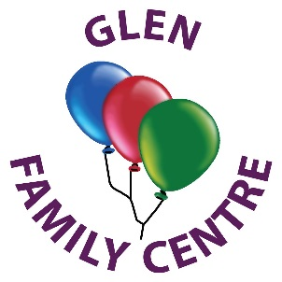



Glen Family Centre

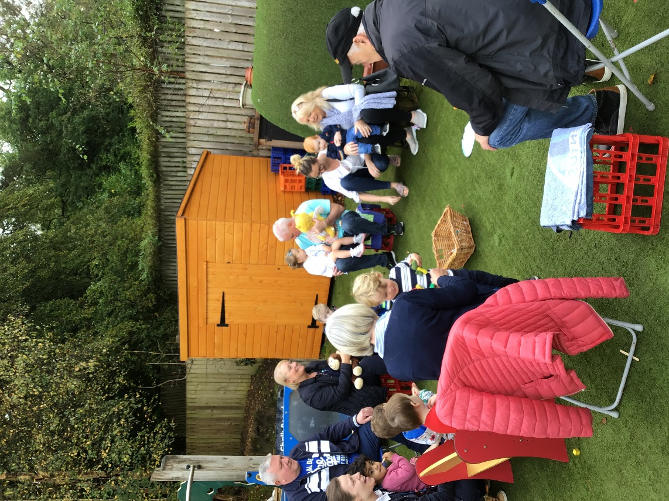

Handbook

2020/2021

Family Centre Information

Address: Woodfarm Road

Thornliebank

G46 7JJ

Telephone no: 0141 570 7510

Email: [schoolmail@glen.e-renfrew.sch.uk](mailto:schoolmail@glen.e-renfrew.sch.uk)

Website: <https://blogs.glowscotland.org.uk/er/glen/>

Twitter: Glen Family Centre @Glen_FC

Denominational Status: non-denominational

Nursery Roll: 50 Full-time equivalent

Age group: 6 weeks – 3 years

**Welcome to Glen Family Centre**

On behalf of everyone at Glen Family Centre, I would like to wish you a warm welcome.

I hope you and your family enjoy looking at our handbook and find the information helpful and supportive in your first steps to becoming part of our Glen family.

Early years experiences are the most important we will have in our lives. Positive early experiences promote positive future life chances. They shape how we grow in all areas of development both now and in the future.

We aim to make your child’s time at Glen a happy one, where they are nurtured, given the time, support and freedom to develop to their full potential.

When your child is allocated a place at the centre, we will work with you to get to know your child and family. This ensures we provide care and early education based on individual needs as well as supporting you.

Glen Family Centre is non-denominational. We welcome and respect children and families of all religions, faiths and beliefs.

This Handbook provides information on the services we offer for children from birth to 3 years and their families and should tell you what you need to know about the Centre; however please feel free to speak to a member of the management team or your allocated key worker if you have any questions.

Thank you for allowing Glen Family Centre team to be part of this precious stage in your child’s learning journey.

Christine Bell

Head of Centre

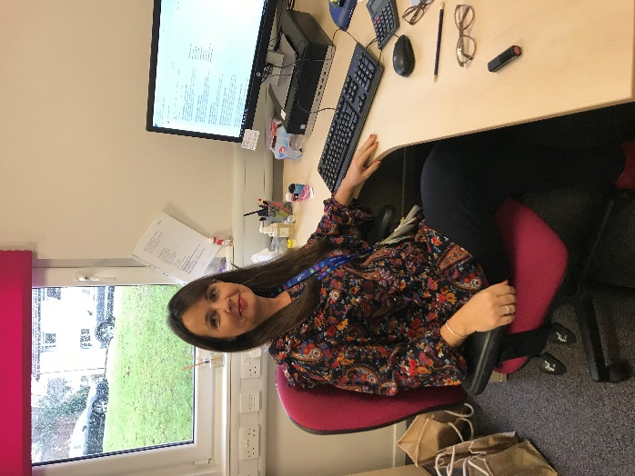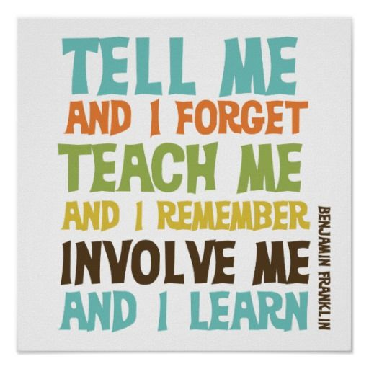

“

**Our Vision Statement**

Children and families achieve their full potential through meaningful involvement in a nurturing and safe environment where they feel respected as individuals and have a positive sense of responsibility for themselves and others.

**Our Values**

Respect Equality Inclusion Achievement

Nurture Reflection Innovation

**Our Aims**

**At Glen Family Centre we aim to**:

Provide a safe, welcoming, secure and healthy environment for everyone involved in the life of the centre.

Provide a range of opportunities for children and families to learn, develop and achieve together in safe and nurturing environments.

Promote children’s learning and development through active play and exploration by providing a challenging and dynamic curriculum which meets the needs of individual children.

Provide services which

o are responsive to the needs of children and families,

o respect their individuality,

o recognise the importance of relationships and

o have a focus on the rights of the child.

Encourage success by celebrating the achievements of children, parents and staff.

Maintain an ethos that recognises, promotes and celebrates diversity, ensuring all members of our learning community feel safe, valued, included, respected and fairly treated.

Engage with agencies in the local community and work in partnership with them to support the needs of children and families.

Ensure our provision is continuously improving and evolving to meet the needs of children and families as we strive to become a Centre of Excellence.

Glen Family Centre Closures 2020/2021

In-service Monday 10 August 2020

In-service Tuesday 11 August 2020

September Weekend Friday 25 September 2020

September Weekend Monday 28 September 2020

In-service Monday 19 October 2020

Last day of nursery Thursday 24 December 2020 *Centre will close at 2pm

Re-open Tuesday 5 January 2021

In-service Friday 5 February 2021

Good Friday Friday 2 April 2021

Easter Monday Monday 5 April 2021

May Day Holiday Monday 3 May 2021

In-service Thursday 6 May 2021

May Weekend Friday 28 May 2021

May Weekend Monday 31 May 2021

Glasgow Fair Monday 19 July 2021

Easter Good Friday: 2 April 2021

Easter Monday: 5 April 2021

Last modified on 7th July 2020

East Renfrewshire Council school holiday arrangements for 2020/2021 can be found at https://eastrenfrewshire.gov.uk/school-holidays.

Allocation of spaces

At Glen we can accommodate up to 31 two year olds and 19 babies aged 6 weeks – 2years.

Places are allocated by East Renfrewshire Council in accordance with their admissions policy which reflects The Standards in Scotland’s Schools Act 2000 and the Children and Young People (Scotland) Act 2014, which place a duty on local authorities to provide 1140 hours of free Early Learning and Childcare for all eligible 2 year olds. All places are allocated by the Education Departments Admissions Team in accordance with East Renfrewshire’s Admission policy.

1140hrs are allocated as follows:

Stretch A – morning session: 5 x 8.00am – 12.45pm

Afternoon session: 5 x 1.00pm – 5.45pm

Stretch B – 2x9 hrs 30mins and 1x4hrs 45mins per week (two and a half days)

Children requiring an additional or alternative placement must be referred by their Health visitor, social worker or educational psychologist. The referral will be made to the authority’s EYIG (Early Years Intervention Group).This is a multi-agency group which meets monthly to consider each case received on an individual basis.

All enquiries regarding allocations should be made to:

Education Department

Admin and Support Section

211 Main Street

Barrhead

G78 1SY

Telephone: 0141 577 3288

Email: [pre.five@eastrenfrewshire.gov.uk](mailto:pre.five@eastrenfrewshire.gov.uk)

Almost all our children have been allocated either through the Early Years Intervention Group (EYIG) or Local Authority Placements (LAP). We also offer a limited number of paying places. These places can be applied for up to 12 weeks before the placement is required by contacting either the nursery office for an application form or emailing [earlylearningandchildcare@eastrenfrewshire.gov.uk](mailto:earlylearningandchildcare@eastrenfrewshire.gov.uk). All applications go to a ballot at the end of the LAP allocations meeting and families will be informed thereafter if they have been successful.

If you require any further information then please speak to either Catherine our Business Support or a member of the management team.

Meet the Staff Team

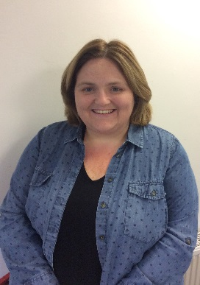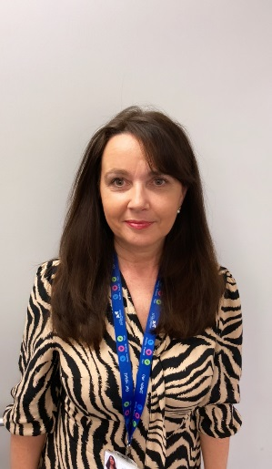

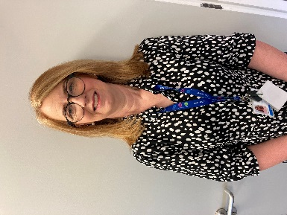

Christine Bell Jackie Campbell Claire Smith

Head of Centre Depute Head of Centre Senior C.D.O

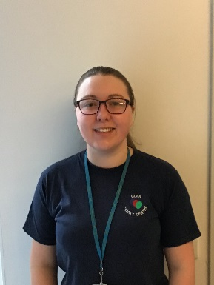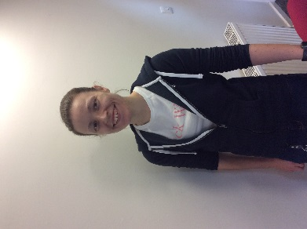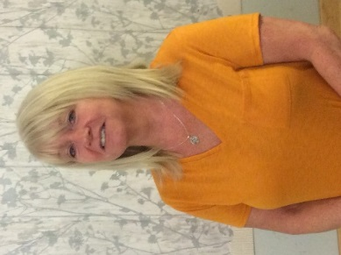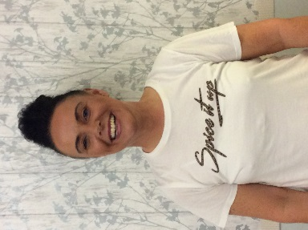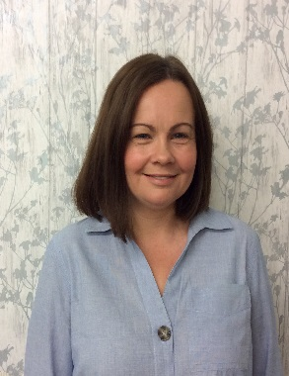

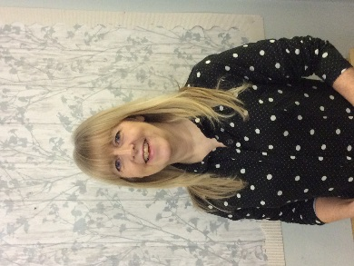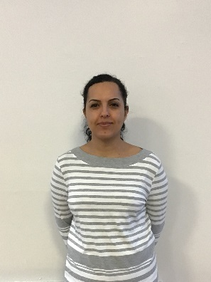

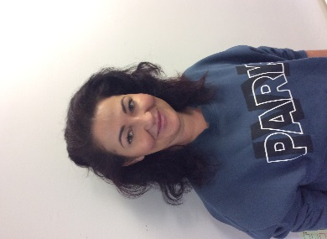Jackie Hughes Kayleigh Greally Claire McFarlane Christine Shand Emma Bryce C.D.O C.D.O C.D.O. C.D.O C.D.O



Pamela Robertson Paywand Sayyad Gordon Schmidt Melanie Farmer Kara Brown C.D.O C.D.O C.D.O C.D.O C.D.O

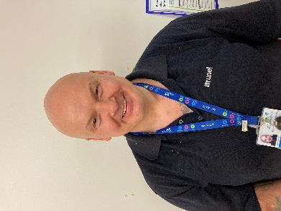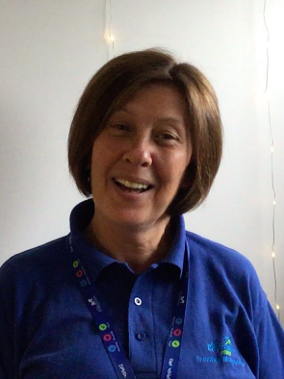

Craig Milligan Caroline Lamb Catherine Carrigan Play Worker Janitor/Cleaner Business Support

**Attendance**

If your child is unable to attend nursery please let us know either in advance or by telephone on the day of absence. If we do not have prior notification a member of the management team or your key worker will contact you by text/telephone to confirm the absence and ask how your child is and when you hope they will be return.

If you are planning a holiday and your child will be absent, please let your key worker or the office staff know. This will then be recorded on the register and we will not need to text or telephone you while you are relaxing.

Attendance is monitored to ensure best use of places allocated.

**Centre Holidays / Closures**

Glen Family Centre is opened all year round with a few exceptions. We close over the Christmas holiday period, for designated public holidays and ERC Education Department ‘In Service’ days.

As detailed in the ‘Allocation of Places’ section, children who have a ‘term time’ placement do not attend during school holiday periods even though the centre is open. Details of school holidays for the current session are displayed in the centre and on the leaflet accompanying this handbook



**Emergency Closure Arrangements**

Establishments may be affected by unforeseeable events, such as, severe weather, power failures or difficulties with heating. If this happens we will do our best to let you know about the details of the closure either by telephone, text, Twitter, in the press or on local radio. Updates will also be on East Renfrewshire Council’s website - [www.eastrenfrewshire.gov.uk](http://www.eastrenfrewshire.gov.uk/)

Should we have to evacuate the centre and not be able to re-enter for any reason, staff and children will walk to Glenwood Nursery School which is further down Woodfarm Road. Parents will be notified as above.

**Enrolment**

When your child has been allocated a place with us, a member of Glen FC management team will contact you and arrange to visit you and your child at home. Your key worker will also come along on the visit.

During this visit we will chat with you about your child and your family, and try to get to know you a little. This also means your child gets to meet his/her key worker in their home environment and will then have a familiar face when they attend the centre for the first time.

We will take this opportunity to discuss any referrals and complete all necessary forms. You will need to have the following documents: your child’s birth certificate and one of the following; mortgage statement, rental agreement, current council tax notice, child benefit letter or utility bill.



Your key worker will bring along some toys from the centre and will use this time to play, bond, engage and form a relationship with your child. During the visit we will arrange a suitable day and time for your child to start nursery.

**Settling In**

During the first few days at nursery you should make yourself available to support your child to settle into the nursery environment. Please remember this is a new experience for both you and your child and as every child is unique, we treat everyone individually with the care and attention they deserve. Some may take a little longer to settle than others; don’t worry and be guided by your key worker. The settling process is very important and ensures your child is happy and secure in making the transition from home to the Centre.

During the settling period you will be asked to complete a Care Plan and will discuss with the keyworker your child’s developmental stage. This information will enable the key worker to plan learning opportunities individual to your child’s needs.

***Please note:***

***\*****Due to COVID-19 no parents or visitors are allowed into the building. Home Visits and the Settling In process have been temporarily cancelled, therefore a member of staff will telephone you to discuss your child’s details.*

**What does my child need to bring?**

Your child will have a nursery bag/box which is kept on their own peg in the cloakroom. Your child should be dressed appropriately for the weather conditions. A pair of soft shoes and a change of clothes – pants, socks, t-shirt and skirt/trousers. We have a limited stock of clothes for changing children so it is important that you refresh these items once they have been used.

(*Please note: due to Covid restrictions, we are unable to use our spare clothing therefore it is imperative that each child has their own)*



A supply of nappies and wipes should also be put in the bag/box. Remember to top these up as required.

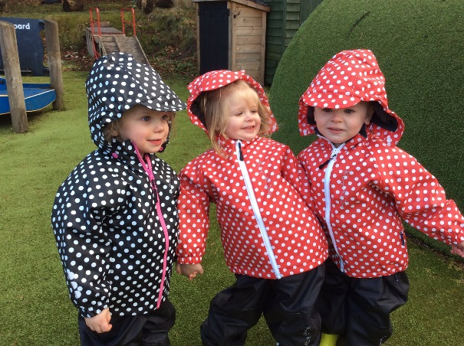

Outdoor learning is an important part of our curriculum. The children play outdoors daily and must have suitable clothes for the weather.

**What should my child wear?**

Early education is about exploring, discovering, creating and experimenting. This often means messy play and messy clothes. Please bring your child to the centre in ‘play’ clothes which you won’t mind being covered in paint, mud, glue and much more. Clothes which have sleeves that roll up easily and trousers which allow independence are also beneficial.

On cold days children should have a warm jacket, gloves and a hat. Even if you come by car, remember we spend part of the session outdoors in all weathers

On warm sunny days children should:

[](http://www.child-smile.org/)



have a sun hat in their bag be wearing sunscreen, factor 30 or

above

Parents/Carers should ensure the first application of sun screen is applied to their child when arriving at nursery regardless of your child’s skin tone. This information should be shared with your child’s key worker. Please supply sun screen for your child for top ups throughout the da

**Safety & Security**

The safety and security of our children, families and staff is of paramount importance. Our security entry systems allow us to be sure we are in control of who is in the centre and aware of why they are here. If you are leaving the building and someone is waiting

to enter, please get a member of staff. Please do not open the doors to anyone, even if you think you recognise them.

To ensure your child’s safety, we will only let them leave with those adults, over 16 years, whom you have nominated during enrolment. (*To comply with general Data Protection Regulations please ensure that this person has given their permission to be added for this purpose.*) If you need to make a change to these arrangements please speak to your key worker or office staff. Should you need someone different to collect your child at short notice or in an emergency situation, you will be asked to provide us and that person with a password to enable us to verify their identity.

**Welcome Time and Home Time**

When you bring your child to nursery you should make them comfortable by removing their outdoor clothes and changing shoes in the cloakroom before bringing them to the playroom.

Please note: *during Covid restrictions, parents/carers will not be allowed in the building and will pick up and drop off the child to a member of staff at the front/back door.*

**Personal Care and Toilet Training**

Your child’s personal care needs will be met with respect and dignity. Our changing stations and toilets ensure privacy is maintained while allowing staff to appropriately supervise and support children. **Parents should NOT enter the children’s toilet.** If your child needs to use the toilet while you are with them in the centre, please speak to a member of staff if they cannot manage on their own and need help.

When you think your child is displaying signs that he/she is ready for toilet training please speak with your key worker who will explain the methods we use to support you and your child.

[](http://www.child-smile.org/)

Toilet training will not be started in nursery without it being discussed and agreed with you.

It is important that children have enough spare clothes in nursery to manage any accidents e.g. many pairs of pants, socks, and trousers/tights/skirts, shoes (crocs are good as these are rubber and easily cleaned.

**Keeping us up to date**



To allow us to provide effective support for your child and family it is important that we are kept up to date with any changes. Obviously having the correct emergency contact information is crucial should we need to get in touch quickly; however, it is just as important to let us know about other things that might be changing to ensure we can help your child manage changes in their circumstances. Things it might be good for us to know include-



* Change of phone numbers, moving house
* illness of close family, new babies, change of sleep pattern,
* bereavement, hospital admissions, separation

**Food and Drink**

**Snacks** [](http://www.child-smile.org/)A healthy snack is offered to children during both morning and afternoon sessions. Glen is a health promoting nursery and all snacks are in line with National Nutritional Guidelines. We offer milk and water to drink and provide a selection of snacks which include a variety of fresh fruit, toast, cereal, raisins, crudities and dips. On special occasions, including birthday and end of term parties, snacks may vary to include some treats such as a small piece of cake or some crisps. You will be notified of these special occasions in the newsletter. Water is available throughout the session from our water cooler in the playroom. To enable our team to continue to support the children to eat healthy, we ask that parents contribute 50p per day to our nursery snack through Parent Pay. This is in addition to any hot meals that parents purchase for their child’s lunch.

**Lunchtime**

If your child attends over lunchtime you can choose to either provide a healthy packed lunch or pay for lunch to be provided by our catering staff. **(*Only******packed lunches during Covid****)*

[](http://www.child-smile.org/)The lunch menu is rotated every three weeks and offers two courses which will include options for children with specific dietary requirements e.g. food allergies, vegetarian. A copy of the menu is available from the office and is on both Glen and East Renfrewshire websites.

If you prefer to provide a packed lunch for your child we would ask that it is a healthy lunch avoiding sweets, chocolate and fizzy drinks. Please ensure that all lunch boxes are labelled and have an ice pack in them as lunch boxes are not kept in a fridge. If you want your child to have something hot, please ensure it is heated in a thermos as due to health and safety guidance, we are unable to heat food.

If your child has any allergies or is on a special diet, please alert the management team who will provide you with the correct ER form to complete with your dietary request.

**Breastfeeding Friendly**

Breastfeeding is widely recognised as the most favourable means of infant feeding with considerable benefits for both mum and baby. Glen Family Centre is a ‘Breastfeeding Friendly’ establishment where staff are specially trained to promote an environment where breastfeeding is seen as the normal way to feed babies and infants.

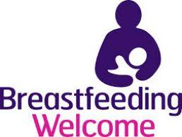At Glen Family Centre the staff team will support breastfeeding and parent:infant relationships as well as raising awareness in children to improve acceptance and standards of care within today’s society.

Staff promote, protect and support any mother who chooses to breastfeed and welcome this within any public or private area of our nursery where both mum and baby feel relaxed and comfortable during this special time. We also promote the awareness in children of breastfeeding as a normal activity through books and resources in the nursery.

A full policy with more detail is available on our website or at the office.

**Consents**

As part of everyday nursery life children will participate in many different events and opportunities. During enrolment you will be asked to consent (or not) to a variety of activities including environmental walks in the local area exploring concepts of nature, numbers, print and healthy living or taking your child to nearby parks or areas of interest. When excursions further afield are planned, you will be informed in advance and asked to complete an additional consent form giving your permissions for your child’s participation. Only children whose parents/carers have given the necessary consent will be able to take part in outings.

Staff also like to take photographs and video recordings of the children during these events as well as during every day nursery sessions. This helps to provide a record of your child’s learning and development for both you and them to enjoy and recognise their achievements. Photographs and recordings may also be used for displays in the Centre, for Twitter, our website or staff training. Your child’s images will only be used if you are happy to sign the consent form.

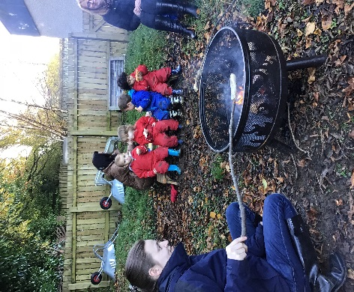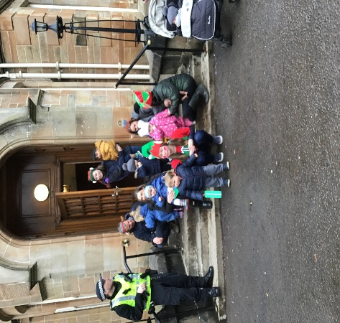

**Tooth-brushing Programme**

Childsmile is a national programme designed to improve the oral health of children in Scotland and reduce inequalities both in dental health and access to dental services. Good oral health in childhood means healthy teeth and gums throughout life. Childsmile is working to ensure all children, regardless of income or background, have the best possible start in life. Young children need help with tooth brushing on a daily basis, with research showing us we need to brush at least twice a day with fluoride toothpaste.

For more information please log on at: [www.child-smile.org](http://www.child-smile.org/)

At Glen Family Centre we have a ‘Smile Too’ award and understand the importance of tooth brushing in young children. Our tooth-brushing programme is part of our daily nursery routine and is a fun and educational experience for your child. Your child will be allocated a toothbrush with a picture on it that will be stored in an individual container.

Containers are washed regularly with hot soapy water and the toothbrushes are replaced on a regular basis. Someone from ‘Smile Too’ visits the centre regularly.

Please note: *Due to Covid restrictions, the tooth brushing programme has been temporarily suspended.*



**Medical Information & Illness**

To ensure your child receives the appropriate care while they are at nursery it is important for us to be aware of any medical needs he/she has. You have the opportunity to inform us of any conditions/allergies during enrolment; however you must remember to keep us up to date with any changes or if your child develops a medical condition after enrolment.

If your child requires to be given medication during the nursery session you should discuss this with your key worker. We can only administer drugs which have been prescribed for your child and cannot give cough bottles or pain relief such as ‘Calpol’ on an ‘ad hoc’ basis. You need to complete a form which authorises nursery staff to administer the medication. This is called the ‘Administration of Medication’ form and is available from the office or our website. You should read the ‘Medication- Guidance for Parents’ information which is also available from the office or on the website.

If your child suffers from asthma or allergies and requires medication when they are having an attack or reaction, you will need to complete a ‘Symptoms’ form. Again this is available from the office or on the website. We cannot accept medication that says ‘as required’ without details of the circumstance when the medicine would need to be given.

**Accidents and illness**



All minor accidents or injuries are recorded in our Accident Log. If your child has an accident, you will be asked to sign an accident form. A copy will be held in office files and another will be given to you if you so require.

If your child becomes ill while attending the Family Centre we will contact you immediately. If you cannot be reached we will use the information you have provided to contact the named emergency contact person. **Please remember to keep contact details up to date.** Your child will be given immediate attention as necessary in order to make him/her comfortable until a parent or carer arrives to collect them. If we were unable to contact anyone, we would contact emergency services directly if necessary.

If your child is unwell prior to coming to nursery, it is important that you keep them at home. This will ensure a speedier recovery and prevent other children or staff becoming infected. If your child is suffering from a virus or any kind of contagious illness, we ask that you keep them at home where they will be most comfortable and to avoid infecting other children. **PLEASE NOTE Public Health Authority guidelines stipulate that children should be absent from nursery for 48 hours following a bout of sickness or diarrhoea.**

If your child has an accident which needs further attention, we will follow the same procedures to contact you as above; however, should there be the need for emergency treatment, we will call an ambulance first and a member of staff will accompany your child to hospital and meet you there. Any incident resulting in a child needing hospital treatment will be logged on ERC’s electronic system and the Care Inspectorate will be notified.



**Wellbeing**

The best way of getting to know your child is by using information only you can give to us. The information gathered from the home visit will give a starting point for planning personal learning goals agreed between the parent and keyworker taking into consideration individual needs, interests and stage of development.

Many children need a little extra support from time to time for a variety of reasons. This may be because they are having difficulty with an area of development, have an identified learning need or medical difficulty or there is something going on in their life such as a family bereavement, breakdown of parents’ relationship or perhaps they have moved house and are struggling to adjust.

Sometimes this support can be provided by staff within the centre, however, occasionally it is necessary to call on the expertise of others for advice on how to support children to achieve their full potential. We work with a range of other professionals to ensure the right people with the appropriate knowledge and skills are available should they be needed. We have very close links with Health Visitors, Speech and Language Therapists and Educational Psychologists.

If we feel your child could benefit from some additional support we will always speak to you first. Nobody will work with your child without your knowledge. If you feel your child needs extra support please speak to your key worker or our Depute Head of Centre, Jackie Campbell who is our Additional Support Needs Co-ordinator. Parents can also approach all of these services independently.

**Joint Support Team**

When it is agreed a child should be considered for additional support we may discuss their needs at our **Joint Support Team** meeting. Our JST is chaired by the Head of Centre and the other members include:

ASN Coordinator – Depute Head of Centre- Jackie Campbell

Educational Psychologist – Gillian Thorburn

Link Speech and Language Therapist – Katherine Walters

While your child is receiving additional support we will use ERC’s Wellbeing Plans to ensure this support is monitored, reviewed and evaluated. You will be invited to attend a meeting every term to participate in setting and reviewing targets for your child.

The purpose of this multiagency support is to ensure that the intervention/support given suits the individual needs of both the child and the family. The nursery can offer a variety of support with the help of various agencies. Please let us know if you require any further information.

**Curriculum and Pedagogy**

Curriculum and Pedagogy…very fancy words which really mean what we do and how we do it.

At Glen Family Centre the key workers are all qualified and registered as Childcare Practitioners. In addition the staff team have received specific training in ‘Nurturing & Child Led Play Approaches’ which is the method, or pedagogy, embraced in our centre.

Research has highlighted how vital early experiences are in shaping and developing a young child’s brain and how future development and learning are impacted by those earliest experiences. In recognising this we understand the importance of a child’s emotional wellbeing and social competence in enabling them to reach their full potential. Providing play and learning experiences using nurturing and child led approaches ensures we are supporting children emotionally and socially which, in turn, enables them to engage fully and meaningfully with all learning opportunities.

Play lies at the heart of the curriculum and makes a major contribution to your child's development. Children learn as they play and as they share experiences with other children and adults. Through play, children practice and develop many skills they need in life. Using a 'Child Led' approach in implementing the curriculum through play means that your child has the opportunity to learn through the experiences they enjoy most.

The Wellbeing wheel details the indicators we consider in all aspects of our work as we aim to get it right for every child.

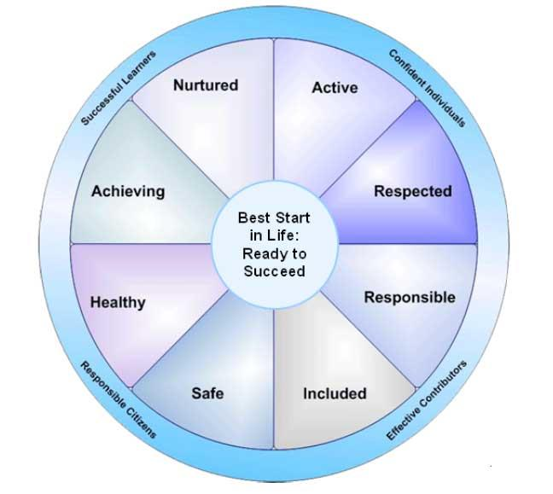

***\*****In light of the current pandemic, Health and Wellbeing and Literacy and Numeracy will be our curricular priorities for 2020-2021*

**Pre birth – 3: Positive Outcomes for Scotland’s Children**

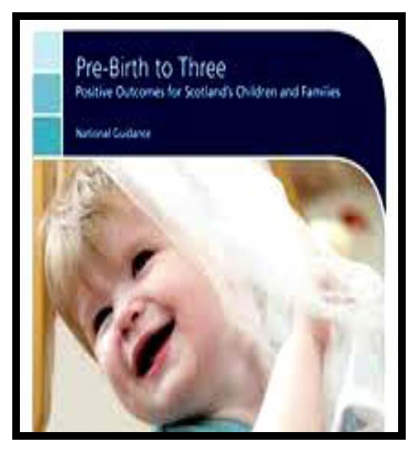At Glen Family Centre we believe that our children are unique individuals and active participants within the world around them showing particular interests, preferences and capabilities in all that they say and do.

Our children’s views and attitudes are shaped from a very early age and being part of a family and community helps to determine individual values and beliefs. We value, respect and respond to parents’ knowledge of their child and this information is imperative to ensuring effective practice within our centre.

When planning for our children’s learning we focus on each individual child while using the ‘Pre-Birth to Three’ document as a valuable tool to support the ‘Rights of the Child’, ‘Relationships’, ‘Responsive Care’ and ‘Respect’ which in turn supports the celebration of the skills and achievements of all our children.

**Realising the Ambition: Being Me**

This document builds on the original philosophy of Building the Ambition extending and strengthening it in line with current research and evidence about how children learn.

It supports us to explore the range of interactions, experiences and spaces we need to provide for babies and young children to help them learn and grow best from their earliest days. All babies and young children develop their individual skills, knowledge and attributes at different rates according to who they are. We also use this guidance to support children with more complex needs by taking this into account.

We have a strong focus on ensuring that the early learning and childcare experience we offer is of high quality and meets the developmental needs of our young learners. The quality of interactions that children have with adults who are caring for them fundamentally affects not only their enjoyment of their nursery experience but also the contribution made to their development.

**Outdoor Play**

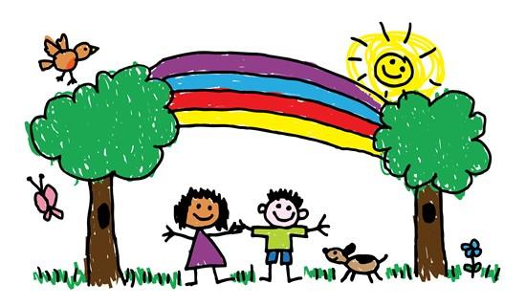

Outdoor play is a very important part of a young child’s learning journey and, at Glen, we extend the playroom to the outdoor environment by ensuring children have access to outdoor learning every day. Children will have choice to move freely between indoors / outdoors throughout their session.

Our aspiration for all children and for every young person is that they should be successful learners, confident individuals, responsible citizens and effective contributors to society and at work. By providing structure, support and direction to young people’s learning, the curriculum should enable them to develop these four capacities. The curriculum should complement the important contributions of families and communities.

Please Note: During the Covid pandemic we will endeavour to spend most of the day outdoors as advised by Scottish Government Guidance so please ensure your child is dressed appropriately.

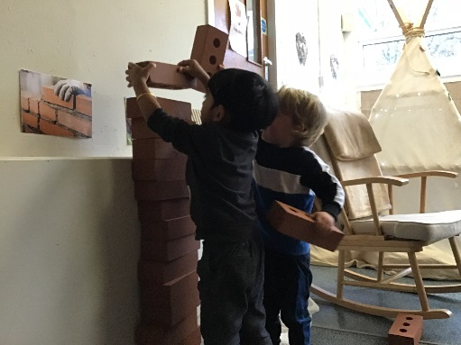

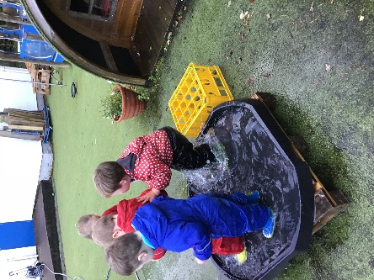

**The role of planning in our nursery**

In order to support learning and development through play we create a high quality curriculum for young children which:-

• provides opportunities to play alone, in pairs, in small groups and large groups depending on the child’s stage of development

• supports independence, interdependence, making choices and decisions

• is content, rich and relevant

• values and extends children’s ways of thinking reasoning and understanding

• helps children to acquire the tools for thinking, learning and playing which enables them to become successful learners

• is culturally diverse and reflects the customs, culture and lifestyles of different ethnic groups

• involves parents in the processes of playing and learning

Taking into consideration children’s interests and consultation with parents, staff prepare plans for each playroom which are displayed on our learning walls. We also encourage you to become involved in planning by reviewing and commenting on your child’s learning story regularly. At the end of each playroom plan, staff observations of children, their interests, reactions and their experiences will form the basis of an evaluation which will inform the content of the next playroom plan. Observations of the children will also help to record each child’s progress and achievement and will be recorded in their Learning Journals.

Useful information available at <http://www.educationscotland.gov.uk/parentzone/>

**Measuring and Reporting Progress**

In Glen Family Centre we know that children will achieve in a variety of ways.

We assess their developmental progress so that we can use this information to develop an appropriate curriculum for each child.

Your child’s key worker monitors the progress of each child in collaboration with other child development officers. Using observations of your child during free-play, a Learning Journal will be built up showing you child’s learning and achievements.

Your child’s progress in nursery will be reported to you:

* Informally through discussions on an on-going basis
* At the end of the Winter & Summer terms your child’s Learning Journal will be sent home for you to look at as a family and for you to add a comment and let us know of any achievement you child has made at home. This said, your child’s journal is available to take home and add to at **any** time throughout the course of the term if you wish.
* Formally at parent consultations

Children are encouraged to be involved in the compilation of their own Learning Journals according to their stage of development. As children participate in opportunities in the playrooms, they are encouraged to reflect upon their efforts and perhaps to make some comment about it, or, for younger children, staff will take note of their response and interactions to particular learning opportunities.

**Celebrating Achievements**

Even the smallest achievement can mean so much and give us an amazing feeling and it can be even better when someone else notices and makes the effort to acknowledge it. We strive to capture that WOW moment in your child’s learning and celebrate it through praise, photographs, displays and twitter.

**Our Wider Community**



Glen FC is located within a vibrant community and we are keen to promote positive partnerships and use it to the benefit of our children and families. We use many of our community resources in the course of our everyday work and encourage staff, parents and children to do so too. We also welcome members of the community into the centre to strengthen links and widen the experiences on offer.

You will often find us out and about in our local community enjoying opportunities such as:

* Book Bug sessions at Thornliebank library. We also borrow books to enjoy in the nursery.
* Walks in Eastwood Park where we love exploring the woodland and the stream

* Outings to Rouken Glen Park where we love to stretch our legs and enjoy the play park or the Ramblers group.
* Visiting the cafe and chatting with the workers in Eastwood Theatre.

As stated above, we also invite members of organisations from the community into the centre to talk about their role in the area. This can include;

* The emergency services to talk about their work and support children in keeping themselves safe and well.
* Charities and voluntary sector organisation
* School Crossing Patrol Person
* Park rangers

Please note: at present visitors to the centre and outings amongst the community are postponed due to Coronavirus.



**Transitions**

Children experience many transition in their lives such as starting nursery, moving to a new room, a new key worker or moving on to a different nursery or school. While these are normal changes that occur, it is important for us as adults to realise these can be daunting experiences for young children. Think about how you felt when you started your first job, had a change of manager or a trusted advisor/friend moved away. Yes, these were events that we can expect in our lives, but they can still cause us anxiety. This is just the same for children when they make transitions and it is important that we help them to adjust and reduce the worry as much as possible by planning effective transition periods.

Internal Transitions:

Internal transitions are simply moves and changes your child will experience within the Centre. If your child joins us when they are just a baby, you can expect them to change room, and possibly key worker, at least once if not more. We will work closely with you and your child to plan any changes and these will always be gradual whenever possible.

Transition to 3-5 Placement:

Children will leave Glen FC on or as soon after they turn three. If your child turns 3 after February then they will transition in August or over the summer period.

When your child turns 2 years of age we will support you in completing a ‘First Steps’ application form. If you do not complete and return the form to the Pre 5 Admission Team at ERC, your child may not be allocated a place in your local nursery.

We work closely with all of our local nurseries to ensure continuity in children’s learning and development and aim to ensure the receiving nursery has a good picture of your child’s strengths and needs before they move. Some of the ways we do this include-

* Introducing the idea of moving on through our everyday work in the Centre
* Information regarding your child’s achievements and stage of development will be shared prior to transfer.
* Arranging visits to the new nursery with your child.
* Informing you of induction events and visits at the new nursery.

Should your child experience any difficulties in settling into the new environment every effort will be made to arrange for his/her key worker to attend and support.

Our main catchment nurseries are:

Braidbar Nursery Class Crookfur Nursery Class

Glenwood Family Centre Giffnock Nursery Class

Isobel Mair Family Centre Thornliebank Nursery Class

Hazeldean Family Centre

**Please note:** during Covid there will be no visits between centres. Your child’s keyworker will call the receiving nursery to share information to ensure your child’s transitions is as smooth as possible.

**Family Friendly Status, Parental Participation & Involvement**

The Scottish Government has set out clear intentions to improve outcomes for all of Scotland’s children and aspires to make Scotland the ‘best place in the world to bring up children’.

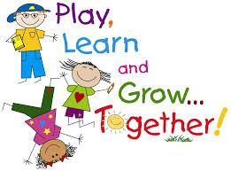At Glen FC we recognise parents as the primary educators of their children. We are continually developing a range of creative and interesting ways to address the needs of children and families. Underpinning all we do are the principles of a nurturing, supportive and family friendly approach which will enhance family wellbeing and support the whole family to reach their full potential. Below are details of some of the ways you can get involved and some of the opportunities you can participate in.

**Stay & Play**

Nursery isn’t just for your child. You too can stay and play and learn more about what your child gets up to during the session. You can also learn some new ways to play from working alongside your key worker with your child. This can be particularly useful in your child’s earliest months when it may seem that all they can do is eat, sleep and cry! Your toddler / older child will love showing you around and getting you involved in their learning.

**Groups for Parents**

There are a range of groups run throughout the year at Glen for you to get involved in. Groups usually meet weekly for around 1.5 – 2 hours and last between 4 -8 weeks depending on the topic. Some groups are ongoing and continue to meet every week. Groups are led by a variety of people including those in our own staff team, Family & Adult Learning Team, Educational Psychologist, voluntary organisations and other parents and many more. Below are some of the topics we have covered. If you have a suggestion or idea for a group you would like to see us offer, please speak to a member of staff or anyone in the Senior Leadership Team.

**[](http://www.scswis.com/index.php?option=com_content&view=article&id=7569&Itemid=369)POPP**

If your child is displaying difficulty with behaviours or regulating emotions, East Renfrewshire have staff trained in Incredible Years Parenting Programme and Triple P. Support is available throughout the year and we would be able to help you find the right programme for you and your family.

The Positive Parenting Programme explores our relationships with our children in the context of helping us to positively manage behaviours. Most parents who take part say the best thing is realising ‘it’s not just me!

**Baby Massage**

Spend some quality time with your baby learning simple baby massage techniques. This can help you both relax, support sleep and help with things like colic.

**Other ways to get involved.**

**Individual Support**

As well as a range of groups, we can also offer support on an individual bases. The staff team are skilled and knowledgeable in many areas including baby feeding and weaning, toilet training and more. Speak to your key worker or a member of the management team if you interested.

**Parents’ Committee**

The Parents’ Committee represent parents in many aspects of the work of the Centre including:

• Supporting self-evaluation and improvement

• Overseeing fundraising efforts

• Engaging with staff in the development and review of policies

• Promoting community involvement in the life of the centre

• Joint Policy Review

If you are interested in joining the Parents’ Committee please speak to your key worker, a member of the management team or Parents’ Committee members.

**Fundraising**



Parents are encouraged to make a small weekly donation of 50p per day to the Centre’s Nursery Fund. These funds are used to help pay for baking ingredients, outings & trips, special events & parties, and any other additional resources required when working with your children. In addition we have larger fund raising events throughout the year. We need your support to make these as successful as possible.

**Nursery Fund Committee**

Funds raised through Nursery Fund donations and other activities are overseen by the Nursery Fund Committee. Membership of the Committee includes staff and parent representatives and is chaired by the Head of Centre. The current membership can be seen on the Centre’s website.

The Nursery Fund Committee has an agreed formal constitution. Accounts are kept for all monies collected and are available for inspection at any time. The accounts are audited by an external, independent auditor annually.

Please note:due to Covid restrictions, we are unable to facilitate any groups or committees at this time but we do hope to resume this as soon as restrictions are lifted.

**Giving your views and suggestions**

At Glen Family Centre we aim to work in partnership with all our families to strengthen the service we provide.

The easiest way to help us improve our service is to get involved and talk to us and tell us what we do well and what we could do better. There are many ways you can do this throughout the year including completing questionnaires, taking part in consultation events, commenting on your child’s profile, completing a comment/suggestion form or talking to us directly. We’re always happy to hear your views and will keep you informed as to how we use them.

**Communication**

We publish a regular newsletter to keep you informed about life in the nursery. Notices will also be placed on the notices boards in the foyer and playrooms. Please make time to have a look when you drop off or collect your child.

The Centre has a website/ twitter feed which has up to date information and useful links to other interesting sites.

If English is not your first language and you would prefer information in an alternative language please let us know.

*During Lockdown periods, on a weekly basis, we will tweet ideas for you to do with your child as well as songs and rhymes you can join in with.

**Centre Improvement**

We are continually striving to be the best we can be for you and your children. We carry out self-evaluation and monitoring activities throughout the year using a variety of methods and measures including national policy and guidance documents such as Getting it Right for Every Child, How Good is Our Early Learning and Childcare? and the national Health and Social Care Standards .

We gather information from everyone involved in the work of the centre including parents, children, the community and other professional. Using this information we identify what we have done well and what we need to develop. We put our evaluation together in a document called the ‘Quality and Standards Report’ and use the information gathered to develop a centre ‘Improvement Plan’. Both of these documents can be found on our website or you can ask for a paper copy from the office.

**Our Policies**

Glen Family Centre has policies in place to ensure that staff, parents and visitors to our centre are clear on our work practices and standards. Our policies are written in line with local and national guidelines including Getting it Right for Every Child, Pre Birth- 3, Health and Social Care Standards and How Good is Our Early Learning and Childcare?. These documents are also used to plan, monitor and evaluate our work. The policies are available in the main entrance, the Parents’ Room and on our website. Policies are monitored and reviewed regularly reflecting our commitment to continuous improvement.

In addition, as part of ERC’s Education Department, Glen Family Centre also use the wider policies of ERC to guide and influence our work with children and families. ERC Policies can be found on ERC Website.



**Equalities**

East Renfrewshire Council Education Department is committed to ensuring equality and fairness for all.

In accordance with the requirements set out by the Equalities and Human Rights Commission, we seek to –

* Eliminate unlawful discrimination, harassment and victimisation and other conduct that is prohibited by the Equality Act 2012
* Advance equality of opportunity between people who share a relevant protected characteristic and those who do not
* Foster good relations between people who share a protected characteristic and those who do not.

Glen Family Centre has clear guidelines and procedures for dealing with incidents of inequality, as advised by the Education Department. We encourage that any concerns be raised with us. Everyone should feel that they are fairly treated and equally valued. Bias, segregation, stereotyping or discrimination are completely unacceptable. Our Equalities Coordinator is our Senior Child Development Officer Claire Smith and can be contacted by emailing or telephoning the centre.

In addition, as part of ERC’s Education Department, Glen FC also uses the wider policies of ERC to guide and influence our work with children and families. ERC policies can be found on the ERC website.

**Child Protection Policy and Procedures**

At Glen Family Centre we take the care, welfare and protection of our children very seriously. We believe all children have a right to feel safe within nursery, home and community.

Within our nursery we strive to provide a safe, secure and nurturing environment for our pupils, which promotes inclusion and achievement. All Education staff have a statutory and professional responsibility to take action if we have reason to believe a child is suffering or is at risk of abuse.

Our child protection policy and procedure sets out what we will do if we have reason to believe a child is being abused or is at risk of abuse, either within the home or the community. These policies are designed to ensure that children get the help they need when they need it.

Every staff member undergoes a minimum of one child protection training activity every session. Many of our staff are more extensively trained in specific areas of child protection to support and identify potential child protection concerns.

All schools in East Renfrewshire have comprehensive Pupil Support systems in place and we work closely with our partners in Social Work, Health and the Police. The nursery operates a multi-agency Joint Support Team to ensure that the best possible supports are available to children when they need them.

The Child Protection Co-ordinator for the nursery is Christine Bell, Head of Centre. If you wish any further information or a copy of the nursery policy, please contact the office. If you wish to discuss this important matter further, please make an appointment to speak with Christine.

If you are worried or know of a child who could be at risk of abuse or neglect please speak to the Child Protection Coordinator, Depute Head of Centre or please call one of the numbers below.

|  |
| --- |
| **Clarkston Social Work Office 0141 577 4000** |
| **Barrhead Social Work Office 0141 577 8300** |
| **Strathclyde Police Family Protection Unit 0141 532 4900** |
| **Standby Social Work Out of Hours 0800 811 505** |

**Improvement Planning**

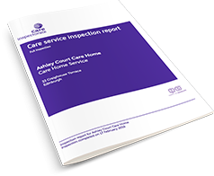

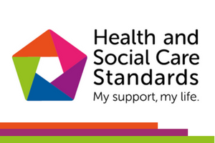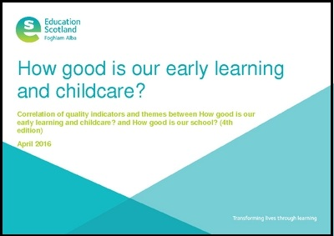

To continually improve our service, we will seek your views in a variety of ways such as questionnaires, consultations and focus groups. We value the opinions of all our stakeholders and will endeavour to consult with you when making big changes. Where possible and through whatever means we can, we will include the children in our consultations allowing them to have a say in decisions that may affect them.

Each year we evaluate the quality of our service using the quality indicators from How Good is our Early Learning and Childcare and The Health and Social Care Standards and use the information gathered to put together our Standards and Quality report. This will identify what we have done well and what our next steps will be. The next steps are then taken forward in our Improvement Plan. You can find both these documents on our website as well as our Care Inspection Report.

**Data Protection**

**Data Protection Act 1998**

Information on children, parents and guardians is stored on a computer system and may be used for teaching, registration, assessment and other administrative duties. The information is protected by the Data Protection Act 1998 and may only be disclosed in accordance with the Codes of Practice. For further information please contact the centre.

Data protection GDPR and the Data Protection Act 2018 means we have a privacy notice which will let you know what we do with the information you provide to the nursery. You can find out more about how we handle this information and your rights by going to www.eastrenfrewshire.gov.uk/privacy. If you do not have access to a computer and wish a paper copy please let us know by contacting the centre.

**Privacy notice – Education**

**Who will process your information?**

The personal information you give to us through any of our forms relating to Education and any other pupil administrative information we hold about you in this context will be processed by East Renfrewshire Council, Eastwood Park Giffnock, G46 6UG for the administration of Education and any additional support you or your child may require.

**Why do we process your information?**

Your information is processed to help us administer education provision and related functions within East Renfrewshire. Your information may be shared with other departments within the council and other organisations for the same purposes and also to check the information we have is accurate; prevent and/or detect crime; and protect public funds. Other organisations may include bodies responsible for auditing or administering public funds, other councils, public sector agencies, government departments, exam bodies and other private companies or partners we use to process information and distribution services for the issue of correspondence.

**What is the legal basis for us to process your information?**

The council processes your information in order to perform a task carried out in the public interest and also to fulfil its legal obligations to ensure proper administration of the council’s financial affairs in terms of the Local Government (Scotland) Act 1973. The law gives certain types of information special significance because of its sensitivity e.g. health information. If we process this type of information about you in relation to Education we do so on the basis that it is necessary for reasons of substantial public interest.

**Do you have to provide your information?**

Education needs your information to allow us to carry out public tasks in the public interest that is set out in law such as teaching in primary and secondary schools. It allows us to organise and administer classes, lunches, exams etc.

**How do we collect information about you?**

Most of the information the council holds about you will come from you as an individual and it provided at your first encounter with education whether it is applying for a place in an early learning and childcare establishment, support in the early years or applying for a place in one of our schools.

Such information includes:-

Such information includes:-

Child’s Forename

Child’s Surname

Child’s gender

School Stage

Details of child’s medical condition

Any other name child is known by

Child’s date of birth

Address including postcode

Mother’s/Carer’s Name

Father’s/Carer’s Name

Mother’s/Carer’s address including postcode

Father’s/Carer’s address including postcode

Mother’s/Carer’s telephone number

Father’s/Carer’s telephone number

Mother’s/Carer’s email address

Father’s/Carer’s email address

Single Parent/Carer family

Name of Brother/Sister

Date of Birth of Brother/Sister

School stage of Brother/Sister

Additional Information Support Application

School applying for

Preferred Alternative School

Early Learning and Childcare place applied for

Council Tax Evidence

Mortgage Statement

Rental Agreement

Rental Agreement End Date

Landlord Registration Number

Birth Certificate

Baptism Certificate

Date of Baptism

Name of Church venue

Child Benefit Statement

Utility Statements

Other Catchment Evidence

**How long will we keep your information?**

The council will hold your information from when your child first has contact with one of our services through to five years beyond them leaving school.

**Who is your information shared with?**

Your information will be accessed by council staff who need to do so to administer education and the many services that run alongside it. If such administration is provided on the council’s behalf by an external agency, that agency will also have access to your information. The information will be shared with SEEMiS, CRB, ParentPay, the Diocese of Paisley (in Roman Catholic schools), Scottish Government including their Analytical Services, Education Scotland, Glow (Scotland’s national education network), SQA, 2Cqr, BAM FM (Carlibar Primary, Barrhead Mearns Castle, Williamwood, Woodfarm High Schools), Bellrock FM (Mearns Primary and St Ninian’s High), Skills Development Scotland, Scholar (Heriot Watt University) and East Renfrewshire Culture and Leisure Trust.

The council also needs to ensure proper administration of its funds so details will be checked internally for fraud prevention and verification purposes. Information is also analysed internally in order to provide management information and inform future service delivery. Your information may also be shared with other departments within the Council. The council also generally complies with requests for specific information from other regulatory and law enforcement bodies where this is necessary and appropriate.

**Do we transfer your information outside the UK?**

In general we do not transfer personal information outside the UK but on the rare occasions we do we will inform you. We will only transfer information outside the UK when we are satisfied that the party that will handle the data and the country it is being processed in have adequate safeguards for personal privacy comparable to those which are in place in the UK.

**Profiling and automated decision-making**

The Education Department does not use profiling or automated decision making for administration.

Your rights

You have the right to be informed of the council’s use of your information. This notice is intended to give you relevant information to meet this right.

Access personal data held about you

You have the right to access personal information the council holds about you by making what is known as a subject access request. You can receive a copy of your personal data held by the council, details on why it is being held, who it has been or will be shared with, how long it will be held for , the source of the information and if the council uses computer systems to profile or take decisions about you.

1. Request rectification of your personal data

You have the right to request that the council corrects any personal data held about you that is inaccurate.

1. Request that the council restricts processing of your personal data

You have the right to request that the council restricts processing your personal data if you think the personal data is inaccurate, the processing is unlawful, the council no longer need the personal data but you may need it for a legal purpose or you object to the council processing for the performance of a public interest task.

1. To object to the processing of your data

You have the right to object to the council’s use of your personal data. The council will have to demonstrate why it is appropriate to continue to use your data.

Complaints

If you have an issue with the way the council handles your information or wish to exercise any of the above rights in respect of your information you can contact the council’s data protection officer by post at:

The Data Protection Officer East Renfrewshire Council Council headquarters Eastwood Park Giffnock G46 6UG

or by email at [DPO@eastrenfrewshire.gov.uk](mailto:DPO@eastrenfrewshire.gov.uk)

You have the right to complain directly to the Information Commissioner’s office (ICO). The address of their head office is:

Wycliffe House, Water Lane, Wilmslow, Cheshire, SK9 5EF Telephone: 0303 123 1113

Alternatively, you can report a concern via their website at www.ico.org.uk The ICO also have a regional office at:

45 Melville Street, Edinburgh EH3 7HI Telephone: 0303 123 1115 e-mail: [scotland@ico.org.uk](mailto:scotland@ico.org.uk)

**While you can go directly to the ICO, the council would welcome an opportunity to address any issues you have in the first instance.**

**Complaints**

We hope that you will always be happy with the service we provide you and your family; however, if this is not the case, please speak to a member of the management team and we will do our very best to work through and resolve any difficulties. We follow East Renfrewshire Council’s Complaints Procedure which encourages complaints to be made directly to the service involved but if you are still unhappy, you can contact ERC directly:

Mr Mark Rattar, Director of Education

East Renfrewshire Council Education Department

211 Main Street

Barrhead

G78 1SY

0141 577 3000

If you feel your concern has not been managed effectively or are not satisfied with the outcome, you can contact the following for further support and guidance:

The Care Inspectorate

4th Floor

1 Smithhills Street

Paisley PA1 1EB

0141 843 6840

The Care Inspectorate has produced a leaflet to support those who wish to complain about a care service. It can be accessed on their website or from the link below.

<http://www.scswis.com/index.php?option=com_content&view=article&id=7569&Itemid=369>



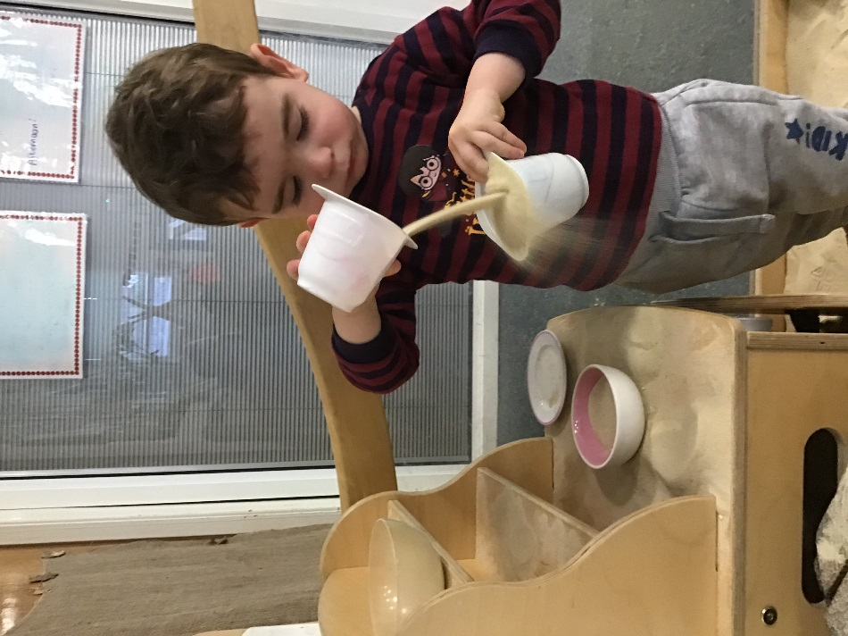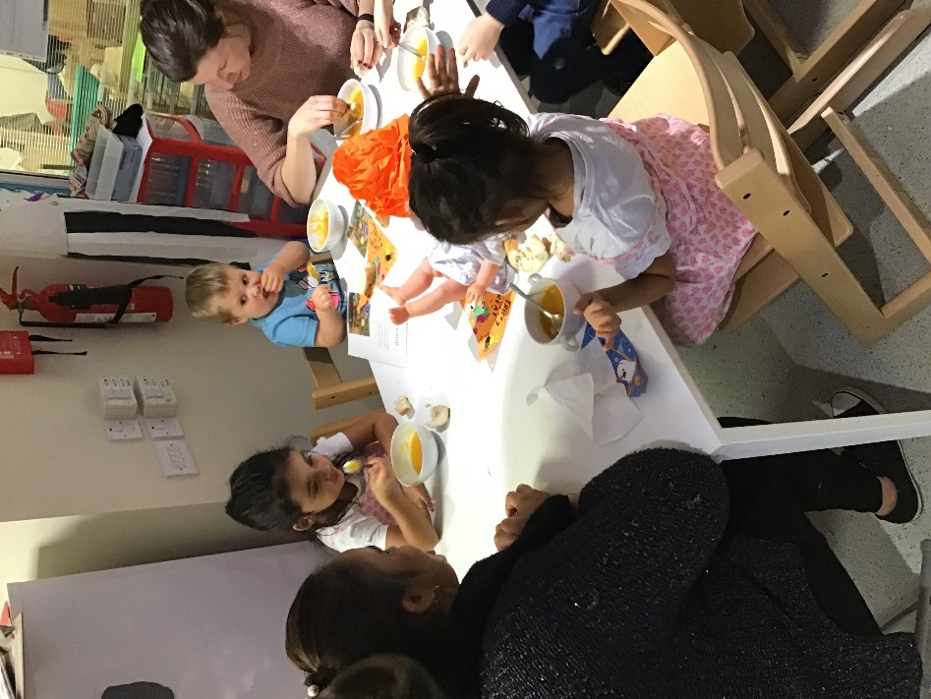

**Contacts Information**

Director of Education Mark Rattar 577 3481

Head of Service Janice Collins 577 3204

Quality Improvement Officer Pre 5 Rosamund Rodriguez 577 3222

Quality Improvement Officer Siobhan McColgan 577 8346

(Woodfarm Cluster)

Psychological Service Gillian Thorburn 577 8510

Early Education and Childcare

Admissions Jennifer Ross 577 3288

East Renfrewshire Council General Enquiries 577 3000

**Useful Links**

***Glen Family Centre*** *Website:* [*https://blogs.glowscotland.org.uk/er/Glen/*](https://blogs.glowscotland.org.uk/er/Glen/)

*Twitter:* [*https://twitter.com/Glen_FC*](https://twitter.com/Glen_FC)

**East Renfrewshire Council Policies and Links**

Sending your child to Nursery (3-5years):

<http://www.eastrenfrewshire.gov.uk/article/1820/Sending-your-child-to-nursery>

*Complaints:* [*http://www.eastrenfrewshire.gov.uk/index.aspx?articleid=1573*](http://www.eastrenfrewshire.gov.uk/index.aspx?articleid=1573)

*Child Protection:* [*http://www.eastrenfrewshire.gov.uk/index.aspx?articleid=1923*](http://www.eastrenfrewshire.gov.uk/index.aspx?articleid=1923)

*Pre Birth to 3:* [*http://www.educationscotland.gov.uk/earlyyears/prebirthtothree/*](http://www.educationscotland.gov.uk/earlyyears/prebirthtothree/)

*Building the Ambition:* [*http://blogs.glowscotland.org.uk/er/curriculinks/*](http://blogs.glowscotland.org.uk/er/curriculinks/)

*Curriculum for Excellence:* [*http://www.educationscotland.gov.uk/thecurriculum/whatiscurriculumforexcellence/*](http://www.educationscotland.gov.uk/thecurriculum/whatiscurriculumforexcellence/)

*Curriculum Links:* [*http://blogs.glowscotland.org.uk/er/curriculinks/*](http://blogs.glowscotland.org.uk/er/curriculinks/)

*Dyslexia:* [*http://www.addressingdyslexia.org/*](http://www.addressingdyslexia.org/)

*Emergency Closure of Schools and Establishments – Severe Weather Conditions:* [*http://intranet.erc.insider/CHttpHandler.ashx?id=4193&p=0*](http://intranet.erc.insider/CHttpHandler.ashx?id=4193&p=0)

*ENABLE – ASN Support:* [*http://www.enable.org.uk*](http://www.enable.org.uk/)

*ENQUIRE - ASN Support:* [*http://enquire.org.uk/*](http://enquire.org.uk/)

*ERC Website – general enquiries:* [*http://www.eastrenfrewshire.gov.uk/index.aspx?articleid=1489*](http://www.eastrenfrewshire.gov.uk/index.aspx?articleid=1489)

*Inclusion:* [*http://www.ea.e-renfrew.sch.uk/curriculinks/Links/Teachers/inclusion.htm*](http://www.ea.e-renfrew.sch.uk/curriculinks/Links/Teachers/inclusion.htm)

*Internet Safety :* [*http://www.ea.e-renfrew.sch.uk/curriculinks/Links/Parents/Parental%20Leaflets/Internet%20leaflet.pdf*](http://www.ea.e-renfrew.sch.uk/curriculinks/Links/Parents/Parental%20Leaflets/Internet%20leaflet.pdf)

*Local improvement plan:* [*http://www.eastrenfrewshire.gov.uk/local-development-plan*](http://www.eastrenfrewshire.gov.uk/local-development-plan)

*Psychological Services:* [*https://blogs.glowscotland.org.uk/er/PsychologicalService/*](https://blogs.glowscotland.org.uk/er/PsychologicalService/)

*Safe Use of ICT:* [*http://www.ea.e-renfrew.sch.uk/curriculinks/Links/Parents/Parental%20Leaflets/Internet%20leaflet.pdf*](http://www.ea.e-renfrew.sch.uk/curriculinks/Links/Parents/Parental%20Leaflets/Internet%20leaflet.pdf)

*Twitter – East Renfrewshire:* [*http://www.twitter.com/EastRenCouncil*](http://www.twitter.com/EastRenCouncil)

**Please Note:**

Due to the current COVID-19 Pandemic we are unable to carry out enrolment, transitions family engagement and many other roles described within our handbook. We will strive to keep you up to date as much as we can on any COVID news, guidelines and procedures through our twitter feeds, website, email and telephone conversations.

Thank you