**Attention for all families…**

**Thinking you might need some advice but don’t know how to or where to go? Have a look at this information and the link below.**

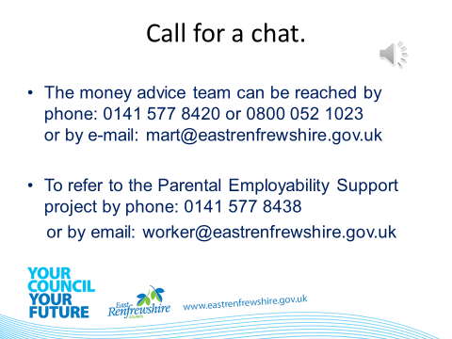

**For further information on support for you and your family can be found at the link below. It brings together a range of key local and national organisations providing a range of support and information to families.**

**This site has been created as a ‘one stop shop’ for families who want to access services and information by themselves in their own time.**

[**https://www.eastrenfrewshire.gov.uk/family-first-information-resource**](https://www.eastrenfrewshire.gov.uk/family-first-information-resource)

**Every little helps ☺**