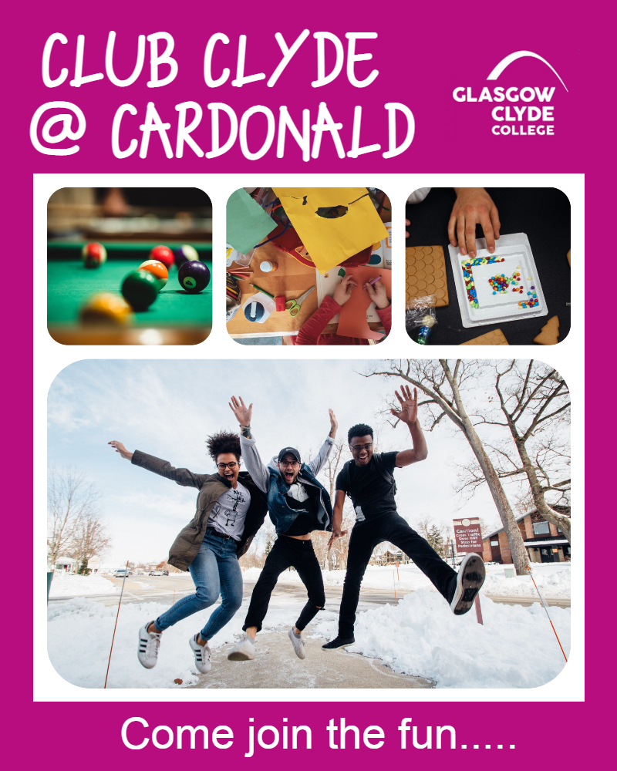

Club Clyde @ Cardonald
FREE!!!!
Join our club for fun activities for young people with additional needs
5.00pm -7.00pm every Tuesday from 25th April to 30th May 2023.
S1-S6
Glasgow Clyde College - Cardonald Campus
Activities including arts & crafts, games, music, cookery, bingo, disco, karaoke and lots more…

If interested please call Julie on
0141 272 3250 to discuss a place.
