
East Renfrewshire Council: Education Department
Practitioner Moderation Template

Prior to the moderation exercise, please complete the following information and submit it to your facilitator with assessment evidence from one learner that you judge to have successfully attained the Es and Os.
School Code | V
Practitioner Code | V5
Curriculum Area(s) | English and Literacy
Level | First Level
Stage(s) | P4
Specific subject (if applicable) | Reading and Writing

Experiences and Outcomes:

To show my understanding across different areas of learning, I can identify and consider the purpose and main ideas of a text.
LIT 1-16a

By considering the type of text I am creating, I can select ideas and relevant information, organise these in a logical sequence and use words which will be interesting and/or useful for others.
LIT 1-26a

Learning Intentions:

- To identify and consider the main ideas of a fictional text.

- To select ideas and relevant information and organise these in a logical sequence.

Success Criteria:

1a- I can identify the main idea of my book ‘Steggie’s Way’.
1b- I can identify the main idea of each chapter.

2a- I can write a summary for each chapter.
2b- I can write about the main idea of a fiction text.

Briefly outline the context and range of quality learning experiences that have been provided making reference to the chosen design principles.

Breadth- We looked at and discussed a variety of different text which the children have read where they have identified the main idea. For example, Harry Potter.

Personalisation- The pupils were summarising the chapters of the book in their own booklet which they designed. They wrote about their interpretation of the main idea.

Lesson 1:

We discussed the main idea of fiction books which we have read.
The pupils read a passage together on the interactive whiteboard and we had to say what was the main idea of the text.

Lesson 2:

We created mind maps of the key events which had happened in each of the chapters in our book. We selected ideas and relevant information from each chapter.

Lesson 3:

We used our mind maps to help us summarise each of our chapters and organise information in a logical sequence.
We wrote a summary of each chapter in our booklet which we created. This helped us generate the main idea of the book.
At the back of the book we identified and wrote about the main idea of our book.

Record the range of assessment evidence that was gathered to meet the success criteria (Say, Write, Make, and Do) considering breadth, challenge and application.

Say:

Child voice (shared during class discussion) teacher assessed.

Write:

Mind Maps of each chapter – peer assessed, pupils traffic lighting against success criteria.

1x Booklet –self assessed-two stars and a wish and verbal feedback.
teacher assessed- verbal feedback.

Briefly outline the oral/written feedback given to the pupil on progress and next steps, referring to the learning intention and success criteria.
Oral Feedback Provided to Pupil:

“You have successfully identified the main idea of your book. You have used your mind maps to help you select relevant information from each chapter. You have summarised each chapter in your booklet in a logical order and have used this information to help you generate an understanding of the main idea of your book.
Well done, you can now use your knowledge and understanding of main idea when writing a book review and synopsis of our next book.”
(Next step- writing a book review and synopsis of another book)

Pupil Voice:
What have you learned? How did you learn? What skills have you developed?

“We were learning about the main idea of a story. We discussed the main idea of different books. We read a story and as a group we had to say what the main idea was.

We had to read our book called ‘Steggies Way’ and write points of what happened in each chapter. We used our mind map planning page to help us in writing a summary of each chapter in our booklet. At the back of our booklet we wrote the main idea of the story. Writing what happened in each chapter helped us with our main idea.”

Did the learner successfully attain the outcomes? YES /NO

Evidence

We discussed the main idea of fiction books which we have read and read this passage to identify the main idea.

Lesson 1:

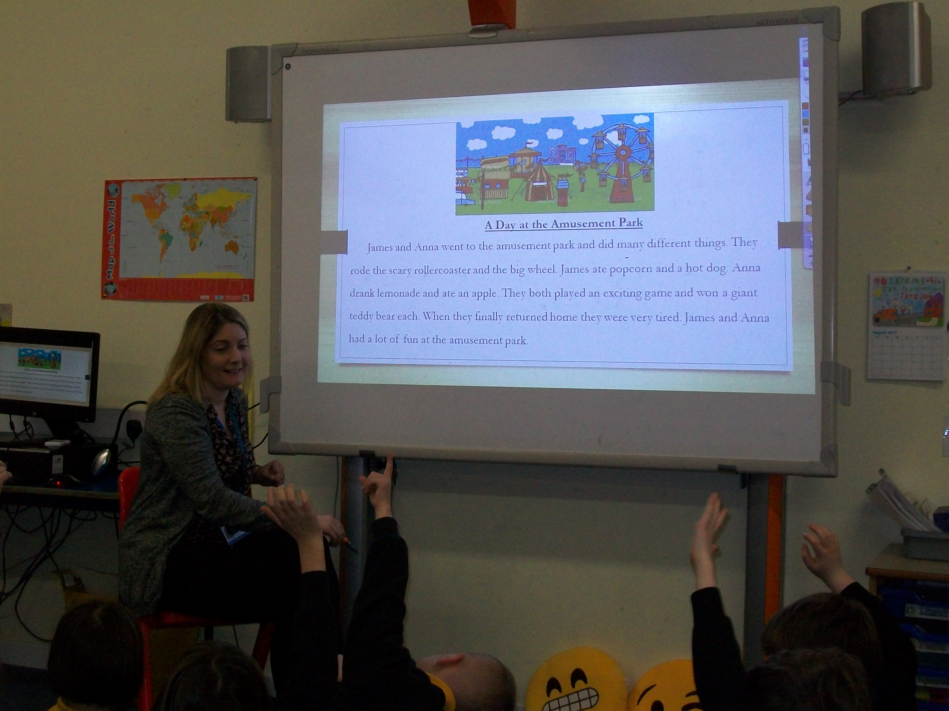

Lesson 2:

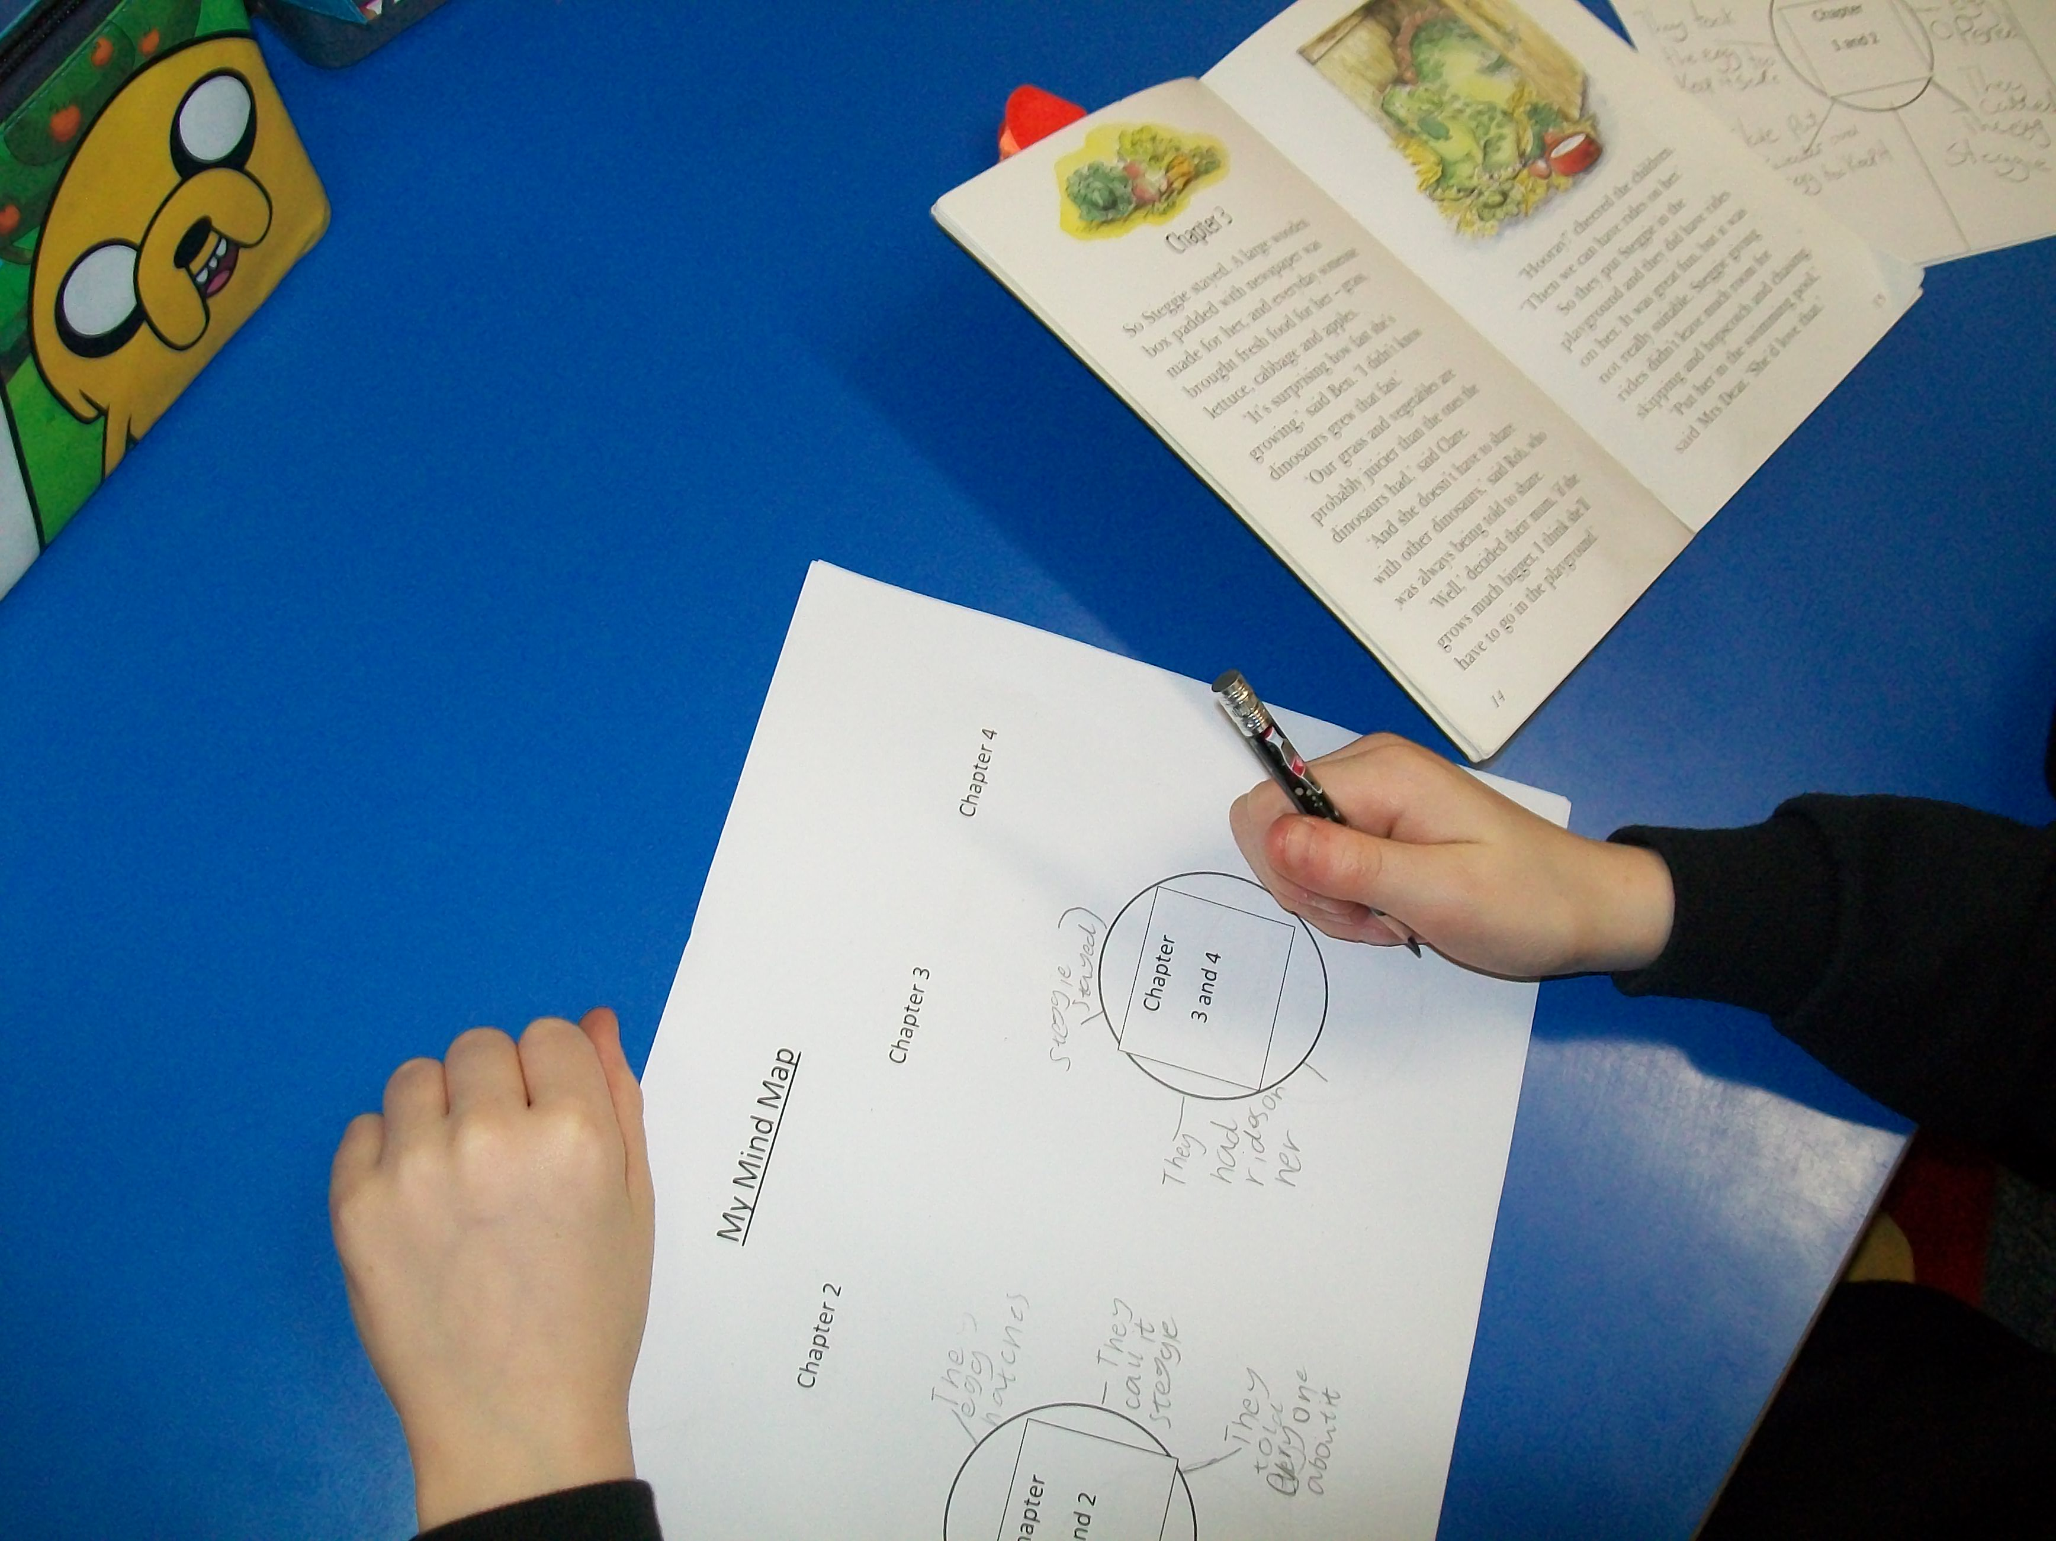

We created mind maps to summarise each chapter by selecting relevant ideas and information.

Work was peer assessed against the success criteria and traffic lighted.
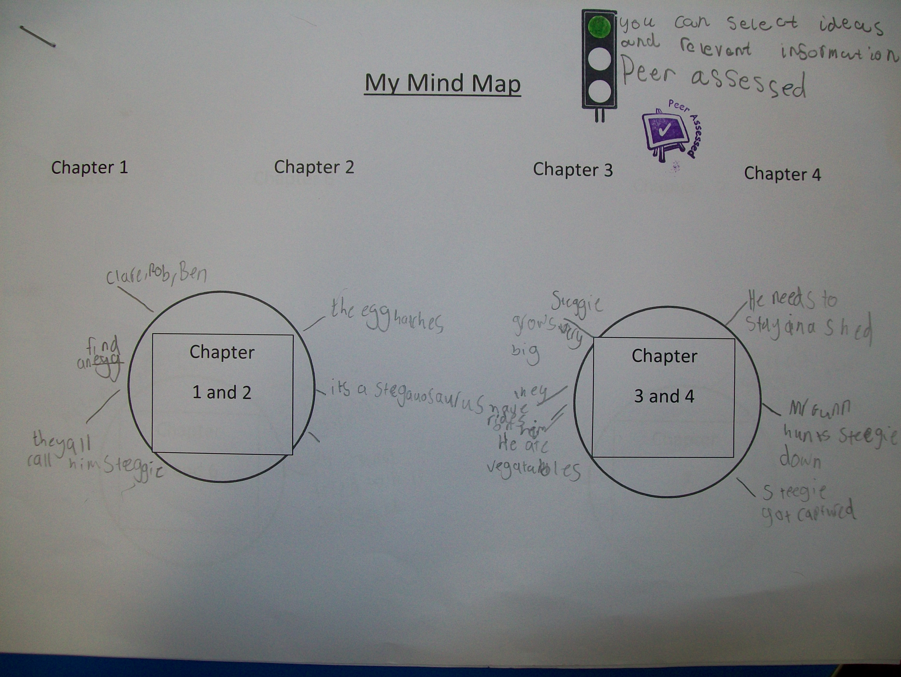
Lesson 3:

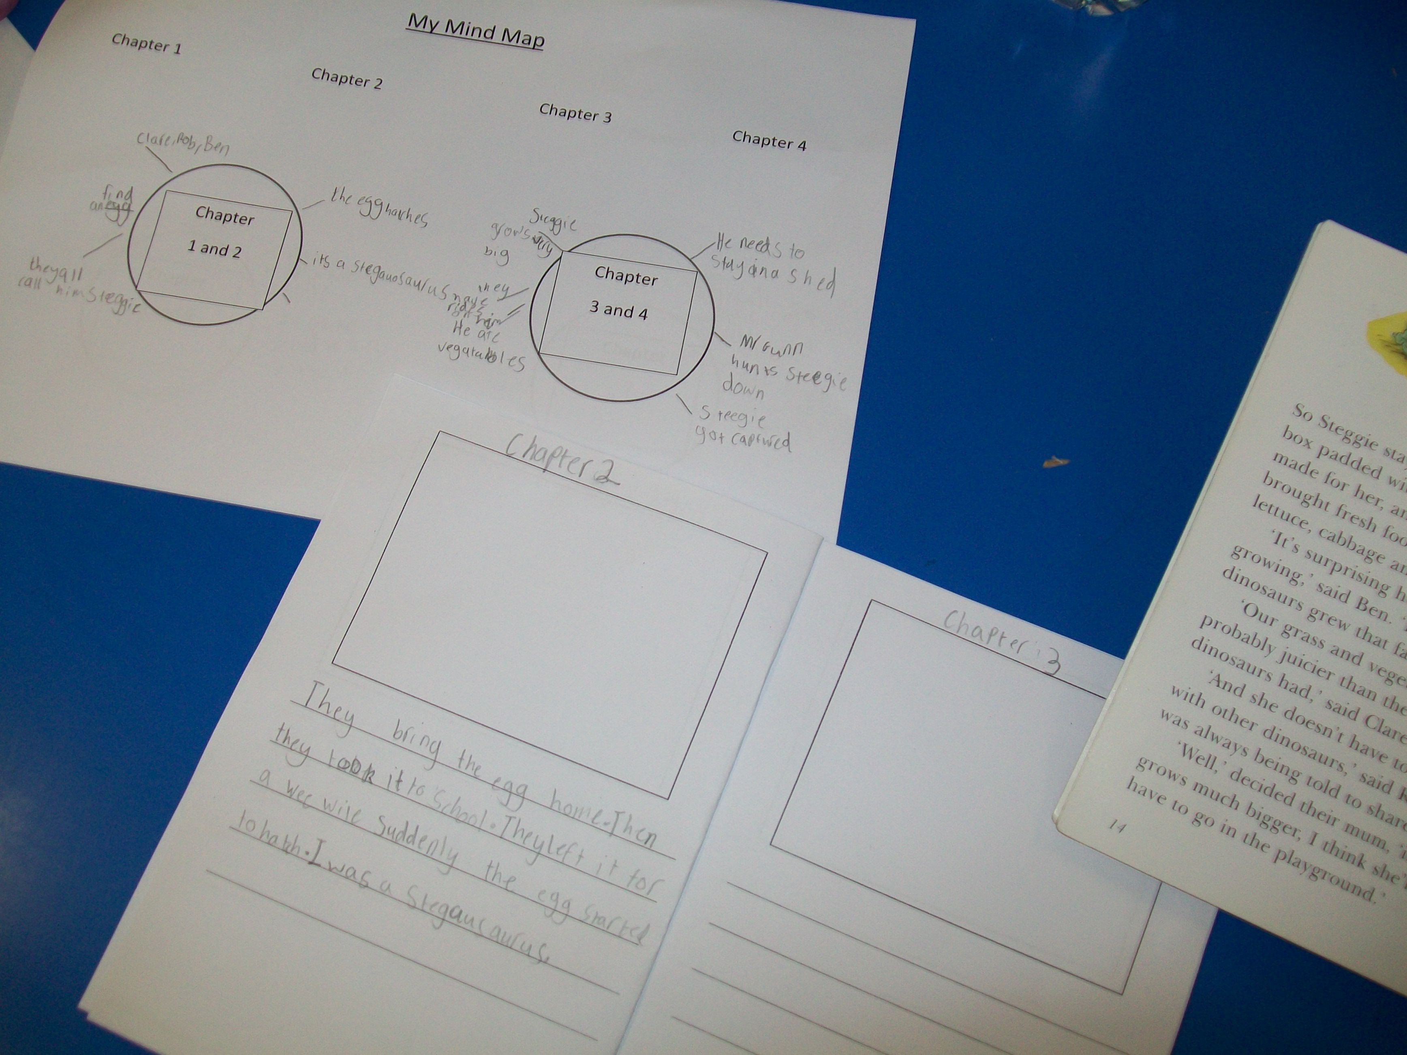

The pupil used their mind map to assist them in creating a summary of each chapter and organise information in a logical sequence.
Teacher feedback provided on learning and next steps. See teacher voice.

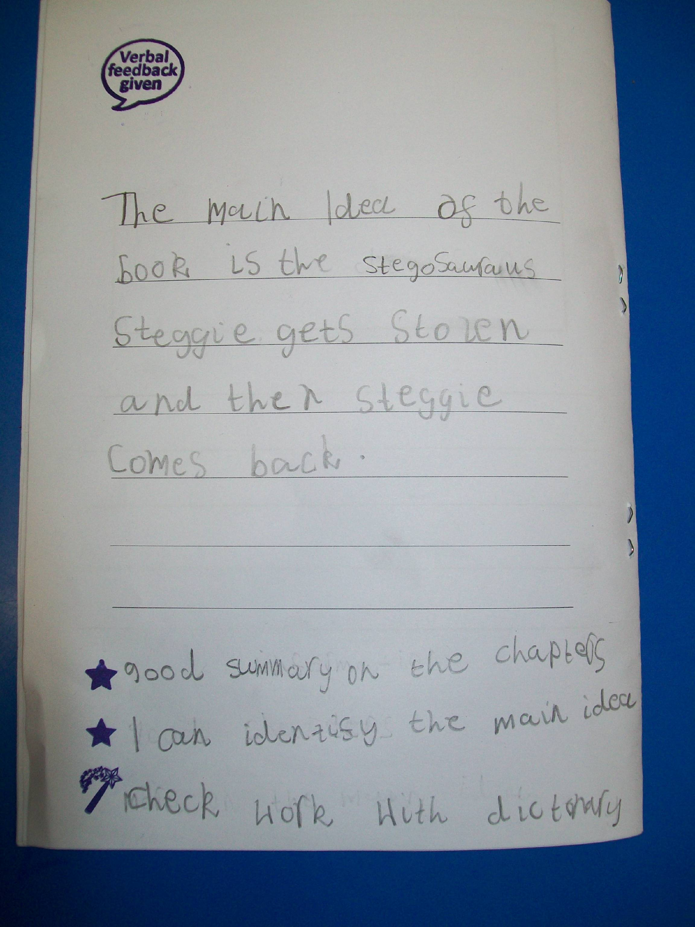

The pupil self-assessed their booklet against the success criteria using two stars and a wish. Verbal feedback to the pupil was given from the teacher.

The pupil identified and wrote about the main idea of their fictional text.

