
East Renfrewshire Council: Education Department
Practitioner Moderation Template

Prior to the moderation exercise, please complete the following information and submit it to your facilitator with assessment evidence from one learner that you judge to have successfully attained the Es and Os.
School Code | F
Practitioner Code | F17
Curriculum Area(s) | Literacy and English, Health and Wellbeing
Level | 2nd
Stage(s) | P7
Specific subject (if applicable)

Experiences and Outcomes:

I can discuss structure, characterisation and / or setting, recognise the relevance of the writer’s theme and how this relates to my own and others’ experiences, discuss the writer’s style and other features appropriate to genre. ENG 2-19a

I can convey information, describe events, explain processes or combine ideas in different ways. LIT 2-28a

I recognise that each individual has a unique blend of abilities and needs. I contribute to making my school community one which values individuals equally and is a welcoming place for all. HWB 2-10a

Learning Intentions:

To discuss characterisation and how this relates to my own and others’ experiences.

To describe events in different ways

To contribute to making my school community a welcoming place for all.

Success Criteria:

I can:
- Describe direct and indirect characterisation
- Identify a character’s speech, thoughts, actions, effect on others and looks
- Describe a character’s personality traits
- Justify my choices using evidence from the text
- Discuss how my view of characters changed

- Recognise and use a range of descriptive vocabulary appropriately
- Recognise and use a wide range of connectives
- Recognise and use a range of sentence openers
- Recognise and use a range of punctuation
- Use events from the text in my writing
- Write from my character’s point of view
- Select a suitable format for my writing

- Identify how I could be kind to a fictional character
- Identify actions that I can take to promote kindness
- Comment on the impact of my actions

Briefly outline the context and range of quality learning experiences that have been provided making reference to the chosen design principles.

Wonder has been read to the class over the term. The class have all been highly engaged and interested in the story (personalisation). There have been some challenging relationships within the class so the novel has been used to allow pupils to consider their actions and the consequences of these within a fictional context before considering how this could be applied within their own class (relevance).

Pupils were initially introduced to direct and indirect characterisation, and how a writer shows what characters are like through the five aspects of characterisation. Pupils were allocated a character in the book and collected evidence of their character traits with a partner. They then discussed with a group what they thought the most prominent traits of that character were. They used these to create word clouds for the character. Pupils also created writing from their character’s point of view (breadth).

Learners then wrote about their character’s first day at school from their point of view. They chose a suitable format for their character. The writing was peer assessed and teacher feedback given then redrafted.

Pupils shared the work they had completed on their character with other groups then discussed how their opinions of characters had changed following this.

Pupils make notes on ways they could have showed kindness to the central character if they were a character in the story. The class shared their ideas and then considered which of these they could adopt within the classroom to promote kindness and make everyone feel included & welcome.

Record the range of assessment evidence that was gathered to meet the success criteria (Say, Write, Make, and Do) considering breadth, challenge and application.

Say:
- Group discussion on character traits
- Discussion reflecting on view of other characters
- Reflection on actions
- Self-assessment

Write:
- Notes on characterisation
- Character’s first day at school
- Notes on showing kindness to character in novel
- List of ways to promote kindness in class
- Self-assessment
Make:
- Character word cloud
- Kindness artwork

Briefly outline the oral/written feedback given to the pupil on progress and next steps, referring to the learning intention and success criteria.

Written feedback on self-assessment & writing in evidence.

Pupil Voice:
What have you learned? How did you learn? What skills have you developed?

See pupil dialogue.

Did the learner successfully attain the outcomes? YES

Notes on characterisation
I can justify my choices using evidence from the text.

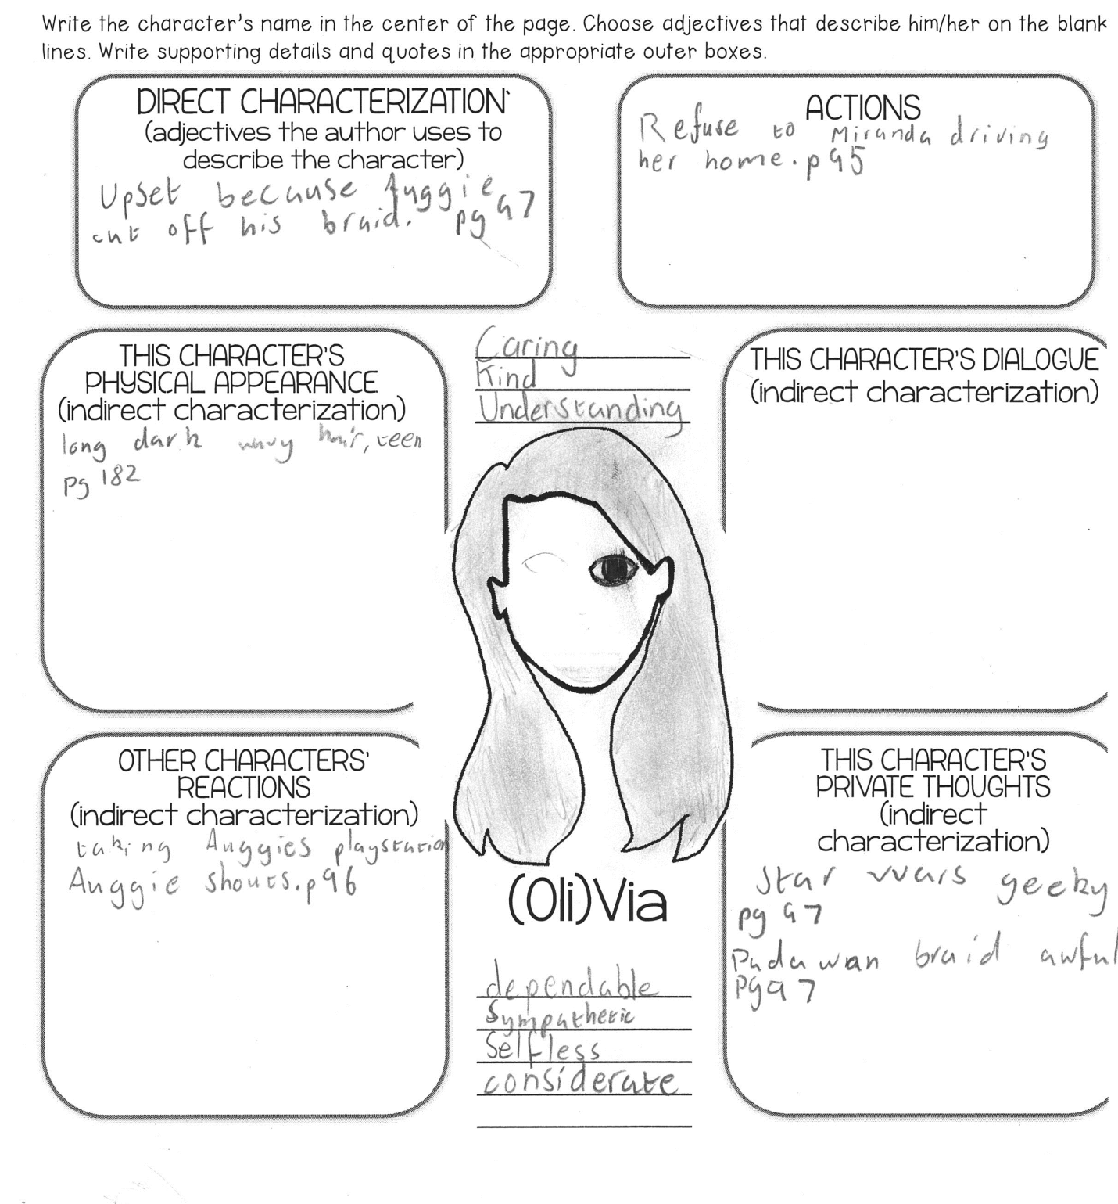

I can describe a character’s personality traits
Group discussion on character traits
Learner: I think that Via is very protective because whenever August is getting bullied or anything like that, Via is always there and just backs him up. I also think she is very understanding and dependable and if she wants to do something, she’ll know that she’s not 100% going to do it because she says that August is the first priority.

Learner 2: I agree that she is protective and understanding. I also think she’s very caring and kind because she always is very nice and always understands him and if anything goes wrong for her she doesn’t get that bad tempered.

Learner: I think she’s very creative because she always makes things out of old discs, into a bag for example, and old bits of pieces of things into earrings and t-shirts into dresses like it states back in the Justin chapter. I also think she’s very kind

Teacher: Why do you think she’s kind?

Learner: Because she’s always there for August no matter what. She’s also always welcoming to people who she didn’t trust at first.

Learner 3: I think that she is very trustworthy because she will never lie unless it will protect her family or to keep secrets or anything like that. And she does keep secrets. She’ll never tell a lie.

Learner 4: I agree partly with Learner because she is very creative… the things she does are very creative. And I also agree with Learner 2.

I can describe a character’s personality traits
I can justify my choices using evidence from the text.

Reflecting on other characters

Teacher: Which character do you most relate to?

Learner: Charlotte because we are both enthusiastic chatterboxes.
I can discuss how my views of characters changed
Teacher: Which character traits did you find interesting?

Learner: Jack – self-conscious, quick tempered. Summer – trustworthy, zen.

Teacher: Did any of your opinions of the characters change?

Learner: Justin isn’t just mean, he has a feeling and he has reasons.

Teacher: What changed your opinion?

Learner: You learn more about him. You see things from his point of view and what he is feeling like.

Character word cloud

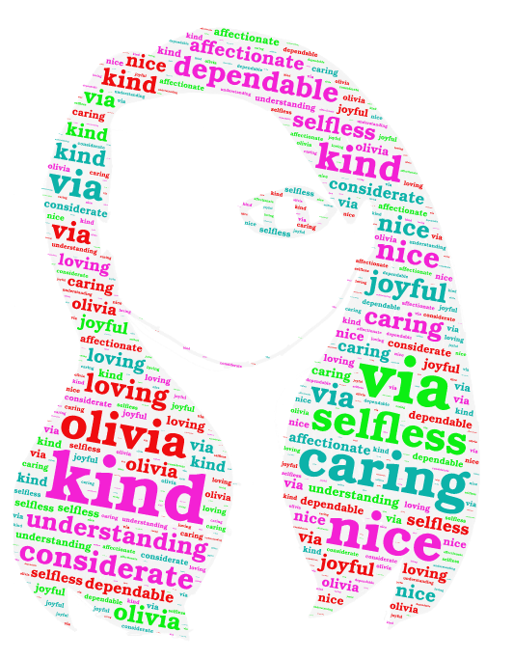
I can describe a character’s personality traits

First day at school

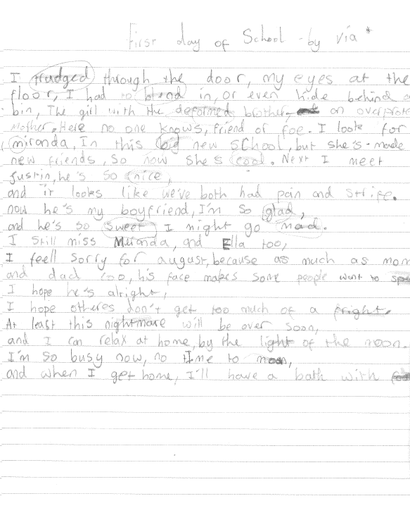

Circles show words highlighted by peer as examples of descriptive vocabulary

Rectangles show words highlighted by peer as examples of connectives

Underlined words are those highlighted by peer for range of openers

First day at school – Self and teacher assessment

Self Assessment
Green
Amber
Amber
Green

Green
Green
Green

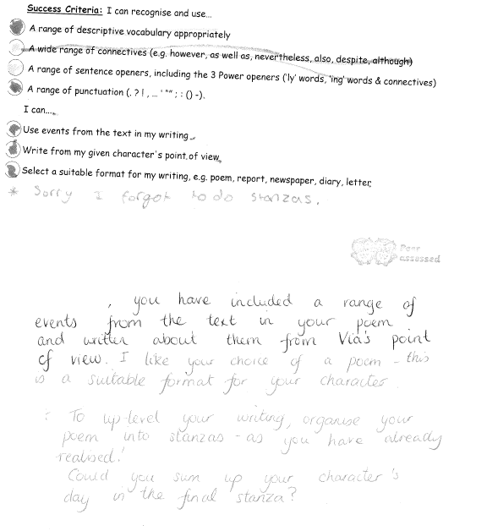

First day at school – Redraft

I can choose a suitable format for my writing

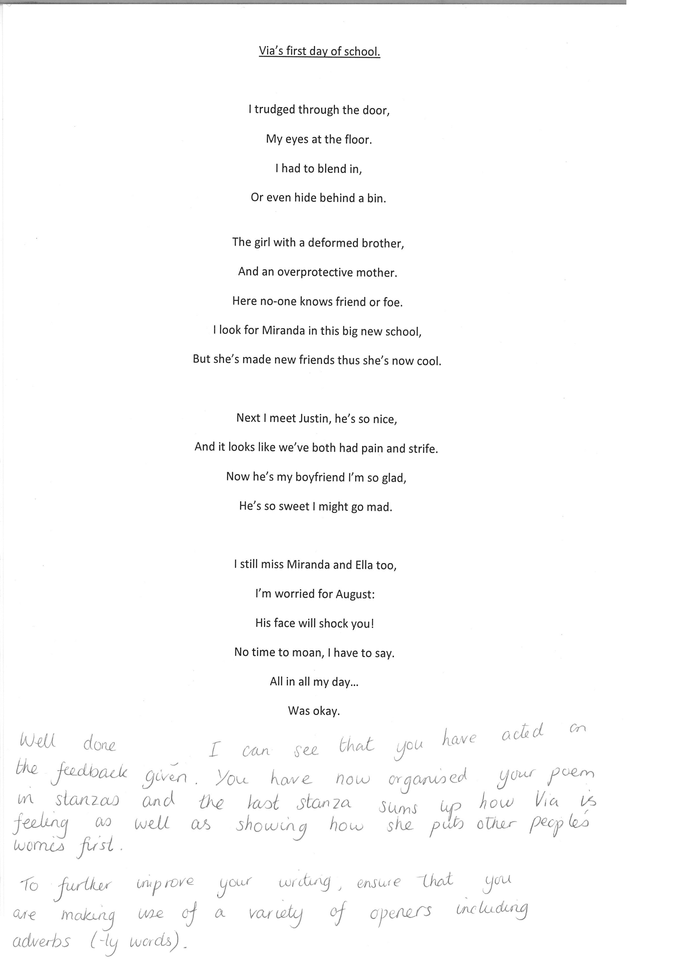
Write from my character’s point of view
Use events from the text in my writing
Recognise and use a range of descriptive vocabulary appropriately
Recognise and use a range of sentence openers
Recognise and use a range of connectives
Recognise and use a range of punctuation

Notes on showing kindness to character in novel

I can identify how I could be kind to a fictional character

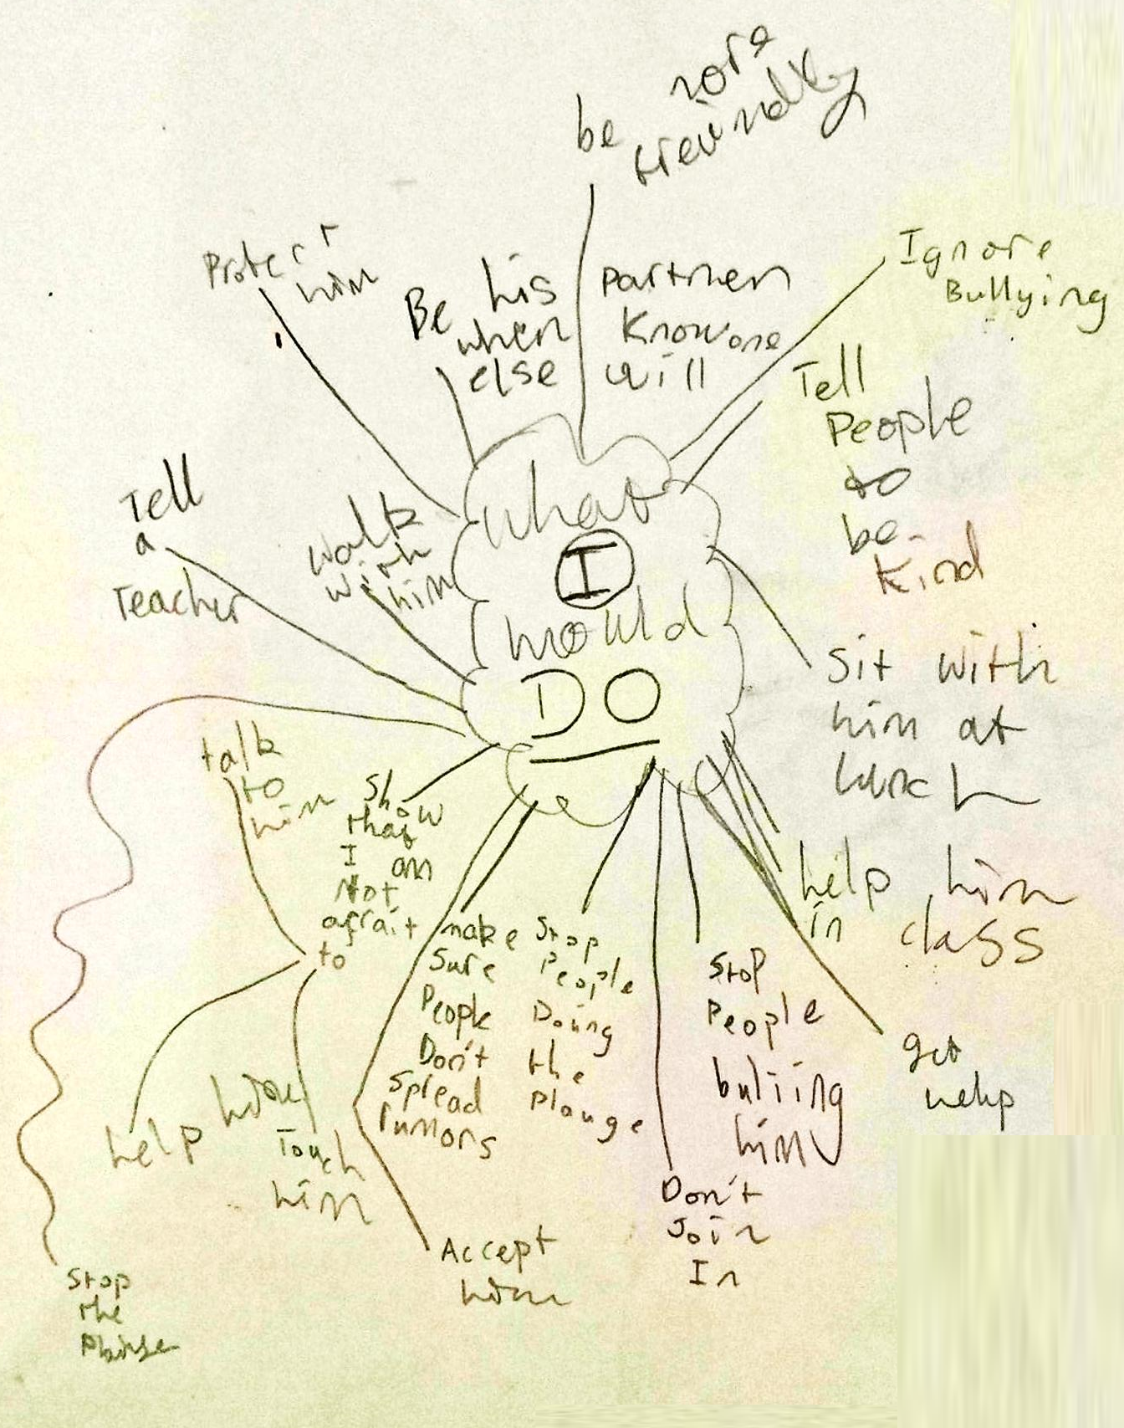

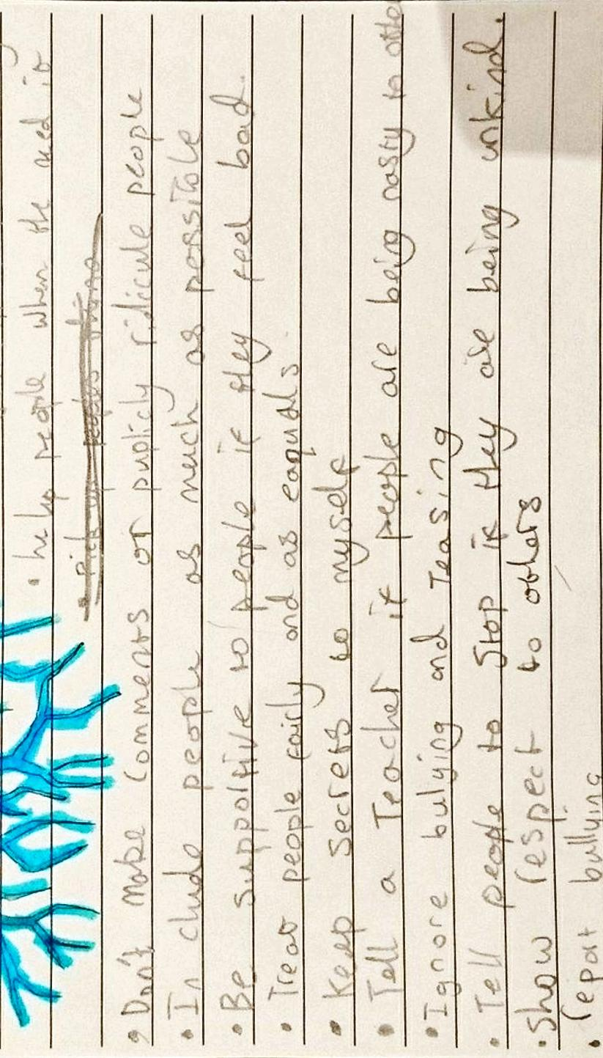
List of ways to promote kindness in class

I can identify actions that I can take to promote kindness

Kindness artwork

I can identify actions that I can take to promote kindness

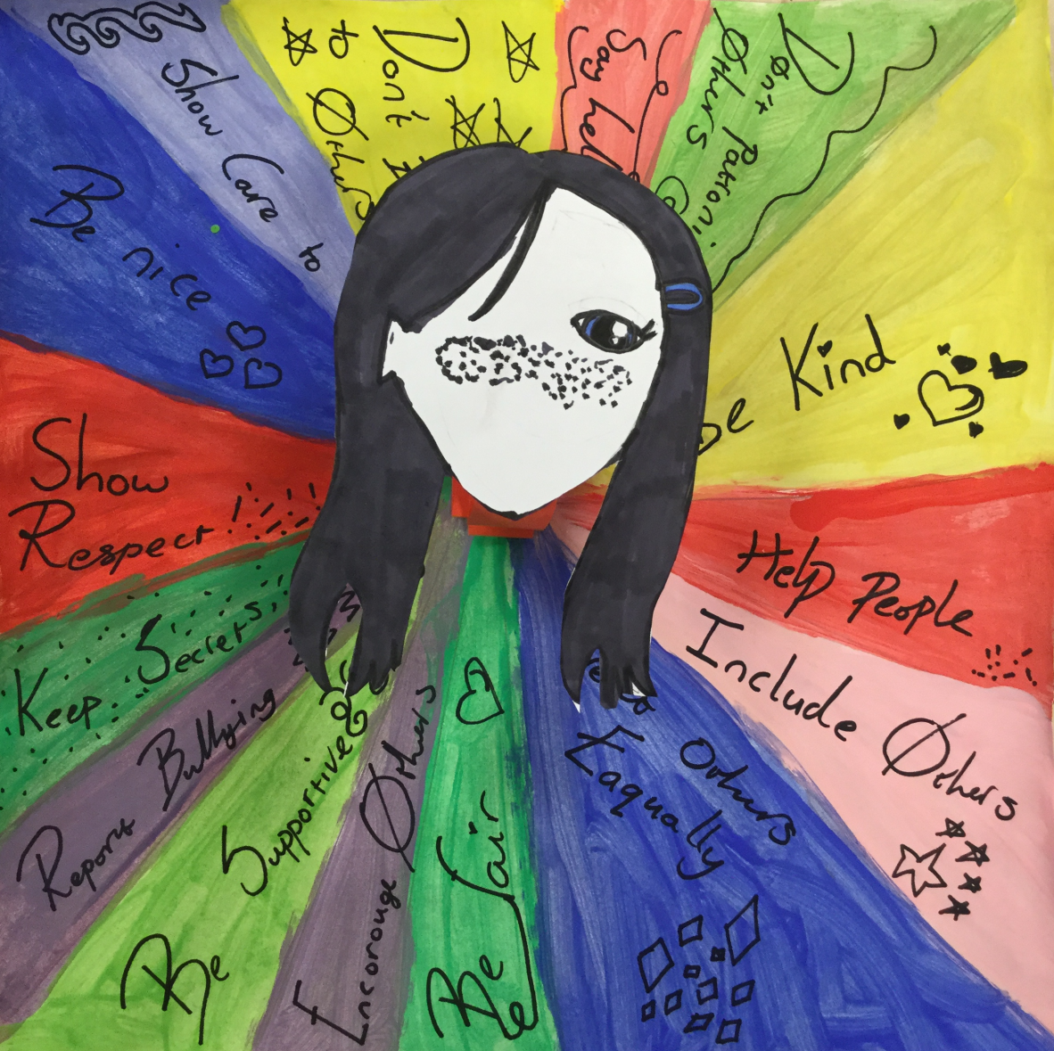
Pupil dialogue

I can identify actions that I can take to promote kindness
I can comment on the impact of my actions
I can distinguish direct and indirect characterisation

Teacher: What have you learned when studying the characters?

Learner: I’ve learned about characterisation and the different types.

Teacher: What are the different types?

Learner: Direct is just when the writer tells you something, like they’re shy or helpful or something else like that. The indirect is when they show you by giving you things like clues in the writing. I can use STEAL to think about how a character is.

Teacher: What skills have you developed?

Learner: I think I can find out more about characters now. Like Julian. I was just looking at his actions and then when I saw what other people had found in the text I saw how he felt as well. So you can find more information about them… and I can use that in my writing to make my own characters. I didn’t describe Via in my writing but her thoughts and actions make it sound like her.

Teacher: What actions have you taken to promote kindness?

Learner: I’ve been more considerate like letting __ in front of me when she was in a hurry and letting people use my school supplies. I have shared with ___ and let __ have my seat. I have been letting people know when they have done something that is good.

Teacher: What do you think the impact of this will be?

Learner: I think it has made people happier and flattered and good about themselves. They will feel comforted and cheer their day up and make my relationships with other people stronger. People won’t feel like they’re alone and I think it will make them feel excited and interested about what I’m doing.

