
East Renfrewshire Council: Education Department
Practitioner Moderation Template

Prior to the moderation exercise, please complete the following information and submit it to your facilitator with assessment evidence from one learner that you judge to have successfully attained the Es and Os.

School Code | D
Practitioner Code | D4
Curriculum Area(s) | Literacy(reading), Art and Design
Level | Early
Stage(s) | Pre-school
Specific subject (if applicable)

Experiences and Outcomes:

I enjoy exploring events and characters in stories and other texts, sharing my thoughts in different ways. LIT 0-19a (reading)

Inspired by a range of stimuli, I can express and communicate my ideas, thoughts and feelings through activities within art and design. EXA 0-05a

Learning Intentions:

To explore what happens and who the characters are in stories.

To share my thoughts about a story through art and design.

Success Criteria:

I can take part in story-telling.
I can identify the main idea in a story.
I can identify characters in a story.
I can create a piece of art to share my thoughts about a story.

Briefly outline the context and range of quality learning experiences that have been provided, making reference to the chosen design principles.
The subject within this learning context is male aged 3years, Child L is in his ante pre year at nursery, he started his placement in August.
The children took an interest in the story box that they chose from with their parents for books to take home. This sparked the discussion on what books they liked to read.
Within child L’s group the key person had a discussion with the children on the books they read at home and what stories they would like to read at the end of the nursery day. The key person brought a selection of books from different authors for the children to look through and discuss what stories they would be interested in learning about. Through this discussion the children within the group had chosen Hairy Maclary from Donaldson Dairy. (Breadth)

Child L took an interest in the Hairy Maclary stories that had been put out in the story area and brought the book to the adult to read it to him. The adult then read the story to child L. Once the story had finished Child L revisited the story and started to talk about what happens within the story, the setting and the characters.
(challenge and application)

Child L then wanted to draw a picture of his story and discussed what he had drawn in relation to the story. He then transferred his interest in to watching the story in animation through using the internet, that he had used within a different learning content.

(Breadth and application)

Record the range of assessment evidence that was gathered to meet the success criteria (Say, Write, Make, Do) considering breadth, challenge and application.

Say: Child L Discussion with adults and peers about the story he wanted to listen to at the end of the day. Child L was able to share his thoughts about the story and discuss the characters within the book.

Write: Child L was able to write his name on his picture using symbols to represent letters in his name. Child L was also able to draw a picture of what his interests were within the story.

Make: Child L wanted to draw a picture of his favourite character within the book to put in his special book to share with his family.

Do: Child L is interested in a book and asked his key person to read Hairy Maclary.
Child L shared his thoughts and interests about the book.
Child L drew a picture of his favourite character.
Child L then transferred his interest in to technology to use the internet to find the story in a different context.

Briefly outline the oral/written feedback given to the pupil on progress and next steps, referring to the learning intention and success criteria.

Within this activity child L initiated his own learning and was allowed to investigate his interests and thoughts at his own pace.
When speaking to child L we listened to his opinions and discussed his thoughts on the characters and what may happen next within the story.
Supporting child L when drawing his picture we discussed what the character was doing and happening to him within child L picture. Child L wrote his own name and was able to identify certain letters within the story.

Child L wanted to transfer his learning through technology through using the internet to find the story in a different format.

Next Steps:
Encouraging Child A to transfer his writing skills into other areas of the curriculum introducing letters sound/names when writing a word. Introducing new authors and their stories within the nursery and using the Hannen principles to develop an understanding of the setting, characters, word direction, expanding vocabulary and what they think may happen next. We can also transfer these skills into writing his own story then either using drama or small world to dramatise his story.

Pupil Voice:
What have you learned? How did you learn? What skills have you developed?

The children in Child A group chose Hairy Maclary stories to read at the end of a nursery day. The children within the group have taken an interested in the adventure Hairy gets up to, so much so that we are reading our way through the collection of the series.

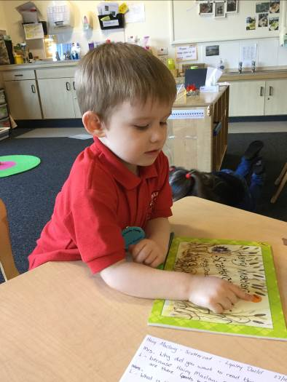
Adult: Child A why do you want read this story?
L: Because Hairy Maclary and Slinky Malinki are there.
What is the orange thing?
(Child A points to the front cover)
Adult: Do you think the setting on the front cover is of the
day or the night time?”
L:”It’s night time”.
A: “What colour is the sky at night?”
L: “It’s black”.
A: “Is the sky on the front cover black?”
L: That’s not black it’s orange”.
A: You are correct. If the sky is black at night, can you tell
me what colour is the sky during the day?”
C: Blue! That is the sun and its day time on the cover”.
A “Well done L you are right it is the day time on the front
cover of our story”.

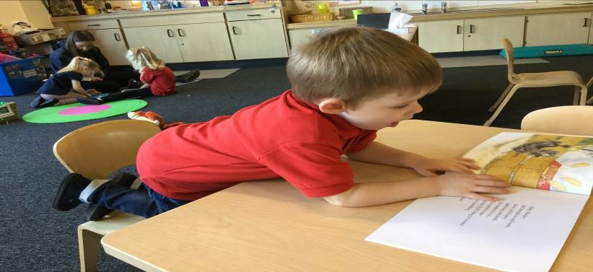
Adult and Child reads the story together. Once the story has finished we return to the start of the book and discuss the book together.
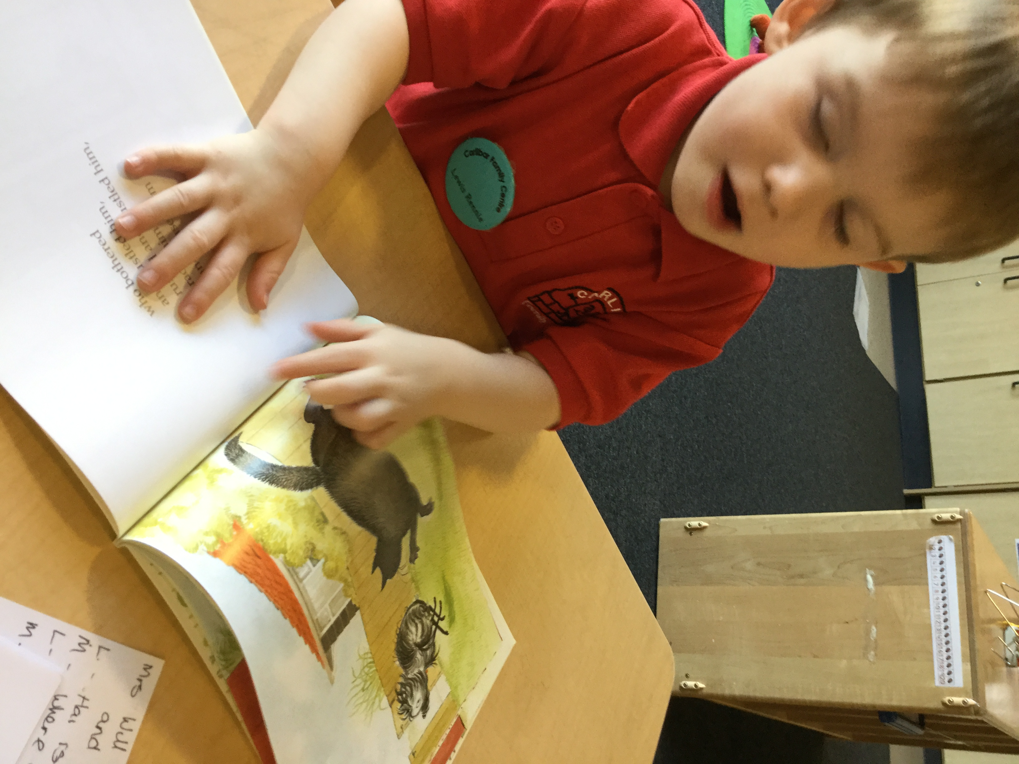
Adult: “Will we have a look through the book and we can talk
about the story?”
L: “Hairy is running away”.
A: “Why do you think he is running away?”
L: “To home, but he has had an adventure”.
A: “Can you tell me what happens to hairy on his adventure?”
L: Hairy is hiding in the bushes and then he jumps out at the cat,
That is chasing bees home”.
A: “Why is hairy hiding in the bushes?”
L: “He is hiding in the bushes to scare the cat”
Child is looking at the book quite intently and points to the words and states
L “that is the letter B, C, D, E is the letters”.
A: “Well done L you are right they are the letters B, C, D, and E”.
Child turns the page.
L:”Hairy he is licking his paw”.
A:”Why do you think he is licking his paw?”
L: “Because he is dirty”.
Child turns the page.

L: Hairy is chasing all the cats away and they all run away and hide. The end!”
A: Does anything else happen in the story?”
L “Scare face Claw the toughest tom in town is in the story.
he chases hairy all the way home”.
A: “Look at Hairy’s face how do you think he feels when
Scarface Claw chases him home?”
L: He was frightened of Scarface Claw, Because he is the big bad baddy cat”.
A: Why so you think Hairy is scared of him?”
L:”All the cats and dogs are scared of him because he is the toughest tom in town”.

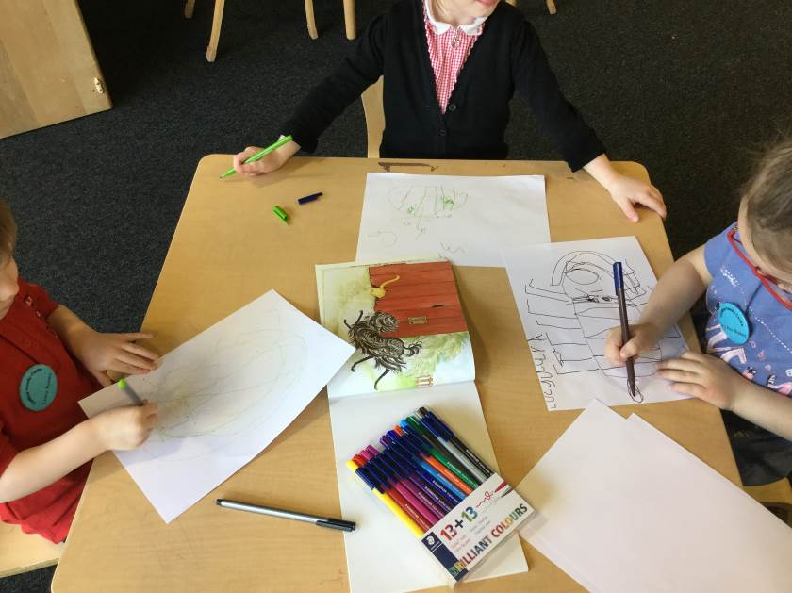
A: “Who is your favourite character in the story?”
L: “Scarface Claw”.
A: Why is Scarface Claw your favourite character in the story?”
L: “Because he is a bit naughty?”
A: Why do you think he is naughty?”
L: “He opens his mouth and shouts at the dogs to make them run away”.

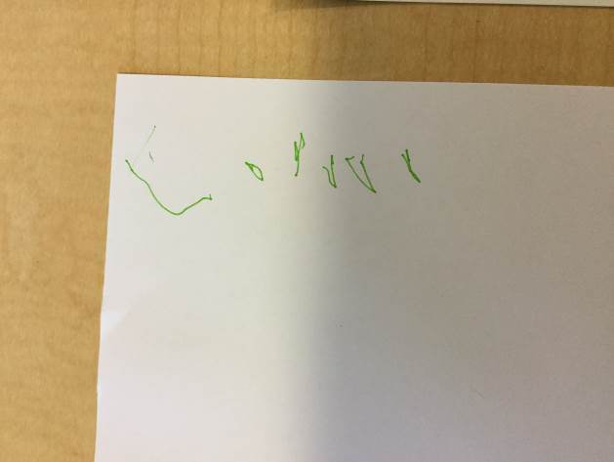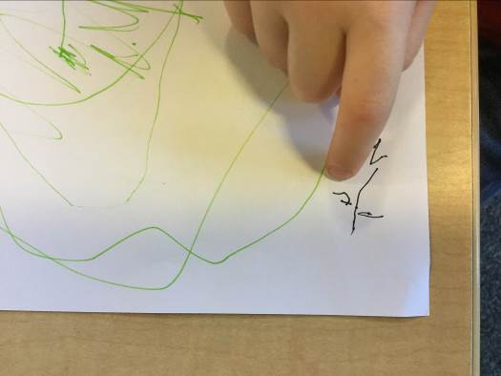

L: This is my name I have written, so I know it’s my picture”.
L: “This is hairy Maclary, he is small because he is running away from Scarface claw, He gave him a fright”.
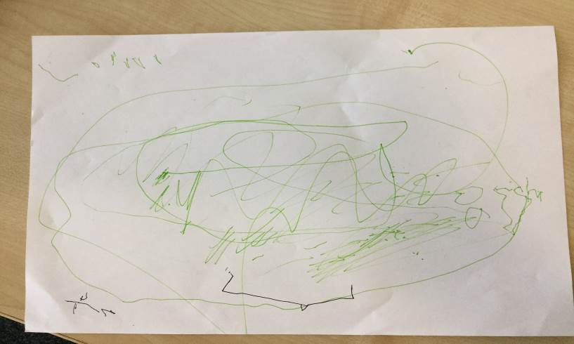
This is child’s L drawing for Hairy Maclary.

L: “This is hairy and he is being chased by Scarface claw all the way home and back to bed”.
Child L: “Can we watch hairy on the computer?”

A: “Let’s go and we will try and find the story”.

Child L and the adult went to the computer and looked up the internet and found and an animated story of the story that had just been read and discussed.

A: “Was the animation the same story as the book we have just read?”

L: “Yes, Hairy got up to mischief he was scaring all the cats, then Scarface Claw gave him a fright and he ran all the way home to his bed”.

A: “Did you enjoy the story?”
L: “Yes”.
A “Would you like to read other stories and find out what adventures hairy get up to”.

L:”Yes, I have read Hairy Maclary’s books but not all of them”.

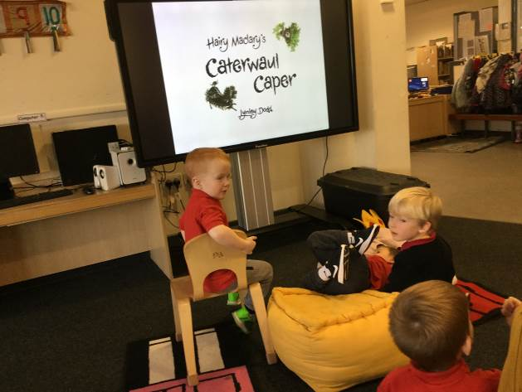
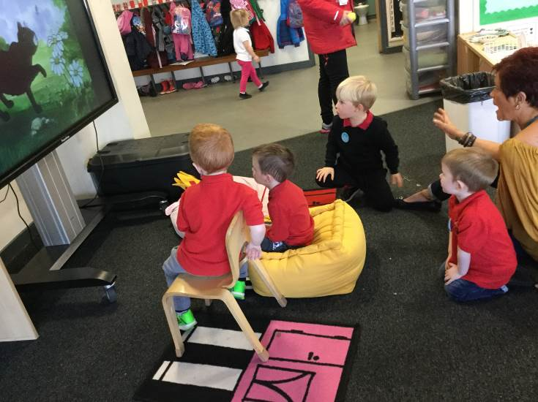

Did the learner successfully attain the outcomes? YES

