Common Language and Methodology for Teaching Numeracy and Mathematics
Mearns Castle Cluster

Contents Page

Introduction 1

Early Level 2

First Level 6

Second Level 15

Third Level 25

Appendix 1: Algebra 36

- Overview
- Algebra: Patterns and Relationships
- Algebra: Expressions and Equations
- Early Level
- First Level
- Second Level
- Third Level
- Fourth Level

Appendix 2: Information Handling 51

Introduction

This document makes clear the correct use of language and agreed methodology for delivering Curriculum for Excellence Numeracy and Mathematics experiences and outcomes within the Mearns Castle Cluster. The aim is to ensure continuity and progression for pupils which will impact on attainment. It should be noted that formative assessment, problem solving and interactive mental maths are also integral to the delivery of the common language and methodology.

It is expected that teachers will ensure that pupils understand the necessity for setting out clear working. This is particularly important for National Qualification Examinations where marks are given for communication and working. Pupils who simply record the answer do not score any marks.

Mearns Castle Cluster Numeracy Sub Group (April 2013)

Early Level

Estimating and rounding
I am developing a sense of size and amount by observing, exploring, using and communicating with others about things in the world around me.
MNU 0-01a

Correct Use of Language

Pupils should be familiar with:
tall; short; long; thick; thin; heavy; light.

Comparative terms e.g. shorter, longer.
Superlative terms e.g. shortest, tallest.

Number and number processes
I have explored numbers, understanding that they represent quantities, and I can use them to count, create sequences and describe order.
MNU 0-02a

Term/Definition  0  Example  0, 1, 2, 3,…  Correct Use of Language  Say zero, one, two, three.  DO NOT USE “nothing” to refer to the digit.  Use “nothing” when using practical examples and concrete materials e.g. 2 cups take away 2 cups leaves nothing. | Methodology  Make the link clear between “nothing” and zero.

Number and number processes
Use practical materials and can ‘count on and back’ to help me to understand addition and subtraction, recording my ideas and solutions in different ways.

MNU 0-03a

Term/Definition  Add   Subtract   Example  2 + 3 = 5  3 + 2 = 5  5 − 2 = 3  5 − 3 = 2  Correct Use of Language  Pupils should be familiar with the various words for operations:  Add – Total, find the sum of, plus,  Subtract – Take away moving towards subtract, minus, difference between  A wall display should be built up  Use “maths” instead of “sums”, as sum refers to addition. Use “show your working” or “written calculation” rather than “write out the sum”.  Try to use the word “calculate”.  Avoid the use of “and” when meaning addition. (e.g. NOT “2 and 3”)  Move from “makes five” towards “equals” when concrete material is no longer necessary. | Methodology  When one addition fact is known, it is important to elicit the other three facts in terms of addition and subtraction.  This is the start of thinking about equations, as 4 + 5 = 9 is a statement of equality between 2 expressions.  Please refer to Algebra Appendix

Fractions, decimal fractions and percentages
I can share out a group of items by making smaller groups and can split a whole object into smaller parts.
MNU 0-07a

Term/Definition  a cake  Correct Use of Language  Teachers should talk about 1 whole item divided into 2 equal parts e.g. One whole cake divided into 2 equal parts.  Use the following terms: share and divide.  Be careful when using a half or one half. Say one half or say I have a half of…. | Methodology  Lots of practical working cutting things in half, drawing lines to divide things in two.  Set fractions out properly. Use rather than ½ or 1/2.

Money
I am developing my awareness of how money is used and can recognise and use a range of coins.
MNU 0-09a
Term/Definition  1p  Correct Use of Language  Say one pence or one p.  With coins refer to a fifty pence piece. | Methodology  Highlight that 5p = 5 pence etc…  Pupils should be aware that one coin can have different values. Show me…5p, 10p. Give children different coins and then ask them to make different amounts

Time
I am aware of how routines and events in my world link with times and seasons, and have explored ways to record and display these using clocks, calendars and other methods
MNU 0-10a

Correct Use of Language

Pupils should be familiar with:

day; night; morning; afternoon; before; after; o’clock; analogue; digital.

Data and analysis
I can collect objects and ask questions to gather information, organising and displaying my findings in different ways.
MNU 0-20a

I can match objects, and sort using my own and others’ criteria, sharing my ideas with others.
MNU 0-20b

I can use the signs and charts around me for information, helping me plan and make choices and decisions in my daily life.
MNU 0-20c

Term/Definition  Pictogram: graph using pictures to represent quantity.  Bar chart: A way of displaying data if the data is discrete or non-numerical. There should be a gap between the bars.  Histogram: A way of displaying grouped data. No gaps between the bars.  Example  Pictogram: The colour of pupils’ eyes in a class.  Bar chart: Pupils favourite flavour of crisps.  Histogram: Number of press-ups pupils can manage in one minute.  Correct Use of Language  Pictogram: Say pictogram or pictograph.  Bar chart: Use bar graph or bar chart not block graph. | Methodology  When using tally marks, each piece of data should be recorded separately in order. Tallying should be done before finding a total.  Please refer to Information Handling Appendix

Measurement
I have experimented with everyday items as units of measure to investigate and compare sizes and amounts in my environment, sharing my findings with others.
MNU 0-11a

First Level

Number and number processes
I can use addition, subtraction, multiplication and division when solving problems, making best use of the mental strategies and written skills I have developed.
MNU 1-03a

Example  5  4  +7  6  7  +4  Correct Use of Language  Say 5 add 4 add 7.  Say 6 add 7 add 4 or 6 add 4 add 7 (using patterns). | Methodology  Always start addition at the top and work downwards as a basic teaching method, moving towards looking for patterns e.g. bonds to ten.  Always start subtraction at the top and work downwards.  9  - 4  Say 9 subtract 4 not, 4 from 9.

Number and number processes
When a picture or symbol is used to replace a number in a number statement, I can find its value using my knowledge of number facts and explain my thinking to others.
MTH 1-15b

Example  2+ =7  2 6=8  6 =3+  2+ = 6  (Pupils should be introduced to a variety of layouts.)  Correct Use of Language  Start to introduce the term algebra when symbols are used for unknown numbers or operators.  Do not use the word, “box” or “square” when solving these equations.  Say:  Two and what makes seven?  What sign makes sense here/completes the equation?  Say:  Two plus what makes six?  What add two makes six?  Six take away two gives what? | Methodology  Please refer to Algebra Appendix  Pupils should be encouraged to think of these in a variety of ways, so that they are adopting a strategy to solve the equation.

Number and number processes
I have investigated how whole numbers are constructed, can understand the importance of zero within the system and can use my knowledge to explain the link between a digit, its place and its value.

MNU 1-02a

Term/Definition

100

Correct Use of Language

Say, “one hundred”, rather than, “a hundred.”

Distinguish between digits and numbers.

Measurement
I can estimate how long or heavy an object is, or what amount it holds, using everyday things as a guide, then measure or weigh it using appropriate instruments and units
MNU 1-11a

Term/Definition

4m

3cm

Correct Use of Language

Use m for metres when writing.
Say four metres.
Use cm for centimetre when writing. Say three centimetres.

Money
I can use money to pay for items and can work out how much change I should receive.
MNU 1-09a
I have investigated how different combinations of coins and notes can be used to pay for goods or be given in change.
MNU 1-09b

Example  £1⋅00  Write £1⋅00 or £1.  (Ensure decimal point is placed at middle height.)  Correct Use of Language  Say one pound not a pound. | Methodology  Explain that there are 100 pennies in £1.  Explain that the written form in pounds is £1⋅80 without the p.  When writing money, only one sign is used, either £ or p.

Measurement
I can estimate how long or heavy an object is, or what amount it holds, using everyday things as a guide, then measure or weigh it using appropriate instruments and guides
MNU 1-11a

Term/Definition

3kg

Correct Use of Language

Abbreviation of kg or g.
Say three kilograms.

Measurement
I can estimate how long or heavy an object is, or what amount it holds, using everyday things as a guide, then measure or weigh it using appropriate instruments and units
MNU 1-11a

Example

3l
700ml

Correct Use of Language

Abbreviation of l for litre.
Say 3 litres.
Abbreviation of ml for millilitres.
Say seven hundred millilitres.

Time
I can tell the time using 12 hour clocks, realising there is a link with 24 hour notation, explain how it impacts on my daily routine and ensure that I am organised and ready for events throughout my day.
MNU 1-10a

Example

3:30pm

Correct Use of Language

Be aware and teach the various ways we speak of time.
Analogue – half past three.
Digital - three thirty.

Number and number processes
I can use addition, subtraction, multiplication and division when solving problems, making best use of the mental strategies and written skills I have developed.
MNU 1-03a

Example  5 6  + 3₁ 9  9 5  ⁴5 ¹6  - 3 9  1 5  Correct Use of Language  Carry  Exchange | Methodology  When “carrying”, lay out the algorithm as in the example.  Put the addition or subtraction sign to the left of the calculation.  Always start subtraction at the top and work downwards. Say 6 take away 9. Can’t do. Exchange one ten for ten units and add to the units.  Do not say score out.

Data and analysis
I have explored a variety of ways in which data is presented and can ask and answer questions about the information it contains.
MNU 1-20a
I have used a range of ways to collect information and can sort it in a logical, organised and imaginative way using my own and others’ criteria
MNU 1-20b

Term/Definition  Bar chart: A way of displaying data if the data is discrete or non-numerical. There should be a gap between the bars.  Histogram: A way of displaying grouped data. No gaps between the bars.  Example  Bar chart: A bar chart showing pupils favourite flavour  of crisps.  Histogram: A histogram showing the number of press-ups pupils can manage in one minute.  Correct Use of Language  Use bar graph or bar chart not block graph.  Do not confuse bar charts with a histogram. | Methodology  When using tally marks, each piece of data should be recorded separately in order.  Tallying should be done before finding a total.  Please refer to Information Handling Appendix

Estimation and rounding
I can share ideas with others to develop ways of estimating the answer to a calculation or problem, work out the actual answer, then check my solution by comparing it with the estimate.
MNU 1-01a
Number and number processes
I have investigated how whole numbers are constructed, can understand the importance of zero within the system and can use my knowledge to explain the link between a digit, its place and its value.
MNU 1-02a
I can use addition, subtraction, multiplication and division when solving problems, making best use of the mental strategies and written skills I have developed.
MNU 1-03a

Correct Use of Language

Use the terms round to and nearest to.

Number and number processes
I can use addition, subtraction, multiplication and division when solving problems, making best use of the mental strategies and written skills I have developed.
MNU 1-03a

Fractions, decimal fractions and percentages
Through exploring how groups of items can be shared equally, I can find a fraction of an amount by applying my knowledge of division.
MNU 1-07b

Term/Definition  Multiply  Divide  Example  2 × 5 = 10  10 ÷ 2 = 5  of 10 = 5  2 6  ×₂ 4  1 0 4  Correct Use of Language  Pupils should be familiar with various words for multiply and then later for divide.  Multiply – Multiplied by, product, times.  Divide – Divided by, quotient, shared equally, division, how many left? How many remaining?  Stress multiplied by rather than times. Use multiplication tables rather than times tables.  Do not use times by or timesing. | Methodology  When teaching multiplication tables the link to division and to fractions should also be stressed.  For multiplication tables the table number comes first. E.g.  3 × 1 = 3  3 × 2 = 6  3 × 3 = 9  Say three ones are three.  Say:  This is 72 divided by 4.  What would you expect the answer to be?  Start by saying, 7 divided by 4. Support if necessary by asking how many fours are there in seven? Never say 4 into 7. Never say goes into.
   | 1 8 | r1
  4 | 7 ³3
   | 0 7
  4 | 2 8

Fractions, decimal fractions and percentages
Having explored fractions by taking part in practical activities, I can show my understanding of:

- how a single item can be shared equally
- the notation and vocabulary associated with fractions
- where simple fractions lie on the number line.
MNU 1-07a

Through taking part in practical activities including use of pictorial representations, I can demonstrate my understanding of simple fractions which are equivalent.
MTH 1-07c

Term/Definition  Numerator: number above the line in a fraction.  Showing the number of parts of the whole.  Denominator: number below the line in a fraction.  The number of parts the whole is divided into.  Example  Correct Use of Language  Emphasise that it is “one divided by four.” | Methodology  Emphasise the connection between finding the fraction of a number and its link to division (and multiplication).  Ensure that the equivalence of and is highlighted. Use concrete examples to illustrate this. Show is smaller than . Pupils need to understand equivalence before introducing other fractions such as or .

Number and number processes
I can use addition, subtraction, multiplication and division when solving problems, making best use of the mental strategies and written skills I have developed.
MNU 1-03a

Example  2 6  ×_₂ 4  1 0 4 | Methodology  When multiplying by one digit, lay out the algorithm as in the example.  The “carry” digit always sits above the line.

Measurement
I can estimate the area of a shape by counting squares or other methods.
MNU 1-11b

Example

3cm²

Correct Use of Language

Say 3 square centimetres, not 3 centimetres squared or 3 cm two.

Second Level

Number and number processes
I have extended the range of whole numbers I can work with and having explored how decimal fractions are constructed, can explain the link between a digit, its place and its value.
MNU 2-02a
Example  2⋅05  2⋅36  0⋅5  2⋅45 - decimal fraction  - common fraction  Correct Use of Language  Say:  two point zero five, not two point nothing five.  two point three six not two point thirty-six.  zero point five not point five.  Talk about decimal fractions and common fractions. | Methodology  Ensure the decimal point is placed at  middle height.

Number and number processes
Having determined which calculations are needed, I can solve problems involving whole numbers using a range of methods, sharing my approaches and solutions with others.

MNU 2-03a
I have explored the contexts in which problems involving decimal fractions occur and can solve related problems using a variety of methods.

MNU 2-03b

Having explored the need for rules for the order of operations in number calculations, I can apply them correctly when solving simple problems.

MTH 2-03c

Example:  5 6  + 3₁ 9  9 5  2 6  ×₂ 4  10 4  4 7  × 5₄ 6  2 8 2  3  2 3₁ 5 0  2 6 3 2  Correct Use of Language  For multiplying by 10, promote the digits up a column and add a zero for place holder.  For dividing by 10, demote the digits down a column and add a zero in the units’ column for place holder if necessary. | Methodology  When “carrying”, lay out the algorithm as in the example.  Put the addition or subtraction sign to the left of the calculation.  When multiplying by one digit, lay out the algorithm as in the example.  The “carry” digit always sits above the line.  Decimal point stays fixed and the numbers move when multiplying and dividing.  Do not say, “add on a zero”, when multiplying by 10. This can result in 3⋅6× 10=3⋅60.

Number and number processes
I can show my understanding of how the number line extends to include numbers less than zero and have investigated how these numbers occur and are used.

MNU 2-04a

Term/Definition

Negative numbers

Example

−4

0ºC

Correct Use of Language

Say negative four not, minus four.
Pupils should be aware of this as a common mistake, even in the media e.g. the weather.

Use minus as an operation for subtract.

Twenty degrees Celsius, not centigrade
Explain that it should be negative four, not minus four.

Fractions, decimal fractions and percentages
I have investigated the everyday contexts in which simple fractions, percentages or decimal fractions are used and can carry out the necessary calculations to solve related problems.
MNU 2-07a
I can show the equivalent forms of simple fractions, decimal fractions and percentages and can choose my preferred form when solving a problem, explaining my choice of method.
MNU 2-07b
I have investigated how a set of equivalent fractions can be created, understanding the meaning of simplest form, and can apply my knowledge to compare and order the most commonly used fractions.
MTH 2-07c
Term/Definition  Numerator: number above the line in a fraction.  Showing the number of parts of the whole.  Denominator: number below the line in a fraction.  The number of parts the whole is divided into.  Example  2⋅45 decimal fraction  common fraction  Start with 4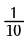is written 4⋅1  7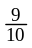is written 7⋅9 etc.  Then 3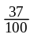is written 3⋅37 etc.  Finally 6 is the same as 6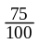which is 6⋅75  Correct Use of Language  - Emphasise that it is one divided by four.  £5⋅80 – Say five pounds eighty to match the written form. DON’T WRITE OR SAY £5⋅80p.  Say:  two point zero five, not two point nothing five. (2⋅05)  two point three six, not two point thirty-six.(2.36)  zero point five not, point five. (0.5)  Pupils should be aware of the phrases state in lowest terms or reduce.  Talk about decimal fractions and common fractions to help pupils make the connection between the two. | Methodology  Emphasise the connection between finding the fraction of a number and its link to division (and multiplication).  Ensure that the equivalence of and is highlighted. Use concrete examples to illustrate this. Show is smaller than . Pupils need to understand equivalence before introducing other fractions such as or .  Accept all common language in use:  Five pounds eighty ,  Five pounds eighty pence,  Five eighty.  Ensure the decimal point is placed at middle height.  To find of a number, find one quarter first and then multiply by 3.  Simplifying fractions – Say, “What is the highest number that you can divide the numerator and denominator by?” Check by asking, “Can you simplify again?”  Finding equivalent fractions, particularly tenths and hundredths.  Teach fractions first then introduce the relationship with decimals (tenths, hundredths emphasise connection to tens, units etc) then other common fractions e.g. = 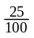 = 0⋅25.  Need to keep emphasising equivalent fractions.  Starting with fractions, then teach the relationship with percentages, finally link percentages to decimals.  60% = 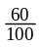 = 0⋅6  Pupils need to be secure at finding common percentages of a quantity, by linking the percentage to fractions.  e.g. 1%, 10%, 20%, 25%, 50%, 75% and 100%.

Time
I can use and interpret electronic and paper-based timetables and schedules to plan events and activities, and make time calculations as part of my planning.

MTH 2-10a

Term/Definition  a.m. - ante meridian  p.m. - post meridian  24 hour time  Speed  Example  Calculating duration.  8:35am→4:20pm  8:35am→9:00am = 25mins  (9:00am→12:00noon = 3h)  12:00noon→4:00pm = 4h  4:00pm→4:20pm = 20mins  7hours 45minutes  Correct Use of Language  Be aware and teach the various ways we speak of time.  3:30pm  Analogue – half past three in the afternoon.  Digital - three thirty pm.  Pupils should be familiar with :  noon; midday; midnight; afternoon; evening; morning; night and the different conventions for recording the date.  Say  zero two hundred hours. (Children should be aware of different displays, e.g. 02:00, 02 00 and 0200)  eight kilometres per hour. 8km/h  sixteen metres per second. 16m/s | Methodology  When calculating the duration pupils should clearly set out steps  .

Measurement
I can use my knowledge of the sizes of familiar objects or places to assist me when making an estimate of measure.
MNU 2-11a
I can use the common units of measure, convert between related units of the metric system and carry out calculations when solving problems
MNU 2-11b

I can explain how different methods can be used to find the perimeter and area of a simple 2D shape or volume of a simple 3D object.
MNU 2-11c

Example  A1 = lb  = 12 × 4  = 48cm²  A2 = lb  = 5 × 4  = 20cm²  Total Area = A1 + A2  = 48 + 20  = 68cm²  1cm³=1ml  1000cm³ = 1000ml  = 1litre  Correct Use of Language  3cm²  Say 3 square centimetres not 3 centimetres squared or 3 cm two.  Abbreviation of l for litre.  Say 3 litres. (3l)  Abbreviation of ml for millilitres.  Say seven hundred millilitres. (700ml)  2.30m  5⋅43m  6⋅124kg  Pupils should understand how to write measurements (in m, cm, kg, g), how to say them and what they mean e.g. 5 metres 43cm.  Six kilograms and 124 grams, say six point one two four kilograms.  Emphasise that perimeter is the distance around the outside of the shape. | Methodology  To find the area of compound shapes:  - Split the shape into rectangles  - Label them as shown  - Fill in any missing lengths  12m  4m  A1  9m  A2  4m

A = l × b  Start with this and move to A = lb when appropriate.  6cm  10cm  DO NOT USE A = l × b or A = lb as this leads to confusion later on with the base and height of a triangle.  80 cm³ | Complete the surrounding rectangle if necessary.  Area of rectangle = 10 × 6  = 60cm²  Area of Triangle = the Area of rectangle  = of 60  = 30cm²  Say 80 cubic centimetres NOT 80 centimetres cubed.  Use litres or millilitres for volume with liquids.  Use cm³ or m³ for capacity.

Patterns and relationships
Having explored more complex number sequences, including well-known named number patterns, I can explain the rule used to generate the sequence, and apply it to extend the pattern.
MTH 2-13a

Term/Definition  Prime numbers: numbers with only 2 factors, one and themselves.  One is not defined as a prime number.  2, 3, 5, 7, 11, 13, 17, 19, …  Square numbers  1, 4, 9, 16, 25, … Should be learned.  Triangular numbers  1, 3, 6, 10, 15… Should be learned.  Example  6, 12, 20, 30, …  Correct Use of Language  Pupils also have to be able to continue the sequence when the steps are not constant, but not give a rule. | Methodology  See Algebra Appendix

Expressions and equations
I can apply my knowledge of number facts to solve problems where an unknown value is represented by a symbol or letter.
MTH 2-15a

Example  Pupils should be introduced to single function machines and then double function machines.  3→21  8→56  10→70  Correct Use of Language  Use “in” and “out” to raise awareness of “input” and “output.”  Pupils should use the following terminology:  Input; output; reverse; do the opposite; work backwards; inverse; undo etc.  Outputs larger than the input, so the options are addition or multiplication  Similarly if the outputs are smaller it implies subtraction or division. | Methodology  Establish the operations that are an option.  See Algebra Appendix

Properties of 2D and 3D shapes
Having explored a range of 3D objects and 2D shapes, I can use mathematical language to describe their properties, and through investigation can discuss where and why particular shapes are used in the environment.
MTH 2-16a

Through practical activities, I can show my understanding of the relationship between 3D objects and their nets.
MTH 2-16b

I can draw 2D shapes and make representations of 3D objects using an appropriate range of methods and efficient use of resources.
MTH 2-16c

Term/Definition

Congruent: Two shapes are congruent if all the sides are the same length and all the angles are the same i.e. the shapes are identical.

Example

The faces on a cube are congruent.

Correct Use of Language

Pupils should be familiar with the word congruent.

Angle, symmetry and transformation
Through practical activities which include the use of technology, I have developed my understanding of the link between compass points and angles and can describe, follow and record directions, routes and journeys using appropriate vocabulary.
MTH 2-17c

Term/Definition  060º | Methodology  Say zero six zero degrees.

I can display data in a clear way using a suitable scale, by choosing appropriately from an extended range of tables, charts, diagrams and graphs, making effective use of technology.
MTH 2-21a / MTH 3-21a

Term/Definition  Histogram: no spaces between the bars, unlike a bar graph. (Used to display grouped data.)  Continuous Data: can have an infinite number of possible values within a selected range. (Temperature, height or length)  Discrete Data: can only have a finite or limited number of possible values. (Shoe size, number of siblings)  Non-numerical data: data which is non-numerical (Favourite flavour of crisps)  Use a bar graph, pictogram or pie chart to display discrete data or non-numerical data. | Methodology  See Information Handling Appendix

Third Level

Estimation and Rounding

I can round a number using an appropriate degree of accuracy, having taken into account the context of the problem.
MNU 3-01a

Example  Round to 3 significant figures: 65364  6 5 3 6 4  so the answer is 65400 | Methodology  When rounding to a specified number of significant figures, draw a line after the number of significant figures that you need. If the digit to the right of the line is 5 or more round the digit to the left of the line up. If it is 4 or less the digit to the left stays the same.

Number and Number Processes

I can use a variety of methods to solve number problems in familiar contexts, clearly communicating my processes and solutions.
MNU 3-03a

I can continue to recall number facts quickly and use them accurately when making calculations.
MNU 3-03b

Example  4 7  × 5₄ 6  2 8 2  3  2 3₁ 5 0  2 6 3 2  Correct Use of Language  For multiplying by 10, promote the digits up a column and add a zero for place holder.  For dividing by 10, demote the digits down a column and add a zero in the units’ column for place holder if necessary. | Methodology  Decimal point stays fixed and the numbers move when multiplying and dividing.  DO NOT say add on a zero, when multiplying by 10. This can result in 3⋅6×10=3⋅60.

Number and Number Processes

I can use my understanding of numbers less than zero to solve simple problems in context.
MNU 3-04a

Term/Definition

Negative numbers

Integer: all the positive whole numbers, negative whole numbers and zero
(…−3, −2, −1, 0, 1, 2, 3, …)

Correct Use of Language

Say negative four NOT minus four.
Use minus as an operation for subtract.
(For 4 – (-4) = 8 say four minus negative four equals eight)

Pupils should be aware of this as a common mistake, even in the media e.g. the weather.

-0ºC - Negative twenty degrees Celsius, NOT minus or centigrade.

Multiples, Factors and Primes

I have investigated strategies for identifying common multiples and common factors, explaining my ideas to others, and can apply my understanding to solve related problems.
MTH 3-05a

I can apply my understanding of factors to investigate and identify when a number is prime.
MTH 3-05b

Term/Definition

Prime numbers: numbers with exactly 2 factors.
One is not defined as a prime number.
2, 3, 5, 7, 11, 13, 17, 19, …

Factor: a factor divides exactly into a number leaving no remainder.

Example

Factors of 4 are 1, 2 and 4.

Powers and Roots

Having explored the notation and vocabulary associated with whole number powers and the advantages of writing numbers in this form, I can evaluate powers of whole numbers mentally or using technology.
MTH 3-06a

Term/Definition

Index: shows the number of times a number is multiplied by itself.

Example

2³

Correct Use of Language

3 is the index.

Fractions, Decimal Fractions and Percentages

I can solve problems by carrying out calculations with a wide range of fractions, decimal fractions and percentages, using my answers to make comparisons and informed choices for real-life situations.
MNU 3-07a

By applying my knowledge of equivalent fractions and common multiples, I can add and subtract commonly used fractions.
MTH 3-07b

Having used practical, pictorial and written methods to develop my understanding, I can convert between whole or mixed numbers and fractions.
MTH 3-07c

Fractions  Example  Start with 4is written 4⋅1  7is written 7⋅9 etc.  Then 3is written 3⋅37 etc.  Finally 6 is the same as 6which is 6⋅75  Correct Use of Language  Pupils should be aware of: “state in lowest terms” or “reduce”.  Talk about “decimal fractions” and “common fractions” to help pupils make the connection between the two.  Decimals  Term/Definition  Recurring decimals: a decimal which has a repeated digit or a repeating pattern of digits.  Example  Recurring decimals: 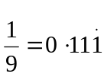  Correct Use of Language  Recurring decimals: and link to decimals. Record the number three times and place a “dot” above the final digit. | Methodology  Fractions  To find of a number, find one quarter first and then multiply by 3.  Simplifying fractions – Say what is the highest number that you can divide the numerator and denominator by? Check by asking, “Can you simplify again?”  Finding equivalent fractions, particularly tenths and hundredths.  Teach fractions first then introduce the relationship with decimals (tenths, hundredths emphasise connection to tens, units etc) then other common fractions e.g. = = 0⋅25.  Need to keep emphasising equivalent fractions.  Starting with fractions, then teach the relationship with percentages, finally link percentages to decimals.  60% = = 0⋅6

Percentages  Example  1%=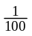, 10% = 25%=, 50%= 20% = , 75% = 33% =  30% of 80 = 24  Find 10% then multiply by 3.  15% of 60 = 9  Find 10% then half that to get 5%, then add.  Find 23% of £300  23 ÷ 100 × 300 = £69 | Percentages  Pupils need to be secure at finding common percentages of a quantity, by linking the percentage to fractions.  e.g. 1%, 10%, 20%, 25%, 50%, 75% and 100%.  Pupils should be able to find common percentages by converting to a fraction.  Pupils can then build other percentages from these. The aim here is to build up mental agility. The pupils should, in time, be able to select the most appropriate strategy.  Percentages without a calculator  For more complicated percentages use the following method:  34%of 410 = 139∙4 (working shown below)  10% of 410 = 41  30% of 410 = 123  1% of 410 = 4∙1  4% of 410 = 16∙4  Percentages with a calculator  Move towards:  0⋅23 × 300 = £69 as pupils become secure in converting percentages to decimals.

Time

Using simple time periods, I can work out how long a journey will take, the speed travelled at or distance covered, using my knowledge of the link between time, speed and distance.
MNU 3-10a

Term/Definition

Speed

Example

8km/h
4m/s

Correct Use of Language

Say eight kilometres per hour.
Say sixteen metres per second.

Measurement

I can solve practical problems by applying my knowledge of measure, choosing the appropriate units and degree of accuracy for the task and using a formula to calculate area or volume when required.
MNU 3-11a

Having investigated different routes to a solution, I can find the area of compound 2D shapes and the volume of compound 3D objects, applying my knowledge to solve practical problems.
MTH 3-11b

Term/Definition  1 hectare = 10000m²  100m by 100m  Example  A1 = lb  = 12 × 4  = 48cm²  A2 = lb  = 5 × 4  = 20cm²  Total Area = A1 + A2  = 48 + 20  = 68cm²  1cm³=1ml  1000cm³ = 1000ml  = 1litre  Correct Use of Language  3cm²  Say 3 square centimetres not 3 centimetres squared or 3 cm two.  Abbreviation of l for litre.  Say 3 litres. (3l)  Abbreviation of ml for millilitres.  Say seven hundred millilitres. (700ml)  2.30m  5⋅43m  6⋅124kg | Methodology  To find the area of compound shapes:  - Split the shape into rectangles  - Label them as shown  - Fill in any missing lengths  12m  4m  A1  9m  A2  4m

Pupils should understand how to write measurements (in m, cm, kg, g), how to say them and what they mean e.g. 5 metres 43cm.  Six kilograms and 124 grams, say six point one two four kilograms.  Emphasise that perimeter is the distance around the outside of the shape.  A = l × b  Start with this and move to A = lb when appropriate.  6cm  10cm  DO NOT USE A = l × b or A = lb as this leads to confusion later on with the base and height of a triangle.  80 cm³ | Complete the surrounding rectangle if necessary.  Area of rectangle = 10 × 6  = 60cm²  Area of Triangle = the Area of rectangle  = of 60  = 30cm²  Say 80 cubic centimetres NOT 80 centimetres cubed.  Use litres or millilitres for volume with liquids.  Use cm³ or m³ for capacity.

Patterns and Relationships

Having explored number sequences, I can establish the set of numbers generated by a given rule and determine a rule for a given sequence, expressing it using appropriate notation.
MTH 3-13a

Example  Find the n^{th} term for a sequence.  Complete the table and find the 20th term | Methodology  Pupils need to be able to deal with numbers set out in a table vertically, horizontally or given as a sequence.  A method should be used rather than trial and error.

Expressions and Equations

I can collect like algebraic terms, simplify expressions and evaluate using substitution.
MTH 3-14a

Term/Definition

Please refer to the Algebra Appendix

Example

3a+6+7a-5 Expression

2a+7=13 Equation

Correct Use of Language

Teachers should make it clear the difference between an algebraic expression that can be simplified and an equation (which involves an equals sign).

Expressions and Equations

Having discussed ways to express problems or statements using mathematical language, I can construct, and use appropriate methods to solve, a range of simple equations.
MTH 3-15a

I can create and evaluate a simple formula representing information contained in a diagram, problem or statement.
MTH 3-15b

Please refer to the Algebra Appendix

Angle symmetry and transformation

I can name angles and find their sizes using my knowledge of the properties of a range of 2D shapes and the angle properties associated with intersecting and parallel lines.
MTH 3-17a

Having investigated navigation in the world, I can apply my understanding of bearings and scale to interpret maps and plans and create accurate plans, and scale drawings of routes and journeys.
MTH 3-17b

I can apply my understanding of scale when enlarging or reducing pictures and shapes, using different methods, including technology.
MTH 3-17c

Example

Bearing: 060º

Correct Use of Language

For Bearings: Say zero six zero degrees.

Data and Analysis

I can display data in a clear way using a suitable scale, by choosing appropriately from an extended range of tables, charts, diagrams and graphs, making effective use of technology.
MTH 3-21a

Term/Definition  Histogram: no spaces between the bars, unlike a bar graph. (Used to display grouped data.)  Continuous Data: can have an infinite number of possible values within a selected range. (Temperature, height or length)  Discrete Data: can only have a finite or limited number of possible values. (Shoe size, number of siblings)  Non-numerical data: data which is non-numerical (Favourite flavour of crisps)  Use a bar graph, pictogram or pie chart to display discrete data or non-numerical data.  Stem and Leaf Diagram:  Please refer to the Information Handling Appendix | Methodology  Please refer to the Information Handling Appendix

Appendix 1:
Common Methodology
for Algebra

Common Methodology - Algebra

Overview

Algebra is a way of thinking, i.e. a method of seeing and expressing relationships, and generalising patterns - it involves active exploration and conjecture. Algebraic thinking is not the formal manipulation of symbols.

Algebra is not simply a topic that pupils cover in Secondary school. From Primary One, staff are involved in helping pupils lay the foundations for algebra. This includes:

Early, First and Second Level

- Writing equations e.g. 16 add 8 equals?
- Solving equations e.g. 2  = 7
- Finding equivalent forms

e.g. 24 = 20 + 4 = 30 – 6

24 = 6 × 4 = 3 × 2 × 2 × 2

- Using inverses or reversing e.g. 4 + 7 = 11→ 11 – 7 = 4
- Identifying number patterns

Second, Third and Fourth Level

Expressing relationships
- Drawing graphs
- Factorising numbers and expressions
- Understanding the commutative, associative and distributive laws

Curriculum for Excellence – Algebra: Patterns and Relationships

Number, money and measure

 | Early | First | Second | Third | Fourth
Patterns and relationships | I have spotted and explored patterns in my own and the wider environment and can copy and continue these and create my own patterns.  MTH 0-13a | I can continue and devise more involved repeating patterns or designs, using a variety of media.  MTH 1-13a  Through exploring number patterns, I can recognise and continue simple number sequences and can explain the rule I have applied.  MTH 1-13b | Having explored more complex number sequences, including well-known named number patterns, I can explain the rule used to generate the sequence, and apply it to extend the pattern.  MTH 2-13a | Having explored number sequences, I can establish the set of numbers generated by a given rule and determine a rule for a given sequence, expressing it using appropriate notation.  MTH 3-13a | Having explored how real-life situations can be modelled by number patterns, I can establish a number sequence to represent a physical or pictorial pattern, determine a general formula to describe the sequence, then use it to make evaluations and solve related problems.  MTH 4-13a  I have discussed ways to describe the slope of a line, can interpret the definition of gradient and can use it to make relevant calculations, interpreting my answer for the context of the problem.  MTH 4-13b  Having investigated the pattern of the coordinate points lying on a horizontal or vertical line, I can describe the pattern using a simple equation.  MTH 4-13c  I can use a given formula to generate points lying on a straight line, plot them to create a graphical representation then use this to answer related questions.  MTH 4-13d

Curriculum for Excellence – Algebra: Expressions and Equations

Number, money and measure

 | Early | First | Second | Third | Fourth
Expressions and equations |  |  |  | I can collect like algebraic terms, simplify expressions and evaluate using substitution.  MTH 3-14a | Having explored the distributive law in practical contexts, I can simplify, multiply and evaluate simple algebraic terms involving a bracket.  MTH 4-14a  I can find the factors of algebraic terms, use my understanding to identify common factors and apply this to factorise expressions.  MTH 4-14b
Expressions and equations |  | I can compare, describe and show number relationships, using appropriate vocabulary and the symbols for equals, not equal to, less than and greater than.  MTH 1-15a  When a picture or symbol is used to replace a number in a number statement, I can find its value using my knowledge of number facts and explain my thinking to others.  MTH 1-15b | I can apply my knowledge of number facts to solve problems where an unknown value is represented by a symbol or letter.  MTH 2-15a | Having discussed ways to express problems or statements using mathematical language, I can construct, and use appropriate methods to solve, a range of simple equations.  MTH 3-15a  I can create and evaluate a simple formula representing information contained in a diagram, problem or statement.  MTH 3-15b | Having discussed the benefits of using mathematics to model real-life situations, I can construct and solve inequalities and an extended range of equations.  MTH 4-15a

Early/First Level - Language

4 + 5 = 9 is the start of thinking about equations, as it is a statement of equality between two expressions.

Move from “makes” towards “equals” when concrete material is no longer necessary. Pupils should become familiar with the different vocabulary for addition and subtraction as it is encountered. A wall display should be built up. See separate sections for more details of this.

First Level – Introducing Algebra

Staff should introduce the term “algebra” when symbols are used for unknown numbers or operators e.g.

2  = 7
2 6 = 8
6 = 3 

Use the word “something” or “what” to represent numbers or operators rather than the word “box” or “square” when solving these equations.

First Level - Function Machines

Use “in” and “out”, raising awareness of the terms “input” and “output”. Introduce the terminology reverse; do the opposite; work backwards; inverse and undo when appropriate.

First/Second Level – Recognise and explain simple relationships

Establish the operation(s) that are an option.

The outputs are larger than the input, so the options are either addition or multiplication.

3→21
8→56
10→70

The outputs are smaller than the input, so the options are either subtraction or division.
18→9
14→7
6→3

In this case, outputs are larger so the options are addition or multiplication. Add 2 works for the first one but
2 add 2 gives 4, we need the answer 6, addition does not work.
For multiplication, look at which table the output values are in. Ensure you check the answer.

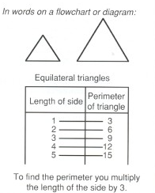

Second Level – Use and devise simple rules

Pupils need to be able to use notation to describe general relationships between 2 sets of numbers, and then use and devise simple rules.

Pupils need to be able to deal with numbers set out in a table horizontally, set out in a table vertically or given as a sequence.

A method should be followed, rather than using “trial and error” to establish the rule.

At Second Level pupils have been asked to find the rule by establishing the single operation used. (+5, ×3, ÷2)

Example 1: Complete the following table, finding the n^{th} term.
In this example, the output values are still increasing, however, addition or multiplication on their own do not work, so this must be a two-step operation.

Input | 1 | 2 | 3 | 4 | 5 |  | n
Output | 5 | 7 | 9 | 11 | 13 |  | ?

Look at the outputs. These are going up by 2 each time. This tells us that we are multiplying by 2. (This means × 2.)

Now ask:

1 multiplied by 2 is 2, how do we get to 5? Add 3.
2 multiplied by 2 is 4, how do we get to 7? Add 3.
This works, so the rule is:

Multiply by 2 then add 3.

Check using the input 5: 5 × 2 + 3 = 13

We use n to stand for any number
So the n^{th} term would be n × 2 + 3 which is rewritten as

2n + 3

Example 2: Find the 20th term.

To find the 20th term it is best to find the n^{th} first.
Input | Output
1  2  3  4  5  6  n  20 | 7  10  13  16  19  22  3n + 4
+3
+3
Look at the output values. These are going up by 3 each time. This tells us that we are multiplying by 3. (This means × 3.)

Now ask:

1 multiplied by 3 is 3, how do we get to 7? Add 4.
2 multiplied by 3 is 6, how do we get to 10? Add 4.
This works so the rule is

Multiply by 3 then add 4.

Check using 6: 6 × 3 + 4 = 22

We use n to stand for any number
So the n^{th} term would be n × 3 + 4 which is rewritten as

3n + 4

To get the 20th term we substitute n = 20 into our formula.

3n + 4
=3×20 + 4
=60 + 4
=64

So the 20th term is 64.

Example 3:

For the following sequence find the term that produces an output of 90.

Input | Output
1  2  3  4  5  6  n | 2  +8  10  +8  18  26  34  42  8n – 6  90

We go through the same process as before to find the n^{th} term, which is 8n – 6.

Now we set up an equation.

8n − 6 = 90
+6 +6
8n =96
÷8 ÷8
n = 12

Therefore the 12th term produces an output of 90.

Second/Third Level – Using formulae

Pupils meet formulae in ‘Area’, ‘Volume’, ‘Circle’, ‘Speed, Distance, Time’ etc. In all circumstances, working must be shown which clearly demonstrates strategy, (i.e. selecting the correct formula), substitution and evaluation.

Example :

Find the area of a triangle with base 8cm and height 5cm.

Remember the importance of the substitution.
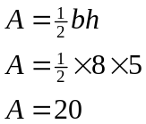

Area of triangle is 20 cm²

Third Level – Collecting like terms (Simplifying Expressions)

The examples below are expressions not equations.

Have the pupils rewrite expressions with the like terms gathered together as in the second line of examples 2, 3 & 4 below, before they get to their final answer. The operator (+, −) and the term (7x) stay together at all times. It does not matter where the operator and term (−7x) are moved within the expression. (see example 3).

Example 1

Simplify

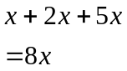

Example 2
The convention in Maths is to write the answer with the letters first, in alphabetical order, followed by number.

Simplify

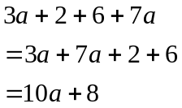

Example 3

Simplify

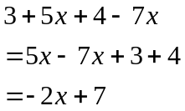 or 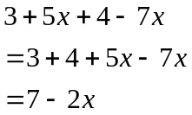
This is still correct although the first answer is preferable.

Example 4

Simplify

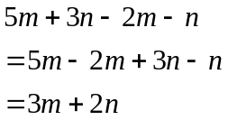 or 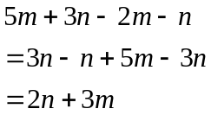

Third Level – Evaluating expressions

If x = 2, y = 3 and z = −4

Find the value of:

(a) 5x −2y
(b) x + y – 2z
(c) 2(x + z) – y
(d) x² + y² + z²

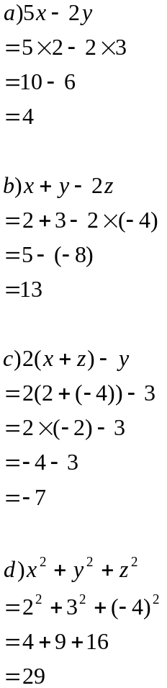
This line where the substitution takes place must be shown.
Marks are awarded in examinations for demonstrating this step.
There is a bracket around the −4 as mathematicians do not write two operators side by side.

Third Level – Solve simple equations

The method used for solving equations is balancing. Each equation should be set out like the examples below. It is useful to use scales like the ones below to introduce this method as pupils can visibly see how the equation can be solved.

x
x
x
This represents the equation
3x + 2 = 8
See example 2 below

Example 1: Solve 6w − 5 = 1

6w − 5 = 1
+5 +5
6w = 6
÷6 ÷6
w = 1

Example 2: Solve 3x + 2 = 8

3x + 2 = 8
− 2 − 2
3x = 6
÷3 ÷3
x = 2

Example 3: Solve 7 = 22 − 3a

7 = 22 − 3a
+3a +3a
3a + 7 = 22
−7 −7
3a = 15
÷3 ÷3
a = 5

Example 4: Solve 4x − 20 = x + 49

4x − 20 = x + 49
4x − x = 49 + 20
3x = 69
x = 23

Example 5: Solve 2(10 − 2x) = 3(3x − 2)

2(10 − 2x) = 3(3x − 2)
20 − 4x = 9x – 6
20 + 6 = 9x + 4x
26 = 13x
x = 2

At Third Level pupils should be encouraged to carry out the steps mentally, however if pupils find this difficult they should continue to show the working.

Other equations at this stage should include ones where x is a negative number or fraction. Pupils should be encouraged to write their answers as a fraction and not as a decimal. Use the language add, subtract, multiply (not times) and divide.

Also when referring to the number ‘−5’ we say ‘negative 5’ NOT ‘minus 5’ as minus should be treated as an operation (verb).

Fourth Level – Solve inequations

Example 1:

Solve the inequation x + 3 > 6 choosing solutions from {0, 1, 2, 3, 4, 5, 6}

x + 3 > 6
−3 −3
x > 3

x = 4, 5, 6

Example 2: Solve x + 5 ≥ 7

w + 5 ≥ 7
−5 −5
w ≥ 2

Example 3: Solve z+ 3 < 4

z + 3 < 4
z < 1

Pupils should set out the working in the same way as solving equations. As they progress they should be encouraged to carry out the steps mentally.

Appendix 2:
Common Methodology for Information Handling

Information Handling

Discrete Data

Discrete data can only have a finite or limited number of possible values.

Shoe sizes are an example of discrete data because sizes 39 and 40 mean something, but size 39∙2, for example, does not.

Continuous Data

Continuous data can have an infinite number of possible values within a selected range.
e.g. temperature, height, length.

Non-Numerical Data (Nominal Data)

Data which is non-numerical.
e.g. favourite TV programme, favourite flavour of crisps.

Tally Chart/Table (Frequency table)

A tally chart is used to collect and organise data prior to representing it in a graph.

Averages

Pupils should be aware that mean, median and mode are different types of average.

Mean: add up all the values and divide by the number of values.
Mode: is the value that occurs most often.
Median: is the middle value or the mean of the middle pair of an ordered set of values.

Pupils are introduced to the mean using the word average. In society average is commonly used to refer to the mean.

Range

The difference between the highest and lowest value.

Pictogram/pictograph

A pictogram/pictograph should have a title and appropriate x (horizontal) and y-axis (vertical) labels. If each picture represents a value of more than one, then a key should be used.

The weight each pupil managed to lift
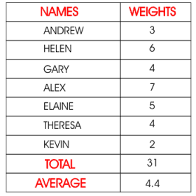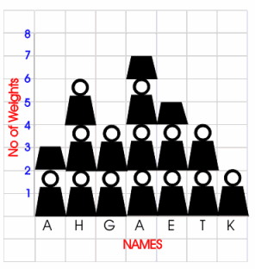
MEAN
represents two units

Bar Chart/Graph

A bar chart is a way of displaying discrete or non-numerical data. A bar chart should have a title and appropriate x and y-axis labels. An even space should be between each bar and each bar should be of an equal width. Leave a space between the y-axis and the first bar. When using a graduated axis, the intervals must be evenly spaced.

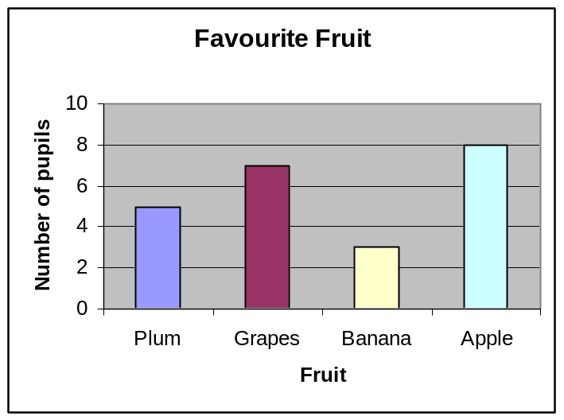

Frequency diagrams

1. Histogram

A histogram is a way of displaying grouped data. A histogram should have a title and appropriate x and y-axis labels. There should be no space between each bar. Each bar should be of an equal width. When using a graduated axis, the intervals must be evenly spaced.
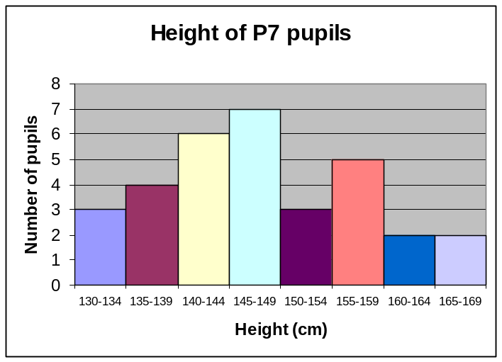

2. Frequency Polygon

To draw a frequency polygon, draw a histogram then join the midpoints of the top of each bar. It is then optional, whether or not you remove the bars. Frequency polygons are useful when comparing two sets of data.

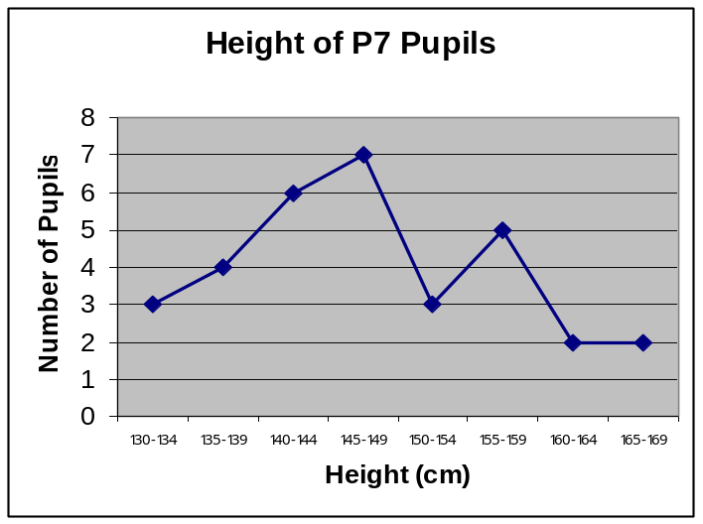

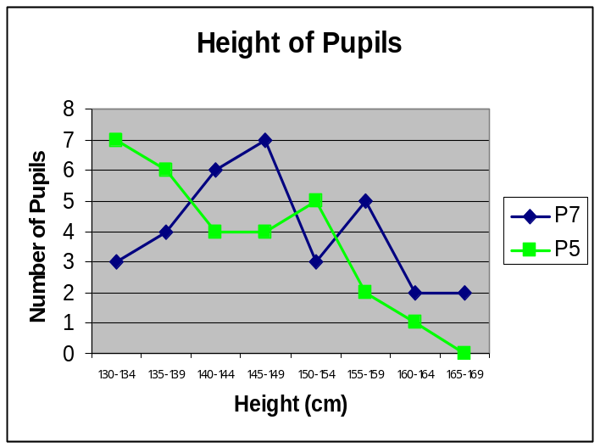

Pie Charts

A pie chart is a way of displaying discrete or non-numerical data.

It uses percentages or fractions to compare the data. The whole circle (100% or one whole) is then split up into sections representing those percentages or fractions. A pie chart needs a title and a key.

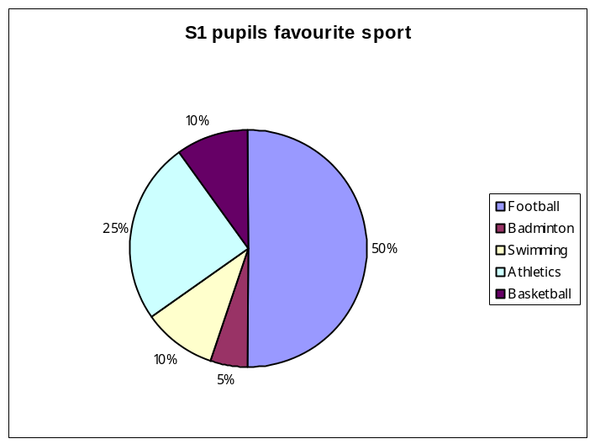

Line Graphs

Line graphs compare two quantities (or variables). Each variable is plotted along an axis. A line graph has a vertical and horizontal axis. So, for example, if you wanted to graph the height of a ball after you have thrown it, you could put time along the horizontal, or x-axis, and height along the vertical, or y-axis.

A line graph needs a title and appropriate x and y-axis labels. If there is more than one line graph on the same axes, the graph needs a key.

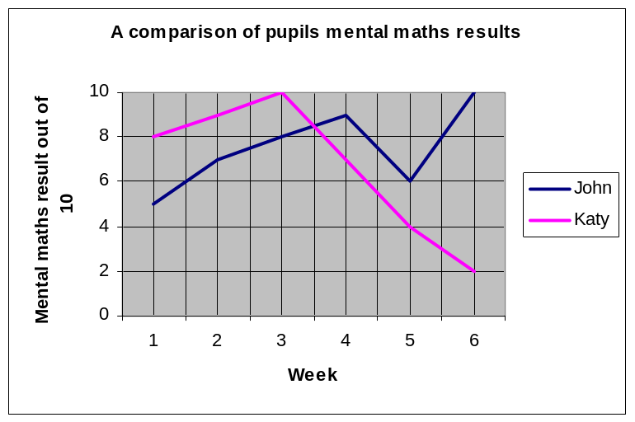

Stem-and-leaf diagram

A stem-and-leaf diagram is another way of displaying discrete or continuous data. A stem-and-leaf diagram needs a title, a key and should be ordered. It is useful for finding the median and mode. If we have two sets of data to compare we can draw a back-to-back stem-and-leaf diagram.

Example: The following marks were obtained in a test marked out of 50. Draw a stem and leaf diagram to represent the data.

3, 23, 44, 41, 39, 29, 11, 18, 28, 48.

Split the data into a stem and a leaf. Here the tens part of the test mark is the stem. The units part of the test mark is called the leaf.

Unordered stem-and-leaf diagram showing test marks out of 50

0 |  | 3
1 |  | 1 8
2 |  | 3 9 8
3 |  | 9
4 |  | 4 1 8

1 3 means 13 out of 50 n = 10

The diagram can be ordered to produce an ordered stem and leaf diagram.

Ordered stem-and-leaf diagram showing test marks out of 50

0 |  | 3
1 |  | 1 8
2 |  | 3 9 8
3 |  | 9
4 |  | 4 1 8

1 3 means 13 out of 50 n = 10

Scattergraphs (Scatter diagrams)

A scattergraph allows you to compare two quantities (or variables). Each variable is plotted along an axis. A scattergraph has a vertical and hrizontal axis. It needs a title and appropriate x and y-axis labels. For each piece of data a point is plotted on the diagram. The points are not joined up.

A scattergraph allows you to see if there is a connection (correlation) between the two quantities. There may be a positive correlation when the two quantities increase together e.g. sale of umbrellas and rainfall. There may be a negative correlation were as one quantity increases the other decreases e.g. price of a car and the age of the car. There may be no correlation e.g. distance pupils travel to school and pupils’ heights.



