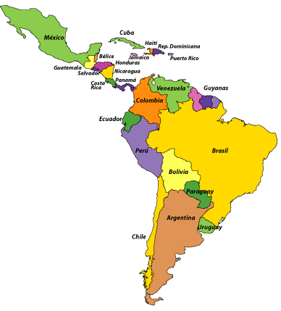
CfE Higher Spanish
Eastwood High School

The course is made up of two units:
- Understanding Language (reading and listening)
- Using Language (talking and writing)
The aim of these units is to develop your ability to use the Spanish language in useful and relevant contexts. It is a one-year course designed to develop the skills of reading, listening, talking and writing already acquired at National 5 level and to expand your knowledge and understanding of detailed and complex language in the four contexts of Society, Culture, Learning, Employability.

Examples of the topics addressed within each context:
Society
Family and friends; home area; lifestyle and health; media; global languages; citizenship
Culture
Travel; living in a multicultural society; traditions and customs; film, television and literature
Learning
Learning styles; school life; education systems; going to university/college
Employability
The world of work; career plans; taking a gap year; importance of language-learning

Many of these topics relate to more than one context.
Assessment and Examination
Unit assessments
During the course, you will sit the following unit assessments:
- reading
- listening
- writing
- speaking (conversation only)
Final course assessment
Paper 1: Reading and Directed Writing (1 hour and 40 minutes)
- The reading paper consists of one text of 550-650 words. You will answer questions in English (20 marks) and translate a short passage from the text (10 marks).
- The directed writing paper provides a choice of two scenarios in the past with four bullet points to be addressed in 120-150 words (10 marks).
Paper 2: Listening and Writing (1 hour)
- The listening paper consists of one monologue (8 marks) and one conversation (12 marks). You will answer questions in English. Unlike at N5 level, you may use a dictionary.
- In the writing paper you will be asked to write 120-150 words in Spanish on a topic related to the monologue you have listened to (10 marks).
Performance (talking)
- You must deliver a presentation of 1½ – 2 minutes (10 marks) and take part in a follow-up conversation of 4½ – 6 minutes (15 marks + 5 marks for ability to sustain the conversation).
- Your presentation will be based on one of the four contexts. The conversation will follow on from this and develop into at least one other context.
- The assessment will be carried out and recorded by your class teacher.
- You may use notes of up to 5 headings of 8 words each in English or Spanish, and/or visual aids.
Study skills
In order to succeed at Higher level, you must be well organised and work consistently throughout the year, not waiting until assessment time to begin studying. You will receive regular homework from your class teacher but it is vital that you take responsibility for your own learning and develop independent study skills.
Here are some suggestions of effective study / revision techniques:

- Get organised! Divide your Spanish folder into separate sections for course information, grammar, directed writing, short essay, performance (talking) and the four contexts of Society, Culture, Learning and Employability.

- Make sure the notes you take in class are clear and easy to refer back to. If it helps, make use of different coloured pens or highlighters.

- Go over any texts you study in class and make a note of new words and phrases in order to increase your vocabulary.

- Make a habit of reading over vocabulary notes on a regular basis.

- Always re-draft any piece of writing you have had corrected and build up a folio of your best work. This will help you prepare for the Performance.

- Revise grammar regularly and ask for help with any point you do not fully understand.

- Make use of online resources to help you practise reading, listening, translation and grammar.

- Surround yourself with as much Spanish as you can, by listening to Spanish music on YouTube or online radio stations such as Cadena Dial.

WEBSITES FOR INDEPENDENT STUDY
http://scholar.hw.ac.uk/
Username:
Password:
This website is specifically designed to prepare you for Higher. It contains loads of really useful exercises on reading, writing, translation, listening and grammar.
www.languagesonline.org.uk
The grammar section is particularly useful.
https://www.laits.utexas.edu/spe/
This website is great for practising your listening skills as it has a huge selection of video clips on different topics, complete with Spanish transcripts and English translations.
www.bbc.co.uk/mundo
News and current affairs. The news stories are similar to those on the English BBC website and by looking at the headlines and using a dictionary to understand them you will build both your vocabulary and your general knowledge.
www.primerasnoticias.com
News items written by young Spanish journalists for young people. Many articles cover the contexts of Higher and Advanced Higher.
www.rtve.es
Spanish news and television. Click on the ‘a la carta’ button at the top of the homepage to take you to a Spanish version of BBC iplayer. Although you might not understand everything you will really improve your listening skills by helping you get used to the way the language is spoken by native Spanish speakers.

