**Eco Code**

**E**nergy is important so save it while you can.

**C**arbon footprint must be reduced.

**O**nly turn on the heater if it is cold.

**S**chool grounds belong to us so let’s keep safe and tidy.

**C**reating new and exciting areas in and around the school.

**H**elping hands are more than welcome to make sure our school stays clean and attractive.

**O**ur bins should never lie empty.

**O**nly we can make a difference!

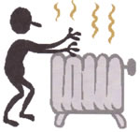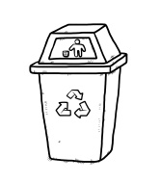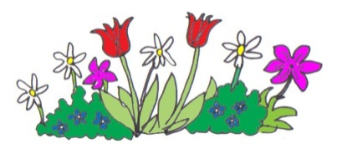**L**itter is a dangerous waste, so put it in its rightful place!

Poem created by taking sections of poems from all classes.

**School Grounds**

**Litter**

**Energy**