Going to School

After the summer holidays, I will be in Primary 1 at school.
I’m excited to go to school! I’m also a little bit worried but I know that’s okay and it is good to talk about how I feel.

I will have a new teacher at school who will look after me and teach me new things.
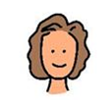

I might miss being at home with my family or playing at Nursery but there are lots of things I can do to make me feel happy at school.
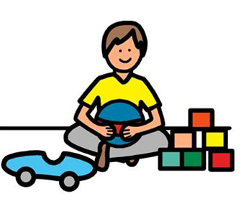
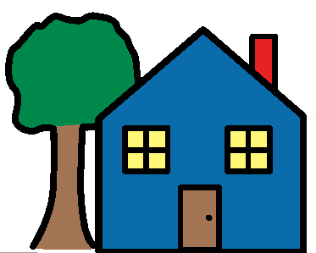

At school, I will play with other children. I might know some of the children already and I will meet new friends as well.
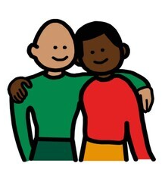
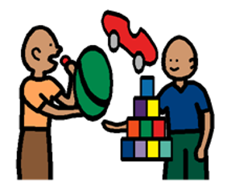

.
I will have a classroom with lots of books, toys and games. Some things will be different from Nursery and some things will be the same.
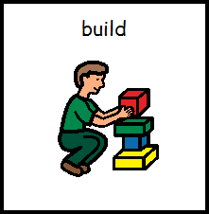
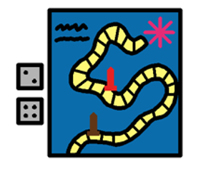
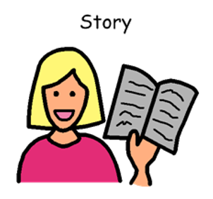
I will have lunch at school and play outside. There will be adults to help me if I hurt myself or can’t open up my snack.
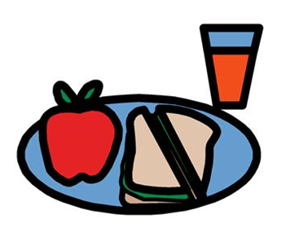
I will learn special rules at school to keep myself safe and will wash my hands to help not spread germs.

At the end of the day, I will go home to my family, I might feel tired after a busy day!
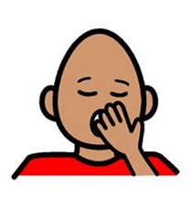
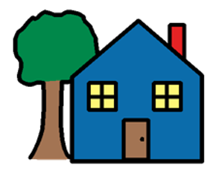

Grown – ups at home will ask me about my day at school. I will be able to tell them all about it and I will have time to play with my own toys at home.
