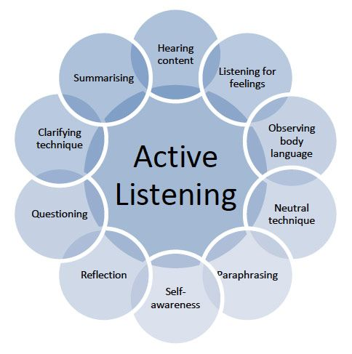

Tell me what happened?

What were you thinking at the time/ How did you feel?

Who else has been affected and how?

How are you feeling now?

C:\Users\SlorachK\AppData\Local\Microsoft\Windows\Temporary Internet Files\Content.IE5\090JV02G\steps[1].jpgWhat do you think needs to happen now/ How do we move forward?

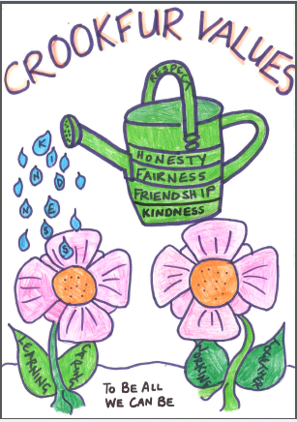

**What happened?** Drawing out each person’s story one at a time, starting with the person who has caused the harm. The aim is not to come to a definitive conclusion on what has happened but for each person to have their point of view listened to.

**What do you think and feel about that?** What each person was thinking and feeling at the time before and since.

**Who has been affected and how?** Who has been harmed/affected and how? Older children areencouraged to think about the wider implications of who has been affected e.g. families.

**What are the needs of those involved**? What those affected need to feel better, move on,

repair harm and rebuild relationships.

**What do you think needs to happen next/to make things right with each other and with the school community?** How do those people agree and negotiate meeting the needs identified above and what support might they need to do this?



Hearing the stories

* **Listen right through without interruption**
* **The listener reflects back what has been heard (reframing)**
* **Check and acknowledge both the thoughts and the feelings**
* **Identify the shared problem**
* **Emphasise the problem is the problem, not the people**
* **Agree on possible options**
* **Clarify roles and responsibilities**
* **Draw up a written agreement if required**

**Guidance**

* **Allow each person to speak one at a time, listen throughout**
* **Summarise and reframe to help discussion**
* **Check and acknowledge both the thoughts, feelings and needs**
* **Identify the shared problem**
* **Emphasise the problem is the problem, not the people**
* **Agree on possible outcomes, work hard to achieve an agreed target**
* **Draw up a written agreement if required**
* **Final feelings**

**Restorative practice in Crookfur Primary**

**5 key questions:**

**Tell me what happened?**

**What were you thinking at the time/ How did you feel?**

**Who else has been affected and how?**

**How are you feeling now?**

**What do you think needs to happen now/ How do we move forward?**

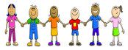

**Guidance**

* **Allow each person to speak one at a time, listen throughout**
* **Summarise and reframe to help discussion**
* **Check and acknowledge both the thoughts, feelings and needs**
* **Identify the shared problem**
* **Emphasise the problem is the problem, not the people**
* **Agree on possible outcomes, work hard to achieve an agreed target**
* **Draw up a written agreement if required**
* **Final feelings**

**Restorative practice in Crookfur Primary**

**5 key questions:**

**Tell me what happened?**

**What were you thinking at the time/ How did you feel?**

**Who else has been affected and how?**

**How are you feeling now?**

**What do you think needs to happen now/ How do we move forward?**