CHILD PROTECTION POLICY AND PROCEDURES
At Crookfur Primary We Work Hard to Keep Our Children Safe
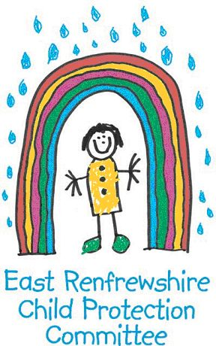

At Crookfur we take the care, welfare and protection of our children very seriously. We believe all children have a right to feel safe within the school, home and community.

Within our school we strive to provide a safe, secure and nurturing environment for our pupils, which promotes inclusion and achievement.
All staff in Education have a statutory and professional responsibility to take action if we have reason to believe a child is suffering, or is at risk of abuse.

Our child protection policy and procedure sets out what we will do if we have reason to believe a child is being abused or is at risk of abuse, either within the home or the community. These policies are designed to ensure that children get the help they need when they need it.

Every staff member undergoes a minimum of one child protection training activity every session. Many of our staff are more extensively trained in specific areas of child protection to support and identify potential child protection concerns.

All schools in East Renfrewshire have comprehensive Pupil Support systems in place and we work closely with our partners in Social Work, Health and the Police. The school operates a multi agency Joint Support Team to ensure that the best possible supports are available to pupils when they need them.

The Child Protection Co-ordinator for the school is HT Mrs Loudon. If you wish any further information or a copy of the school policy, please contact the school office. If you wish to discuss this important matter further, please make an appointment to see name of CP Coordinator.

If you are worried or know of a child who could be at risk of abuse or neglect please speak to the Child protection Coordinator or to a member of staff at one of the following numbers:

Barrhead Social Work Office: 0141 577 8300
Clarkston Social Work Office: 0141 577 4000
Strathclyde Police Family Protection Unit: 0141 532 4900
Standby Social Work Out of Hours 0800 811 505

