Flower Breath:  Imagine you're holding a beautiful flower and you want to smell it; breathe in deeply through the nose and it smells lovely so you breath out a sigh through the mouth, with or without sound, | Feather Breath  Hold a feather with both hands. Inhale deeply as you look at the feather. With a long exhale, slowly blow the feather. Try to make the feathers softly move. Exhale as slowly and quietly as possible. | Hissing Breath:  Breathe in the nose, long deep inhale, and out the mouth on a hissing sound, slow and long.
Bear Breath:  Imagine a bear hibernating. Inhale through the nose, pause; exhale out the nose, pause. Breathe in to a count of 3 or 4, pause for a count of 1 or 2; breath out for a count of 3 or 4, pause for a count of 1 or 2. Repeat a few times. | Bunny Breath:  Take three quick sniffs in the nose and one long exhale out the nose. Pretend to be bunnies, sniffing the air for other bunnies, carrots to eat, or safety. | Volcano Breath.  Facing the child, Bring your hands to your heart in a prayer pose. Extend your hands straight up to the sky while inhaling deeply, and letting the hands fall to the sides during long, deep exhales.

Hissing Breath:  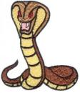 | Feather Breath  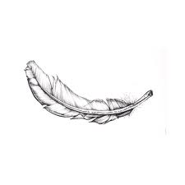 | Flower Breath:  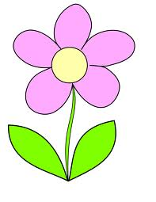
Volcano Breath.  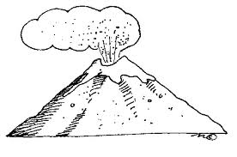 | Bunny Breath:  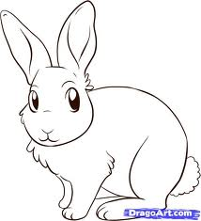 | Bear Breath:  