Safe Healthy Achieving Nurtured Active Respected Responsible Included

CAROLSIDE NURSERY CLASS

HANDBOOK
2019/2020

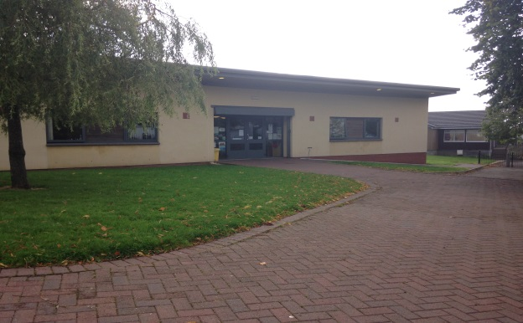
Safe Healthy Achieving Nurtured Active Respected Responsible Included

Carolside Nursery Class

Dear Parent/Carer

A warm welcome to Carolside Nursery Class. Joining our nursery class is your child’s first steps in formal education and in becoming part of the Carolside Learning Community.

One of our aims is to work in partnership with you to support your child in their journey through Carolside. We recognise that you are your child’s first and most important educator and we look forward to linking their high quality experiences here with all those at home. By working together we can build on your child’s skills and knowledge and, responding to this, plan their future development.

Carolside Nursery Class offers high quality learning experiences in playrooms and outdoors. Staff are highly experienced and motivated to provide a learning environment where children are actively engaged and learning through play. All pupils are supported to learn in ways that suit their individual needs.

You are welcome to visit the nursery and we will make every effort to answer enquiries and address any concerns sensitively and promptly.

We hope you will find the following pages useful and that they give you an insight into our nursery. We look forward to working with you over the coming months.

Mr McLachlan
Head Teacher

Safe Healthy Achieving Nurtured Active Respected Responsible Included

Vision
A happy and safe school, providing rich learning opportunities, where everyone is treated with respect and kindness.

Values
Respect Honesty Friendship

Aims
We aim to provide children with a variety of rich learning experiences which meet the needs of the whole child.

We aim to encourage all children to take responsibility for upholding their own and others’ rights.

We aim to foster resilience within all our pupils.

Mission Statement

At Carolside Nursery Class we will seek to work together in partnership with parents, carers, children and other stakeholders to ensure that we foster a positive learning environment within which children can grow and learn. We hope to ensure that all children and families within the nursery community are safe, healthy, well cared for and have access to the highest quality learning experiences. We aim to develop in our young children the ability to see themselves as successful learners and to understand how to access the learning potential in the environment around them. We actively promote nurture and believe that for learning to happen, children must be safe, valued, included and respected. We celebrate diversity and encourage positive relationships for all our pupils.

Breastfeeding Friendly

Carolside Nursery is a Breastfeeding Friendly establishment. Our Aim and Objectives are as follows:

Aim:
To provide an atmosphere where breastfeeding is encouraged, supported and protected and promoted as the cultural norm.

Objectives:

- To provide education and training for all staff to enable them to promote, protect and support breastfeeding.

- To provide an atmosphere where breastfeeding is encouraged, supported and protected in all areas of the nursery establishments.

- To support an informed choice in relation to infant feeding.

- To support breastfeeding staff/users and increase awareness of support and information for breast feeding.

- To contribute to the promotion of social and attitude change in relation to breastfeeding in order to develop public acceptability and the promotion of breastfeeding.

- To use resources which reflect breastfeeding as the cultural norm.

Safe Healthy Achieving Nurtured Active Respected Responsible Included

Nursery Information

Carolside Nursery Class
Carolside Primary School

Ashfield Road
Clarkston

East Renfrewshire
G76 7TX

Tel: 0141 570 7100

Fax: 0141 570 7101
E-mail: schoolmail@carolside.e-renfrew.sch.uk

Nursery Staff Team (Staffing as per session 2019/20)

Name | Role | Group
Mr B McLachlan | Head Teacher
Mrs J McGregor | Depute Head Teacher
Mrs L Gillian | Acting Principal Teacher
Mrs P Nelson | Nursery Teacher
Mrs Z Holmes | Senior Child Development Officer
Mrs S Buchanan | Child Development Officer | Blue Group
Mrs K McGowan | Child Development Officer | Green Group (Mon, Tue, alt Wed)
Mrs J Hillan | Child Development Officer | Green Group (Alt Wed, Thurs, Fri)
Miss N Paton | Child Development Officer | Orange Group
Miss L Kerr | Child Development Officer | Red Group
Mrs P O’Hara | Child Development Officer | Purple Group
Mrs J Kerrigan | Child Development Officer | Yellow Group
Mrs F Tod | Child Development Officer
Mrs F Holmes | Child Development Officer
Mrs J Lees | Administration/Clerical | Mon, Tues, Thu, Fri
Mrs K Irvine | Play Worker
Mrs A Mason | Play Worker
Mr J Kerr | School Janitor

Safe Healthy Achieving Nurtured Active Respected Responsible Included

Core Hours Provision – Nursery Opening Hours

All our pupils are entitled to 600 hours of provision throughout the year.

Nursery Opens: | 8.00 am
Morning Core Sessions begin: | 8.50 am
Morning Core sessions end: | 12 noon
Lunch session begins: | 12 noon
Afternoon Core sessions begin: | 12.50 pm
Afternoon Core sessions end: | 4.00 pm
Nursery closes: | 6.00 pm

During the hours 8.00 am to 8.50 am; 12 noon to 12.50 pm; 4.00 pm to 5.00 pm/6.00 pm additional hours are available in all nurseries at a cost of £2.25 per hour. Should you wish to apply for this service, please speak to Mrs Holmes our Senior Child Development Officer or Mrs J Lees in the office.

Roll and Demographic

We are an 80/80 nursery class, that is, we can accommodate 80 children in our morning session and 80 in the afternoon. Places are allocated in January for children to start nursery in August. As places become available they will be allocated to children in accordance with East Renfrewshire’s Admission Policy. Pupils are a mix of preschool and ante preschool pupils.

Non-Denominational Policy of the Nursery

Carolside Nursery Class is non-denominational. We welcome children and parents of all religions, faiths and beliefs. We celebrate diversity.

Starting Dates

All children are entitled to a funded nursery place for three hours 10 minutes (Core) Monday to Friday on the day after the child turns three. The exception to this is if their birthday falls between 1st March and the end of June when they will be awarded a place for the following school year. Please note this entitlement does not guarantee choice of establishment.

Enrolling at Carolside Nursery Class

To apply for a nursery place, children must have had their second birthday. Application forms are available by telephoning the council offices on 0141 577 3288. Completed application forms should be returned to the council offices and they will notify you if you have been allocated a place in nursery.

East Renfrewshire Council will keep a register of all nursery applicants and the information contained in the applications will be considered by the admissions panel to assist in the allocation of places.

Please note that the length of time a child’s name has been on the register will not affect priority for admission. All enquiries should be directed to Carol Duckett at East Renfrewshire Council Office on 0141 577 3288.

Safe Healthy Achieving Nurtured Active Respected Responsible Included

When you come with your child to enrol you will be asked to complete some very important information. We must have this information before you can leave your child in our care. Please be prepared to provide:
- Two emergency contacts (names, addresses and telephone numbers)

- Names and addresses of children’s doctor, dentist and health visitor
- Details of vaccinations

- Allergies and/or medical conditions
- Special dietary requirements

- Names of people who will normally collect your child from nursery (must be over 16 years old)

Equal Opportunities Policy

East Renfrewshire Council Education Department is committed to ensuring equality and fairness for all.

In accordance with the requirements set out by the Equalities and Human Rights Commission, we seek to:

- Eliminate unlawful discrimination, harassment and victimisation and other conduct that is prohibited by the Equality Act 2012

- Advance equality of opportunity between people who share a relevant protected characteristic and those who do not

- Foster good relations between people who share a protected characteristic and those who do not

Carolside has clear guidelines and procedures for dealing with incidents of inequality, as advised by the Education Department.

Rights Respecting School Award

UNICEF UK is pioneering an initiative in UK schools called the Rights Respecting School Award. The Rights Respecting Schools Award recognises achievement in putting the United Nations Convention on the Rights of the Child (UNCRC) at the heart of a school’s planning, policies, practice and ethos. Children’s rights are central to all aspects of UNICEF’s work, including education, and Carolside Primary use the UNCRC as a framework for their activities.

On 23rd March 2017, Carolside Primary School was awarded Level 2 Rights Respecting School Award.

We encourage that any concerns be raised with us. Our Equalities Co-ordinator is Mrs Gillian, Acting Principal Teacher, who can be contacted by email or by telephoning the school.

Protecting Children

At Carolside Primary we take the care, welfare and protection of our children very seriously. We believe all children have a right to feel safe within the school, home and community. Within our school we strive to provide a safe, secure and nurturing environment for our pupils, which promotes inclusion and achievement.

Safe Healthy Achieving Nurtured Active Respected Responsible Included

All staff in Education have a statutory and professional responsibility to take action if we have reason to believe a child is suffering, or is at risk of abuse.

Our child protection policy and procedure sets out what we will do if we have reason to believe a child is being abused or is at risk of abuse, either within the home or the community. These procedures are designed to ensure that children receive the help they need, when they need it.

Every staff member undergoes a minimum of one child protection training activity every session. Many of our staff are more extensively trained in specific areas of child protection to support and identify potential child protection concerns.

All schools in East Renfrewshire have comprehensive Pupil Support systems in place and we work closely with our partners in Social Work, Health and the Police. The school operates a multi-agency Joint Support Team to ensure that the best possible supports are available to pupils when they need them.

The Child Protection Co-ordinator for the school is Mr McLachlan (HT). If you wish any further information or a copy of the school policy, please contact the school office. If you wish to discuss this important matter further, please make an appointment to see Mr McLachlan.

If you are worried or know of a child who could be at risk of abuse or neglect please speak to the Child Protection Coordinator or to a member of staff at one of the following numbers:

Barrhead Social Work Office: | 0141 577 8300
Clarkston Social Work Office: | 0141 577 4000
Strathclyde Police Family Protection Unit: | 0141 532 4900
Standby Social Work Out of Hours | 0800 811 505
Child Protection - East Renfrewshire Council

http://www.eastrenfrewshire.gov.uk/index.aspx?articleid=1923

Safe Healthy Achieving Nurtured Active Respected Responsible Included

Settling Policy

We will be informed when you have been offered a place. Following this we will be in touch with you with your child’s start date. We will also you a home visit from your child’s key worker.

Your child is welcome to stay for three hours from their first day. However, we would suggest the following arrangements in order to help your child settle in fully within their new environment.

Day 1: Children stay for 1 hour with their parent/carer also staying in the staff/parent room.
Day 2: Children stay for 2 hours. Parent/carer can leave if preferred.
Day 3: Children stay for full session. Parent/Carers are asked to collect their child promptly to avoid them waiting whilst other children are collected ahead of them.

While most children follow this pattern and will be settled into nursery within the first week, some children can take longer. Nursery staff will work with parents/carers to formulate the best possible settling plan for their child.

Some children may also settle very quickly. Again nursery staff will work with parents to allow for a quicker settling period.

Our settling procedure can be adapted to suit the needs of every individual child.

Other Policies

Carolside Nursery Class has policies in place to ensure that staff, parents, and visitors to our nursery are clear on work practices, standards and processes. All stakeholders are involved in the development of these where possible.

Policies are written in line with school and Local Authority guidelines, our self-evaluation tools, How Good Is Our Early Learning and Childcare, and Child at the Centre 2, Building the Ambition and the National Health and Social Care Standards. You are entitled to full access to these. All policies are reviewed regularly.

Additional Hours

East Renfrewshire Council operate a system called Additional Hours, formally known as Wraparound Care. This facility means that a child who has a place in Carolside Nursery Class can be accommodated for extra hours over and above his/her funded session. Additional hours within the nursery day and lunchtime provision can be provided if there are places available. If you are interested in using this service, please speak with a Senior Child Development Officer at the time of enrolling your child in the nursery.

Additional Hours allow parents/carers to book and pay for ad hoc sessions online, according to availability. All sessions must be booked and paid for at least 48 hours in advance and are non-refundable.

This would help parents/carers with those times when they need some extra childcare on a one-off basis like attending a medical appointment or going for an interview. Speak to Mrs Holmes or Mrs Lees for more information or logon to Parent Pay to see what sessions are available.

The School Session

First term
Teachers return | Thursday 15 August 2019
In-service | Thursday 15 August 2019
In-service | Friday 16 August 2019
Pupils return | Monday 19 August 2019
Last day of school | Thursday 26 September 2019
September Weekend | Friday 27 September 2019
September Weekend | Monday 30 September 2019
Re-open | Tuesday 1 October 2019
Last day of school | Friday 11 October 2019
In-service | Monday 21 October 2019
Re-open | Tuesday 22 October 2019
Last day of school | Friday 20 December 2019

Second term
Re-open | Monday 6 January 2020
Last day of school | Thursday 6 February 2020
In-service | Friday 7 February 2020
Mid term | Monday 10 February 2020
Mid term | Tuesday 11 February 2020
In-service | Wednesday 12 February 2020
Re-open | Thursday 13 February 2020
Last day of school | Friday 3 April 2020

Third term
Re-open | Monday 20 April 2020
Last day of school | Wednesday 6 May 2020
In-service | Thursday 7 May 2020
May Day Holiday | Friday 8 May 2020
Re-open | Monday 11 May 2020
Last day of school | Thursday 21 May 2020
May Weekend | Friday 22 May 2020
May Weekend | Monday 25 May 2020
In-service | Tuesday 26 May 2020
Re-open | Wednesday 27 May 2020
Last day of school | Friday 26 June 2020

Changes to Personal Details

It is imperative that you inform us immediately of changes to your personal details. You will understand the importance of us being able to contact parents in the event of an emergency.

Attendance/Absence

Regular attendance will ensure that your child is fully involved in the life of the nursery and benefits from all the learning experiences there. Absences are recorded and monitored and we would encourage you to phone if your child is going to be absent. Please contact us before 9.30 am on the day of her/his absence by telephoning 0141 570 7100.

In the interest of your child’s safety you should make a point of telling the teacher or key worker if he or she is to be collected by someone not known to the nursery. This avoids difficult situations when a child cannot be allowed to leave with an adult who is a stranger to the staff.

Please notify us of any holidays or planned absence in writing.

Accidents and Injuries

All minor accidents or injuries are recorded in our accident book which parents/carers will be asked to sign.

If your child becomes unwell whilst at nursery then you or the emergency contacts you have named will be contacted. Your child will be made comfortable until someone arrives to take him or her home.

We do ask if your child is suffering from a heavy cold, viruses or any kind of contagious condition that you keep them at home to avoid affecting other children. If your child has a vomiting/diarrhoea bug please keep them at home until their symptoms have completely gone. Information on infectious periods of common childhood ailments can be found in the foyer.

An ambulance will be called if emergency attention should be required. Your child will be accompanied to hospital by a member of staff. Staff will stay with your child until you arrive.

Safe Healthy Achieving Nurtured Active Respected Responsible Included

Administering of Medication

The administering of medication should be discussed with a member of staff. There are forms to be completed by parents. Prescribed drugs are administered at the discretion of the Head Teacher.
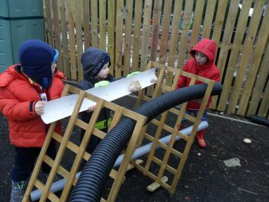
Suitable Clothing and Uniform

Carolside Nursery Class has an optional uniform for children which consists of a red sweatshirt with the Nursery Logo.
This can be ordered through Stevenson’s, 192 Fenwick Road, Giffnock G46 6UE.

At Carolside we have a focus on Outdoor Learning. Pupils have daily access to our nursery garden.

What does my child have to bring?

It would be very useful if you could help your child choose a ‘nursery bag’ that he or she will bring every day.

The nursery bag should contain:
- Change of clothes – pants, socks, t-shirt and skirt/trousers.
- A cagoule or waterproof jacket

- A pair of wellies

- If your child is not yet fully toilet trained please provide appropriate pull ups and wet wipes.

We ask that all items of clothing and footwear are labelled clearly with the child’s name.

At Carolside pupils spend a lot of time learning outdoors in all weathers. We have outdoor waterproof suits. However, all pupils should be appropriately dressed for outdoors at all times.
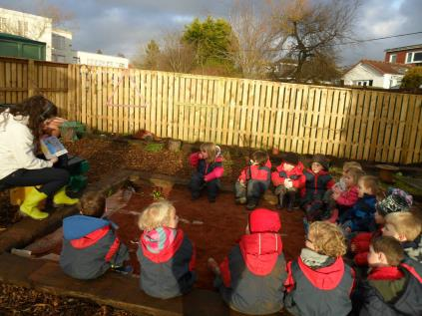
In winter and on cold days children should have:
- A waterproof/heavy jacket

- Gloves and a hat
In summer and on sunny days children should:

- Have a sun hat in their bag
- Be wearing protective lotion

Safe Healthy Achieving Nurtured Active Respected Responsible Included

Emergency Closure Arrangements

We make every effort to maintain a full educational service, but on some occasions circumstances arise which lead to disruption. Schools may be affected by, for example, severe weather, power failures or similar emergencies. In such cases we shall do all we can to let you know about the details of closure or reopening. Please ensure your emergency contact details are updated regularly. Details will appear on the school website and updates will also be on the Council website:

http://www.eastrenfrewshire.gov.uk
ERC Twitter https://twitter.com/EastRenCouncil

Excursions and Consent Forms

When outings or excursions are planned for children, you will be informed in advance. If the outing is considered out with the immediate locality you will be asked to complete a consent form which gives your permission for your child’s participation. Please note that your child cannot take part in outings unless your consent has been given in advance.

You will be asked at the time of enrolment at nursery for your consent to take your child out into the immediate locality. This normally involves taking children on environmental walks around the school grounds or in the immediate vicinity.

East Renfrewshire Council guidelines on staff/child ratios are adhered to for all outings and all risks assessments are completed by staff.

Photographs

Pupils are regularly filmed and photographed working and playing at nursery. These images are then used for discussion, display and assessment purposes. Occasionally pupils will be photographed for local council, press or website purposes. At the time of enrolment you will be asked to complete a consent form. If you do not wish your child to be photographed for any or all of these purposes you can withhold permission.

Healthy Eating and Snack Time

During each session the children will have an opportunity to have a snack of milk/water and fruit on 3 days. On a Monday and Friday the children will have the opportunity to make, sample and suggest different snack ideas. Pupils are fully involved in the process and independently help themselves to their food. They will also be encouraged to consider healthy foods and discuss why we should eat healthily. Regularly they will be involved in preparing snacks, preparing foods or baking activities. Again this is to encourage a responsible approach to healthy foods.

If your child has a special diet or there any foods which your child should not have, please inform the nursery. Information on food allergies is held within the food preparation area.

Safe Healthy Achieving Nurtured Active Respected Responsible Included

Partnership with Parents

We believe that parents are the child’s first educator and know the needs, interests and disposition of their own child best. We recognise that children will come to nursery having already learned a great deal about their world.

We aim to
- Foster and develop a strong partnership between home, school and community.

- Welcome parents into the nursery and provide opportunities for participation in learning experiences and in developing the environment.

- Provide opportunities for parents to develop an understanding of how children learn.

- Develop home school links and involve parents directly in the learning process.

- Create a vibrant, positive ethos and culture where all parents/ carers and families are welcome and nurtured.

We have developed a Family Communication Information Leaflet to share with families the different ways we communicate between nursery and home.

Parent Consultations and Reporting

We hold parental consultation meetings twice a year for both preschool and ante-preschool children. The purpose of these consultations is to give parents an opportunity to discuss their child’s progress with a member of staff.

Pupils contribute to a nursery learning journal which tracks their progress and contains samples of their work. They are encouraged to revisit these to look at how much they have learned.

Pupils participate fully in the development of floor books and learning walls. These are visible and accessible and track children’s progress through their contexts for learning the skills of a Curriculum for Excellence. Parents and pupils are regularly invited to evaluate and comment on children’s learning.

At the end of each session preschool pupils are issued with a summative report with comments on progress in Literacy, Numeracy, Health and Wellbeing and general progress through the nursery curriculum.

Safe Healthy Achieving Nurtured Active Respected Responsible Included

Ongoing Communication

We pride ourselves in having an excellent relationship with our parents. If you are worried, curious or anxious about any matter concerning your child, please speak to a member of staff. Depending on the nature of the enquiry you will either receive an immediate response or an appointment will be made to discuss the matter in private.

Our newsletters keep you informed about events in the nursery and notes and reminders are written on our notice board in the foyer.

We maintain our Twitter account where we hope to keep you regularly updated on the daily life of the nursery and other events.
Please follow us @Carolside_ELCC

Feedback

Throughout the session there will be many opportunities for you and your child to provide written and verbal feedback on a variety of issues, events and learning experiences. We welcome all comments and use these to inform and impact on our practice. Any suggestions or ideas you may have can be put into the suggestion box or given to a member of staff.

Parent Workshops

Carolside Nursery staff have developed a programme of parent workshops designed to demystify the Early Years Curriculum. These workshops have been invaluable in forming the first links between learning and home and learning within a more formal curriculum. Throughout the year you will be invited to participate in workshops on a range of subjects including Literacy and Numeracy.

Parent Fundraising Association

The Parents’ Fundraising Association (PFA) is a very important part of the life of Carolside Nursery Class. Parents work hard and work collaboratively on a number of events throughout the year. These are purposeful, enjoyable and bring the whole community together for the benefit of the pupils. Parents are asked at the time of enrolling their child if they would like to join. All parents are welcome participants.

Funds

As well as having regular fundraising events, we also collect a voluntary Nursery Fund. Nursery Fund is charged at £3 per week but can be paid monthly or termly. Payments should be made via ParentPay. Please see our clerical team for further details.

The Nursery Fund is used to buy the daily snack and to pay for ongoing expenses such as printer ink for our photographs. We also use money from the fund to subsidise the cost of educational outings and to invite guests such as children’s authors or specialist teachers to come into nursery to work with our children.

Safe Healthy Achieving Nurtured Active Respected Responsible Included

The Nursery Curriculum

Aims of our curriculum
Through offering a balanced and coherent curriculum we seek to:

- Provide a safe and stimulating environment in which children can feel safe and secure

- Encourage the emotional, social, physical, creative and intellectual development of our children

- Encourage positive attitudes to self and others and develop confidence and self-esteem Provide opportunities to stimulate the children’s interest and imagination

- Extend the children’s abilities to communicate ideas and feelings in a variety of ways

At Carolside Nursery Class we provide high quality learning experiences designed to engage and motivate pupils and actively involve them in the learning process. Pre-school education is vital in developing and broadening children’s range of learning experiences, developing children as learners and laying a solid foundation for future success. We place children firmly at the centre and for each child we identify what needs to be in place for learning to happen. Children are actively involved in their learning and in planning and identifying their own learning journey.

We follow the Curriculum for Excellence framework (3-18) as set out by the Scottish Government. This curriculum enables children to meet the ‘four capacities’ as set out in the framework to become successful learners, confident individuals, responsible citizens and effective contributors. This framework will follow your child from their early years in nursery right through to secondary school and, possibly, on to further education. This ensures a smooth transition for your child between nursery to primary and primary to secondary. There are now eight areas of the Curriculum with a set of ‘Experiences and Outcomes’ for each area. These areas include:

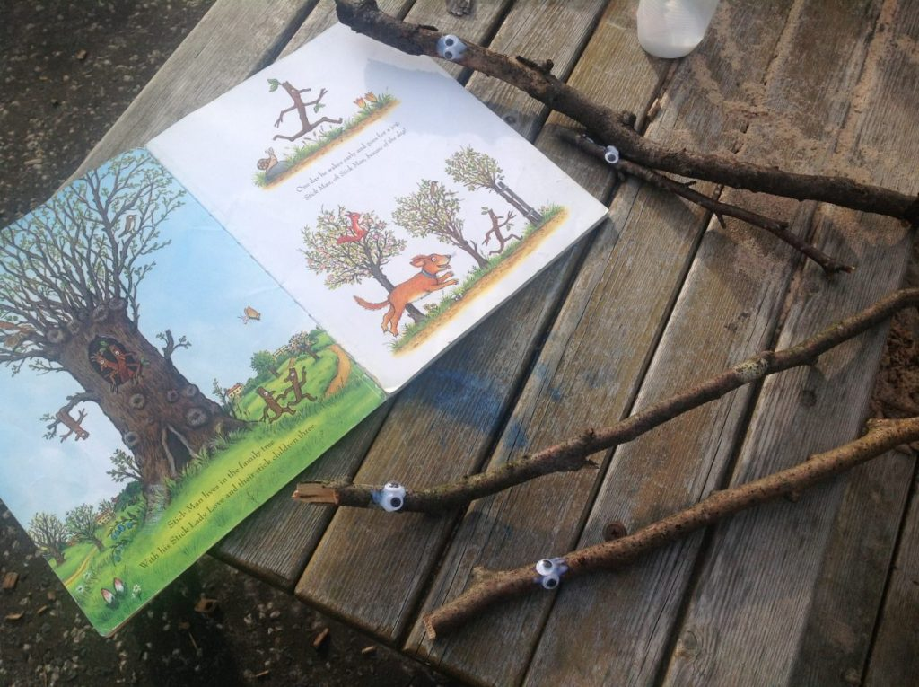
- English & Literacy

- Mathematics
- Sciences

- Technologies
- Expressive Arts
- Religious & Moral Education

- Health & Wellbeing
- Social Studies.

The curriculum is designed to offer pupils; Challenge and Enjoyment, Personalisation and Choice, Breadth, Progression, Depth, Coherence and Relevance.

At Carolside, children learn actively and experientially which means they are directly engaged with, and responsible for, their own learning. They learn through play. Staff work with pupils to plan high quality learning experiences throughout the nursery and work with pupils to assess progress. Staff plan responsively according to pupils’ needs, interests and abilities.

Pupils chose Talking and Thinking Time topics and these form interesting contexts for learning. The progression of learning is then tracked and displayed by pupils on learning walls.

Safe Healthy Achieving Nurtured Active Respected Responsible Included

Curriculum for Excellence experiences and outcomes are used to frame all learning and assessment of pupils’ progress. Planning is available to you – please ask a member of staff. You will be invited to evaluate and comment on your child’s progress in your child’s Learning Profile.

Helpful links:
Parentzone

http://www.educationscotland.gov.uk/parentzone/

Information for parents and carers - Early Years http://www.educationscotland.gov.uk/learningandteaching/earlylearningandchildcare/prebirthtothree/parentsandcarers.asp

Additional Support for Learning

Carolside Nursery is committed to East Renfrewshire Council’s policy on inclusion. We believe that every child has a right to access the curriculum and work in partnership with the school Additional Support Needs Coordinator and a range of other agencies to fulfil this responsibility.

Our aim is to support children with additional support needs to be fully involved in all aspects of our school and enjoy and celebrate success in their learning.

The following websites may be of interest:-

Addressing Dyslexia ENABLE - ASN Support ENQUIRE - ASN Support

http://www.addressingdyslexia.org/ http://www.enable.org.uk/Pages/Enable_Home.aspx http://enquire.org.uk/

Transition

Careful consideration is given to each individual pupil during the transition from nursery to Primary 1.
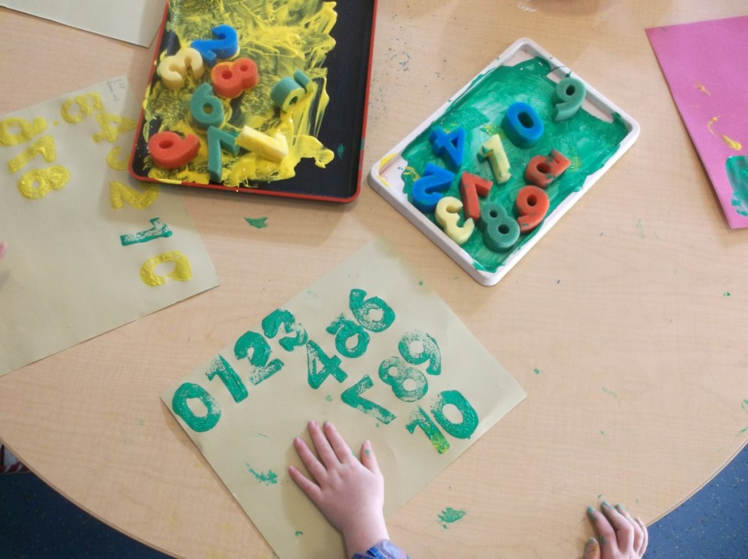
Information is collated on pupils’ strengths, care and welfare, ASN, progress and wider achievements. All information is shared with receiving members of staff. Visits to new stages are arranged in the final term of each year.

Parents will be kept fully informed of the transition process through newsletters and meetings. Some children may benefit from extended transition and this is planned in consultation with parents, school staff and nursery staff as required. If your child should require extended transition, parents will be invited to attend extended transition meetings at school.

Safe Healthy Achieving Nurtured Active Respected Responsible Included

Complaints Procedure

At Carolside we hope that all parents and pupils feel valued, welcomed and included. We strive to ensure that any complaints, concerns are dealt with sensitively and promptly. All enquiries will be acknowledged within 24 hours.

- In the first instance a nursery member of staff will attempt to sort out any difficulties. This will then be passed to the nursery manager and recorded. The head teacher will then be informed and any action taken will be noted.

- If no resolution can be reached the complaint will then be referred to the nursery manager or the head teacher who will meet with the person who instigated the complaint.

If you feel that any query or concern has not been dealt with effectively by the staff then you can contact the following agencies for further support or guidance:-

Mhairi Shaw
Director of Education

East Renfrewshire Education Department
211 Main Street

Barrhead
G78 1QA

Tel: 0141 577 8635

East Renfrewshire Council Complaints and Feedback link:
http://www.eastrenfrewshire.gov.uk/index.aspx?articleid=1573

You have the option at any time to contact the Care Inspectorate, the regulatory body of day care of children’s services in Scotland, through its national enquiry line 0845 600 9527.

Information about the Care Inspectorate, including the complaints procedure, can be found at the link:

http://www.careinspectorate.com/

You can also write to the local area office at:-

Care Inspectorate Scotland
4th Floor
1 Smithhill Street

Paisley
PA1 1EB

Tel: 0141 843 4230

