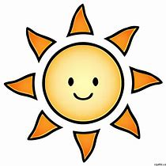  AM  Bathroom:  - Wash hands and face  - Brush teeth  - Brush hair  Make my bed  Get dressed  Put washing in laundry basket  Breakfast  *Activity*  Wash hands + Snack  *Activity*  Wash hands + Lunch | My daily routine  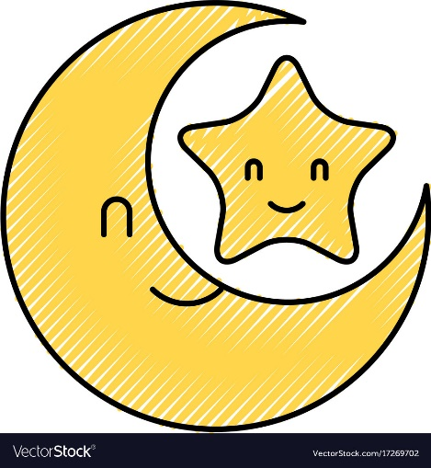  PM  *Activity/Chill out *  Wash hands + Dinner  *Activity*  Tidy up my toys  Put my pyjamas on  Put washing in washing basket  Bathroom:  - Wash hands and face  - Brush teeth  - Brush hair  Read a story  Bedtime

