Using Glow tools at home
What is Glow? Watch this overview video

- Navigate to https://sts.platform.rmunify.com/account/signin/glow on any internet-enabled device.

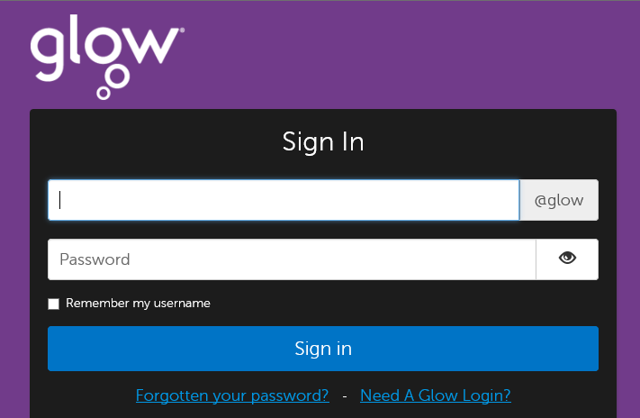

- Your child uses their Glow login details to access the digital learning platform. Their username should be entered in the top box (for example gw14smithjohn) and their password in the bottom box.
Your child will either know their username and password, or these details will have been provided to them by their teacher.

- If your child has forgotten their password then you should fill in this form: Glow password reset request
Within 3 hours, your child’s password will be reset temporarily to changeme1234 and then at next login your child will be asked to change their password to something else.

- When logged in, your child has access to the same apps and platforms that they are already familiar with in school. These look the same as they do in school. These include Google Classroom, Google Drive, OneDrive and Microsoft 365 tools.

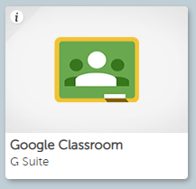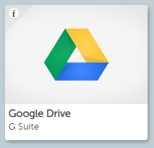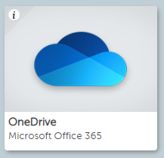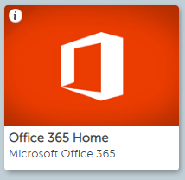

Google Classroom and Microsoft Teams are used in East Renfrewshire schools as digital classrooms, where teachers and students can communicate with each other and where assignments and other learning activities can be posted. Microsoft Teams is accessed via the Office 365 Home tile. Google Drive and OneDrive are online storage apps for files, photos and other learning resources. Files can also be shared between teachers and students in these areas.

It is important to remember that comments in these virtual learning environments should only be between students and teachers. Parents should contact schools through the usual channels (phone or email).

