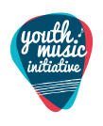

East Renfrewshire Primary Music
2019-2020
Primary 3

The Primary Music team are working with all children in Primary 3 on class music lessons throughout the year. They will be learning a variety of songs and games, rhythms and pitches and learning how to read music. Pupils will be taught rhythms (ta, tete etc.) and pitches with hand signs (la so mi etc.) using the Kodály method.

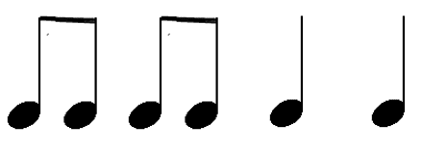

In Primary 3, pupils will be covering the story of ‘Peter and the Wolf’ as their listening unit and pupils will learn about various instruments of the orchestra.

This is a progressive music course and we hope your child will share some of their learning with you. Our Primary Music Service is funded by Youth Music Initiative and we thank them for their continued support.

If you have any questions about our Primary Music courses or want any further information, please contact Donald Finlayson (Music Service Manager) on 0141 577 3835.

Many thanks from the Primary Music Team
(Mrs Carey, Mrs Duggie and Mrs Lyall)
East Renfrewshire Music Service

