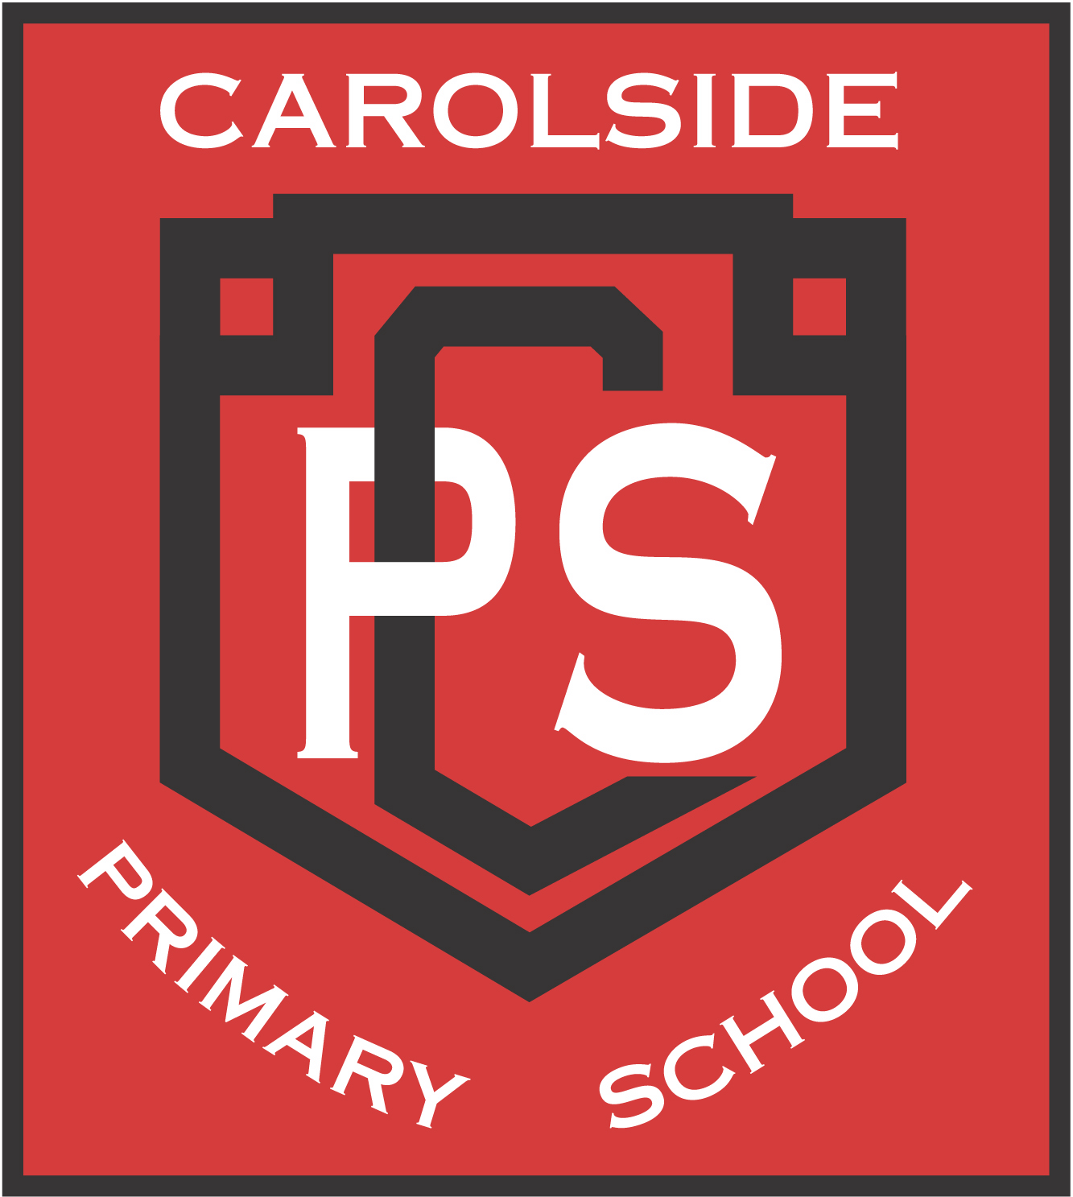

Carolside Primary School

Code of Conduct

1. Respect everyone and everything.

2. Treat everyone fairly, in the way you would like to be treated.

3. Be kind to others and remember our zero tolerance to bullying behaviour.

4. Use kind words and kind hands at all times.

5. Always put litter in the bin to maintain our Eco Schools status and care for the environment.

6. Move quietly and carefully around the school for everyone’s safety.

7. Ensure everyone feels included at Carolside.

8. Always strive to do your best.



Our Code of Conduct was written by our pupils, in consultation with the staff of Carolside Primary School. Close reference has been made to the UN Convention on the Rights of the Child:

* Every child has the right to have a say in all matters affecting them and to have their views taken seriously. (Article 12)
* Every child has the right to freedom of thought and religion. (Article 14)
* Every child has a right to an education. (Article 28)
* Discipline in schools must respect children’s dignity. (Article 28)
* Every child has the right to relax, play and join in a wide range of activities. (Article 31)