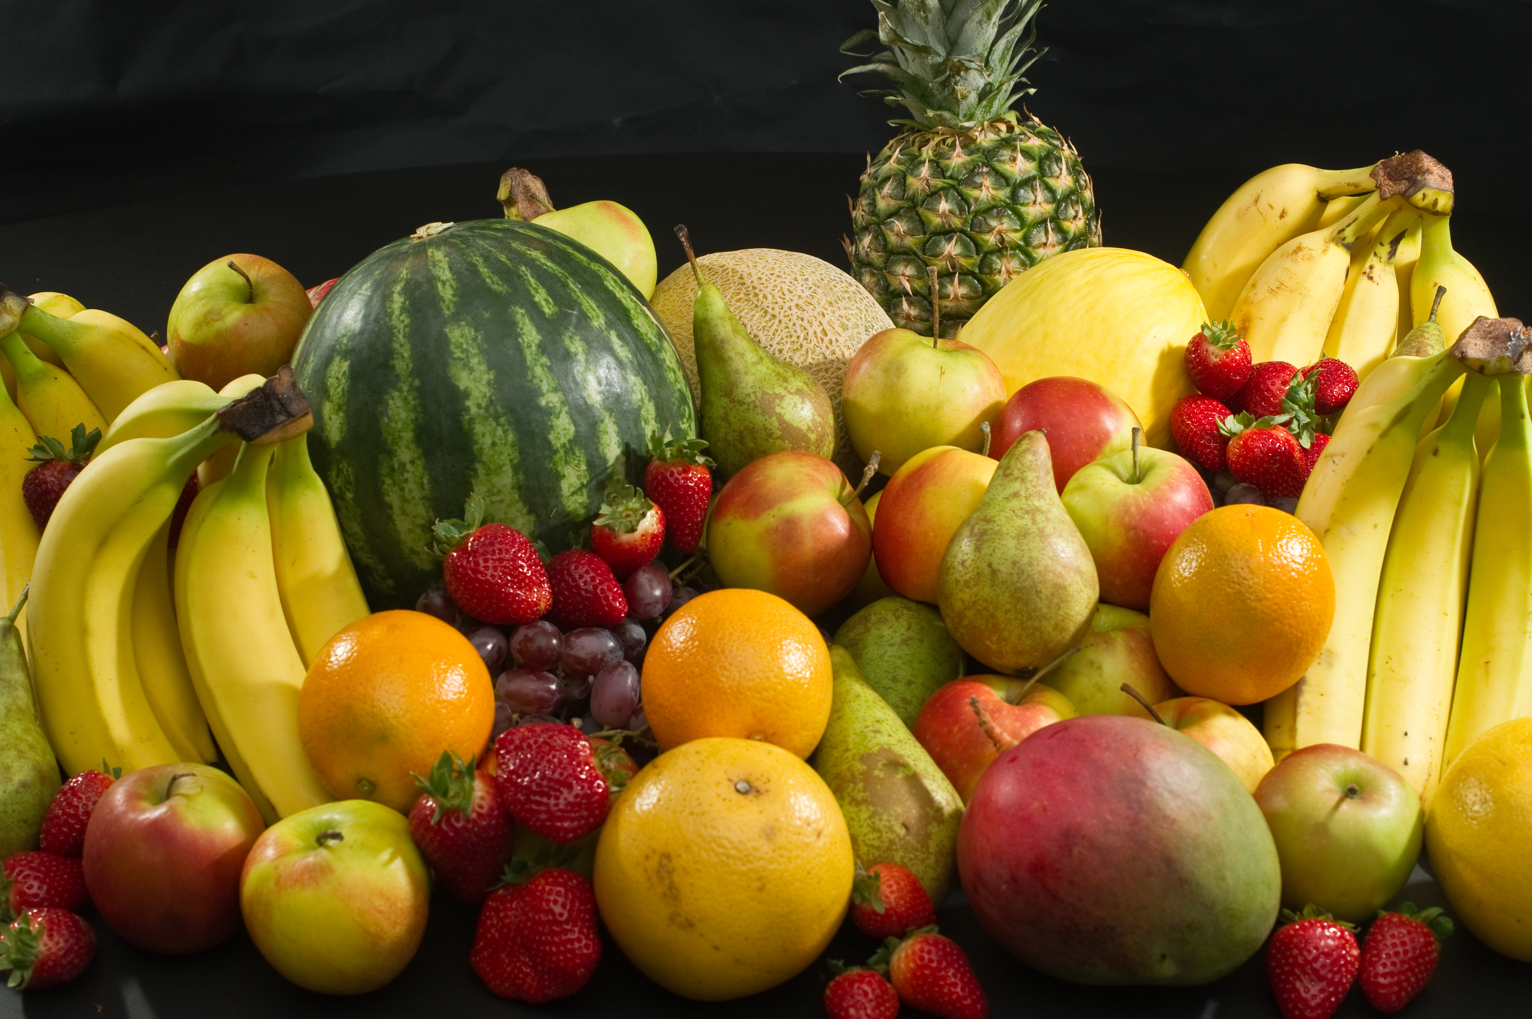
Every day in nursery children talk and learn about healthy eating and demonstrate their learning by growing in confidence in making healthy food choices during snack routines and in their conversations with peers and staff.
Children follow a set routine at lunchtime which makes the whole experience a pleasant and enjoyable one.
The lunchtime routine goes like this:
- Before lunch children are encouraged to use the toilet and then to wash their hands.
- Afterwards the children will collect their pack lunch, staff will offer assistance to any children requiring help in opening their lunch boxes and its contents.
- While lunch is being eaten, the children and staff converse amongst themselves about following good routines, what they’ve been doing that morning or any relevant topic of conversation.
- Children who are finished their lunch are encouraged to tidy their place at the table.
- Children can then request to leave the table to play with the activities set out by staff.

As children only have a short time to eat their lunch so it’s best if they are not given too much food. A healthy lunch might be One/two small sandwiches/wrap/bagel or a wholemeal roll
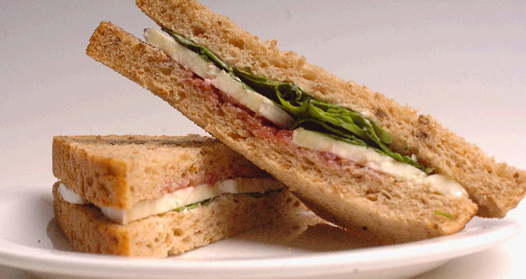
A small yoghurt or fromage frais
Pieces of fruit. if sending grapes, please cut lengthways to prevent choking.
A non-fizzy drink (low or no sugar)
A piece of cheese.
We know that not all children like to eat a sandwich and might prefer to eat: Vegetable sticks / pasta / crackers and cheese.
If providing hot food for your child, please use a thermos bowl as we CANNOT REHEAT food.
Please provide a snack clearly marked as such in their lunchbox. don’t leave this snack in their backpack, as we can’t always monitor children going in and out of each other’s bags during the session therefore can’t control allergy prevention.

As we are a health promoting nursery we ask that you support our ‘Healthy Eating Policy’ by discouraging your child any chocolate bars/biscuits or chocolate yoghurts/sweets. Children learn that these are treats to have with their family at home.
We are also a ‘NUT FREE’ nursery as some children can have varying degrees of nut allergy which can be very harmful to a child. So no Nutella, hazelnut wraps, Kinder Bueno etc. (please check labels).

Remember to place an ice pack into your child’s lunch box to keep food fresh.

We hope that current parents will continue to support our Healthy Eating Policy, and our new parents will join us in promoting healthy habits.

Thanks for your co-operation.

Louise Wright
Senior Child Development Officer

