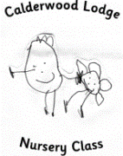 | Forest Schools  March 2016

Mon. | Tue. | Wed. | Thu. | Fri. | Sat. | Sun.
 | 1 | 2 | 3 | 4 | 5 | 6
 | AM: Group 3  PM: Group 5 |  | AM: Group 2  PM: Group 6
7 | 8 | 9 | 10 | 11 | 12 | 13
 | AM:  PM: Group 4 |  | AM:  PM: Group 1
14 | 15 | 16 | 17 | 18 | 19 | 20
 | AM: Group 3  PM: Group 5 |  | AM: Group 2  PM: Group 6
21 | 22 | 23 | 24 | 25 | 26 | 27
 | AM:  PM: Group 1 |  | AM:  PM: Group 4
28  LL:  HH: Dawud  NN: | 29 | 30 | 31
LL
notes

