***Calderwood Lodge Primary School***





***Newsletter 1***

*Dear Parent/Carer,*

*We have had a very busy first few weeks in our new building. The staff and pupils have settled well and have found their way around with ease!*

*A very warm welcome to our new Primary 1 pupils and their families and to the new pupils and families who have joined us at other stages in the school. I hope you already feel like part of the Calderwood Lodge community.*

*Our newsletters will continue to be published monthly and will contain examples of things that have been happening in our school alongside reminders or information for parents and carers.*

*Please follow us on Twitter @CalderwoodLodge and visit our class blogs for regular updates from our school.*

*Kind Regards,*

*Marion Carlton*

*Head Teacher*

**Staffing**

This year we have welcomed a number of new staff to Calderwood Lodge:

Mrs Tracey Davie

Mrs Carol Stevenson

Mrs Madihah Ajmal

Mrs Ann Turner

Mrs Michele Liddle Pupil Support Assistant

Mrs Emily Moyce Pupil Support Assistant

Mrs Claire Nisbet Class Teacher

Mr Onder Ozdemir Class Teacher

Miss Amy Berrett Newly Qualified Teacher

Mr Tam Edgar Senior Janitor

We are delighted to welcome these new members of staff to our team. We also welcome Mrs Gayle Santi back after her maternity leave.

**Parent Pay**

East Renfrewshire Council operates a cashless catering system for primary school pupils. Parents can top up their child’s lunch account and pay for trips online. We would ask that parents **do not** hand lunch money into the school office.

*Miss Darling*

**Diary of Events**

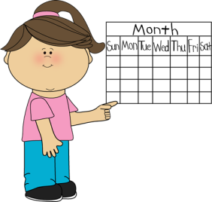We have issued a diary of events to all families. This diary has all of the events across our school year. Please keep it somewhere handy at home. As new events are planned we will e-mail messages to allow you to add these dates to your diary.

**Dressing for Excellence**

The pupils are all looking very smart in their uniforms. In line with the ‘*Dressing for Excellence’* policy, the uniform at Calderwood Lodge consists of the following:



* Blue blazer/dark jacket
* Grey trousers/skirt
* White shirt
* School polo shirt (P1 *only* *on PE days*)
* School tie
* Blue cardigan/jumper
* Black shoes not trainers

In addition to this, Jewish boys should wear a kippa (all boys are encouraged to wear a kippa during prayers). The school office has a stock of kippot with the school badge on if parents wish to purchase one.

Our PE kit is navy or black jogging trousers, shorts or leggings and a t-shirt in your child’s house colour. Vest tops are not suitable for PE. All jewellery must also be removed on PE days.

**School Lunches**

In line with Scottish Government legislation, all pupils in P1, P2 and P3 receive free school meals. For pupils in all other classes lunches cost £2 per day. Please ensure your child’s account is topped up to cover the cost of lunches. If a child has no money in their account we can issue a **maximum** of 3 vouchers, after this your child will be unable to order a school lunch and the office will contact you to either top up their account or bring in a packed lunch.

Copies of the menus can be found on the East Renfrewshire and school website. If you send in a packed lunch please ensure you follow our Kosher guidelines. As we have a dairy kitchen pupils should not have any meat or shellfish in their packed lunches.

**Class Blogs**

The class blogs have been moved on and are updated weekly by the pupils and staff to share the learning that has taken place. Our Blogs can be accessed via the school website.

*Mr Robson*

**Communication Folders**

Every child in Primary 1 to Primary 7 has been given a new communication folder. Any communication from the school will be put in here. Please check these folders regularly and return permission slips to the school promptly.

*Miss Darling*

**Festival Assembly Programme**

Celebrating Jewish festivals is an important element of our school ethos and culture. Each class will take responsibility for preparing and leading an assembly for a festival over the school year. Details of who is leading which assembly can be found in the *Diary of Events* issued to pupils last week. Parents are welcome to attend the assemblies that their children’s class are leading; we would ask that you telephone the school office that week if you are going to attend.

*Mrs Rosenberg*

**Water Bottles**

Pupils are encouraged to bring water bottles to school to ensure they stay hydrated during the day. Water bottles should contain water only and not juice. We have water machines in school to allow the children to refill their bottle if they need to.

**Meet the Teacher**

Thank you to all of the parents who have attended our Meet the Teacher afternoons, I hope you enjoyed the tour of our new school. We will issue a short evaluation soon to allow us to review and adapt these events to meet the needs of parents.

**Baby News!**

Miss Ross finished for her maternity leave on Tuesday 22nd August. We wish her well and look forward to welcoming her new baby soon.

**Students**

Over the session we will welcome students from Glasgow and Strathclyde Universities who are undertaking their B.Ed or PGCE teaching qualifications. These students are always a great support to the class teachers and the pupils benefit from having an additional member of staff during teaching times.

**Head Lice**

Head lice can be common in children of nursery and school age. Head lice can’t be prevented but regular checking ensures early detection and treatment if necessary. The best detection method is wet combing. Parents should aim to check their children’s hair once a week during hair washing. All you need is your usual shampoo, ordinary conditioner and a louse detection comb. Local pharmacists will provide parents with the latest guidance on treatment.

**School Library**

Mary Dickie from Library Services very kindly set our library up for us. A few parents have volunteered to run our lending library for us. Mary will deliver training to the parents over the next few week then children will be able to borrow books to read in class and at home. If your child is not a member of their local library you might want to consider joining to support us in developing a love of reading among our pupils.

**Morning Drop Off and Afternoon Collections**

I have noticed a number of children being dropped off quite early for school. Archie will open the gates to give access to the playground at 8:30am; parents are advised not to drop children off before this as they as will have no access to the secure playground before this time. If parents need to drop off before this time I would recommend contacting Clarkston Afterschool Service who run the breakfast club in school.

I know that a few families are relying on elder sibling at Mearns Castle for the end of day pick-ups, on the days that Mearns Castle finishes at 3:45pm we have had children staying at the office until their brothers and sisters collect them. Again we cannot provide a childcare service at this time and I would recommend parents contact Clarkston Afterschool Service or make alternative arrangements.



**Lost Property**

There is a lost property basket in our school reception area. Our aim for the year is to try to keep it empty. Things do get lost from time to time, to help us return items to their owners please put your child’s name on everything especially water bottles, lunchboxes and pencil cases. Any unclaimed items will be donated to charity at the end of every month.

**Primary 1 Siddurim Presentation**

On Friday 1st September Primary 1 pupils were presented with their own copy of *The Tribe Siddur for Young Children & Familie*s. The siddur contains tefillot (prayers) for Shabbat and our Brachot (blessings). A huge thank you to Rabbi Rubin for presenting the siddurim to the children. It was lovely to see so many parents and family members join us to celebrate this special day. Parents are more than welcome to join us any Friday for Kabbalat Shabbat.

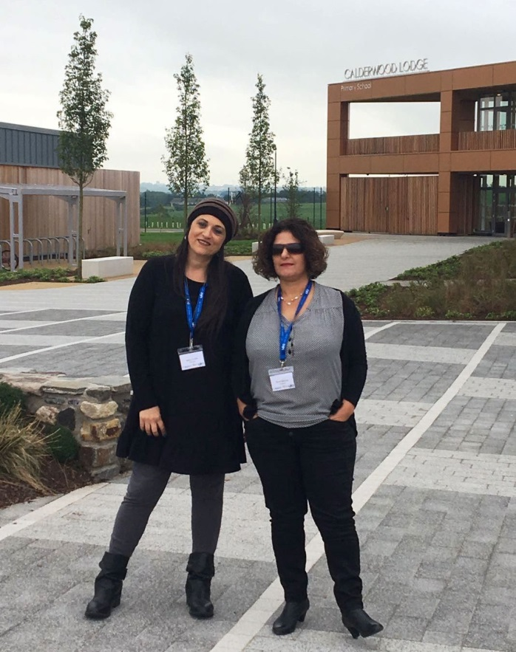**UJIA School to School Partnership Programme**

We welcomed the headteacher and English teacher from our partner school, Arazim, on the 21st August. Ronit and Nava spent 3 days in our school learning about the Scottish Education system, getting to know the staff and pupils and planning our partnership programme for the year ahead.

During their visit they were very impressed with our pupils and commented on how polite and welcoming they were. We were also able to show them a bit of Glasgow and the local countryside! Mr Guetta took them to Loch Lomond where they were amazed with the Highland cows. We also took them on the Glasgow open top bus tour and thankfully it stayed dry.

Mr Guetta and Mrs Fraser will be part of the UK delegation of teachers visiting Israel in October. This partnership has been really positive and supports our Hebrew and Israeli education programmes by giving the children a real life context for learning.

**Aron Kodesh and Bimah**

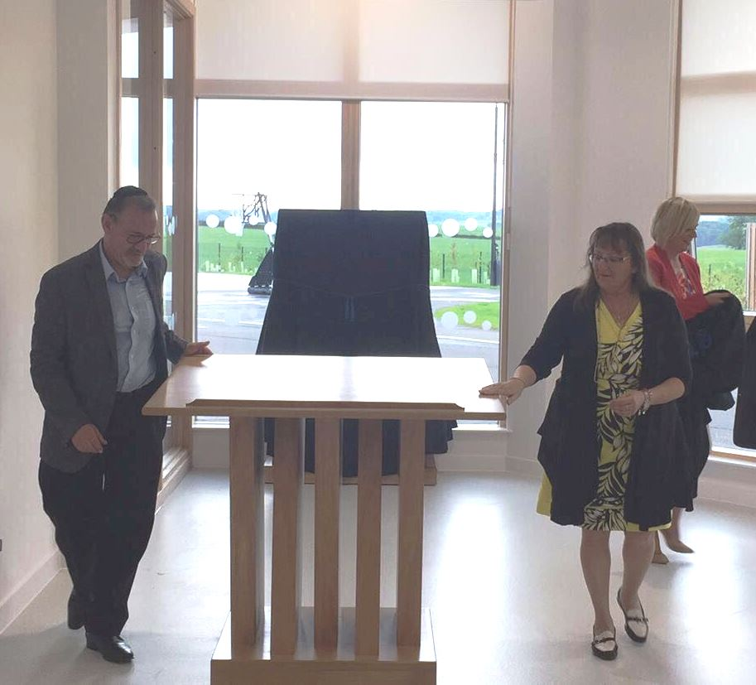The Berkley Foundation made a very generous £5000 donation to the school to fund a new Aron Kodesh and Bimah for the school. On the 23rd August we had a special assembly attended by Adam and Delia Berkley who unveiled these very special pieces of furniture. Fred Berkley was one of the original founders of Calderwood Lodge Primary so it is fitting indeed that his memory lives on within our new building.

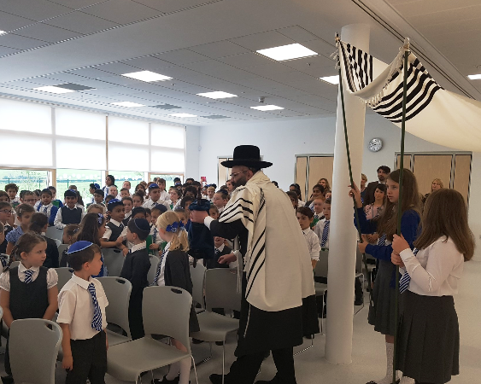Clarkston and Netherlee Trust also donated a new Sefer Torah to the school, during the assembly Rabbi Rubin brought the new Sefer Torah to the school and placed it in our beautiful new Aron Kodesh.



|  |  |
| --- | --- |
| **Important Dates for your Diary** | |
| Thursday 7th September | P6 Diversity Day outing |
| Friday 8th September | P3 whole class Kabbalat Shabbat |
| Wednesday 13th September | P7 parent Amsterdam trip information evening – 7:30pm |
| Thursday 14th September | Parent Council AGM – 7pm |
| Wednesday 20th September | P7 leading the Rosh Hashana assembly |
| Thursday 21st to Monday 25th September | School closed |
| Tuesday 26th September | School reopens |
| Thursday 28th September | P1 parent curriculum workshop |
| Friday 29th September | Maths work home today |
| Friday 29th September | P6 leading the Yom Kippur assembly |
| Wednesday 4th October | P5 leading the Succot assembly |
| Thursday 5th and Friday 6th October | School closed |
| Monday 9th October | School reopens |
| Thursday 12th to Friday 20th October | School closed |
| Monday 23rd October | In-service day, school closed to pupils |
| Monday 23rd October | Mr Guetta and Mrs Fraser leave for Israel |
| Tuesday 24th October | School reopens |
| Tuesday 24th October | Simchat Torah |
| Wednesday 25th October | P4 parent curriculum workshop |
| Thursday 26th October | Whole school challah bake or Shabbat UK |

***We value your views***

***Please let us know if you are particularly pleased about something or have any suggestions:***

**Parent’s Name: ____________________________**

**Child’s Name: _____________________________**

*Please return to the school office.*

*Thank you!*