Busby Primary School

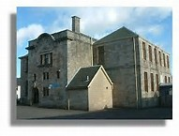

School Travel Plan
2017 – 2018

1. Introduction

1.1 School Description

- Busby Primary School
- Type of school - Primary

- Age range of pupils – 4-12 years

- Approx. 300 pupils on the school roll.

- Number of staff members employed at the school - 20

- The boys and girls must live within Busby to attend the school.

- School begins at 9:00am and finishes at 3:00pm

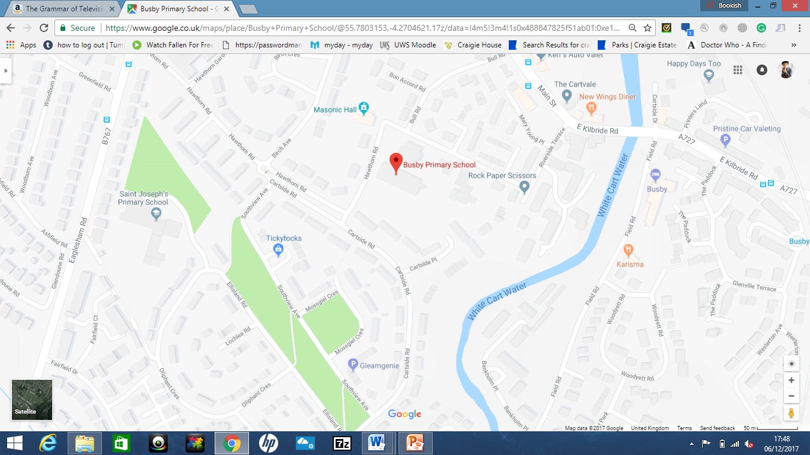

2. Current Situation

2.1 Current Travel Patterns

- A survey was carried out by the Junior Road Safety Officers in September 2017 to find out how pupils arrived at school in the morning and travelled home in the afternoon.

- The school is currently running 2 campaigns to encourage children and families to walk, park and stride and either scooter/cycle to school.

 | Walk | Cycle | Bus /Train | Car / Taxi
How pupils usually travel to school* | 120 (47%) | 5 (2%) | 0 | 128 (51%)
How pupils usually travel from school* | 122(48%) | 24 (9%) | 0 | 112 (43%)
Preferred travel mode* | 107 (42%) | 47 (19%) | 10 (4%) | 89 (35%)

Number of pupils / parents surveyed | 253
Number of responses received | 253

Figure 1

Figure 1 above shows how pupils travel to school in the morning.

Figure 2
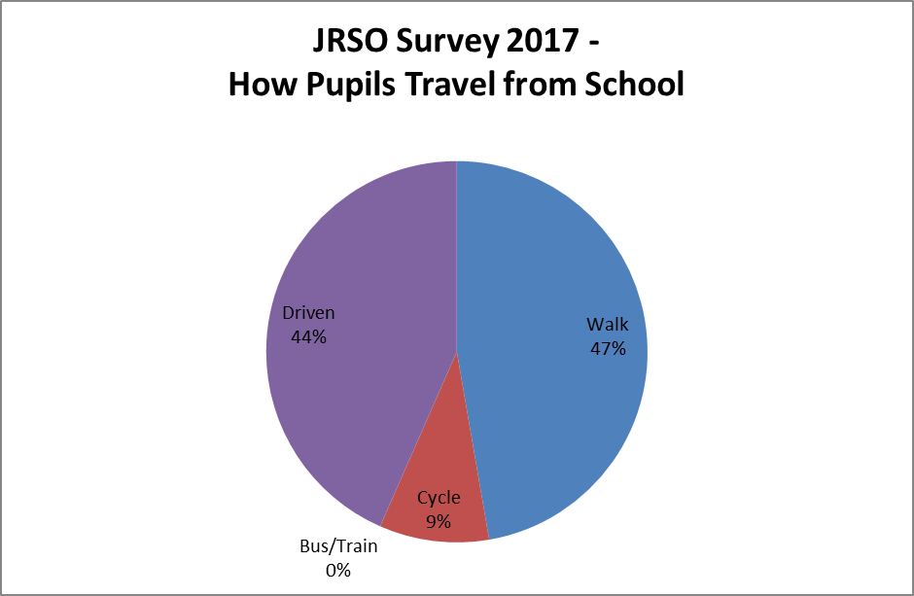
Figure 2 above shows how pupils travel home from school in the afternoon.
2. Current Situation

2.2 Issues and Problems

- The school has 3 pupil entrances on the fence surrounding the main building of the school. There are no steps to these gates and are assessable to all as they are suitable for buggies, bikes and wheelchairs. There is a ramp which leads to an electric door located on the middle of the building (ASN access) and there is another main door entrance located on the front of the old building which has 3 steps leading up to it.
Vehicles can enter the school playground if need be by opening the double gates located at the front of the school.

- The school has a staff car park which can park up to 13 cars located beside the school field. There are currently plans to develop this car park and increase the parking spaces in 2018. There is no car park or spaces available for visitor parking, however there are often spaces on the streets adjacent to the school.
There is a bike shed for pupils and staff who cycle to school with poles to secure bikes to.
There is a train station located 500m away (Busby) and a bus stop within 500m both located on East Kilbride Road.

- During school start and closing times there is often traffic congestion surrounding the school which causes a hazard on the sharp corner adjacent to the school.

- There is a sharp corner outside the school which poses as a danger as if cars on parked on the right hand side of the road, children struggle to see round the corner. The road is not very wide and when cars are parked on both sides, it can create a passing issue between cars.

- The busiest places are outside the school main gate at 3:00pm. There is often congestion on the road and the pavement is congested with families.

- Currently there are no transport issues affecting participation in after school activities.

- Issues affecting the local community are cars being blocked in, drive ways blocked, cars parking on the pavement preventing pedestrians to pass in particular wheelchair users and families with pushchairs.

- The school in 2018 will be undergoing renovations and new buildings being built. This may create increase in road traffic and cars being parked as the staff car park will be out of use.

2.3 Current Achievements

- Policies already in place are:
- Bikeability - about gaining practical skills and understanding how to cycle on today’s roads. Bikeability gives everyone the skills and confidence for all kinds of cycling and the children at Busby feel that they learn many life skills from completing the bikeability programme.
- Walk to school week
- Travel tracker which is used in Busby to record how the children arrive at school on a daily basis. The children insert their own method and they can be rewarded with a badge at the end of the month if they walk a certain number of times.

3. Preferred Situation

3.1 School Travel Plan Objectives

- To reduce unsafe parking i.e. parking on the zig zags outside the school and on the pavements.
- To encourage parents to park and stride and park on streets 500m distance away from the school.
- To encourage more children to cycle to school.

3.2 School Travel Plan Targets

- To reduce car use by 10% over the first three years of the travel plan.

- To increase the proportion of pupils cycling or walking to school by 8% after one year.

- The increase the amount of students who park and stride by 10% in the first year.

4. Implementation

4.1 School Travel Plan Partnership

- Roles and responsibilities of the various parties involved;
- Junior Road Safety Officers (JRSO), Road Safety Officer – Mrs Forsyth – Her role is to oversee all Road Safety matters within Busby Primary School and look at new initiatives to reduce traffic and increase safety around Busby Primary.

- School crossing patrol and school janitor – their role is to ensure that children cross the road safely on a daily basis to arrive and leave at school.

4.2 Consultation

- Opinions and ideas were communicated through hold meetings with the JRSO team, presenting to the parent council and survey carried out around the school involving pupils and teachers.

- Pupils, teachers, neighbours of the school and parents were consulted.

- The outcomes of the consultations were extremely positive. Following presenting to the parent council, they have been an instrumental factor in supporting the safe parking plans. Children are also keen to encourage their parents to drop them off further away from the school. Children are also motivated to received reward by cycling to school.

- Evidence of consultation in the appendix.

4. Implementation

4.3 Action Plan

What is to be done | Who is responsible | Cost | Funding source | Timescale for completion
Continue to provide and maintain Bikeability to P6 children. | Emma Harris | Free | East Ren Council and Cycling Scotland. | Yearly
The children in P7 will be producing a leaflet to encourage families to park and stride to school and they will be looking at suggesting safe parking zones. | Brydon Forsyth  East Ren Road Safety dept. | Met by East Renfrewshire Council | Paths for All | Jan – Feb 2018
The school will be promoting cycle or scoot to school day every Friday. The JRSO will be patrolling the playground and they will be handing out stickers to anyone who cycles or scoots to school and when they have received 10 stickers they will receive a certificate. | Brydon Forsyth | Free | NA | Ongoing from Dec 2017
The school will participate in walk to school week in May 2017. | Brydon Forsyth | Free | Packs provided by East Renfrewshire Council | End of May 2017
The children will be asked to design a Road Safety Logo as part of Road Safety week.  The JRSO’s will be leading 2 road safety assemblies to participate in road safety week. | Brydon Forsyth | Free | Free | Nov 2017
The whole school participated in the Road Safety calendar competition ran by the LA. | Brydon Forsyth | Free | Free | October 2017
P7 will participate in a road safety transition programme looking at ways of using active travel to get to secondary school and planning a route. | Brydon Forsyth  Craig Dalziel  (East Ren Road Safety) | Met by East Ren Council | Paths for All | June 2018
Continue promotion of Road Safety through assemblies and other activities. | JRSO’s and Brydon Forsyth | N/A | N/A | Road Safety Week – November 2017 and throughout the year.

5. Monitoring and Review

5.1 Monitoring process

- The next surveys will be carried out quarterly therefore the next surveys will be carried out in February 2018.

- Mrs Forsyth will be responsible for ensuring the survey will be carried out.

- Survey results will be communicated on the JRSO blog and on the school twitter account.

Travel Plan Agreement

We support the content of our School Travel Plan.

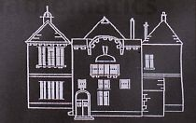

Name Position
Brydon Forsyth Class Teacher and JRSO Leader

Craig Dalziel Road Safety Assistant, East Renfrewshire Council

Busby Primary Junior Road Safety Officers

