How to Upload Photos to Google Classroom Using Google Slides

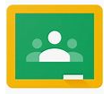

Using a webcam to upload your work:
You can submit any type of media to Google Classroom: photos, videos and audio. There are a few different ways to do this. You can submit the photos as an “Add” using the paper clip icon however, when you do it this way you have to open each photo individually and depending on your device this can take time. I will give you some suggestions on how to upload documents. Again, choose the way that works best for you. If you have one photo, using the “Add” option would be your quickest way.

Google Slides
Within Google Classroom is a tool called; Google Slides. It may be helpful to think of this like a blank piece of paper that children can collaborate with their teacher on, if appropriate.

From a tablet or a mobile the children (or the adult helping them) should click on “Add attachment” and can choose “New Slides” from the list of options.
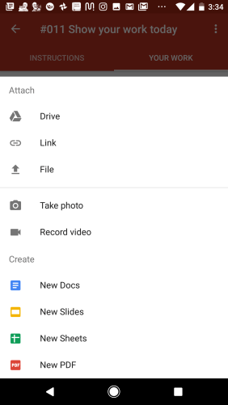

If using a Chromebook or a laptop, students click on the “Create” button and choose “Slides.”
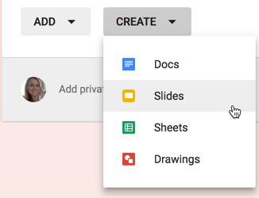

You Can Use a Webcam
The easiest way to attach an image of the children’s work is by using the camera or webcam attached to the device they are using. This eliminates a stage of saving the date to Google Drive. This may not be possible in all cases but if you are using your webcam please follow these instructions:
Using the “Add Image” icon click on “camera”.
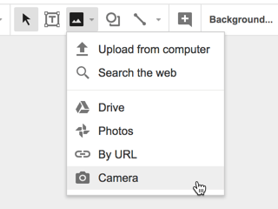
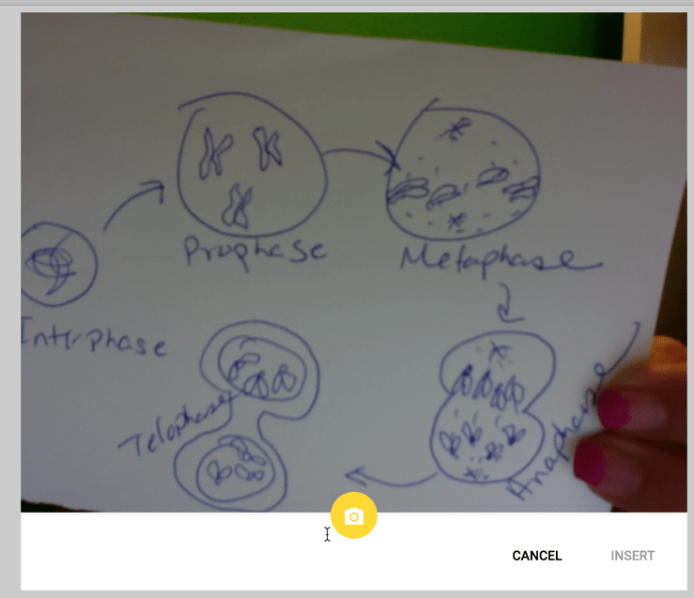

You Can Add a Textbox
Google Slides are multi-media! In addition to a picture or screenshot of their work, students can add a textbox. This allows them to explain and reflect on their work.
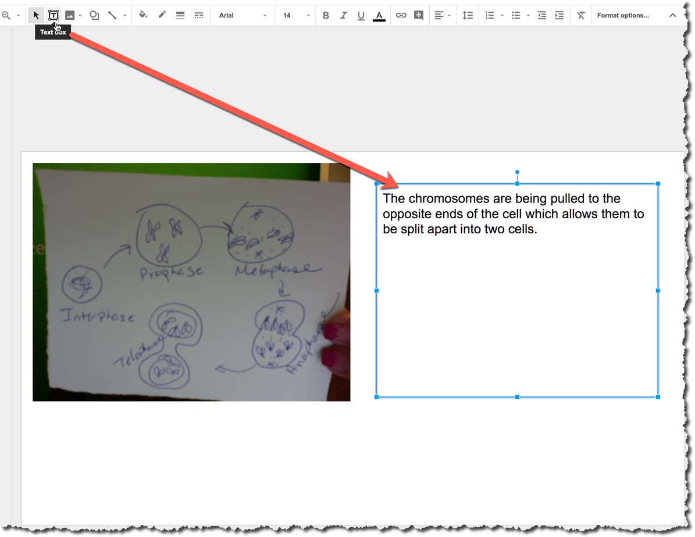

You Can Add More Than One Slide
Google Slides allows the children to add more than one slide to show their work. The benefit of this is all images and comments can be kept together. The pictures will be shown and organised in the order that they have been uploaded; creating a timeline of images and text. This means that from the main class stream there is only document to open which will contain a sequence of images which can show the learning journey.

You Can Add Shapes
Adding shapes to Google Slides allows you to point or draw attention to different parts of your work. Perhaps your child (or the adult helping them) wants to show something to their teacher. The shapes are text boxes. This means that you can immediately start typing into the shape and comment on your work.
