

***Busby Primary School and ELCC***

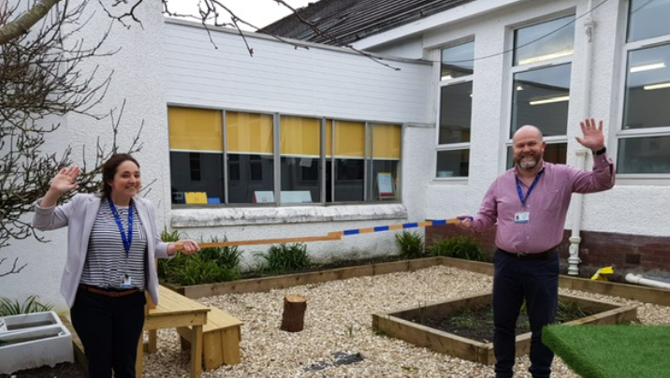

Supporting you to learn at home

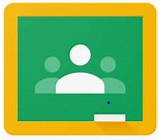

@BusbyPrimary

#BPSlearnathome

To our Busby Family,

Firstly, we would like to extend a warm thank you for your ongoing support in these ever-changing times. Together, we have worked hard to bring our Google Classrooms to life with the same values and ethos which we demonstrate in the school building. The children have embraced this new way of learning and we are very proud of the way in which they are engaging with us. We may not be in the building together but nevertheless, Busby Primary School and ELCC is very much a hive of activity and learning experiences.

We have been so impressed with the variety of learning happening at home and we thank you for sharing these moments with us in the virtual classrooms and on our Twitter feed @BusbyPrimary. Please continue to do this, so we can share the children’s achievements and successes whilst they are a little further away from us. You can also contact us at [schoolmail@busby.e-renfrew.sch.uk](mailto:schoolmail@busby.e-renfrew.sch.uk) and someone will get in touch with you as soon as possible.

Over the last few weeks, we have tried to ensure that we provide a rich range of suggested learning activities for the children to try at home; through Google Classrooms, Twitter and the ‘Family Learning’ section of our school website. Please remember that these are only suggested activities and what suits every family will be different. Remember that home learning should be a small part of your day, not your whole day. In addition to school work this is a useful time to develop further life skills and learn some new crafts. We hope that this guide may collate some of this information, share some creative learning ideas, and help you until we can all be together again!

Stay safe and keep in touch,

From everyone at Busby Primary School.

**Contents Page**

Words of wisdom from the staff Pages 4-6

Healthier Minds Page 7

Social Stories Page 8

Handwashing Page 8

Google Classroom Page 9

Creativity and Imaginative Play Pages 10-11

Games and Activities Page 12

Outdoor Learning Page 13

Acts of Kindness and Friendship Page 14

Getting Active and Staying Fit Page 15- 19

Exemplar Daily Timetable Page 20

Possible Daily Online Activities Page 21

Helpful Websites Pages 22- 23

ELCC Learning at Home Activities Page 24

ELCC Learning at Home Websites Page 25

**Some words of wisdom from the staff…**

“Set yourself a good study routine

“Find opportunities to use your skills at home e.g. help prepare a meal using your maths skills to measure!” Mrs Brysland

and remember to take regular breaks

in between.” Miss Doris.

“Try to do some of your activities outside, like playing Lego or building dens.” Miss Nelson

“Try to get outside and spend some time in nature every day!” Miss Paisey

“Try to have some quiet time for you in a quiet spot in the garden taking in all the nature around you or in your room to read quietly or to do some mindful colouring.” Mrs Thomson.

“Try to learn a new skill or craft- you will have plenty of time to practice! Remember that keeping yourself healthy is the number one priority!”

Mr Weir

“Work, play exercise…repeat!” Miss Wight.

“Be kind to yourself and others.” Mrs Branco

“Life skills are so important. Learn to make a smoothie, try out a new recipe, help in the garden, cook a meal, how to sew or build using real tools (with some adult help!). Mrs Houston.

“We don’t grow when things are easy; we grow when we face challenges. We see you grow every day and we are very proud of everyone. Keep finding new ways to face those challenges and growing together.” Mrs McRobb

“Remember that everyday activities count as learning. For example: baking cooking, building with Lego, cleaning and doing chores.” Miss McVitie

“Create yourself a little reading nook, either in the house or garden, and set aside time each day to get lost in your favourite book.” Mrs Reid

“Set yourself a challenge to learn a new skill, whether that is to learn how to make a cup of tea, hoover or try a new recipe. There is learning in everything that we do.” Miss Morgan

“Include mindfulness in your daily routine; waken up all of your spidy senses!” Mrs Small

“Enjoy spending this unique amount of time with your family. Treat each other e.g. massages, read to each other, make a game for someone to else to enjoy like an obstacle course.” Mrs Guy

“Before you go to sleep at night take 5 minutes to think about, talk about, or write about 3 things that you are grateful for that happened that day. If you keep it in a diary it’s a lovely thing to look back on.” Mrs Farrant

“Find some time in the day to be gentle and kind to yourself or to do something gentle and kind for each other.” Miss Cairnie

“Reading gives us a place to go when we have to stay where we are. Pick up that favourite book and let it transport you to a new and exciting place!” Mrs Mc Nee

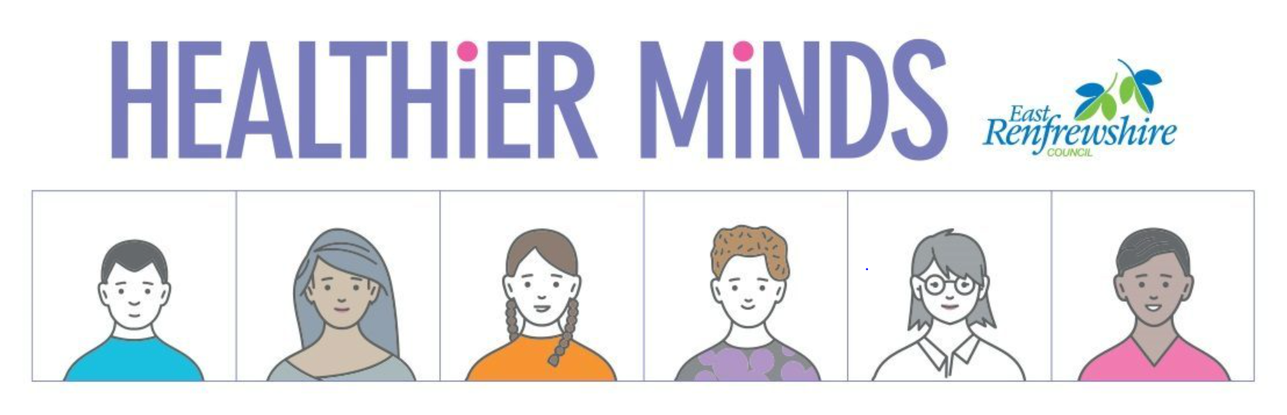

Above all else, the mental and emotional wellbeing of your family is our absolute priority during this time. This year, Educational Psychologists from East Renfrewshire Council created the very useful [Healthier Minds Website](https://blogs.glowscotland.org.uk/er/healthierminds/). Here you can find relevant information to support your children, and wider family, through this ever-changing time.

**Talking to Children and Young People about Coronavirus**

Children will remember how they felt during this time. Giving them the time and space to talk about their feelings and thoughts will be very useful for them. Often it can difficult for us to know what to say or how to say it, you may find some of these statements helpful. You know your child the best but remember there is lots of places that you can find support too! Even for adults this is an uncertain time.

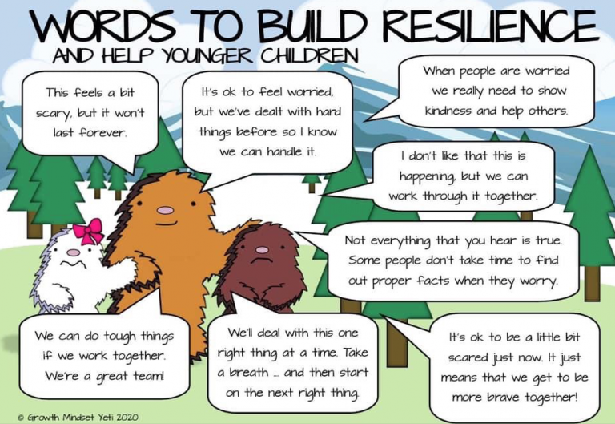

**Social Stories and Visualisation**

For some children and young people, using social stories and cartoons may be the best way to support their understanding of this current situation.  Social stories use simple pictures and words to explain something in a child friendly way.

You can find lots of different visual social stories, to use with all children and young people, here: [Social Stories](https://blogs.glowscotland.org.uk/er/healthierminds/coping-covid-19/social-stories/).

**Hygiene and Handwashing**

Explaining the importance of hygiene and hand washing is especially important right now for children and young people to keep themselves and those around them safe.

Social stories can help children to understand how to apply infection control independently.

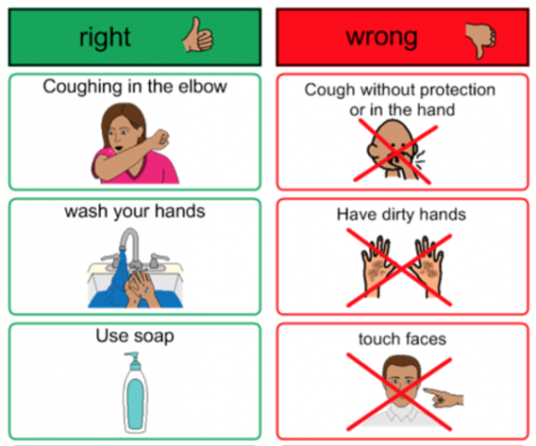

The NHS has some very useful guidance for correct handwashing techniques and this can be found here: [The Best Way to Wash Your Hands](https://www.nhs.uk/live-well/healthy-body/best-way-to-wash-your-hands/)

 **Google Classrooms**

Each day the children’s Google Classrooms will be updated by the class teacher with some suggested tasks or experiences which compliment the learning they have taken part in at school. All children should have their GLOW username and password to sign in but if you need any assistance please contact us via [schoolmail@busby.e-renfrew.sch.uk](mailto:schoolmail@busby.e-renfrew.sch.uk). Try to encourage your child to check in each day; we look forward to hearing from them and enjoy sharing in their learning at home. However, there is no expectation that children should be undertaking formal learning activities all day every day from 9am-3pm. With your child, plan the day out in advance, doing this will help to reduce pressure or anxiety.

The children, with support from home, can access these activities and communicate with their class teacher. You may choose to complete all the tasks each day or pick a few to focus on for a short period of time. This will depend on your child, your family and your circumstances. Not all activities should require direct adult support, plan so that children can undertake some activities independently in order to ensure that you can continue to work at home if necessary. It is important to make sure that your child isn’t sitting working online all day- factor in time for breaks, lunch, shared activities, time outdoors and fresh air. If you feel that your child is losing focus or not engaging, respond to this and take a break. Nothing has to be set in stone.

Please feel reassured that your children are learning valuable life skills through everything they do at home. Whilst a weekly routine is important, the health and wellbeing of all our families is our priority. Do what you can do, when you can do it. This is enough. Short periods of learning with scheduled breaks and time to play and rest with your family is most effective.

This is a new way of learning for us all. We have uploaded some useful guidance on how to use GLOW and Google Classrooms on our website. You can find this information here: [Family Support](https://blogs.glowscotland.org.uk/er/Busby/support-materials/). We will continue to update this where appropriate. Teachers will interact with your child through the online platform that the school is using. They will check in to see how your child is doing, not only in terms of their school work but their general wellbeing. Teachers will provide feedback on completed activities and will be on hand to offer support, advice or reassurance when required. **Please be aware that teachers may not respond immediately, they will be busy working on other activities but will respond when they can between the hours of 9am-3pm.**

**Creativity and Imaginative Play**

Play is a vital part of learning and can also help children to process challenging emotions and thoughts. Play materials and loose parts which are common, household objects are just as educational and can actually be more fun and helpful for promoting imagination and creativity than expensive toys from shops. We have collated some suggestions for alternative toys here: [Household Toys](http://www.hanen.org/Helpful-Info/Articles/Toys-that-kick-start-the-imagination!.aspx). Imaginative play and creativity is important for children (and adults) of all ages! You can find some useful information about loose parts play here: [Loose Parts](https://www.playscotland.org/parents-families/loose-parts-play/)

When playing with children, **particularly young children**, commenting on what you see rather than asking too many questions shows them that you are really interested and paying attention. This really does work – try it! (E.g. “You’ve worked so hard on that. I love the colours you’ve used!”)

It’s never too late to develop your playful, humorous side. You can reclaim your inner child by setting aside *regular, quality* *playtime*. The more you play, joke, and laugh - the easier it becomes. Play Scotland provide some excellent ideas to try at home to encourage creative and loose parts play. You can find this useful information here: [Play Scotland](https://www.playscotland.org/parents-families/im-bored/)

**Other ideas for imaginative play**

Children could be encouraged to use simple ‘junk’ materials to allow them to create and make things using their own imagination. Cardboard boxes/tubes, yoghurt tubs, paper, material and clothes can all be used to create imaginative worlds, toys and objects which allow children to develop fine and gross motor skills as well as problem solving skills.

**Some ideas include:**

Creating a car, boat, rocket or imaginary vehicle. Encourage children to describe an imaginary adventure.

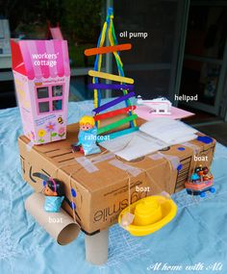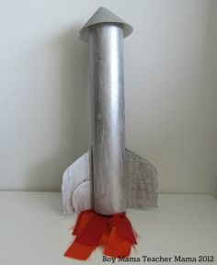

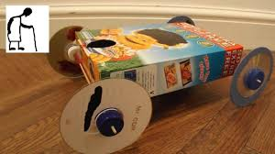

Create a puppet theatre, perform a puppet show, write a script!



Create a robot using cereal boxes and other materials. Make a comic strip telling a story about the robot.

.

Set up a restaurant. Junk could be used to create food and other items like a pizza oven. Children could create a menu and posters for their restaurant and design a logo or uniform.



Design and build a ‘Fairy-tale’ Castle or a house for a character from a story such as ‘3 Little Pigs’

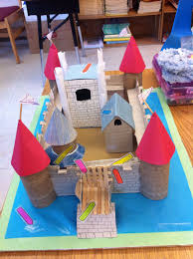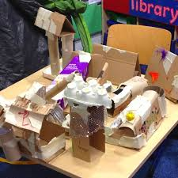

**Games and Activities**

You can create many games and activities up using household objects and a little imagination. Follow your children’s ideas and let them take the lead and make up their own games. Often, they have very unique ideas. They will really enjoy playing with their own creations and teaching others to join in too!

|  |  |  |
| --- | --- | --- |
|  |  |  |
|  |  |  |
|  |  |  |

**Outdoor Learning**

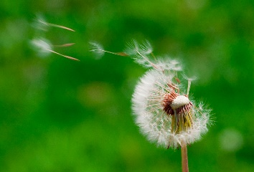

[This Photo](http://commons.wikimedia.org/wiki/File:Blown_dandelions,_green_background.jpg) by Unknown Author is licensed under [CC BY-SA](https://creativecommons.org/licenses/by-sa/3.0/)

Getting outside for some time each day is so beneficial for everyone in your family. Embrace the wonderful weather that we have been enjoying and go on a local family walk or play in your own garden if you have one. Amazing learning can happen in the outdoor environment and nature can often teach us many useful life lessons.

|  |  |  |  |
| --- | --- | --- | --- |
| Find and accurately draw a tree close to your house or in your garden. | Go on a mini beast hunt. How many can you find? Use tally marks or a pictogram to record your findings. | Create a map about somewhere you have walked to this week. Can you add detail and landmarks? | Write an outdoor poem. Use all of your sense to help you. |
| Make a journey stick and add something you find to this each time you go on a local family adventure. | Create a picture or piece of art using natural materials or loose parts. | With an adult, go a walk in the dark. What do you notice? Try to listen and look carefully. Can you spot any wildlife? | Go stargazing. Can you spot any constellations? |
| Keep a moon chart and draw your observations. | Design a nest or home for a bird or small animal. Perhaps you could make a bug hotel. | Write a poem about being out in the dark. What do you notice when it is dark? | Create and decorate some plant pots using recycled materials. |
| Plant and nurture some seeds. If you plant vegetables you can enjoy harvesting them once they grow. | Create a fairy garden in part of your own garden or local green space. | Paint some rocks. You could create rock bugs or paint numbers on them to play games. | Create a natural bird feeder using animal friendly materials. Enjoy watching birds visit your garden. Can you spot a variety of birds? |

**Acts of Kindness and Friendship**

When we are kind to someone it makes them and us feel good. It is important to look after each other, especially when we are all sharing a living space. Kindness and patience can go a long way. Why not try some of these acts of kindness at home and see if you can make someone smile.

1. Smile at someone to cheer them up
2. Write a note or draw a picture to thank a front-line worker e.g. the bin men or NHS
3. Write a nice note to someone in your family
4. Ask someone how their day is going
5. Draw a rainbow or Busbee to put on your window
6. Wave to another child who walks past your house
7. Draw or write about three things you are grateful for
8. Offer to help someone in the house to do something without being asked
9. Compliment someone
10. Help a sibling to do their chores or school work
11. Write an acrostic poem about someone in your family
12. Tell someone in your family a reason that you are proud of them
13. Ask someone you live with what they would like to watch on tv
14. Offer to make someone you live with a snack or a drink
15. Create you own act of kindness and try to do one each day

**Getting Active and Keeping Healthy**

We have included some fun activities to try at home, using equipment that may be available to you or that can be easily adapted. Have fun trying out some new ideas!

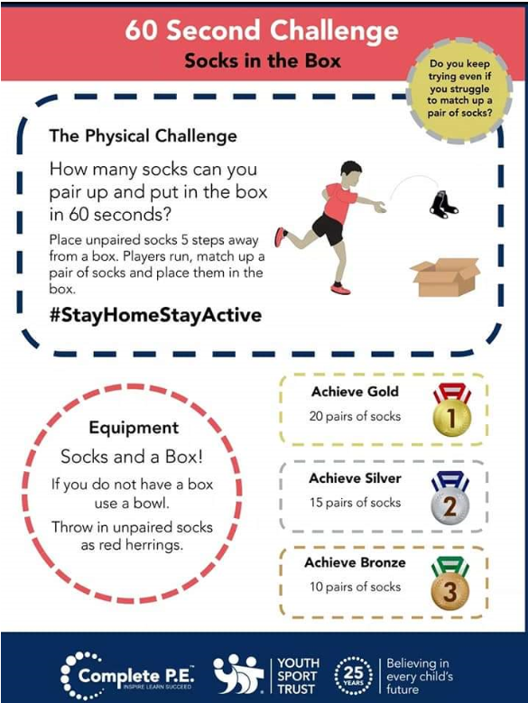

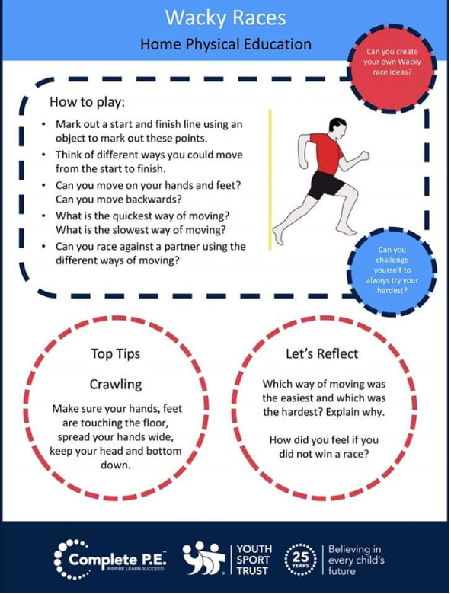

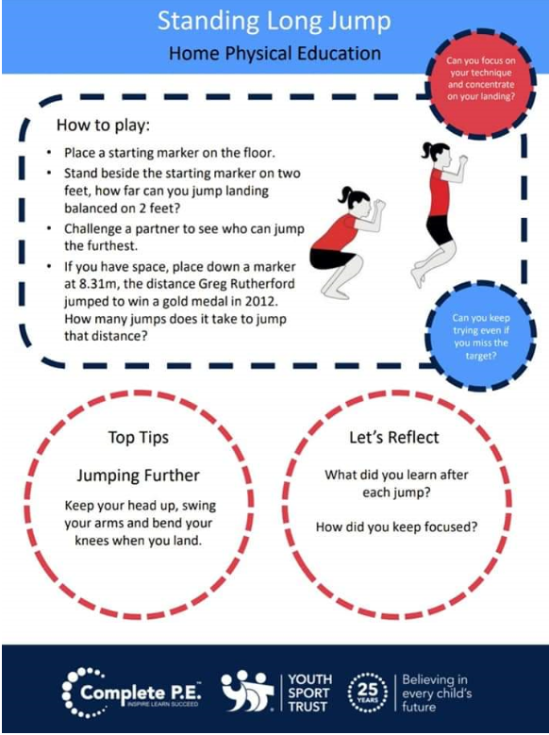

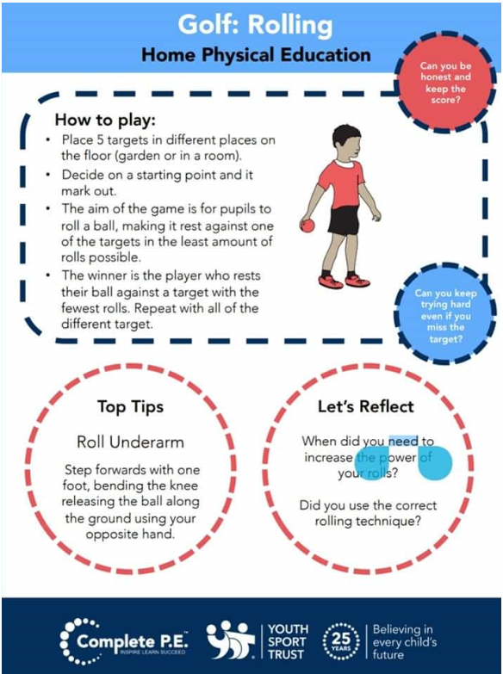

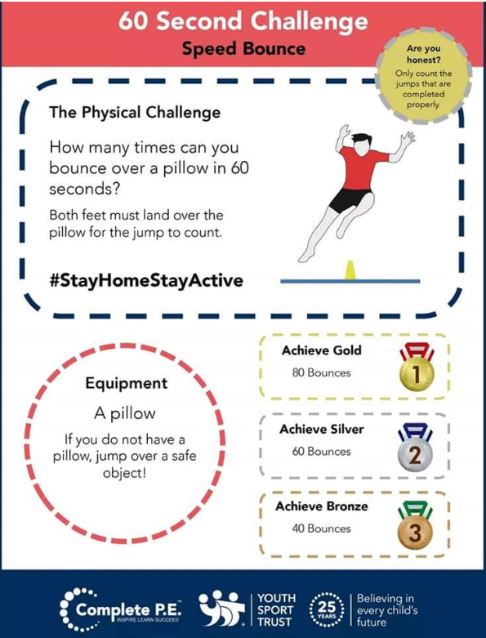

**An Example of a daily timetable**

This is not prescriptive! It may give you an idea of how a day might be structured.

Within the ‘School work block’ you may want to do a selection of the activities that the teacher has set in order to break up the block.

In the ‘Do I need help? column, you may want to discuss with your child and decide between you, the times when they will be able to work independently.

|  |  |  |
| --- | --- | --- |
| **Activity** | **Do I Need Help?** | **What We/I Might Do** |
| Morning Routine | I can do this by myself  I can do this with a sibling  I need adult support | * Have breakfast * Get washed * Get dressed * Brushed teeth * Make your bed * Tidy your room |
| Exercise Time | I can do this by myself  I can do this with a sibling  I need adult support | * Scooter or bike ride * Walk round the block * Indoor exercise – The Body Coach PE Workout * Sensory activities, cosmic yoga, Zen Den * Jacks, running on spot/up and down stairs, squats… * Exercise ideas – see separate page |
| School Work | I can do this by myself  I can do this with a sibling  I need adult support | * School work packs * Numeracy, Writing/Reading- independently/shared * *Include brain breaks and snack to chunk focus time* |
| Creative Time | I can do this by myself  I can do this with a sibling  I need adult support | * Lego, drawing, colouring * crafting, singing, music * cooking/baking together * jigsaw, puzzles, junk modelling * clay/playdoh/plasticine * Help prepare lunch |
| Lunch/Free play | I can do this by myself  I can do this with a sibling  I need adult support | * Controlled Electronics * iPad/Kindle/tablets/computers/consoles |
| Quiet Time | I can do this by myself  I can do this with a sibling  I need adult support | * Relaxing music * Read a story * Watch a TV programme * Play a game * Do a jigsaw |

**Possible Daily Online Activities**

**Remember: Not all activities should be ‘online’ and taking breaks is important.**

|  |  |  |  |
| --- | --- | --- | --- |
| **Time** | **Subject/Activity** | **Link** | **Description** |
| **Live at 9am**  **or view recorded episodes anytime** | **Health and Wellbeing**  **PE with Joe Wicks** | [**https://www.youtube.com/user/thebodycoach1**](https://www.youtube.com/user/thebodycoach1) | Half hour live daily PE video on YouTube with Joe Wicks |
| **Live at 9am** | **Health and Wellbeing**  **Jumpstart Jonny** | **https://www.youtube.com/watch?v=IDuWSTyM8RA** | Very energetic start to the day. Exercise class with Jumpstart Jonny. |
| **9.15am** | **Social subjects**  **Newsround** | [**http://www.bbc.co.uk/newsround**](http://www.bbc.co.uk/newsround) | News programme for children |
| **9:30am**  **10am**  **11am** | **Twinkl Home Learning**  **Age3-5**  **Ages 5-7**  **Age 7-11** | [**http://www.twinkl.co.uk/home-learning-hub**](http://www.twinkl.co.uk/home-learning-hub) | A range of learning activities if you are looking for support |
| **Live at 9:30am** | **Science**  **Wildlife with Steve Backshall** | [**https://www.youtube.com/channel/UCm-URP49TgSgyIU1rgh2m7A/**](https://www.youtube.com/channel/UCm-URP49TgSgyIU1rgh2m7A/) | Live wildlife Q&A on YouTube |
| **Live at 10 am or Interact anytime** | **Maths**  **Mathsfactor** | [**https://www.themathsfactor.com/**](https://www.themathsfactor.com/) | Sign up for free access to Carol Vodermann’s maths website. Let Carol teach your children maths. Age 4-12 |
| **10am live** | **Science**  **Live from Glasgow Science Centre** | [**https://www.youtube.com/user/scienceshowbob**](https://www.youtube.com/user/scienceshowbob) | A series of videos from Glasgow Science Centre hoping to spark your imagination to explore the world |
| **10am onwards** | **BBC Scotland Educational programmes** | **BBC Scotland channel (TV)** | A variety of programmes from across the curriculum see your tv guide for details |
| **Live at 11am** | **Literacy -reading**  **Audio Elevenses with David Walliams** | [**https://www.worldofdavidwalliams.com/**](https://www.worldofdavidwalliams.com/) | David Walliams is releasing an audio story every day for the next 30 days for free. |
| **Live at 12pm** | **Health and Wellbeing**  **Lunch with Jamie Oliver** | [**https://www.jamieoliver.com/features/category/get-kids-cooking/**](https://www.jamieoliver.com/features/category/get-kids-cooking/) | Range of recipes, ideas and videos |
| **Live at 1pm** | **Music With Myleene Klass** | [**https://www.youtube.com/channel/UCQh2wgJ5tOrixYBn6jFXsXQ**](https://www.youtube.com/channel/UCQh2wgJ5tOrixYBn6jFXsXQ) | Join Myleene for her music class |
| **Live at 1:30pm** | **Dance with Darcey Bussel** | [**https://twitter.com/diversedancemix/status/1241098264373592065**](https://twitter.com/diversedancemix/status/1241098264373592065) | Join in for a Facebook shake up |
| **Live at 2pm** | **History with Dan Snow** | [**https://tv.historyhit.com/signup/package**](https://tv.historyhit.com/signup/package) | Free for 30 days |
| **3pm** | **Story time for Home Time** | [**https://www.youtube.com/watch?v=awVpVMHFl5Y**](https://www.youtube.com/watch?v=awVpVMHFl5Y) | James Mayhew author and illustrator tells a story daily |

**Helpful Websites**

Some websites which are offering free subscriptions during school closures can be found here: [Free Subscriptions to Support Learning at Home](http://www.amazingeducationalresources.com/). This is updated on a daily basis and can be accessed at home. We have collated some websites that we find useful to support learning at home. You can also find these on our website under the ‘Family Learning’ tab.

**Daily Lessons**

* **BBC bitesize** [**https://www.bbc.co.uk/bitesize**](https://www.bbc.co.uk/bitesize)

**Outdoor Learning**

* <https://www.outdoorlearningmadeeasy.co.uk/>
* <https://www.ltl.org.uk/parents/>
* <http://www.bbc.co.uk/gardening/gardening_with_children/>

**Numeracy and Maths**

* **Khan Academy** [**www.khanacademy.org**](http://www.khanacademy.org)
* **BBC Learning** [**http://www.bbc.co.uk/learning**](http://www.bbc.co.uk/learning)
* **Maths Bot** [**www.mathsbot.com**](http://www.mathsbot.com)
* **Transum** [**www.transum.org/software**](http://www.transum.org/software)
* **Topmarks** [**www.topmarks.co.uk**](http://www.topmarks.co.uk)
* **Maths Shed** [**www.mathematicsshed.com**](http://www.mathematicsshed.com)
* **Nrich** [**www.nrich.maths.org/primary**](http://www.nrich.maths.org/primary)
* **Maths Playground** [**www.mathsplayground.com**](http://www.mathsplayground.com)
* **Maths is Fun** [**www.mathsisfun.com**](http://www.mathsisfun.com)
* **Oxford Owl** [**www.oxfordowl.co.uk**](http://www.oxfordowl.co.uk)

**Literacy and English**

* **Pobble 365** [**www.pobble365.com**](http://www.pobble365.com)
* **Once upon a Picture** [**www.onceuponapicture.com**](http://www.onceuponapicture.com)
* **The Literacy Shed** [**www.literacyshed.com**](http://www.literacyshed.com)
* **Story Nory** [**www.storynory.com**](http://www.storynory.com)
* **Ted Ed** [**www.ed.ted.com**](http://www.ed.ted.com)

**Digital Learning**

* **Blockly** [**www.blockly.games.com**](http://www.blockly.games.com)
* **Scratch** [**www.scratch.com**](http://www.scratch.com)
* **Chrome Music** [**www.musiclab.chromeexperiments.com**](http://www.musiclab.chromeexperiments.com)

**STEAM**

* **Crash Course Science** [**www.m.youtube.com/user/crashcoursekids**](http://www.m.youtube.com/user/crashcoursekids)
* **Mystery Science** [**www.mysteryscoence.com**](http://www.mysteryscoence.com)
* **The Kids Should See This** [**www.thekidsshouldseethis.com**](http://www.thekidsshouldseethis.com)
* **National Geographic** [**www.natgeokids.com/uk**](http://www.natgeokids.com/uk)

**Languages**

* **Learn languages for Free** [**www.duolingo.com**](http://www.duolingo.com)

**ELCC Early Learning at Home**

Below are some fun activity ideas that could be done at home.

If you wish, you could share pictures of your learning in your learning journal and

[Nursery Blog](https://blogs.glowscotland.org.uk/er/wwbbnursery/) .

|  |  |  |
| --- | --- | --- |
| ***Act Out a Story***  *Act out a scene from one of your favourite books. You could use costumes, props, make your own puppets and even set up a stage!* | ***Mark-Making***  *Find interesting materials to draw and write with. These could be messy materials like paint and mud.* | ***Make Play-Dough***  *Make playdough with*  *2 cups of flour, 1 tsp. salt, 1 tbs. oil and 1 cup water. Add food colouring, glitter or herbs and spices.* |
| ***Missing Number***  *Write out a line of numbers (e.g. 0-10). The adult should cover a number for the child to figure out which number is missing.* | ***Loose Parts***  *Find interesting objects like bolts, marbles and pine cones. Use them to make groups of 5s etc.* | ***Junk Modelling***  *Use up some of the items in your recycling bin to make models. These could be robots, buildings or inventions.* |
| ***Counting Games***  *Counting tins in the cupboard, estimate the number pasta shells in the jar and count the steps in the house.* | ***Threading Pasta***  *Make some jewellery using string and pasta. You can decorate your shells with paint or glue and glitter.* | ***Watch the Clock***  *Keep an eye on the clock for o’clock times. Have a think about the time of day that you do different things like have your meals and go to bed.* |
| ***Matching Coins***  *Find some money and sort the coins into matching groups. Can you recognise the £1 coin? Practise spending your money at the shops.* | ***Sensory Play***  *Fill bowls with different sensory materials like rice, jelly, gloop (cornflour and water), soapy water and cereal. Play in them all, try to describe how they feel.* | ***Take Photographs***  *Take photos of different scenes. This could be family, your toys, plants or interesting patterns.* |

***Below are some useful links for early learning online resources:***

<https://www.storylineonline.net/>

<https://www.bbc.co.uk/teach/school-radio/nursery-rhymes-songs-index/zhwdgwx>

<https://www.bbc.co.uk/cbeebies/games/get-squiggling-letters-mobile>

<https://www.teachyourmonstertoread.com/>

<https://www.oxfordowl.co.uk/for-home/advice-for-parents/fun-ideas-learning-at-home/fun-ideas-ages-3-4/>

<https://www.bbc.co.uk/cbeebies/curations/nursery-rhymes>

<https://www.topmarks.co.uk/maths-games/3-5-years/counting>

[*https://www.funwithspot.com/*](https://www.funwithspot.com/)

[*https://www.nasa.gov/kidsclub/index.html*](https://www.nasa.gov/kidsclub/index.html)

[*http://www.bobthebuilder.com/en-gb/activities/more*](http://www.bobthebuilder.com/en-gb/activities/more)

[*http://www.kidspsych.org/index1.html*](http://www.kidspsych.org/index1.html)

[*http://www.twinkl.co.uk/offer*](http://www.twinkl.co.uk/offer)

*https://www.science-sparks.com/science-and-stem-challenge-cards/*

[*http://www.vooks.com*](http://www.vooks.com)

<http://www.bigbrownbear.co.uk/magneticletters/index.html>

<https://resource-bank.scholastic.co.uk/>

<https://www.learningandexploringthroughplay.com/>

<https://www.youtube.com/user/CosmicKidsYoga>

***Apps***

***The Hello Atlas***

***Bookbug***

***BBC iPlayer Kids***

***Alphablocks/ Numberblocks***