Online Resources
Your child will be familiar with a variety of online resources and websites that are used in school. Here is a selection of worthwhile sites for the different areas of the curriculum that you may want to look at. There is no expectation that children are required to access these sites, they are merely provided as suggestions.
Literacy and English 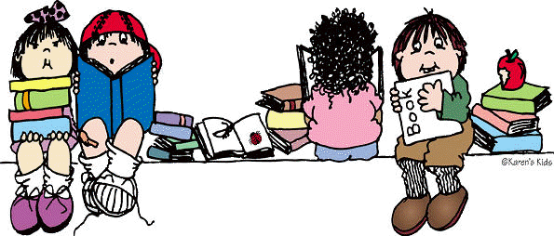

For Pupils

BBC Bitesize - BBC free online study support resource for school aged children. The links focus on a range of Literacy and English resources for learners working at early, first and second Curriculum for Excellence Levels.
https://www.bbc.co.uk/bitesize/subjects/z8rdtfr

Early Level (nursery to end of P1 approx) – https://www.bbc.co.uk/bitesize/subjects/znqtbdm
BBC/Scottish Book Trust Authors Live Watch along
https://www.scottishbooktrust.com/learning-and-resources/authors-live
Bookbug online sessions - https://www.scottishbooktrust.com/topics/bookbug-sessions

First Level P2-4 approx - https://www.bbc.co.uk/bitesize/subjects/zdj2tfr
Second Level P5-7 approx - https://www.bbc.co.uk/bitesize/subjects/z7mtsbk

BBC Teach - Creative Writing Resources for Primary Pupils
https://www.bbc.co.uk/programmes/articles/15y5L5JSCSVvnhpzcpLNjmt/creative-writing-resources

BBC Teach – free Literacy and English resources suitable for primary and secondary school learners.
Primary
Ages 5-7 https://www.bbc.co.uk/teach/ks1-english/z67ncqt
Ages 7-11 https://www.bbc.co.uk/teach/ks2-english/zbrwnrd
Secondary
3rd and 4th level https://www.bbc.co.uk/teach/ks3-english-literature/z47n92p
National 4 and 5 https://www.bbc.co.uk/teach/gcse-national-5-english-literature/z6rjscw National 5 https://www.bbc.co.uk/teach/gcse-national-5-english-language/z69skmn
Doorway Online – interactive online support and activities for spelling https://www.doorwayonline.org.uk/literacy/
BBC 500 words – live lessons with resources
https://www.bbc.co.uk/teach/live-lessons/500-words-2020-live-lesson/zn7jkmn
Letters and Sounds Website
This includes a range of free, online games to develop knowledge and understanding of letters and sounds. Suitable for ages 5-7. The first link provides an overview of the website and the other links provide links to phonic games.
http://www.letters-and-sounds.com/what-is-letters-and-sounds.html
http://www.letters-and-sounds.com/phase-2-games.html
http://www.letters-and-sounds.com/phase-3-games.html
http://www.letters-and-sounds.com/phase-4-games.html
Spelling City -Spelling City’s online spelling and vocabulary games explore spelling, phonics and aspects of writing. https://www.spellingcity.com
The Literacy Shed -The Literacy Shed has a wide range of visual resources linked to a range of different themes. This allows your child to choose a genre linked to their individual interests e.g adventure, history, myths and legends and fun! https://www.literacyshed.com
Topmarks Topmarks has a variety of literacy-based learning games for 3 - 11 year olds. https://www.topmarks.co.uk

BBC Dancemat- supports computer keyboard skills for Ages 7-11
https://www.bbc.co.uk/bitesize/topics/zf2f9j6/articles/z3c6tfr

For Parents/Carers

Read Write Count – Parent Club – features Read Write Count games and challenges parents can use – Primary 1-Primary 3 https://www.parentclub.scot/articles/read-write-count
Scottish Booktrust - useful information and advice on ways to encourage reading from ages 3-14.
https://www.scottishbooktrust.com/learning-resources
https://www.scottishbooktrust.com/learning-resources/encouraging-reading-top-tips-for-parents

Parentzone - contains leaflets, video clips and an e-book to provide support regarding literacy at home
https://education.gov.scot/parentzone/learning-at-home/supporting-literacy-at-home/
National Literacy Trust- Information for parents and families
https://literacytrust.org.uk/parents-and-families/

Questions about Questions: http://www.hanen.org/Common-Questions-about-Questions.aspx
National Literacy Trust – lots of ideas for parents to support their child’s literacy and includes a range of items including, milestones, activities, tips and information as well as recommended books for each of the stages listed below.
Literacy Activities – 3-5 - http://www.wordsforlife.org.uk/3-5
Literacy Activities – 5-7 - http://www.wordsforlife.org.uk/5-7
Literacy Activities – 7-11 - http://www.wordsforlife.org.uk/7-11

Twinkl – free resources for use by schools and parents
https://www.twinkl.co.uk/blog/how-to-utilise-twinkl-during-the-coronavirus-shutdown-a-guide-for-schools

BBC 500 words - (Writing)
Parents and Teachers learning resource pack for story writing
http://downloads.bbc.co.uk/radio2/500words/500words_2020_teacher_pack.pdf

Scholastic – Learn From Home – featuring literacy ideas and much more
https://classroommagazines.scholastic.com/support/learnathome.html

Oxford Owl – Information for parents on Learning at Home. Both teachers and parents can register. Includes a range of ideas, tips, games to play as well as access to free e-books (ages 0-11).
https://www.oxfordowl.co.uk/for-home/advice-for-parents/fun-ideas-learning-at-home/
https://www.oxfordowl.co.uk/for-home/find-a-book/library-page/

Numeracy and Mathematics 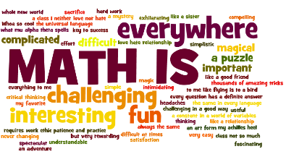

Wild Maths - brand new website from the NRich team for all ages. Free, open access to all. Great games and puzzles that develop problem solving skills
https://wild.maths.org/

Khan Academy -This site has videos and interactive courses for almost every maths topic imaginable. Use the search facility to find the topic your child is working on. https://www.khanacademy.org/math
Corbett Maths -Corbett Maths contains video tutorials and worksheets for a huge number of topics. The best way to navigate is to use the find facility (press ctrl + f) and type in the topic your child is working on. The worksheets all contain a link to the answers at the end. https://corbettmaths.com/contents/
Sumdog - key numeracy skills in a games-based environment. This would be a good way to spend time on numeracy if your child is struggling to access the task that has been set for them. https://pages.sumdog.com/
Oxford Owl - both teachers and parents can register. Games to play, books to read and fun family activities for all ages. Battle of the Robots could be my favourite!
http://www.oxfordowl.co.uk/for-home/ - free registration
https://cdn.oxfordowl.co.uk/2013/08/13/10/58/37/142/Battle_of_the_Robots.pdf

NRich - suitable for primary and secondary pupils. Free, open access. https://nrich.maths.org/

CoolMath4kids – more games and puzzles https://www.coolmath4kids.com/

Maths is Fun - home learning tasks, games and puzzles https://www.mathsisfun.com/

Scholastic Learn at Home - Maths, Literacy, STEM and more... https://classroommagazines.scholastic.com/support/learnathome.html
Family Maths Toolkit - tips on helping your child maths, and family activities too https://www.familymathstoolkit.org.uk/
Play materials which are common household objects are just as educational and can actually be more fun and helpful for promoting imagination and creativity than expensive toys from shops. https://www.playscotland.org/parents-families/loose-parts-play/

Health and Wellbeing
Road Safety: The Scottish Government Road Safety website has ideas for supporting the teaching of this vital skill https://roadsafety.scot/learning/
Think u Know: This website provides information for supporting children to remain safe while online https://www.thinkuknow.co.uk/
Go Noodle – Lots of activities to keep children moving and active https://www.gonoodle.com/
Food a Fact of Life – Free resources for teaching young people aged 3-16 about where food comes from, cooking and healthy eating https://www.foodafactoflife.org.uk/
Twinkl Wellbeing– a range of resources to support pupil self-esteem, help them understand their feelings and the world around them https://www.twinkl.co.uk/resources/ks2-pshe/health-and-wellbeing-pshce-subjects-key-stage-2/health-and-wellbeing-pshe-subjects-key-stage-2
Health for Kids – as resource designed to promote healthy activities for children https://www.healthforkids.co.uk/
Young Scot - find out more about what you can do if you are feeling anxious and worried, and how you can support others in your community. https://young.scot/campaigns/national/coronavirus
Kids Independently Developing Skills - a new website from NHS with information and advice from NHS staff for young people, families and professionals. https://www.nhsggc.org.uk/kids
PE with Joe Wicks – a daily 30 minute workout at 9am. https://www.thebodycoach.com/blog/pe-with-joe-1254.html
Change4Life 10 Minute Shake Up games - games based on famous Disney and Pixar movies. https://www.nhs.uk/10-minute-shake-up/shake-ups
NHS Free Fitness Ideas - free ideas to get and stay fit. https://www.nhs.uk/live-well/exercise/free-fitness-ideas/
SHOUT! Crisis Text Line | Confidential support by text, available 24hrs every day | Text Shout to 85258 (free) | https://www.giveusashout.org/
Childline | Phone 0800 1111 (free) | Currently 9am until midnight | https://www.childline.org.uk/

Parents/Carers
HealthiER Minds- East Renfrewshire’s Mental Health and Wellbeing Site https://blogs.glowscotland.org.uk/er/healthierminds/
Parentline Scotland | Phone 08000 28 22 33 (free) | Monday – Friday 9am – 9pm, Saturday and Sunday 9am – noon | https://www.children1st.org.uk/help-for-families/parentline-scotland/
YoungMinds Parents Helpline | 0808 802 5544 (free) | Monday – Friday 9.30am – 4pm | https://youngminds.org.uk/find-help/for-parents/parents-helpline/
Play@home - activity sheets developed by the Care and Learning Alliance as additional play ideas for parents, carers and children. http://www.healthscotland.com/documents/20735.aspx
BBC Food - as well as staying active, eating well is also important. Here are some healthy recipes that kids will love. https://www.bbc.co.uk/food/collections/healthy_recipes_for_kids
Parent/Carer wellbeing- You will have more energy to take care of your children if you take care of your own wellbeing. Set aside some time in your day to recharge. Chat on the phone. Read. Have a bath. Go for a walk if you can. Look after you. https://www.samh.org.uk/about-mental-health/self-help-and-wellbeing/less-stress-in-60-seconds
Breathing Space | Phone 0800 83 85 87 (free) |Monday – Thursday 6pm-2am, Friday 6pm – Monday 6am | https://breathingspace.scot/
Samaritans |Phone 116 123 (free) | Email jo@samaritans.org | 24 hrs every day | https://www.samaritans.org/

Positive Parenting:
https://www.triplep-parenting.net/parentsite3/files/downloads/TRIPLE_P_GUIDE_Parenting-during-COVID-19_A4_UK-EN.pdf?_ga=2.133881869.2001675501.1586262366-1773671581.1584373179
https://www.triplep-parenting.net/parentsite3/files/downloads/tpi-top-tips-covid19-a4-uk-en.pdf?_ga=2.157919289.2001675501.1586262366-1773671581.1584373179
Try to keep to simple routines so that children know what to expect. Encourage children to help design your daily family routine. Build quality play times into your routine so that children are clear what to expect. Remember, build in time for yourself too!https://www.parentclub.scot/articles/staying-at-home-with-children

Expressive Arts 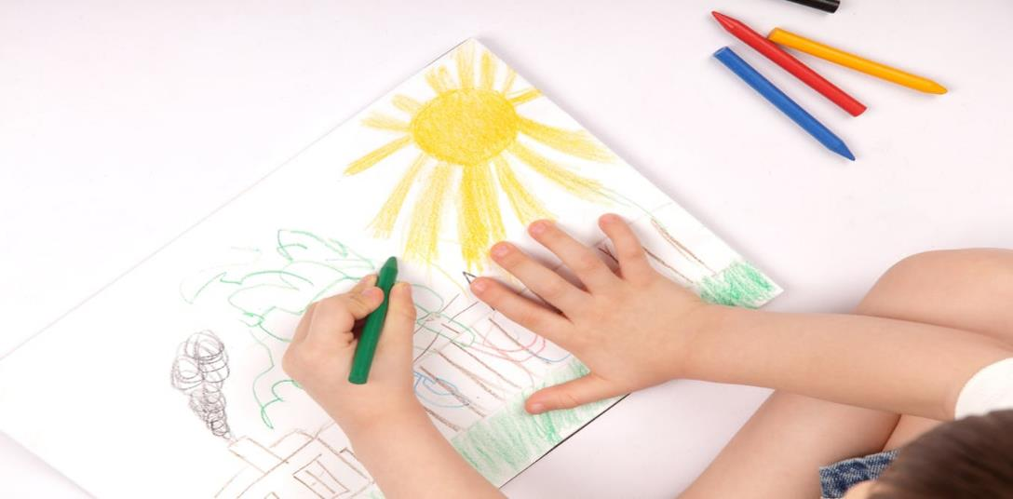
Music Lab: Children can create their own music through fun, hands-on experiments.
https://musiclab.chromeexperiments.com/Experiments
Tate Kids – The Tate Museum website for kids has lots of suggestions for art and creative activities.
https://www.tate.org.uk/kids?gclid=EAIaIQobChMI5YXxy_SV6AIVhLHtCh3VCQJtEAAYASAAEgLUafD_BwE
Autodraw – Free online drawing
https://www.autodraw.com/
BBC TEN Pieces- Resources to support the latest phase of the project for 7-14 year olds.
https://www.bbc.co.uk/programmes/articles/4lz0vpshsfVvDbD95F3v8xB/ten-pieces-resources
Nicola Benedetti String Tutorials - https://www.benedettifoundation.org/resources

Music Education Partnership Group have come up with a project of a mass rendition of Somewhere Over The Rainbow on 30 April at 8.00pm in recognition of the great work of the NHS.
This link gives music for every single instrument
https://wemakemusicfornhs.weebly.com/
pbone website- lots of activities and resources for children and parents
https://blog.pbone.co.uk/coronavirus-free-resources-for-parents-and-students?hsCtaTracking=23c26995-e906-4eb7-a149-6bba19ebc671%7Ca7ec5bbb-c0ce-4497-a945-8c2c19df8db4

Scottish Association of Music Education- Variety of resources- http://same.org.uk/resources/
Science and Technologies 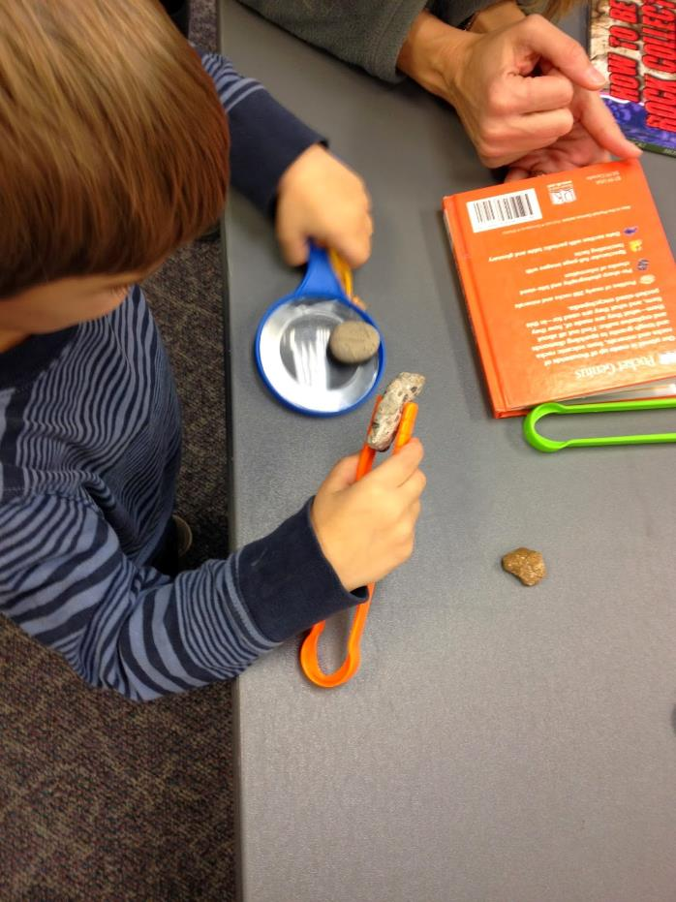
Wow Science: Online resources, video clips and ideas for supporting learning in Science
https://wowscience.co.uk/
National Geographic Kids – Online resource full of facts about our planet
https://www.natgeokids.com/uk/
Mystery Science – Online lessons that inspire kids to love Science
https://mysteryscience.com/
Scratch – Create stories, games, and animations.
https://scratch.mit.edu/
Blockly – Games for tomorrow’s programmers
https://blockly.games/
Languages 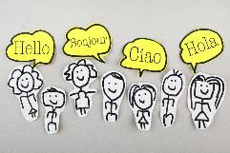
SCILT – Resources to enable parents to support their children in their language learning
https://scilt.org.uk/Parents/Forparents/tabid/1874/Default.aspx
Duolingo- Easy way to learn a new language. Very simple to use, website or app available https://www.duolingo.com/

Preparing for Transitions
- General – ALL ages/ stages:
https://education.gov.scot/parentzone/my-child/transitions/whataretransitions
www.familyeducation.com/school-learning/transitions
- Early Level:
www.bbc.co.uk/cbeebies/grownups/how-to-prepare-your-child-for-primary-school
www.kidspot.com.au/school/primary/starting-school/15-ways-to-prepare-your-child-for-primary-school
- P7 – S1:
https://barclayslifeskills.com/parents/navigating-the-transition-from-primary-to-secondary
https://youngminds.org.uk/resources/school-resources/find-your-feet-transitioning-to-secondary-school
- Leavers:
www.myworldofwork.co.uk/helping-your-child-prepare-leave-school
www.skillsdevelopmentscotland.co.uk/careers/parents
www.npfs.org.uk/wp-content/uploads/edd/2020/02/learner_journey_2002_E.pdf
https://enquire.org.uk/parents/leaving-school

