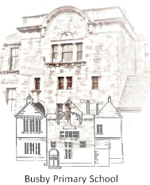

Busby Primary School
Pupil Council Meeting
22nd January
Family Room

Minutes

- Vision and values
Mrs Farrant feed back to the pupil council about Mrs Mc robs thoughts on the competition and assembly

Mrs Farrant asked the P6 and 5s to start a presentation on relaunching the busby values

Attendees: Mrs Farrant, Bailey (P7), Christopher (P7), Nuala (P6/5), Olivia C (P5), Amelia (P4a), Zach (P3), Ella (P2/3), Naomi (P1) and Aliza (P1), Megan P5/6, Rajath (P2), Maya (P3), Madeline (P6), Fionn (P4b) (Bailey and Christopher are not avalible Nuala absent.)

Next Meeting – 1.20 Monday

Mrs Farrant thanked all members of the team and closed the meeting

Minutes typed by Olivia C

