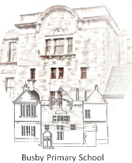

**Busby Primary School**

**Pupil Council Meeting**

**15th January 2020**

**Family Room**

**Minutes**

* **Pupil Council Action Plan**
  + All members looked at the action plan and decided the priorities for the coming weeks.
* **Vision and values**
  + Speak to Mrs McRobb about having an assembly and doing a competition (visit her on Monday?)
  + Create a PowerPoint to introduce the competition.
  + Design a template that people can fill in.
  + Offer an art club to support the competition (Monday, Wednesday and Friday).

Attendees: Mrs Farrant, Bailey (P7), Christopher (P7), Nuala (P6/5), Olivia C (P5), Amelia (P4a), Zach (P3), Ella (P2/3), Naomi (P1) and Aliza (P1), Megan P5/6, Rajath (P2), Maya (P3), Madeline (P6), Fionn (P4b) (Olivia and Nuala absent.)

Next Meeting – 1.20 Monday

**Mrs Farrant thanked all members of the team and closed the meeting**

**Minutes typed by Bailey**