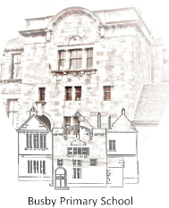

Busby Primary School
Pupil Council Meeting
31st October 2019
Family Room

Minutes

- Remembrance Day
  - Bailey and Christopher typed up a timetable to include all the children in the pupil council for selling poppies. A plan was made to sell them every day on the run up to the 11th November.

Next Meeting – 14th November 2.10

Mrs Farrant thanked all members of the team and closed the meeting

Minutes typed by Christopher

