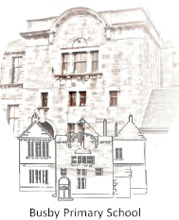

Busby Primary School
Pupil Council Meeting
14th November 2019
P4b Classroom

Minutes

- Remembrance Day
  - The pupils felt that it had been a great success selling poppies across the school.
  - Mrs Farrant let the children know that the money would be sent off and counted by Poppy Scotland. We would get a certificate to tell us how much we have raised and can tell the children in the school once we know.
- Pupil Council Action Plan
  - All members looked at the action plan and decided the priorities for the coming weeks.
- Vision, Values and Aims.
  - Children had idea to put it to the children in the school to ask for themes. They liked Mrs McRobb’s idea for bees. They would like to see if each class could come up with an idea for themes for the Vision, Values and Aims. A bit like the Eco.

Attendees: Mrs Farrant, Bailey (P7), Christopher (P7), Nuala (P6/5), Olivia C (P5), Amelia (P4a), Zach (P3), Ella (P2/3), Naomi (P1) and Aliza (P1), Megan P5/6,

Next Meeting – 1.20 Monday

Mrs Farrant thanked all members of the team and closed the meeting

Minutes typed by Christopher

