BUSBY PRIMARY SCHOOL AND EARLY LEARNING AND CHILDCARE CENTRE
IMPROVEMENT PLAN 2018 - 2019

Values

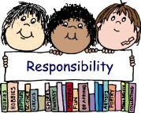
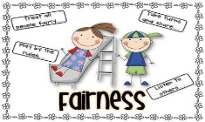
Respect Responsibility Honesty Fairness Courage

Vision

To be a happy, caring and inclusive school where everyone is valued and encouraged to reach their full potential.

In Busby Primary School and Early Learning and Childcare Centre we aim to:

- Promote the health & wellbeing of Busby Primary School and its Community.
- Provide an inclusive, nurturing environment for everyone in the school community.
- To work as a team to recognise and celebrate achievement.
- Follow the code of conduct to contribute to the positive school ethos.
- To provide high quality learning and teaching experiences within a bright and stimulating environment.
- Provide a broad, balanced and innovative curriculum with high expectations of achievement and equal opportunities for all pupils.

Pupil Equity Funding (PEF) Interventions – How we are helping those who need it most:
Social and Emotional Wellbeing

Pupil group focusing on developing resilience and leadership capability.

To increase pupils’ motivation, confidence and resilience skills.

High Quality Learning Experiences

Quality targeted support given to all pupils who require it.

To increase literacy and numeracy attainment for specific pupils.

Promoting Healthy Lifestyles

Specific pupils attend a breakfast club, 5 times per week.

Pupils will be better prepared to engage in their learning.

Partnership Working Employability and Skills Development

Pupil group focusing on Art Therapy to improve resilience and self-esteem.

To increase levels of engagement and attainment.

BUSBY PRIMARY SCHOOL AND EARLY LEARNING AND CHILDCARE CENTRE

Pupil and Parent Improvement Plan
Please note: Detailed version of our Improvement Plan can be found on our Busby Primary website.
2018-2019

