Unveiling our Environmental Sculpture
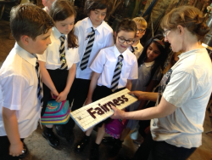
The school has commissioned artist Elspeth Bennie to create our environmental sculpture. Ms Bennie came into the school and delivered workshops to P6 and P7 pupils. She also met with pupils to view and discuss the work we had done so far with Mrs Brysland. Ms Bennie used the children’s work and ideas as the inspiration for our sculpture. A number of pupils from P4 and P5 have visited Ms Bennie’s studio in Balfron in May to contribute to the making of the final sculpture.
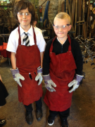

We are very excited as our Director of Education, Mhairi Shaw, will unveil our sculpture at the ‘Celebration of Values’ Day on Friday 16th June at 1pm. All the artwork produced by pupils earlier in the term will also be on display. Our new cob oven will be fired up, serving delicious pizzas to our guests.
As this is a whole school event, we have to limit the number of adults invited to one per pupil. I hope that a representative from every family can join us for what promises to be a wonderful afternoon.
Yours sincerely
Sharon Hunter
Head Teacher

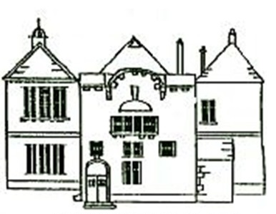

Busby Primary School
Celebration of Values Day
Friday 16th June 2017
Information for Parents

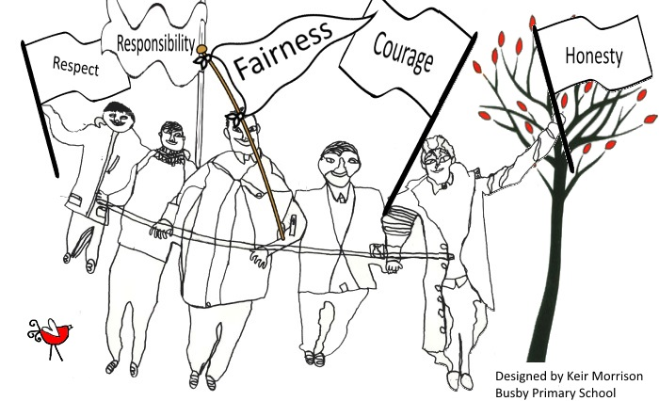

The Story of Busby’s Values
Last school session, pupils, staff and parents worked together to identify the values that we felt were most important to the ‘Busby Family’. After numerous discussions, we agreed that the values Courage, Fairness, Honesty, Respect and Responsibility truly represented the ethos of our school.
We have been promoting these values through all that we do at Busby but still wanted to share and embed our values further. Therefore, teachers nominate children who best personify each of the values and the pupils will be presented with special trophies at our end of term service. These trophies will continue to be awarded annually.
Outdoor Learning
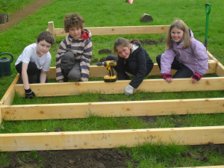
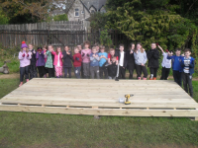
As teachers plan for their Skills Academy courses, they also consider our 5 values and thread them through the skills and attributes they teach. During the 2nd Level ‘Community’ Skills Academy, all P5-P7 pupils focused on being respectful to nature and responsible for outdoor space. So far, they have built an outdoor performance area with seating, a ‘bottle garden’, a willow bed, outdoor tables and have begun to create an early years outdoor learning zone which will carry on next session.

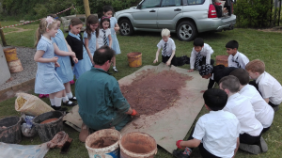
Thanks to funding from ‘Food for Life’, we have been able to purchase a KEG barbeque and all pupils in the school contributed to build the wonderful wood fired cob oven for our future al-fresco cooking Skills Academy.

Creativity
We have challenged ourselves further through our creativity curriculum. This session, all pupils in the school have participated in creative work led by Mrs Brysland in partnership with Glasgow School of Art, Glasgow Sculpture Studios and Warriors Studios. The challenge set to pupils was to work through the design process and create an idea that could be transferred from 2D to a 3D piece of environmental structure that represented each of our 5 school values.

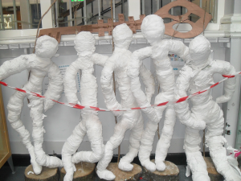
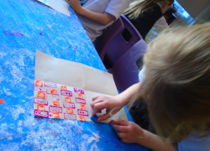
Pupils across all stages of the school used a number of techniques to create their ‘Values’ artwork including printing, stop-start animation, painting and sewing. The children also made models out of different materials including clay, mod roc rolls, tape and aluminium rods.

