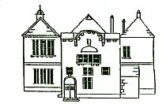
Busby Primary School
and Nursery Class Newsletter
Summer 2017

Dear Parent/Carer,

We have reached the end of another busy school year and I am very proud of all that our pupils have achieved in session 2016/17. Highlights have included P7’s residential trip to Lochgoilhead, the P6 overnight science themed trip to Edinburgh, visiting the Robert Burns Birthplace Museum, our Burns Supper, the installation of our cob oven and our amazing Values Day Celebration event.

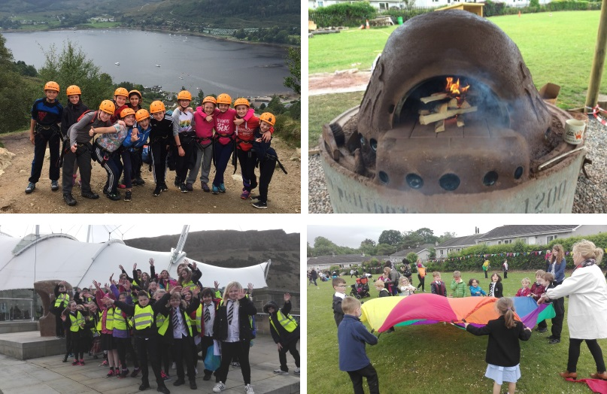

The school gained a ‘Digital Schools’ award and we won the first ever Primary School ‘Better Eating, Better Learning’ award. The class assemblies have continued to be of the very highest standard and the upper school show “Frannie” was a tremendous success. It has been a brilliant Busby year!

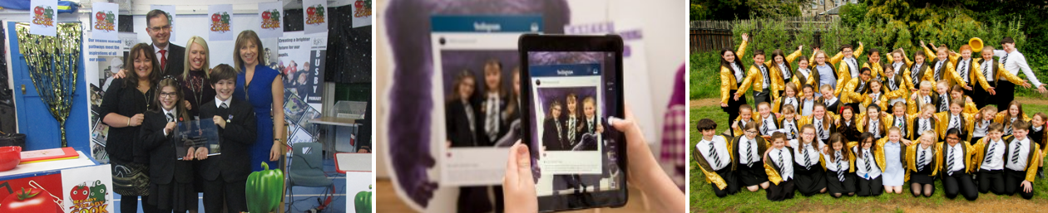

Nursery News
Summer Trip
Our summer trip to Pollok Park was a great success. The children and families enjoyed exploring the Fairyland and searching for dinosaur bones before a fun picnic and playtime with bubbles – bliss!

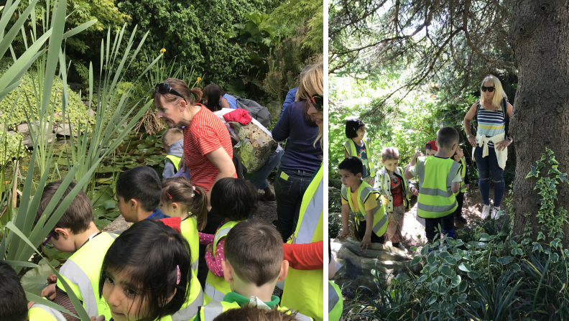

Sports Day
We all had great fun at our Sports Day events on Friday 9th June. A little light rain didn’t put off the morning children and the sun came out for the children who attend the afternoon session. Thank you to all parents who joined us to cheer the boys and girls on.
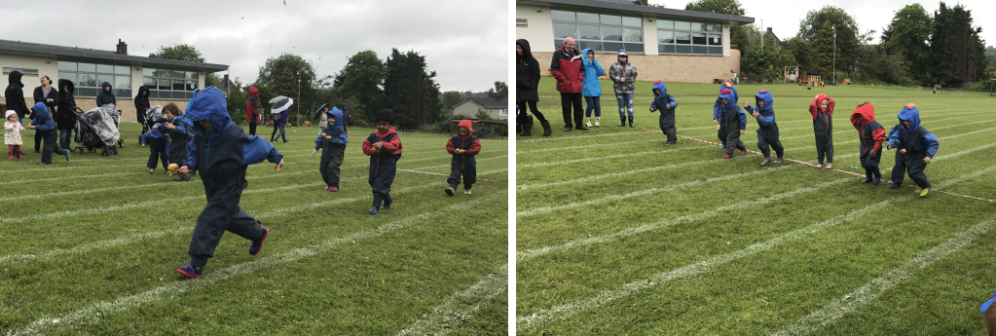

Nursery Fund
Thank you to all families who contribute to the Nursery Fund. In addition to our new outdoor play resources, the Fund paid for a summer fun day on Monday 19th June. The entertainment team from ‘Kidnetick’ visited the Nursery and organised the fun for the children, who deserved a super end of term treat for all their hard work.

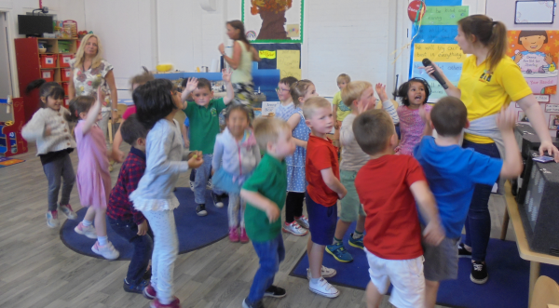

Parent Group
Thank you to everyone who attended the recent social night for mums at the White Cart restaurant. It was a lovely evening and a great opportunity to meet and chat with old friends and new. As a bonus, an amazing total of £312.50 was raised which will fund a gift for the children who are leaving to join classes in Primary 1.

We are all very grateful to the Parent Support Group who meet regularly to discuss Nursery issues. Their support has been incredible and pupils, parents and staff have benefited from their efforts.

Graduation
Our pre-school children started their journey to school on Friday 23rd June as we celebrated their time in Nursery at our Graduation Ceremony.

School News
Parent Council News
Thank you to all parents who attended the Summer Fayre on Sunday 11th June and to everyone who donated chocolate/a bottle/money on Friday 9th June. It was a well-attended afternoon.

All staff and pupils would like to thank the Parent Council office bearers and committee for their support and effort over the 16/17 session.

Values Day
Thank you to everyone who turned out for our ‘Celebration of Values’ event on Friday 16th June. I am sure all who attended would agree that the artwork was out of this world, as was the delicious pizza cooked by Miss Taylor. Mrs Kerr had organised ‘Fun on the Field’ activities for all pupils and they seemed to particularly enjoy the bouncy castles! I’d like to say a huge thank you to all staff who worked so hard to ensure the event was a success. A special word must go to Mrs Brysland and her creative vision for the project.
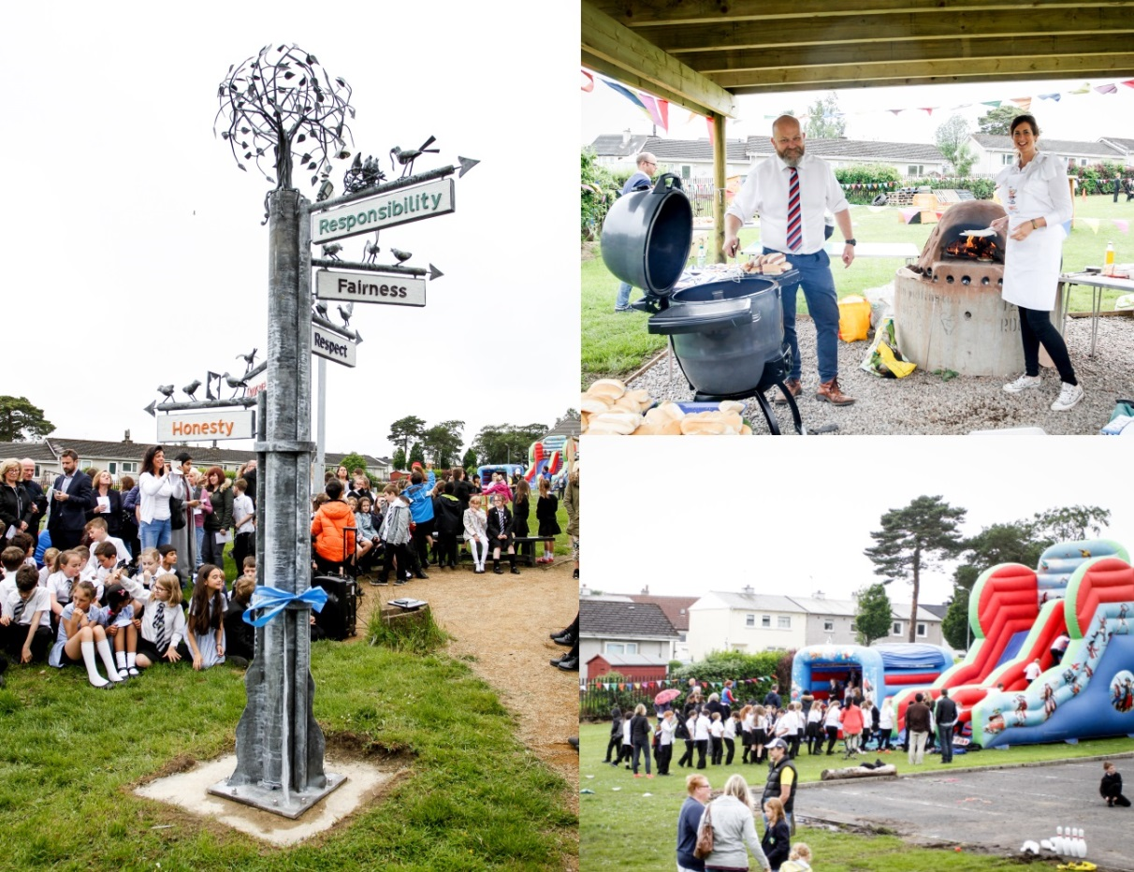
Sports Day
We had a great afternoon at Williamwood for our annual Sports Day. Thank you to all parents who braved the drizzle to come along and support the boys and girls. It was lots of fun. The pupils will hear which House won Sports Day at the Summer Service. The House race has been very close this year so we are all on tenterhooks!

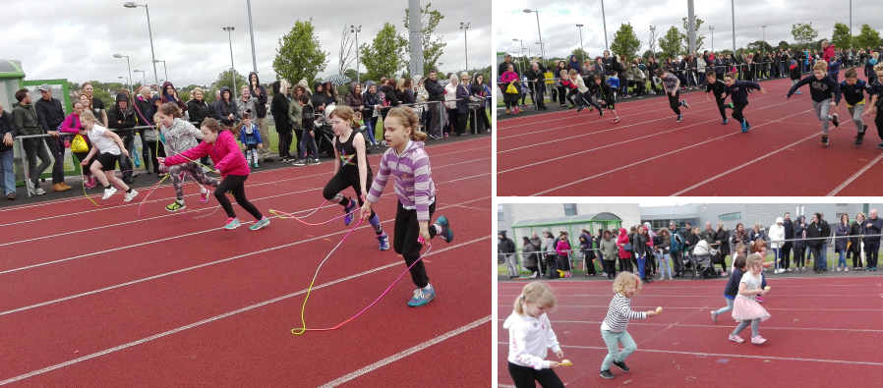

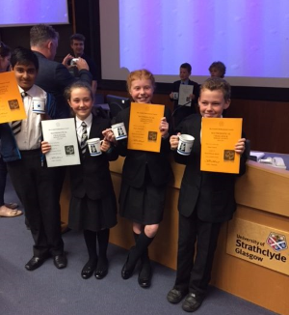
Achievements
Strathclyde University Primary Maths Challenge
Miss Taylor escorted Shubh (P7), Adam, Emma and Susannah (all P6) to Strathclyde University on Friday 2nd June. The pupils were presented with Gold and Silver awards they had earned through completing the Primary Maths Challenge. Well done!

Cluster Maths Champions
I am delighted to inform you that Busby successfully defended their P7 Cluster Maths title earlier this month. Well done to Rae, Shubh, Sam and Kshitij.
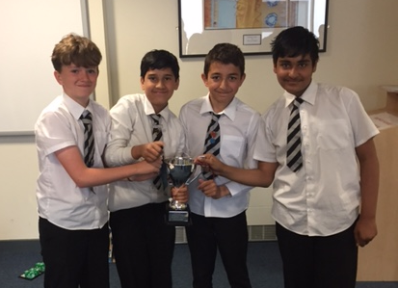

P4 West of Scotland Tennis Competition
After winning the Williamwood Cluster heat and then the East Renfrewshire final in May, Eilidh, Sarah, Rory and Hamish competed in the West of Scotland Tennis Championships on Sunday 4th June. They all played magnificently and finished in second position, only 3 points behind the winning team from the High School of Glasgow. We are all very proud of them.

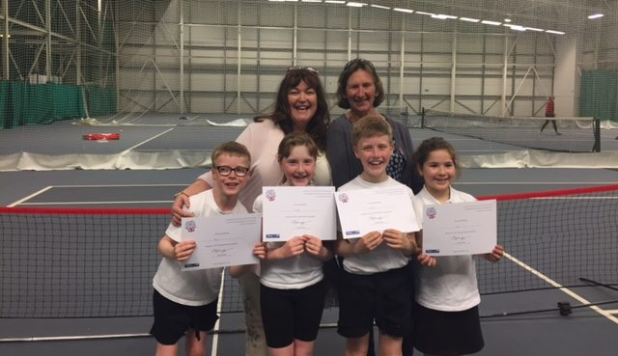

Digital Schools Award
Our use of technology throughout the curriculum has been recognised by Digital Schools Awards Scotland and Busby is now officially a ‘Digital School’. The Awards committee was particularly impressed by our use of augmented reality. Busby is one of only three Primary Schools in East Renfrewshire to hold this accreditation.

Frannie
It certainly wasn’t a “Hard Knock Life” for the audiences of our fabulous performances of “Frannie” – what a show! Miss Harris did a fabulous job of writing, directing and producing the show and the cast was outstanding. There are some real shining stars at Busby and I am sure they will continue to flourish.

P7 Leavers Dance
The P7 Leavers Dance will take place on the evening of Monday 26th June. The dance starts at 7pm and pupils can arrive from 6.30pm for photographs. I would ask that you do not put pictures of other children on social media without their parents’ permission.

Transition
Your child met their new class teacher on Thursday 15th June at our transition afternoon. The classes for next session are as follows:

Class | Teacher
Nursery | Mrs Curran (Acting PT) and Mrs Robinson
P1a | Miss Paisey
P1b | Mrs McNee
P2a | Miss Lawson and Miss Blackhall
P2b | Mrs Farrant
P3 | Mrs Nilsen-Nygaard and Mrs Dallas
P4/3 | Miss Doris
P4 | Miss Cairnie
P5 | Miss Harris
P6/5 | Mrs Kerr
P6 | Mr Milliken
P7a | Mrs McLean and Mrs Forsyth
P7b | Miss Wight
Support for Learning | Mrs Guy

When pupils return in August, Mr Weir will be Acting Head Teacher and Mrs Oswald will be Acting Depute Head Teacher. Miss Taylor will work with the Management team to raise attainment across the school.

School Lunch Accounts – P7 parents
Parents of pupils in P7 are reminded not to top up their child’s lunch account too much using the cash machine in the main hall as funds cannot be transferred with them to High School. If you use ParentPay, do not assign too much money to the Busby Primary School Meals account.

Advance Notice
Pupils in P1-P4 will be attending the Edinburgh International Book Festival on Tuesday 29th August. Pupils in P5-P7 will enjoy a visit to the theatre in Glasgow to see David Walliams’ “Awful Auntie” later in the term.

In March, we have three residential trips planned for 2nd Level pupils. P5 will visit the Millport Field Centre to learn about biodiversity. Following this session’s successful P6 Science themed Edinburgh trip, P6 will visit the city on an overnight visit.

Uniform
Our school uniform consists of white shirt, tie and black trousers/skirt, black jumper/cardigan and black school shoes (no trainers). Our PE uniform is black shorts/jogging trousers and a white T-shirt/polo shirt.

Pupils return on Wednesday 16th August at 9am for school pupils and 8.50/9.00am or 12.50/1.00pm for the Nursery. The school office will be open on Monday 14th and Tuesday 15th August for the In Service days.

Dates for your Diary – School
Monday 26th June P7 Leavers Dance 7.00pm
Tuesday 27th June Summer Service, Busby Parish Church 9.45am
All welcome

School closes 1pm, Tuesday 27th June for summer holidays

Monday 14th August In-Service Day 1
Tuesday 15th August In Service Day 2
Wednesday 16th August Pupils Return 9am
Tuesday 29th August P1-P4 Edinburgh Book Festival

Dates for your Diary – Nursery
Friday 23rd June Nursery Graduation

Nursery closes 1pm, Tuesday 27th June for summer holidays
No pm session

Monday 14th August In Service Day 1
Tuesday 15th August In Service Day 2
Wednesday 16th August Pupils Return 8.50am/12.50pm

So it’s goodbye from me …
I have had a wonderful time as Head Teacher of Busby Primary for the past eight years and will miss all the ‘Busby Family’ very much. I wish all pupils, staff, parents and friends all the very best for the future. I will be sure to keep up with all Busby’s news and achievements.

Thank you very much for the support you have always shown me. It has been an absolute pleasure to work here and I have loved every minute. I will keep the memories made at Busby with me for the rest of my life.

Yours truly,

Sharon Hunter

Head Teacher

