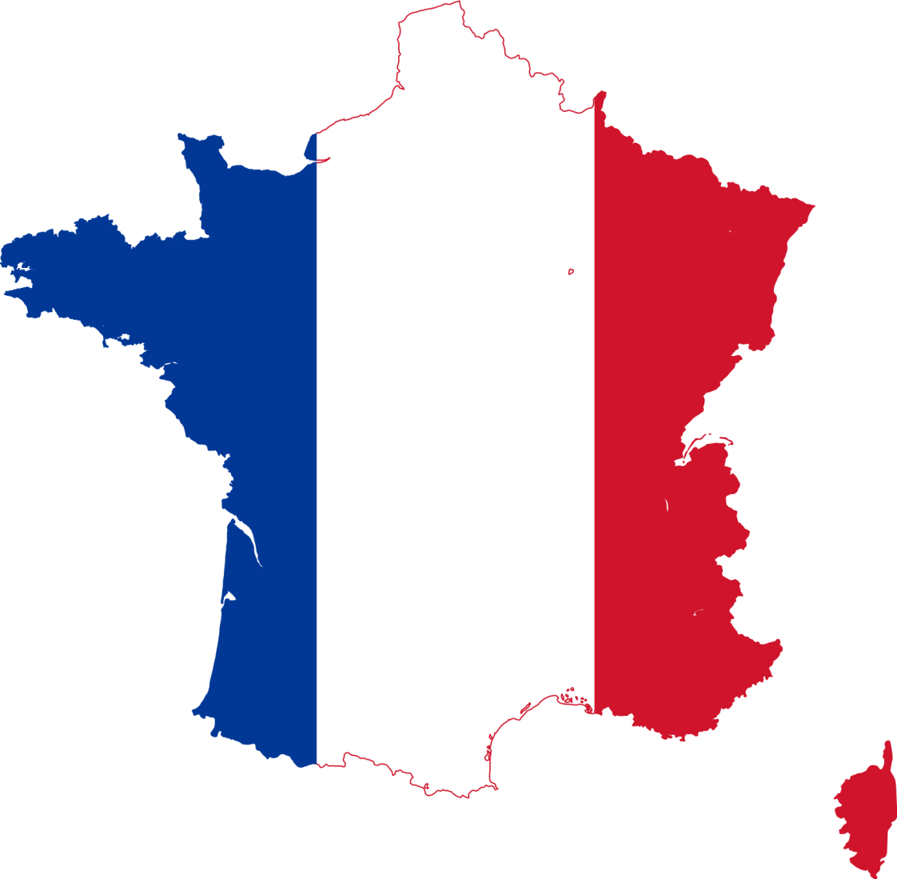

French Family Fun Evening

Tuesday 28th February, 6.45pm-8.00pm

Dear Parents and Carers

As part of our continuing commitment to enhancing family engagement, we are hosting a ‘French Family Fun Evening’ on Tuesday 28th February 2017 from 6.45-8.00pm. Families are invited to come along to take part in some exciting French activities, some of which will be competitive!

Each family will participate in two activities, making this an excellent opportunity for teamwork. Places are limited, so we recommend booking your place early to avoid disappointment.

Please refer to the brochure for more information about the activities on offer. The booking form is also in the brochure. Please complete and return to the school office if you would like to attend.

Yours sincerely,

Sharon Hunter

Sharon Hunter
Head Teacher

Come to Busby’s French Family Fun Evening!

There will be six activities for you to choose from…

The Great French Bake-Off
Try your hand at making a delicious French crêpe. Can you name the ingredients in French?

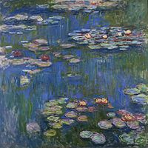
Show Me the Monet

Can you paint as well as Claude Monet? Have a go at one of his paintings and find out!
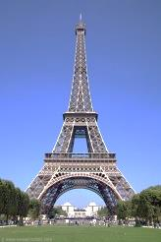
Le Grand Design

Your mission is… to build the Eiffel Tower! Can you make the tallest tower? Using only spaghetti and marshmallows of course…

A Lotto Fun
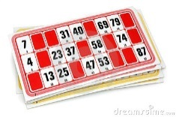
Come and play a game of Bingo – known in French as Lotto! Make sure you brush up on your French numbers and colours for this!

Quiz – Do you know your onions?
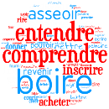
Put your French knowledge to the test in this quiz, all about French culture, geography, celebrities and more! Which family team will be victorious?

Bowled Over
Have a go at a game of bowls, known in French as Pétanque. Easy to play and fun for all the family!
Places at this event will be allocated on a first-come, first-served basis, so reserve your place early to avoid disappointment!

If you would like to come along, please fill in this form and return it to the school office.
_____________________________________

French Family Fun Evening

Child’s Name: ……………………………………………….

Total number of family member(s) attending (including pupils):

……………………………………………………………

You will be able to participate in two activities. Please indicate your preferences, ordering the activities from 1 to 6. (Please note, we cannot guarantee your first choices, but will do our best!)

The Great French Bake-Off

Show Me the Monet

Le Grand Design

A Lotto Fun

Quiz

Bowled Over

