

Education
Director: Mhairi L Shaw DCE

Braidbar Primary School and Nursery
Head Teacher: Mrs Gillian Friel
Kyle Drive, Giffnock
East Renfrewshire G46 6ES
Phone: 0141 570 7020
E-mail: schoolmail@braidbar.e-renfrew.sch.uk
Date : 16 January 2019
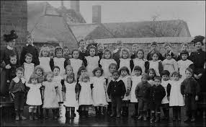

Dear Parent/Carer

Primary 6 visit to Scotland Street Museum – ‘The Victorians’

Pupils in P6 have been learning about the Victorians. To enhance their learning experiences, we have arranged for our Primary 6 classes to visit Scotland Street School Museum, Glasgow where they will experience a Victorian Classroom and will be able to compare it to their classroom of today.
The children will have their lunch in a selected area in the museum after they undertake the workshop.

Details of the trip are as follows:

Date/ Time- Friday 25 January 2019 10.30 am – 2 pm approx.
Lunch- Pupils should bring a packed lunch (no glass bottles please)
Clothing- school uniform
Cost- £5.62 (This trip has been subsidised by our Parent Council)

Please arrange to pay for this using your ParentPay account.

If you would be available to help with this trip, please complete the tear-off slip below and return.

I hope that our pupils enjoy their visit to Scotland Street Museum.

Yours sincerely

L.Macintyre

Mrs Macintyre
Class Teacher
"………………………………………………………………………………………………………

Braidbar Primary School

Primary 6 visit to Scotland Street Museum – Friday 25 January 2019

Child’s name:………………………………………………………….

I am available to help with this trip

Signed: ………………………………………….. (parent/carer



Mhairi Shaw, Director of Education, East Renfrewshire Offices, 211 Main St, Barrhead, G78 1SY

