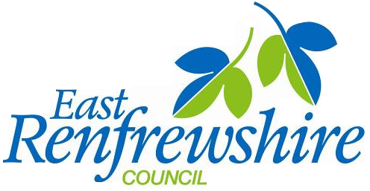



20th May 2020

Dear Parent/Carer

We are always looking to improve how we communicate and engage with you during your child’s time at school. The use of digital connections gives further opportunities for us to communicate with you and you with us, which will help improve the school experience for both you and your child. I am delighted to let you know that East Renfrewshire schools are now at an important stage that will advance our digital engagement.

We have been working for the last year with national partners to provide parents/carers with access to a range of digital services. This will be taken forward through parentsportal and I would like to tell you about the services it can provide, and what you need to do to take part.

I would highlight that during the challenging times that the Covid-19 pandemic has brought to us all, this new digital provision will be particularly helpful.

The portal is designed to replace ‘schoolbag mail’ which will reduce the use of paper and avoid some of the challenges in making sure information is passed on. The portal gives parents online access to a range of school-related services.

This is an exciting first phase of a new initiative which enables and creates a digital relationship between parents, pupils and schools. With almost all parents having digital access, either through the web or a mobile phone, we expect that uptake will be high. It will let you as a parent view information, update details and take actions at a time that suits you.

Initially this new service will give you basic information about your child’s school and will allow you to:-

- view school calendar and events
- view your child’s timetable (for pupils in secondary school)
- view your child’s attendance
- complete the annual data check process electronically when issued
- update your own, as well as your child’s, details at any time (Please note that schools will still require address evidence before they will authorise any change.)
- access online school payments without having to login separately to ParentPay.
- access your child’s report card online (available soon, initially for secondary schools)
- move easily between individual children in a family, at different schools, without the having to log back into the system.

As the product develops we look forward to seeing more services including an absence reporting service and links to parents’ meeting booking systems where these are used by schools. Additional services are being developed to provide further insight to your child’s education.

For further information, guidance and access to parentsportal.scot, please scan the QR code or click on the link below:-

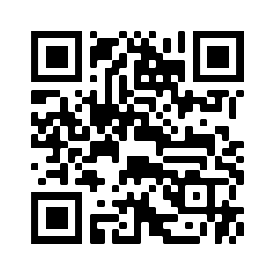 www.eastrenfrewshire.gov.uk/parentsportal

At the heart of the system is a secure online account through mygov.scot which is referred to as a ‘My Account’. On signing up to the portal, the verification stage will link your child to you and you will be able to gain access to the services which are currently available. In order to link to your child, the data you provide during the sign-up process must match the most up-to-date data that your child's school holds.

The Education Department has an agreed planned roll-out approach to manage the introduction of the new service. This will start with secondary schools, then primary schools will follow within the next 2 to 3 weeks. Although the service is being rolled out first to our secondary schools, if you have a child at both an East Renfrewshire primary and secondary school at this stage, you will also be able to link your primary child. Please note your request to enroll your secondary aged child will normally be approved within 5 working days, but it may take longer for this link to be authorised for children at primary since the primary roll-out will take place after secondary schools are complete. (Due to other developments that are underway nationally, parentsportal is not available to early-year learning and childcare establishments at this stage.)

If you have any difficulty in linking your child to your account, you should initially email your school who will resolve the difficulty or pass it to staff within the Education Department.

Please note that parentsportal can be accessed by two parents – the ‘main contact’ and a second contact. The second contact is unable to view any of the data on the Annual Data Check screens and is therefore not permitted to see any data for the ‘main contact’. The ‘main contact’ however will have access to the data held on the Annual Data Check screens, including contact details for the second contact, as well as other emergency contacts. If this would be an issue for any parents, then parentsportal may not be suitable for their circumstances. Please contact the school to discuss this further.

I hope that parentsportal.scot and its services will become an every-day part of the school experience for both you and your child, and I am sure we will all see the benefits very quickly.

Yours sincerely

Andy Sinclair
Head Teacher

