



Barrhead High School – English Department
S1 Homework Pack

TO BE COMPLETED IN HOMEWORK JOTTER AND SIGNED EACH WEEK

And signed each week.



Week One - Plurals

One thing or person is referred to as SINGULAR. More than one thing or person is referred to as PLURAL.

When we make a word plural we usually do it by adding ‘s’.

one car
two cars

Words ending in ‘s’, ‘sh’, ‘ch’ and ‘x’ have ‘es’ added to make them plural.
two glasses

four dishes
five matches
three boxes

Beside each noun write its PLURAL.

1. mask 2. watch

3. fox 4. church

5. class 6. sash

7. latch 8. speck

9. fish 10. tax

We have already learned how to make words plural – mostly by adding ‘s’.

When a word ends in ‘y’ we change the ‘y’ to ‘i' and add ‘es’


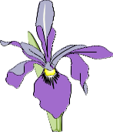
two ladies
one lady
one lily
A bunch of lilies

BUT if the letter immediately before the ‘y’ is a vowel (a, e, i, o, u) we just add ‘s’

one boy
two boys

Write the PLURALS beside each of these words.

1. puppy 2. tray

3. army 4. baby

5. dairy 6. day

7. cherry 8. fly

9. key 10. chimney

. Don’t forget to get your jotter signed...

Week 2 - Nouns and proper nouns.

A NOUN is the name of a person, place, animal or object.
A PROPER NOUN is the name of a PARTICULAR person or place etc.
When writing PROPER NOUNS we start each one with a CAPITAL LETTER.

Scotland
Anna

December

We also use capital letters for titles to go with the names of people.
Mr Brown
Dr Hassan
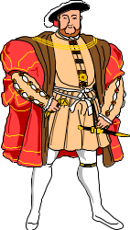

King Henry

Can you write these names properly putting in the capital letters?

captain mainwaring mr ahmad

mrs smith major smart

sir alex ferguson queen mary

dame judi dench lord lawrence

prince charles archbishop stephens

Don’t forget to get your jotter signed…
Week 3 - Proper Nouns

Capital letters are used for the first letters of the important words in the names or titles of T.V. programmes, films, books, plays and poems.

Romeo and Juliet
Jack and the Beanstalk

NB: Usually ‘a’, ‘an’, ‘the’, ‘in’, ‘on’ and ‘and’ in the title don’t need capital letters.

Copy and correct these titles out in your jotter:.

home and away ______________________________________________________

to a mouse__________________________________________________________

danny, champion of the world____________________________________________

lord of the rings _____________________________________________________

harry potter and the philosopher’s stone____________________________________

the wind in the willows__________________________________________________

Now write out one title for each, putting in the capital letters:

1. a book ________________________________________

2. a film _________________________________________

3. a T.V. programme _________________________________

4. a poem ________________________________________

- a play _________________________________________

Don’t forget to get your jotter signed…

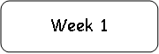
Week 4- Collective Nouns Nouns

COLLECTIVE NOUNS are names for groups or collections or nouns.
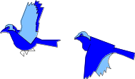
A flock of birds

A bunch of flowers

An orchestra of musicians
A string of beads

Choose a COLLECTIVE NOUN from the list to fill each gap.

1. The _________________of elephants charged through the bush.
2. The magician used a _________________of cards to perform his trick.
3. Mum swept down the _________________ of stairs.
4. Asif asked to join the school football _________________
5. The_________________ of geese wandered along the lane.
6. A __________ of people gathered outside the theatre to see the pop star.
7. We could see a large _________________ of fish swimming close to the boat.
8. The _________________ of small ships sailed into the harbour.
9. The gardener collected a huge ______________ of stones from the garden.
10. A _________________of bees settled on the beekeeper’s hive.
crowd swarm pack fleet herd
pile gaggle flight shoal team

Don’t forget to get your jotter signed…
Week 5 - Adjectives

An ADJECTIVE is a word that describes a noun. Most will be used before a noun. Sometimes they will come after a linking verb.



The blue car. The colourful flowers. The stars were bright.

Choose an ADJECTIVE to complete the following sentences.

- The sky was dotted with clouds.
- They have a very house.
- Their house was very .
- We saw a very film night.
- The chair was very .
- “This must be the most teacher in the world.”
- The cat stretched its limbs in the sunshine.
- After the sun went down the night got very .
- The children crowded round the ice cream van.
10. The bus driver drove far too fast.

Lazy wispy beautiful comfortable boring impatient.

Blue beautiful exiting warm cold rowdy

Don’t forget to get your jotter signed…

Week 6 - Adverbs

An ADVERB is used to describe the way something happens. They are usually formed by adding –ly to the end of the adjective. If the word ends in –y you must replace it with –i before adding –ly. So happy becomes happily. You can identify the adverb by asking yourself “how” something has been done. They can also show how much or how little of something. They will tell you more about a verb.

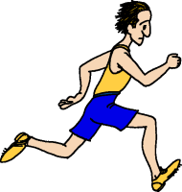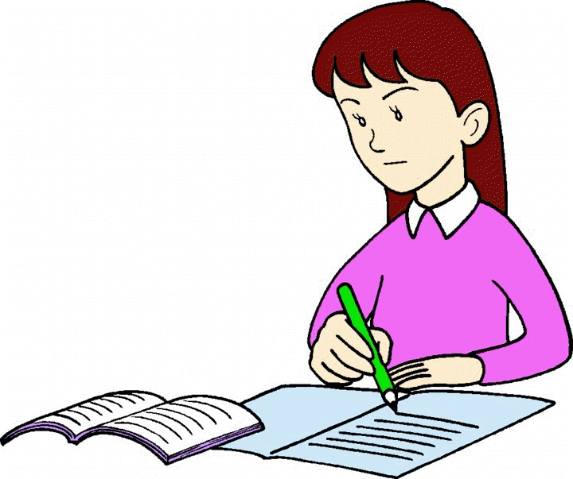

The man ran quickly. She was studying very hard.

Copy the text below into your jotter. Underline or highlight the adverbs. There are ten of them.

“Ben was taking his driving test today. He drove nervously to the text centre, trying not to drive too quickly. The examiner told him to set off and he drove slowly and carefully down the main street. Shortly after he started, things went horribly wrong. Sadly, he turned right before he could see clearly and hit another car. The car was badly damaged. The examiner told him coldly he had failed the test.”

Look at the sentences below. Copy them into your jotter and add in the correct adverb. Use the adjective in brackets as a prompt.

- We lost the football match 4-2 yesterday. I don’t think we played .
- You drive quite (danger).
- “You are late!” said Olga . (angry)
- The teacher spoke so (quiet), it was difficult for the class to hear.
- This is a very important question. Please think . (careful)

Don’t forget to get your jotter signed…

Week 7 - Verbs

A verb is a doing word. They tell us what people, or things, are doing or being. They can refer to the past, present or the future. All sentences must have a verb. If you don’t have a verb, you don’t have a sentence.

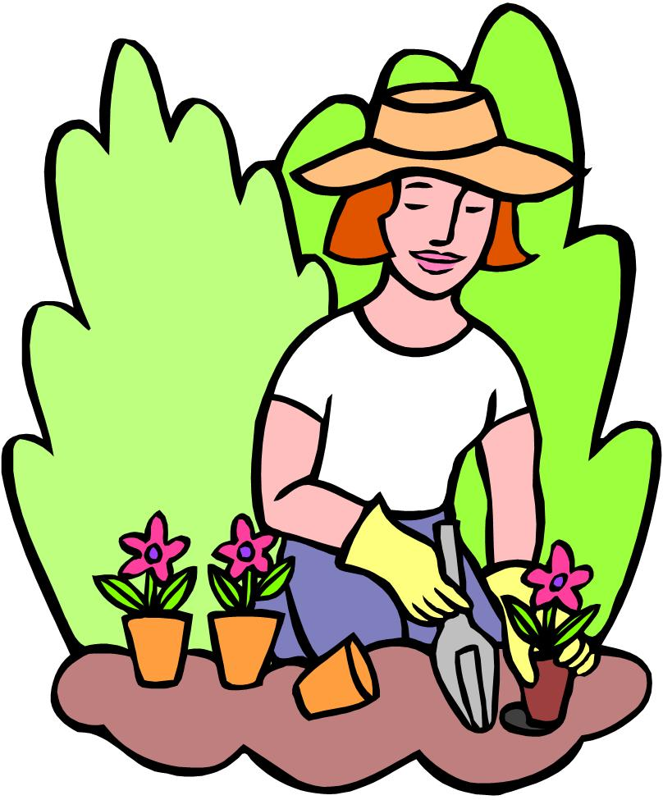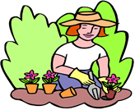

She enjoys gardening. She enjoyed gardening She will enjoy gardening.

Present past future

Copy these sentences into you jotters. Highlight the verbs.

- Sam finished his homework in the library.
- Jenny reads the metro on the train every morning.
- That bicycle belongs to me.
- I can see the sea my house.
- We have been driving for hours.

Write a short paragraph that describes your friends, family and their hobbies. When you have finished go through it and highlight all the verbs you have used.

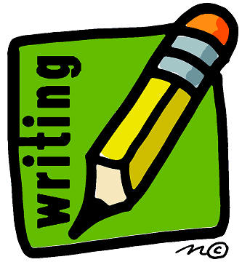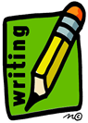

Don’t forget to get your jotter signed…

Week 8 - Matching Nouns & Verbs

We use a SINGULAR verb if we are writing about a thing or a person. When we write about more than one thing or person we use a PLURAL verb.

SINGULAR verbs are:- “is/was” PLURAL verbs are:- “are/were”

To make a noun PLURAL we usually add ‘s’ or ‘es’ BUT we usually add ‘s’ or ‘es’ to make a verb SINGULAR.

Jim and Asif like sweets.
Asif likes chocolate too.

Underline the correct SINGULAR or PLURAL verb to match the noun in the following sentences.

1. Mrs. Smith (shop/shops) in town every Friday.
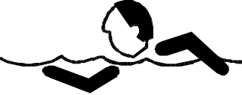
2. We all (goes/go) to the Baths on a Wednesday.

3. Mum, Dad and Anna (like/likes) to read books.

4. Anna (read/reads) animal stories.


5. The herd of cows (come/comes) into the dairy to be milked.

6. The women all (meets/meet) outside the hall.

7. The front door (need/needs) to be painted.

8. The painters (starts/start) tomorrow.

9. The mice (are nibbling/is nibbling) at the cheese.

10. The children (plays/play) in the playground.

Don’t forget to get your jotter signed…

Week 9 -Adjectives versus adverbs
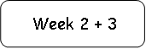

Although they are easily confused adjectives and adverbs are completely different. An adjective gives you information about a noun. An adverb gives you information about a verb.


The serious student studied hard for the test.

Serious is the adjective because it describes the student (noun).

Hard is the adverb because it tells you how the student studied (verb).

Look at the sentences below. Copy them into your jotter. Highlight the adjectives in red and the adverbs in blue. The first two have been partially done for you.

- The sports car sped down the road.
- The noisy students laughed happily.
- The dark clouds gathered ominously.
- Wheeling seagulls flapped their wings rapidly.
- The confident sixth years walked aimlessly round the halls.
- I read the exciting book quickly.
- I gently stirred the hot soup.
- The wind blew wickedly, bending the spindly trees.
- The ferocious sun shone brightly in the sky.
- The heavy filing cabinet fell slowly over.

Don’t forget to get your jotter signed…

Week 10 - Research Skills-
Three Steps.

I am going to research the topic of .

Complete the table below using these headings.
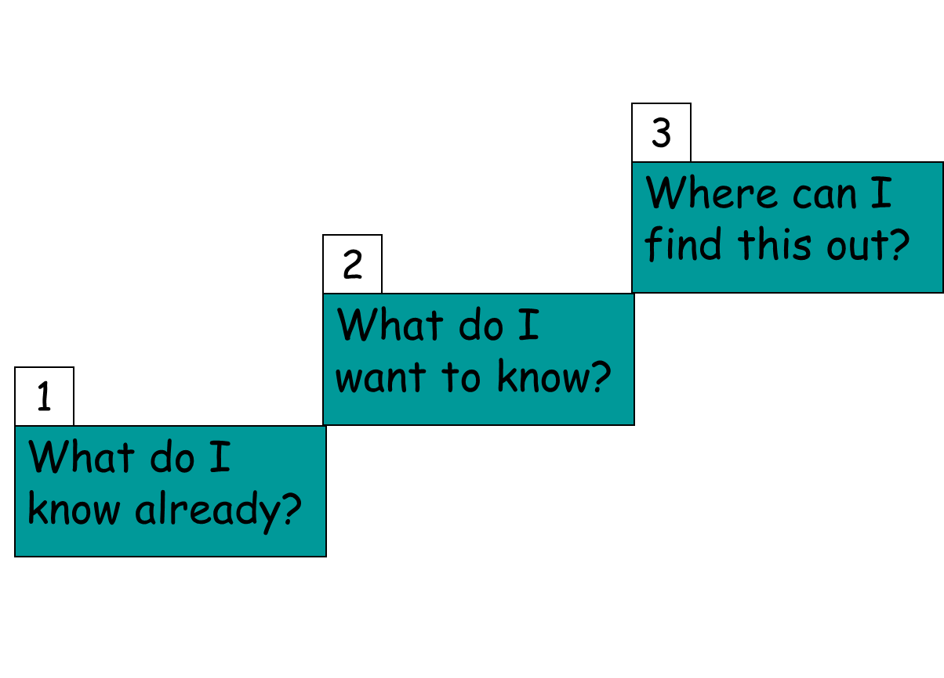
Make sure your sources are reliable!

What do I know already?

What do I want to know?
Where can I find this out?
Make a list of potential sources.

Don’t forget to get your jotter signed…

Week 11 - Note taking.

Now that you have your topic and have identified where you can find your information it is time to take some notes. Making sure your notes are organised as this will help you use your information. Complete the table below in your homework jotters.

Sources. | Quote / what you have found out.
www.bbc.co.uk

Don’t forget to get your jotter signed…

Week 12 - Research / own words.

Now that you have gathered your information you need to put it into your own words. Write out the information you have found from your sources making sure that the key points are in your own words.



Don’t forget to get your jotter signed…
Week 13 -Fact or Opinion?

Below are some statements put out by a new Holiday Park. They are a mixture of FACT and OPINION.

Read each of the statements and underline any part that is an OPINION. One has been done for you.

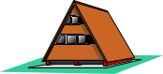
1. 200 luxury chalets.
2. Chalets sleep 4 to 8 people.

3. A magnificent Olympic-sized swimming pool.
4. Stunning views over the town of Seabay.
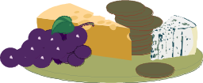
5. Excellent-value restaurants open till 10pm each day.
6. Friendly, helpful staff.
7. Fun discos each evening in the fantastic nightclub.
8. Superbly equipped gymnasium with sauna and steam room.
9. Terrific Talent Contests twice per week.
10. Gift Shop selling a wide-range of special souvenirs.

Don’t forget to get your jotter signed…

Week 14 - Similes

When we are writing we can sometimes make our writing more interesting to the reader by using SIMILES. SIMILES are phrases where the writer compares something or someone as something else.

The cake I bought was as hard as iron.

Here is a list of SIMILES. Match each one with an arrow. One has been done for you:

as hard as a bee
as green as snow
as busy as gold
as fierce as iron
as light as ice
as solid as grass
as white as a needle
as sharp as a lion
as good as a rock
as cold as a feather

Now use 5 of the above SIMILES in sentences of your own
1.

2.

3.

4.

Don’t forget to get your jotter signed…

Week 15 - Metaphors

METAPHORS are used in writing when the writer wants the reader to have a better picture of the situation being written about. METAPHORS are written about someone or something as if it were something else.

The storm was a wild beast roaring round the cottage.

Write each of these METAPHORS in sentences:

Eg. The wind whistled through the trees
The wind through the trees made a whistling sound

1. A thick white blanket of snow

2. The sky was ablaze

3. A river of tears
Now choose 3 of the following subjects and write a sentence containing a suitable METAPHOR for each subject:

a stormy sea; children playing; a man running; a heavy shower of rain;
an angry person; a lovely sunset;

Don’t forget to get your jotter signed…
Week 16 –
Analysing Imagery (1)

Analyse the images below, following the 3 steps:

- State what is being compared to what.
- Explain how the two things being compared are similar.
- Explain how this image helps you understand the writer’s ideas/attitude towards something/a character.


- Her heart jumped like a scared rabbit.

- That one small boy with a face like pallid cheese

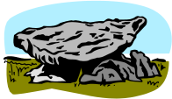
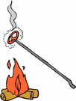
- On the sand banks the rabbits sat as quietly as little gray, sculptured stones.

- His face burnt like a brand.

The writer compares ………………………….………..  …………………………to………………………….…………………  ……………………………………………………………………………  …………………………………………………………………………… | This is effective because ……………………………………………………………………  ……………………………………………………………………  ……………………………………………………………………
The writer compares ………………………….………..  …………………………to………………………….…………………  ……………………………………………………………………………  …………………………………………………………………………… | This is effective because ……………………………………………………………………  ……………………………………………………………………  ……………………………………………………………………
The writer compares ………………………….………..  …………………………to………………………….…………………  ……………………………………………………………………………  …………………………………………………………………………… | This is effective because ……………………………………………………………………  ……………………………………………………………………  ……………………………………………………………………
The writer compares ………………………….………..  …………………………to………………………….…………………  ……………………………………………………………………………  …………………………………………………………………………… | This is effective because ……………………………………………………………………  ……………………………………………………………………  ……………………………………………………………………

Don’t forget to get your jotter signed…

Week 17 - Analysing Imagery (2)

Analysing Similes using TEE

Using the TEE formula complete the table analysing the images and explaining why they are good.
- His bag was like a feather
- My love is like a red, red rose.
- The room was like an oven

TECHNIQUE | EXPLAIN | EFFECT
The writer uses a simile to | The writer compares  …………………………to………………………….  …………………………………………………………  …………………………………………………………  …………………………………………………………  …………………………………………………………  ………………………………………………………… | This is effective because …………………………………………………………  …………………………………………………………  …………………………………………………………  …………………………………………………………  …………………………………………………………  …………………………………………………………
The writer uses a simile to | The writer compares  …………………………to………………………….  …………………………………………………………  …………………………………………………………  …………………………………………………………  …………………………………………………………  ………………………………………………………… | This is effective because …………………………………………………………  …………………………………………………………  …………………………………………………………  …………………………………………………………  …………………………………………………………  …………………………………………………………
The writer uses a simile to | The writer compares  …………………………to………………………….  …………………………………………………………  …………………………………………………………  …………………………………………………………  …………………………………………………………  ………………………………………………………… | This is effective because …………………………………………………………  …………………………………………………………  …………………………………………………………  …………………………………………………………  …………………………………………………………  …………………………………………………………

Don’t forget to get your jotter signed…

Week 18 - Analysing Imagery (3)

Analysing Metaphors Using TEE

Using the TEE formula complete the table analysing the images and explaining why they are good.
1. A thick white blanket of snow.
- A curtain of cloud hid the distant mountains from view.
- The laugh of a bell swung by a running chid.

TECHNIQUE | EXPLAIN | EFFECT
The writer uses a metaphor to | The writer compares  …………………………to………………………….  …………………………………………………………  …………………………………………………………  …………………………………………………………  …………………………………………………………  ………………………………………………………… | This is effective because …………………………………………………………  …………………………………………………………  …………………………………………………………  …………………………………………………………  …………………………………………………………  …………………………………………………………
The writer uses a metaphor to | The writer compares  …………………………to………………………….  …………………………………………………………  …………………………………………………………  …………………………………………………………  …………………………………………………………  ………………………………………………………… | This is effective because …………………………………………………………  …………………………………………………………  …………………………………………………………  …………………………………………………………  …………………………………………………………  …………………………………………………………
The writer uses a metaphor to | The writer compares  …………………………to………………………….  …………………………………………………………  …………………………………………………………  …………………………………………………………  …………………………………………………………  ………………………………………………………… | This is effective because …………………………………………………………  …………………………………………………………  …………………………………………………………  …………………………………………………………  …………………………………………………………  …………………………………………………………

Don’t forget to get your jotter signed…

Week 19 - Full stops, capital letters and question marks.

The following sentences can be either a question, an exclamation or a statement.
Correct each sentence by putting in all CAPITAL LETTERS, QUESTION MARKS, EXCLAMATION MARKS or FULL STOPS.
One has been done for you.

1. don’t touch that Don't touch that!

2. why did you do that

3. we all went on last week’s outing

4. where did tim go

5. help i'm stuck

6. he didn’t like what i gave him

7. that’s where you will go when you leave here

8. give me that at once

9. what is mrs smith’s christian name

10. at what time on monday will i call for you

Now punctuate this paragraph by adding all PUNCTUATION MARKS and CAPITAL LETTERS

mrs smith our neighbour told us that she was going on holiday to spain she said that she would be away for seven days and would we see to her cat fluffy mum said that it would be no trouble but that the family would be away all day on sunday mrs smith replied that fluffy would be alright on her own if it was only for one day
Don’t forget to get your jotter signed…

Week 20 - Using COMMAS in SENTENCES (1)

We use COMMAS when we write lists.

The boy packed gym shoes, shorts, his pencil case, books and a snack in his schoolbag.

Each item is separated by a COMMA except after the last item which has AND before it.

Write out lists of at least 5 items for each of the following – remember to use AND before the last item:

1. | Items of holiday clothing.
2. | Garden Flowers
3. | Sports and Games.
4. | Towns in Scotland.
5. | Books you have read.

We also use a COMMA where we want the reader to take a short pause in a long sentence.

Shaheed took a long time in getting home from school, he had met with some of his friends.

Put a COMMA in each of the following sentences where you think the reader should make a short pause:

1. They walked slowly along the steep path which wound up from the beach towards to castle.

2. Hearing a scraping noise at the door Sara leapt up from the table sure that it must be her lost puppy

3. The snow fell steadily all day slowly covering the garden with a blanket of spotless white.
Don’t forget to get your jotter signed…
Week 21 - Using COMMAS in SENTENCES (2)

We have already learned that COMMAS can be used when writing lists. They are also used in sentences where we want the reader to take a short pause.

COMMAS are also used after YES or NO when they begin a sentence.

No, I cannot come out to play tonight.

When we use several adjectives to describe a noun we separate them using COMMAS after each except the last adjective.

Mum baked a huge, round, rich cake for Dad’s birthday.

Look at the following sentences carefully and put COMMAS in the relevant places:

1. We took sandwiches biscuits fruit coffee and sweets with us to the beach.

2. Yes I will come with you to the cinema.

3. The cave was cold dark large and creepy.

4. Anna hid in the cupboard which was dark while the others tried to find her.

5. No you certainly cannot have ice cream when you haven’t eaten your lunch.

6. The children returned hot tired and thirsty from their long hike.

7. Slipping carefully out of the door Tom crept silently away from the house.

8. John wanted fish chips salad and bread for his tea.

9. Katie said that she saw lions tigers seals and penguins when she went to the zoo.

10. Sheena Gregory Shaun and Fiona spent the day at the fair.

Don’t forget to get your jotter signed…

Week 22 - Inverted Commas.

Inverted commas, or speech marks, are used to indicate direct speech i.e. “Wait! There is something I’d like to tell you.”

When the speech is split, inverted commas are used to indicate speech only e.g. “Hang on a minute”, said Jim. “I’m just need to tie my shoelaces.”

They are also used to indicate titles of books, films and television programmes.

Copy the sentences below into your jotter. Insert inverted commas into the correct places in these sentences.

- Oh no, said Bob. I’ve forgotten my homework.

- Look out! shouted the referee.

- It’s not the end of the world said his Dad.

- Can you pass me the salt please? asked his sister.

- Look over there, called Kevin. Can you see the submarine?

- They ordered the most recent season of Game of Thrones from Amazon.

- The book was called Italian for Beginners.

- The last words I heard him say before he left were I’ll be back in twenty minutes.

- Come on! Laughed Jack. It’ll be fun.

- The latest film based on the Marvel universe was Captain America: Civil War.

Don’t forget to get your jotter signed…

Week 23 - Colons and Semi Colons
TASK: Make a list of four foods, four instruments and four kinds of vehicle. Remember to use a colon.
Eg: Foods: ….
Now add to the sentences below. Put the colon in, too.
- My favourite books are as follows…
- My least favourite books are…
- My dad likes the following movies…
- My sister doesn’t like…
TASK: In the following sentences, a colon has been forgotten! Rewrite each one, inserting the colon where it belongs.
- There are five continents Asia, Africa, the Americas, Europe and Australasia.
- Our last five games are against the following opposition Melbourne, Sydney, Adelaide, Perth and Tasmania.
- I nominate the following for membership Anne, Bill and Maggie.
TASK: Rewrite each of the following pairs of linked sentences, inserting a semi-colon where appropriate.
  - My favourite colour is blue. Hers is red.
  - In America, baseball and football reign supreme. In this country it is football and tennis.
  - The voters were in favour. The government, however, were opposed.
  - Our friends love to cook for themselves. We prefer to eat out.
TASK: Rewrite the following article inserting colons and semi-colons where appropriate
Science fiction film and television series are once more very popular. There are several reasons for this popularity a growing interest and belief in the possibility of alien life the success of some blockbuster films such as Independence Day the huge following that The X-Files has on television a fashion for Sci- fi in the world of entertainment where one big success tends to breed another. I personally like Sci-fi many, I know, detest it.

Week 24 - Apostrophes 1 - showing ownership (possession)

To show someone owns something we can add an s to the owner.
If the thing/person which is the owner is singular (there is only one of them), the apostrophe comes before the s. For example,

The bee’s knees the cat’s claws the car’s engine
The pupil’s work the lion’s den the man’s hair

If the owner is plural (there are two or more of them), the apostrophe comes after the s.

The bees’ knees the cats’ claws the cars’ engines
The pupils’ work the lions’ den the men’s hair

Look how the last example changes – this is because man has an irregular (unusual) plural – men.

IMPORTANT: the apostrophe is always attached to the owner, not the thing that is owned


Rewrite the following sentences, adding apostrophes for possession:

- The boys room was tidy. (one boy)
- The girls changing room was a mess. (a class of girls)
- Jane pulled the dogs lead to stop him from running onto the road.
- The cars bonnets gleamed in the showroom.
- Harrys collection of stamps was his pride and joy.
- All English teachers classes should go to the theatre for assembly.
- Lady Gagas outfits are controversial at times.
- Bobs tooth was causing him pain.
- Childrens clothes are usually cheaper than adults clothes.

Don’t forget to get your jotter signed…

Week 25 - Apostrophes- contractions

One of the uses of apostrophes is to indicate missing letters when two words have been shortened into one word.
E.g. can not = can’t
have not = haven’t

Your Task

Rewrite with apostrophes in the correct place:

- Its a beautiful day.
- Ill be back again someday.
- Theyd never believe you!
- Justins rarely late.
- I cant stand the rain.
- Wed love to take them home.
- They’ve left already.

Now see if you can change this letter so it shows all the missing apostrophes:

Dear Mark,
I wont be able to come out to Germany this weekend but ill definitely be flying over soon, if youll have me to stay of course! I cant give a definite date yet, as ive got to mark these essays first. Id be free in the middle of December if youre free then too? Well have to decide whos going to book the tickets. If you wouldn’t mind doing it that would be great.
Itd be great to meet your new girlfriend and all your friends. Id love to go and see a film but in English, not in German again, like weve done before.
Im looking for a new flatmate as Georges left to go to New York. I wondered if youd know of anyone whod like to move in? That would be good because theyd know you if you came to visit too!

Thats all for now,
Steven

Week 26 - Apostrophes – its or it’s

‘Its’ is an exception to the general apostrophe rule.
‘It’s’ only uses an apostrophe when it is short for ‘it is’ or ‘it has’, in other words, when it is a contraction.

e.g. It is a nice day = It’s a nice day.
It has been too long = It’s been too long

‘Its’ does NOT need an apostrophe when it possesses something.

e.g. The dog lost its ball.
(Think of this kind of ‘its’ being a neutral version of his or her, which don’t require apostrophes either.)

Your Task

Add apostrophes where necessary to the sentences below (not every sentence will require an apostrophe!):

- Its a shame you can’t make it to the party.
- The cat had lost its collar.
- Its my dad’s fault I was late this morning.
- Its not nice to gossip about people.
- The dog scratched its paws furiously.

Don’t forget to get your jotter signed…

Week 27 - Word Choice.

“Word Choice” is what we call it when writers choose a specific word on purpose. They do this because they think that their chosen word will have a certain effect on the reader. They try to make us think and feel in a particular way.

Copy the following paragraph into your homework jotter. Highlight six words that you feel the writer has used on purpose to create a specific effect.

The last day of school before the summer holiday passed painfully slowly. When the bell rang at 8:40am the morning was already bright and clear. John joined the herd and shuffled through the dim corridor to his first class. He slumped wearily into his seat and drifted through his lesson. The minutes scraped by as the teacher droned on. Around him his classmates buzzed and chattered. By lunchtime he had already left. He could feel the sun on his face and the endless, empty weeks of summer blossoming before him. When the bell finally rang the class erupted around him and as passed through the school gates he felt the sun’s warmth on his face.

Continued on next page.

Week 27 - Word Choice- analysis.

Now- remember T.E.E? Copy this grid into your jotter and use T.E.E. to analyse 4 of the six words you highlighted.

Technique | Explain | Effect
The writer uses the word………………..to describe……………...  ………………………..  ……………………….. | The word ……………..  Is a / an ……………….and has connotations of………………............  ………………………….  …………………………. | This suggests that

Don’t forget to get your jotter signed…

Week 28 - Making Lists

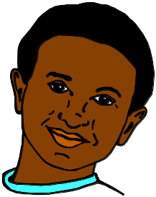

Asif is going to have a very busy day on Saturday. His Mum and Dad
have left notes on his notice board along with notes he has made himself.

Things I have to do:-
Play football – 10 am
Clean my bike
Go to Bill’s party – 5 pm
Buy Bill a present
Asif - could you change
my library book this
afternoon - Dad.

Come to my party at the Sports Centre at 5⋅00pm.

Bill

Help Asif to plan his day by putting the activities in the order he should do them.
Morning
Afternoon

Don’t forget to get your jotter signed…
Week 29 - Writing Instructions

Mum has had a busy day and comes home from work feeling tired and hungry. You offer to make her favourite sandwich.

Write down under the headings listed below a list of INSTRUCTIONS for this and put each step in the order you would do them.

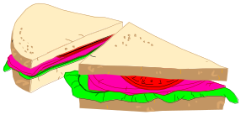


EQUIPMENT REQUIRED:-

INGREDIENTS REQUIRED:-

HOW TO MAKE THE SANDWICH:-

Don’t forget to get your jotter signed…
Week 30 -Writing in Paragraphs

When we write a story or an account we use PARAGRAPHS to help set the story out in a more logical manner.

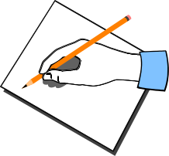
Write a short story of 3 PARAGRAPHS telling about an outing with your friend. You see something unusual happening and go to help or find out more. [Paragraphs 1 and 3 should not be very long]

First Paragraph:- set the scene – where you are and who you are with.

Second Paragraph:- what happens, what you do.

Third Paragraph:- what happened after the incident, how it ended.

Don’t forget to get your jotter signed…
Week 31 -Collecting Information

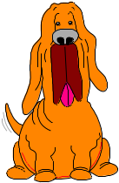
Write down at least 5 facts about your pet or about a creature you are interested in. These facts will help you to make up a wallchart for a young child when you are in the classroom. Your wallchart should be interesting, clear and simple to read.


Facts about:-………………………………………………………………………………….

1.

2.

3.

4.

5.

Make a rough plan of your wallchart below:
A picture of
your pet or
creature here!
(1)
(2)
(4)
(3)
(5)

Don’t forget to get your jotter signed…
Week 32 - Being a Reporter

Think about something that has happened in your school recently. It might be an accident, a visit from someone special, a sports’ event or special assembly. Make notes like a reporter would which will help you write an interesting article.

REMEMBER: Notes are short phrases or sentences which will be made longer and more interesting when you come to write your report/article in full.



MY NOTES

1) Last week Anytown School had a/an…………………………….

2)

3)

4)

5)

6)

Don’t forget to get your jotter signed…

Week 33 - Writing an Account

In order to write an accurate account of something, it is necessary to record your ideas and memories in an orderly way. To help you do this it can help by jotting notes in a table.

Choose an outing which you went on with your class or your friends or your family. Complete this table with notes to help you write an accurate account of your outing:

Where you went
Who went with you
When you went
What the weather was like
How you got there
What you saw and did there
Any other important happenings
When you got home

Don’t forget to get your jotter signed…
Week 34 - Planning a Story

Choose one of the titles below and, using the table underneath, plan a story based on one of the titles:

- An Accident in the Kitchen.
- A Journey in Space.
- The Magic Spectacles.
- Locked in the School.

Title
Characters
Setting/Settings
The main plot
The ending

Don’t forget to get your jotter signed…

Week 35 - Persuasive Writing

Imagine that you are going to give a talk on Homework. To help you prepare for your talk make a list of reasons why you think you should do Homework:

REASONS FOR DOING HOMEWORK -

Now think up a similar number of reasons for not doing Homework:

REASONS FOR NOT DOING HOMEWORK –

Don’t forget to get your jotter signed…

Week 36 - Letters of Complaint

A firm of builders is going to build a housing estate on land which has been used by the children of the village for recreation. It is also an area with some unusual wild plants and is the habitat of badgers and red squirrels.

You are going to write a letter to your local newspaper as a protest and in order to persuade others to support you in your efforts to have the housing estate built elsewhere. Make notes for you letter below.
1. State your point of view.

2. Give as many reasons as you can for arguing your point of view.

3. Give a reason for the building going ahead (show that you understand that there is another point of view).

4. End by asking for support for your point of view.

Don’t forget to get your jotter signed…
Week 37 - Writing Slogans

On the previous sheet you were thinking of reasons for stopping a firm of builders building
a housing estate on an area of special importance to children and to wildlife.

Think up a list of slogans which you might use to put on posters:

*NOTE*: A SLOGAN must express in as few words as possible an idea or point of view.

SAVE THE BADGERS’ HOME!
EXAMPLE:

Don’t forget to get your jotter signed…

Week 38 - Information Poster

You have been asked to prepare a poster persuading visitors to visit your town or village.

List as many reasons as possible why people should visit your town or village. Try to put
your reasons in as interesting ways as possible:

*REMEMBER* Use as few words as possible but make them interesting to the reader.

1.

2.

3.

4.

5.

Don’t forget to get your jotter signed…
Homework Tasks S1 - Writing

For the following writing pieces you must use punctuation accurately and effectively. You should also use ambitious vocabulary.

Personal
- Describe your favourite grandparent or aunt or uncle or friend.
- Write about a time when you were either excited or afraid.
- Write about your favourite possession or birthday present or Christmas present.
- Write about a busy function or ceremony you have been to, such as a party, a wedding etc.
- Write about something which you now regret doing or not doing.

Creative
- Describe the view from your bedroom window.
- Create either a mysterious, frightening or pleasant character.
- Write the opening of either, a romance, western, sci-fi, fantasy or adventure story.
- Describe the sights, sounds and smells of a school or a carnival or football match or beach or busy chip shop.
- Describe the thoughts and feelings of a character who is about to do something forbidden or dangerous or exciting.

Informative
- Write about your favourite sport, hobby or pastime, explaining what exactly is involved.
- Watch a news article and write about it, explaining exactly what it is about.
- Research and write about your favourite animal.
- Research and write about someone you admire.
- Research and write about either William Shakespeare or the Globe theatre.

Writing about Character (1) - Prose

Use the following template to gather information about your character as you read the text in class. Try to add some EVIDENCE from the text as you make your notes.

This will help you when writing your Essay!

In each box, write a word or phrase which describes the main character in your book.

PERSONALITY APPEARANCE
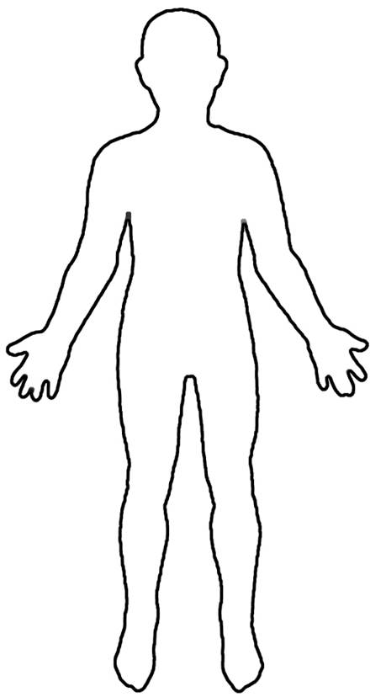

Writing about Character (2) - Drama

Use the following template to gather information about your character as you read the text in class. Try to add some EVIDENCE from the text as you make your notes.

This will help you when writing your Essay!

In each box, write a word or phrase which describes the main character in your book.

PERSONALITY APPEARANCE

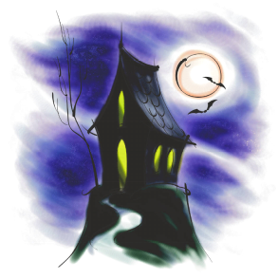
Setting 1 – Elements of setting

Read the following passage and select the information that best describes the setting.
Write your notes in the graphic organiser provided. You can use the organiser when making notes about the setting of your class novel/play as well!

The House with No Name

They turned off the road onto a track running onto a wood. The long branches of the trees on either side almost met overhead. The sunlight glittered through the summer leaves.
‘There’s our new home!’ said dad. ’What do you think of it?’
‘It looks like a face!’ said Jamie
The house did look like a face, a pale face with thatch for hair. The two upstairs windows glinted in the sunshine like winking eyes. The windows downstairs were boarded up with dark planks and looked like blushing cheeks. The faded red door was the mouth and the triangular porch roof above it was the nose.
Setting Graphic Organiser
Setting – Provide at least one example
Descriptions of Buildings | Description of the  Landscape | Weather | Colours | Sound Techniques

