

Education
Director: Mhairi L Shaw DCE

Braidbar Primary School and Nursery
Head Teacher: Mrs Gillian Friel
Kyle Drive, Giffnock
East Renfrewshire G46 6ES
Phone: 0141 570 7020
E-mail: schoolmail@braidbar.e-renfrew.sch.uk

Date:

Dear Parent/Carer

JRSO’s ‘Beep Beep’ Day - Wednesday 20th November

Braidbar’s Junior Road Safety Officers have organised a ‘Beep Beep Day’ on Wednesday 20th November. This is to raise money for Brake the road safety charity. Every day in the UK, 5 people die on roads and about 60 more are seriously injured. Brake works to prevent these tragedies and support people left injured. They also highlight the threat from traffic pollution.

On Wednesday 20th November pupils can come to school wearing a stripy top/bottoms to represent a zebra crossing. It is not a ‘dress as you please’ so please ensure if you choose to wear a stripy top that you are wearing the rest of your uniform. The JRSOs would appreciate it if you could please bring a 50p donation on this day. Classes will be participating in fun activities to engage children with road safety basics. The whole school will also walk for a mile around the school to put their road safety learning into action! There will also be traffic light biscuits being sold at tuck on this day, if you wish to buy one.

We are looking forward to raising some money for this worthwhile charity!

Yours sincerely,

The Junior Road Safety Officers

Braidbar Primary School
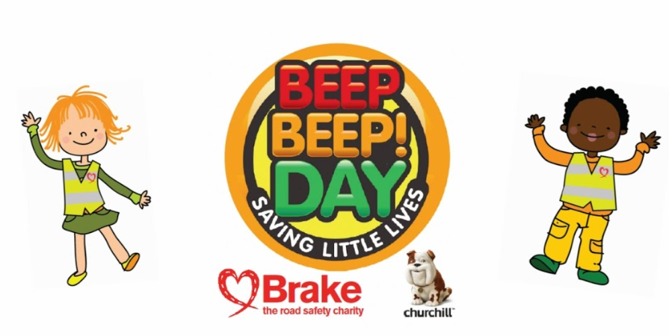

Mhairi Shaw, Director of Education, East Renfrewshire Offices, 211 Main St, Barrhead, G78 1SY

