Woodfarm High School



School Improvement Plan 2022/2023



Higher Standards, Higher Expectations, Greater Opportunity

**Improvement Priorities 2022 - 2025**

With a new Senior Leadership Team now in place and upon a return to full time education post Covid-19 pandemic. Woodfarm HS will begin our new 3 year cycle in session 2022-23. This is in line with the ERC cycle and will add value to the outcomes of our school improvement.

|  |  |  |  |
| --- | --- | --- | --- |
| **Target** | **Broad Outcome** | **Expected Impact** | **Progress to date** |
| **1** | **Improving the quality and consistency of Learning and Teaching for all** | * **Improve quality of teacher feedback** * **Increased focus on effective questioning** * **Increased pupil enjoyment** * **Increased attainment** * **Focus on skills and Career Standard Education** |  |
| **2** | **Raising Attainment, Recognising Achievement** | * **Update systems and processes for attainment Tracking and Monitoring** * **Update systems and processes for recording of pupil achievement in and out of school** * **Update systems and processes for celebrating achievement at all levels** |  |
| **3** | **Safeguarding and supporting pupils** | * **Focus on attendance and engagement through Pupil Support** * **Build resilience and increase awareness of positive mental health strategies** * **Promoting Positive Relationships** |  |
| **4** | **Developing leadership** | * **Staff CLPL programme, promoting leadership at all levels** * **Further increase pupil leadership opportunities in line with RRS** |  |

**Woodfarm High School Outline Targets for session 2022 / 2023**

|  |  |  |  |  |
| --- | --- | --- | --- | --- |
|  | Targets 2022 – 2023 | Quality Indicators | N.I.F. Drivers | SHANARRI Indicators |
| Target 1 | Improving the quality and consistency of Learning and Teaching for all | **1.1, 1.2, 1.3, 2.2, 2.3, 3.1, 3.2, 3.3** | Pupil Progress; Performance Information; Teacher Professionalism; School Improvement | Achieving, Included, Nurtured, Responsible |
| Target 2 | Raising Attainment, Recognising Achievement | **1.1, 1.4, 1.5, 2.2, 2.3, 2.4, 2.6, 2.7, 3.1, 3.2, 3.3** | Pupil Progress; Parental Engagement; Performance Information | Safe, Healthy, Nurtured, Achieving, Respected, Responsible, Included |
| Target 3 | Safeguarding and Supporting Pupils | **2.1, 2.4, 2.6, 2.7** | School Improvement; Pupil Progress; Parental Engagement | Respected, Responsible, Included |
| Target 4 | Developing Leadership opportunities across the school | **1.1, 1.2, 1.3, 1.4, 2.7, 3.1** | School Leadership; School Improvement; Teacher Professionalism |  |
| Maintenance | Section for continued working |  |  |  |
|  |  |  |  |  |

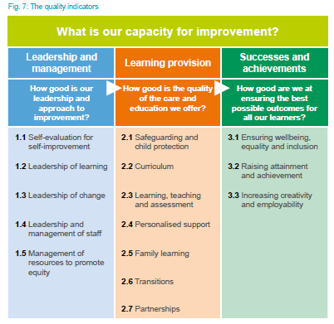

How Good is our School? 4th edition Quality Indicators

2022 National Improvement Framework and Improvement Plan for Scottish Education. Drivers for Improvement

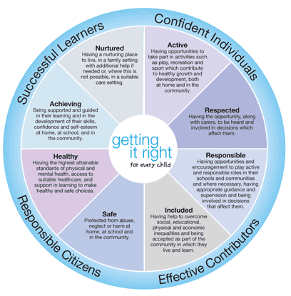

Getting it Right for Every Child Wellbeing Wheel

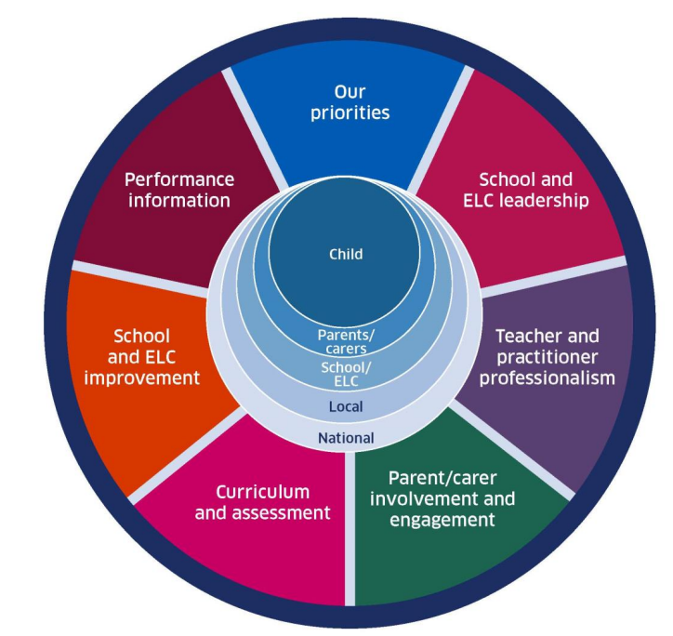

|  |  |  |  |  |  |  |  |  |  |
| --- | --- | --- | --- | --- | --- | --- | --- | --- | --- |
| **TARGET 1** | | ***IMPROVING THE QUALITY AND CONSISTENCY OF LEARNING AND TEACHING FOR ALL*** | | | | | | | |
| ***Actions*** | | | ***HGIOS? 4 Quality Indicators*** | ***N.I.F. Drivers of Improvement*** | ***SHANARRI Indicators*** | ***Personnel*** | ***Time-scale*** | ***Impact / How will success be measured?*** | ***Resources*** |
| **a** | *Continue to improve learning and teaching with a particular focus on developing high quality feedback & effective questioning* | | ***1.2***  ***2.3*** | *School Improvement*  *Performance Information* | *Achieving*  *Included*  *Responsible* | ***All staff***  ***Lead: J Galt*** | *Throughout the session* | *A return to active learning in all curricular areas, children are challenged and supported in their learning. Pupil feedback and learning observations will highlight teacher questioning, feedback and learner conversations as a strength.* | *Time, CLPL and Budget* |
| **b** | *Evaluate and update the PSHE programme to ensure emphasis on promoting resilience and positive mental health as well as a renewed focus on careers* | | ***1.3***  ***2.2***  ***2.3***  ***3.1***  ***3.2***  ***3.3*** | *Curriculum and Assessment*  *Performance Information*  *School Improvement* | *Safe*  *Healthy*  *Nurtured*  *Respected*  *Achieving*  *Included*  *Responsible* | ***G Lamb***  ***Lead: Pupil Support***  ***K Scott*** | *Throughout the session* | *The PSHE programme will be adapted where appropriate to give greater emphasis to promoting resilience and positive mental health in pupils. This will be evaluated through professional dialogue with staff, lesson observations and pupil voice.* | *Time, CLPL and resources* |
| **c** | *Develop timetabling strategies to ensure pupil learning is maximised. Overhaul and update of curricula plans to take cognisance of upcoming changes to the timetable structure & National Curriculum changes* | | ***1.1***  ***1.2***  ***2.2***  ***2.3***  ***3.2*** | *Curriculum and Assessment*  *Teacher Professionalism*  *School Improvement* | *Achieving*  *Included*  *Responsible* | ***Lead: G Boyle***  ***SLT***  ***HoF’s***  ***All Staff*** | *Ongoing.*  *Initial phase to be completed by June 2023* | *Updating curricular provision in line with OECD, Muir and Morgan reports (2021-22) taking cognisance of the focus on skills development.*  *L&T strategies to be updated alongside assessment strategies to ensure a 21st century approach to learning.* | *Time and CLPL* |
| **d** | *At BGE (S1-S3) and National Levels (S4-S6) continue to develop and implement national and local, routine moderation practices that ensure rigour, consistency and a shared understanding of standards* | | ***1.1***  ***1.2***  ***1.3***  ***1.4***  ***2.2***  ***2.3***  ***2.4***  ***3.2*** | *Curriculum and Assessment*  *Teacher Professionalism*  *School Improvement*  *Performance Information* | *Achieving*  *Included*  *Responsible* | ***All staff***  ***Lead: J Galt & M Hamid*** | *June 2023* | *Consistent approach across all faculties/departments with regards moderation in BGE and Senior Phase. Planning for cross authority moderation at all levels in session 2023/24* | *Time*  *CLPL* |
| **e** |  | |  |  |  |  |  |  |  |

|  |  |  |  |  |  |  |  |  |  |
| --- | --- | --- | --- | --- | --- | --- | --- | --- | --- |
| ***TARGET 2*** | | ***RAISING ATTAINMENT AND RECOGNISING ACHIEVEMENT*** | | | | | | | |
| ***Actions*** | | | ***HGIOS?***  ***4*** | ***N.I.F. Drivers of Improvement*** | ***SHANARRI Indicators*** | ***Personnel*** | ***Time-scale*** | ***Impact / How will success be measured?*** | ***Resources*** |
| **a** | *Target lowest performing / most deprived pupils to improve attainment/achievement and to close any gaps in opportunity in attainment or achievement caused.* | | ***1.4***  ***1.5***  ***2.2***  ***2.3***  ***2.4***  ***2.6***  ***2.7***  ***3.1***  ***3.2*** | *School Improvement*  *Performance Information*  *Parental Engagement* | *Included*  *Nurtured*  *Responsible*  *Achieving* | ***Lead:S Wilson***  ***SLT***  ***English and Maths staff*** | *Ongoing* | Make effective use of pupil equity funding to enhance provision for the lowest performing and least affluent young people. Evaluation through tracking of pupil outcomes.  New Learning Centre to provide bespoke curricula where necessary and widen opportunities for all. | *PEF funding* |
| **b** | *Systems updated to incorporate new Assessment, tracking, and reporting systems in-school and from Seemis/ Parent Portal.* | | ***1.3***  ***2.3***  ***3.1***  ***3.2***  ***3.3*** | *School Improvement*  *School Leadership*  *Parental Engagement* | *Included*  *Nurtured*  *Responsible*  *Achieving*  *Respected* | ***Lead: S Higgins***  ***SLT***  ***G Boyle*** | *Ongoing* | Update current systems. Audit current provision and amend with new procedures for T&M, Interventions etc.  What data should we collect and why – changes in equity categories? (PEF funding for interventions)  Impact to be assessed through Pupil, Staff and Parent feedback. | *Time* |
| **C** | *Implement a series of “study skills” lessons for S1 to S6 that will enhance the curriculum, improve attainment and build confidence and resilience in our learners* | | ***1.3***  ***1.4***  ***1.5***  ***2.2***  ***2.3***  ***2.4***  ***2.5***  ***2.6*** | *School Improvement*  *Performance Information*  *Parental Engagement* | *Included*  *Nurtured*  *Responsible*  *Achieving* | ***Lead: S Higgins***  ***SLT***  ***PSMT***  ***Heads of Faculty*** | *Ongoing* | Implement a series of lessons on strategies to maximise yield from studying. CLPL on current research and metacognition to provide all staff with the skills to tailor the learning experience for all stakeholders. Also include in-person parent sessions on study skills to enable parents to better support their child in their learning. | *Time, CLPL.* |
| **d** | *Relaunch Pupil Parliament with links to new Pupil Council programme.* | | ***1.2***  ***1.3***  ***3.1*** | *School Improvement* | *Included*  *Responsible*  *Achieving*  *Respected* | ***Lead: J Galt***  ***Pupils*** | *Ongoing* | Firm links with Pupil Parliament and Pupil Council to ensure the views of all young people are heard and shared. Continue the excellent work in relation to Learning Ambassadors and further develop pupil leadership roles. | *Time, Staff and Pupil Committee*  *Looking outwards* |
| **e** | *Further develop strategies for collecting, collating and sharing pupil achievements both in and out with school* | | ***1.3***  ***2.7***  ***3.1***  ***3.2***  ***3.3*** | *School Improvement*  *Performance Information*  *Parental Engagement* | *Included*  *Nurtured*  *Responsible*  *Achieving*  *Respected* | ***Lead: J Kelly***  ***J Galt***  ***Interested staff*** | *Ongoing*  *Census to be completed by October 2022* | Census of pupil achievements to be undertaken early in new session. Outcomes of this to be shared with relevant staff. Updates to be shared at assemblies. Pupil views on best way to collect and celebrate achievements to be gathered. Faculty processes for sharing achievements to be shared. | *Time,*  *Working groups* |

|  |  |  |  |  |  |  |  |  |  |
| --- | --- | --- | --- | --- | --- | --- | --- | --- | --- |
| **TARGET 3** | | **SAFEGUARDING AND SUPPORTING PUPILS** | | | | | | | |
| **Actions** | | | **HGIOS? 4 Quality Indicators** | **N.I.F. Drivers of Improvement** | **SHANARRI Indicators** | **Personnel** | **Time-scale** | **Impact / How will success be measured?** | **Resources** |
| **a** | *Review of implementation of new attendance & latecoming policy and introduction of systems to identify and challenge pupil non-attendance and non-engagement* | | **1.3**  **1.5**  **2.4**  **2.5**  **2.7** | *Performance Information*  *Parent/Carer Involvement* | *Included*  *Achieving* | **Lead: G Lamb**  **G Boyle**  **PSMT** | December 2022 | Pupil participation in engagement interventions. Parent participation and feedback through surveys / written responses. Ongoing monitoring of pupil attendance figures and interim reports to track engagement | Time,  Personnel for group interventions  PEF funding to assist with removal of barriers |
| **b** | *Apply the principles of nurture as a whole-school approach, underpinned by trauma-informed practice to improve and address the MHWB of young people.* | | **2.1**  **2.3**  **2.4**  **2.5**  **2.7** | *Pupil Progress*  *School Improvement* | *Nurtured*  *Included*  *Achieving* | **Lead: G Lamb**  **S Wilson**  **Educational Psych.** | Throughout the session | Ongoing monitoring of the pupils involved and the programme using the schools quality assurance procedures. On-going monitoring of the pupils involved and the programme by Educational Psychologists | Time, CLPL and Budget |
| **c** | *Introduce and regularly evaluate our new Promoting Positive Relationships policy for Woodfarm High School.* | | **1.2**  **1.3**  **1.5**  **2.1**  **2.3**  **2.4**  **2.7**  **3.1**  **3.2** | *Teacher Professionalism*  *School Improvement*  *Performance Information* | *Included*  *Nurtured*  *Responsible*  *Achieving*  *Respected* | **Lead: G Lamb**  **All staff** | Introduced Aug 2022. Ongoing evaluation | Implement initial phase of our new Promoting Positive Relationships policy ensuring consistency of application in all areas of the school. Ongoing evaluation, views sought from all stakeholders and policy amended appropriately. | Time, CLPL, Budget |
| **d** | *To ensure Woodfarm High School’s most vulnerable pupils receive contact and support from the school and partners to support their personal, social and educational needs in line with national priorities from the Review of ASL and The Promise* | | **2.1**  **2.3**  **2.4**  **2.5**  **2.7** | *Pupil Progress*  *School Improvement* | *Nurtured*  *Included*  *Achieving* | **Lead: G Lamb**  **PSMT** | Throughout the session | All key equity groups have regular contact with the support team and achieve equitably with their peers. The recommendations of the ASL review and The Promise will be implemented at WFHS  Pupil Profiles, Wellbeing Questionnaires, Attainment data, Learning Centre intervention evaluations  New systems in place within the school will target key equity groups and vulnerably young people facilitating time for discussion leading to intervention where appropriate | Time, CLPL, Pef, staff training |

|  |  |  |  |  |  |  |  |  |  |
| --- | --- | --- | --- | --- | --- | --- | --- | --- | --- |
| **TARGET 4** | | **DEVELOPING OPPORTUNITIES FOR LEADERSHIP AND EMPOWERMENT ACROSS THE SCHOOL** | | | | | | | |
| **Actions** | | | **HGIOS? 4 Quality Indicators** | **N.I.F. Drivers of Improvement** | **SHANARRI Indicators** | **Personnel** | **Time-scale** | **Impact / How will success be measured?** | **Resources** |
| **a** | *Further develop, share and implement systems for school self-evaluation in line with HGIOS 4* | | **1.2**  **1.3**  **1.4**  **1.5**  **2.2** | *School Improvement*  *School Leadership*  *Teacher Professionalism* | *Responsible*  *Included* | **Lead: J Galt** | December 2022 | Comprehensive systems in place for departmental and whole school quality assurance and self-evaluation.  Analyse and review implementation of new QA procedures introduced by the Working group | Time |
| **b** | *Develop meaningful pathways for leaders looking to become: PTF; PTPS; SLT* | | **1.2**  **1.3**  **1.4** | *School Improvement*  *School Leadership*  *Teacher Professionalism* | *Responsible*  *Included* | **Lead: J Galt** | December 2022 | Create and implement a programme of CLPL to allow aspiring PT’s and/or DHT’s an opportunity to explore leadership theory and identify their own personal leadership potential | Time |

|  |  |  |  |  |  |  |  |  |  |
| --- | --- | --- | --- | --- | --- | --- | --- | --- | --- |
| **MAINTENANCE** | | **PROGRESS UPDATE: TARGETS NOW REMOVED FROM PLAN AS POINTS FOR ACTION.**  **THESE WILL REMAIN AS MAINTENANCE TARGETS UNTIL FURTHER NOTICE** | | | | | | | |
| **Previous Action Points**  **(Taken from 2021/22 Plan)** | | | **HGIOS? 4 Quality Indicators** | **N.I.F. Drivers of Improvement** | **SHANARRI Indicators** | **Personnel** | **Time-scale** | **Impact, Next Steps for 2022/23 and Evidence** | **Resources** |
| **a** | All Active Learning strategies to be reintroduced  Further use of digital resources at home and in school in learning and teaching | | ***2.2***  ***2.3***  ***1.5***  ***2.3*** | Pupil Progress  School Improvement | Achieving  Included  Active | **All staff** | On going | Young people are active within classrooms, to motivate and inspire their own leadership of learning. Evidence of improvements noted (hopefully) in the ERC Transitions Review and CIVs. | Time to reinforce expectations in FMs |
| **b** | To continue to build on our culture of professional enquiry and distributive leadership across the school leadership within Faculties (established in individual PRDs)  To ensure all young people are participating the wider life of the school  Parental Engagement | | ***1.1***  ***1.2***  ***2.3***  ***3.1***  ***3.2***  ***2.5*** | School Leadership  Curriculum and  Assessment  Teacher Professionalism  Parental Engagement | Responsible  Achieving  Included  Respected | **All staff**  **J Galt,**  **W Morrow** | On going | Staff responsibility for an area within faculty Achievements across the school – consider again how these can be celebrated consistently across the school  A continuation of the positive foundation in place through W Morrow’s programme; impact on families and community | Time to reinforce expectations in FMs targets and expectations set in PRDs |
| **c** | |  | | --- | |  |   To ensure DYW priorities are a focus; opportunities to exemplify and develop Skills for Learning, Life & Work in Faculties across the school  Promotion of alternative pathways – NPAs, vocational choice | | **1.1, 1.2, 1.3, 2.2, 3.1,**  **3.3** | Pupil Progress  Curriculum and  Assessment | Responsible  Achieving  Included  Safe  Healthy | **K Scott, All staff** | On going | Young people have a greater awareness of skills for Life, Work and Learning within their lessons, as well as ways in which subjects can link to careers, though ’My World of Work’ resource and ‘I can’ statements.    An awareness of alternative pathways continues to build through DYW and potentially SCQF Ambassadors | CLPL Staff and Pupil Committee |