As adults we will: | The Article | As children we will:
- Provide healthy food options.  - Provide access to clean water.  - Encourage less food and water wastage.  - Remind children to fill bottles are correct time to ensure learning is not interrupted. | We all have the right to good food and water.  (Article 24) | - Try to eat as much as we can and we won’t waste food.  - We will fill our water bottles up at lunch time and play time.  - Be careful not to spill our water.
- Remind children to respect others by modelling and advising.  - Remind children to sit and eat properly.  - Encourage you to eat as much as you can. | You have the right to life and to be healthy.  (Article 6) | - Respect others when they are eating.  - Try to minimise food waste.  - Eat all of our vegetables.  - Eat our food in our packed lunches and not take food from the lunch hall if we are not supposed to.
- Help if children need assistance  - Provide food and nourishment  - Provide adequate supervision to ensure appropriate behaviour. | We all have the right to be protected from doing things that could harm us. (Article 36) | - Behave responsibly.  - Walk through the lunch hall and not run.  - Walk up/down the stairs and not jump them.  - Be patient and stay sitting when waiting for our lunch.  - Watch my step in case there is food on the floor.
- Remind children of the routines of lunch time  - Provide appropriate bins to recycle.  - Provide help when needed. | Everyone who works with children should always do what is best for each child. | - Listen to and respect the adults in the lunch hall.  - Follow instructions from the adults.  - Use good manners for all. Saying please and thank you.
- Help to clear up spillages and place hazard signs where needed.  - Get the lunch hall ready for children to have their lunch. | Children have the right to a clean and safe environment.  (Article 24) | - Not throw food or juice.  - Keep the lunch hall tidy.  - Be careful when putting things in the bin and make sure they don’t end up on the floor.  - Put food waste in the correct bin.  - Clean up after ourselves and clean our area.
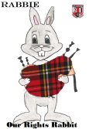
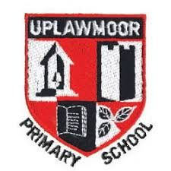
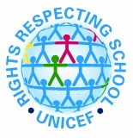
Uplawmoor Primary School Lunch Hall Charter
We have created our lunch hall charter to help us be happy, safe and support us as learners.

