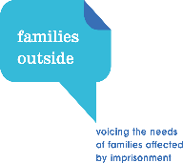 Families Outside Conversation Café
Families Outside invite you to come along and chat with us about creating a new peer support group for children, young people and their parents/ carers affected by imprisonment or the criminal justice system.
Where? VOX Liminus, The Music Shop, 217 Gallowgate, Glasgow, G1 5DX
When? Thursday 24th January 2019 , 4.30pm (snacks & refreshments will be provided)
How? If you would like to attend please contact: Tracey Burns – 07384469640 tracey.burns@familiesoutside.org.uk

Where we are and how to find us:

