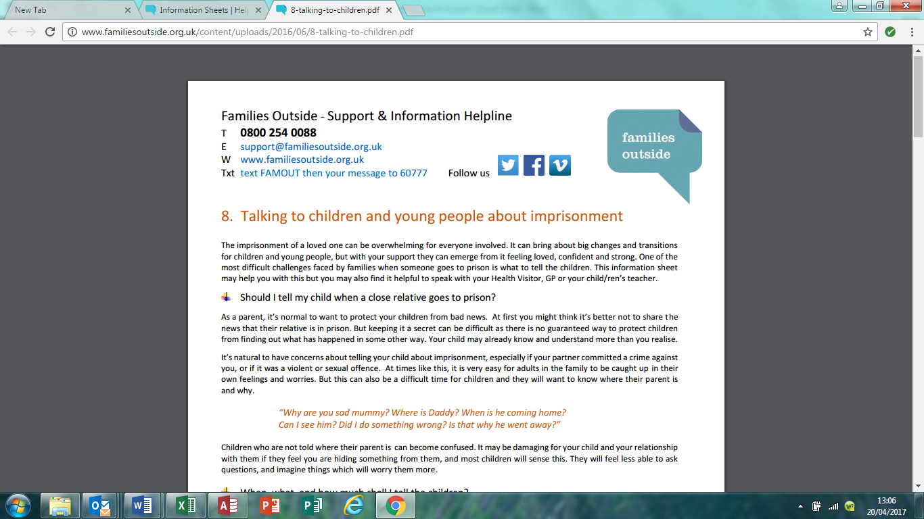

**Information on speaking to your child about imprisonment**

**Visiting and maintaining contact**

**Resources to support your child**

This can affect the whole family. If this is happening in your family it may be that the school or the charity Families Outside can help.

For support or information for families contact Families Outside

Helpline 0800 254 0088 Txt text FAMOUT then your message to 60777

Chat private webchat via www.familiesoutside.org.uk Email [support@familiesoutside.org.uk](mailto:support@familiesoutside.org.uk)

Come and meet Families Outside for information & support over a coffee

St Mark’s Primary

Tuesday 2nd May at 2- 3pm

In every community there are families with a family member involved in the criminal justice system