**Italian Meatballs & Spaghetti**

**N5 Hospitality**

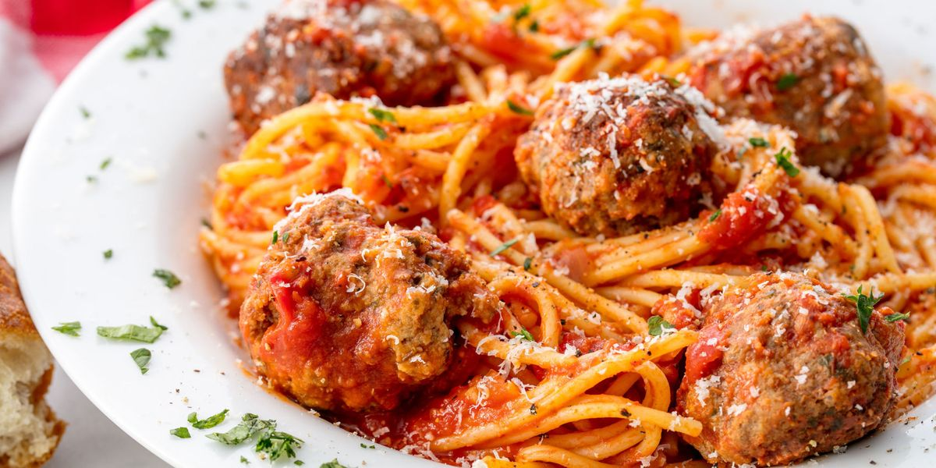

**Learning Intentions**

1. Shape and brown mince
2. Independently follow a recipe.
3. Present to a high standard.
4. Work safely & hygienically.

**Method**

1. Finely dice the onion.
2. Heat 10ml oil in a pan.
3. Sweat 50g of onion until soft.
4. Remove onion & cool.
5. Combine the beef, oregano & breadcrums with the cooked onion.
6. Season with salt & peper and add enough egg to bind.
7. Divid into 12 equal portions.
8. Shape & allow to chill.
9. Crush garlic.
10. Heat 10ml oil in a frying pan.
11. Add the garlic & remaining onion.
12. Add tomato mixture. Bring to boil & simmer for 10 minutes.
13. Put pot of water on to boil.
14. Heat remaining oil in frying pan and carefully seal the meatballs.
15. Adjust consistcy of sauce. Taste & Season. Put pasta in boiling water.
16. Drain pasta.
17. Arrage spaghetti at the bottom and the meatballs on top.
18. Serve on a clean, warm place, garnished with basil & a van dyke tomato.

**Equipment**

Frying pan  
pot & lid

Wooden spoon

Measuring jug

Bowl

Red chopping board

Green chopping board

Chef knife

Non slip mat

Colander

Serving bowl

Table spoon

Plate

Garlic crusher

Bowl for scraps

**Ingredients**

Onions 100g

Sunflour oil 30ml

Minced beef 300g

Dired oregano 2.5ml

Wholemeal breadcrumbs 25g

Beaten egg ½

Plain flour 30ml

Garlic clove 5ml

Chopped tomatoes 200ml

Passata 100ml

Beef stock 50ml

Tomato puree 30ml

Spaghetti 100g