Fashion and Textiles
National 5
Practice Questions Workbook

Question 1
A garment manufacturer wants to hire a new designer and extend their range of clothes to include trousers and dresses.
- A prototype of one of these trousers is shown below.

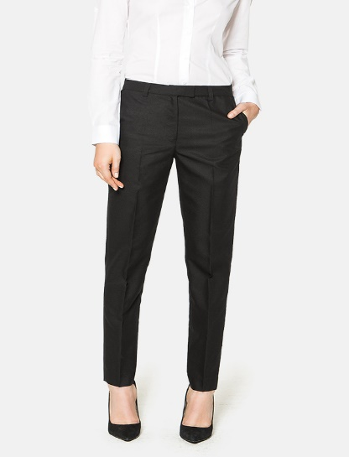

Identify one construction technique that could be used for each of the following processes. Explain why the construction technique is suitable for this trouser.

- Waistband (2)
Construction technique ________________________________
Explanation _________________________________________
__________________________________________________
__________________________________________________
- Pocket finish (2)
Construction technique ________________________________
Explanation _________________________________________
__________________________________________________
__________________________________________________
- A prototype of one of these dresses is shown below.

Identify one construction technique that could be used for each of the following processes. Explain why the construction technique is suitable for this dress.

- Collar (2)
Construction technique ________________________________
Explanation _________________________________________
____________________________________________________________________________________________________
- Sleeve (2)
Construction technique ________________________________
Explanation _________________________________________
__________________________________________________
__________________________________________________
- A fabric with the following composition is being considered for the dress.
70% VISCOSE
5% ELASTANE

Evaluate the suitability of four key aspects of this fabric. (4)
Evaluative comments must include reference to the dress.
Evaluation 1 _____________________________________________
______________________________________________________________________________________________________________
Evaluation 2 _____________________________________________
______________________________________________________________________________________________________________
Evaluation 3 _____________________________________________
______________________________________________________________________________________________________________
Evaluation 4 _____________________________________________
______________________________________________________________________________________________________________

Question 2 (2)
Explain two safety features you need to consider when operating an iron.
Safety factor 1 _______________________________________________
___________________________________________________________
___________________________________________________________
Safety factor 2 _______________________________________________
___________________________________________________________
___________________________________________________________

Question 3
A luxury boutique is planning to launch a range of outerwear coats and jackets during the Winter season.
- Describe four factors that need to be considered when planning the outerwear range. (4)
Factor 1 ________________________________________________
_______________________________________________________
_______________________________________________________
Factor 2 ________________________________________________
_______________________________________________________
_______________________________________________________

Factor 3 ________________________________________________
_______________________________________________________
_______________________________________________________
Factor 4 ________________________________________________
_______________________________________________________
_______________________________________________________
- One of the coats or jackets to be included in the range must be suitable for a teenager. Consider the following three aspects of design for the teenager’s outerwear.
- Style
- Fabric to be used
- Embellishment
For each aspect of the coat or jacket, describe one feature that would be important in the design of the outerwear. Explain why each design feature you have described makes the coat or jacket suitable for a teenager to wear during the Winter season. (6)
Style
Description ______________________________________________
_______________________________________________________
_______________________________________________________
Explanation ______________________________________________
_______________________________________________________
_______________________________________________________
Fabric to be used
Description ______________________________________________
_______________________________________________________
_______________________________________________________
Explanation ______________________________________________
_______________________________________________________
_______________________________________________________
Embellishment
Description ______________________________________________
_______________________________________________________
_______________________________________________________
Explanation ______________________________________________
_______________________________________________________
_______________________________________________________
- The luxury boutique has decided to use the following symbol on the teenager’s coat or jacket from the outerwear range.
Evaluate the suitability of one key aspect of the fabric properties, for a teenager buying a coat or jacket with this symbol on the care instructions. (1)
Evaluation _______________________________________________
_______________________________________________________
_______________________________________________________

Question 4
A textile manufacturer is making fabrics for a designer of swimwear.
The designer is planning to use the fabric to make men’s swimming shorts.
- Name two methods of fabric construction that could be used to make a fabric that is suitable for swimming shorts. (2)
Method of fabric construction 1 ______________________________
Method of fabric construction 2 ______________________________
- Choose one method of fabric construction you have named. Give two reasons why it would be suitable for making swimming shorts. (2)
Method of fabric construction _______________________________
Reason 1 ________________________________________________
_______________________________________________________
_______________________________________________________
Reason 2 ________________________________________________
_______________________________________________________
_______________________________________________________
- Explain two advantages and one disadvantage of using a fabric with Lyocell to make men’s swimming shorts. (3)
Advantage 1 _____________________________________________
_______________________________________________________
Advantage 2 _____________________________________________
_______________________________________________________
Disadvantage 1 ___________________________________________
_______________________________________________________
_______________________________________________________
- The designer has told the fabric manufacturer that a male celebrity will be modelling the swimming shorts for the online store.
- Evaluate the suitability of one key aspect of the designer using a celebrity/role model to advertise the swimming shorts. (1)
Evaluation __________________________________________
__________________________________________________
__________________________________________________
- Evaluate the suitability of one key aspect of men shopping online to buy swimming shorts. (1)
Evaluation __________________________________________
__________________________________________________
__________________________________________________
- State one other explanation that could be used to understand the fashion trends of men when choosing swimwear. (1)
_______________________________________________________
_______________________________________________________
_______________________________________________________

